**Assignment No.2**

* **pwd**

**Use to know current working directory.**

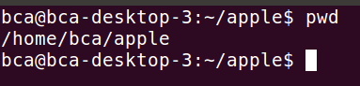

* **cd**

**Use to change the current directory**

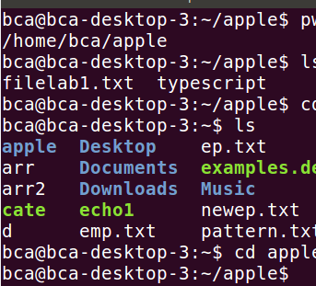

**To Move Upward Directory, use cd .. or cd\**

* **mkdir**

**Use to create directories.**

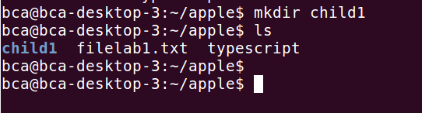

* **rmdir**

**Use to remove directories**

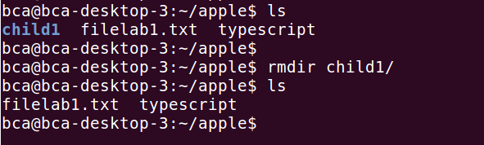

* **ls**

**Give a list of all filenames in the current directory**

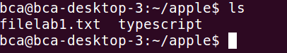

* **cat**

**Used to create a file and also used to open file content**

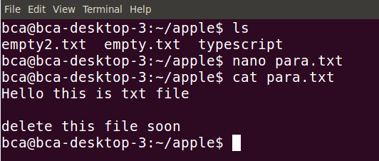

* **cp**

**Used to copying files**

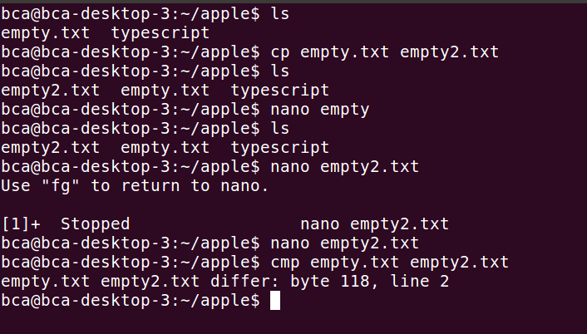

* **rm**

**Used to delete one or more files.**



* **mv**

**it renames or moves files.**

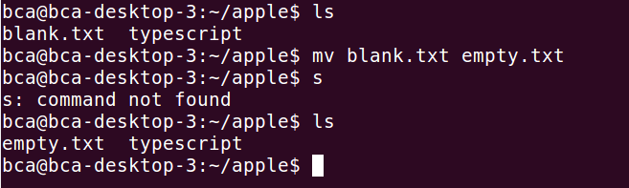

* **file**

**Used to determine the type of file**

**Syntax:**

***$file [filename]***

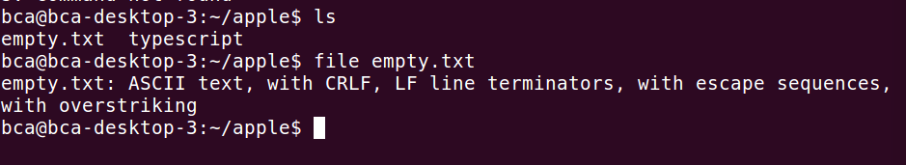

* **wc**

**Counts lines, words and characters**

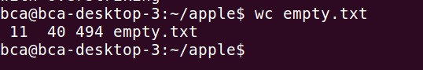

* **od**

**Displays octal data**

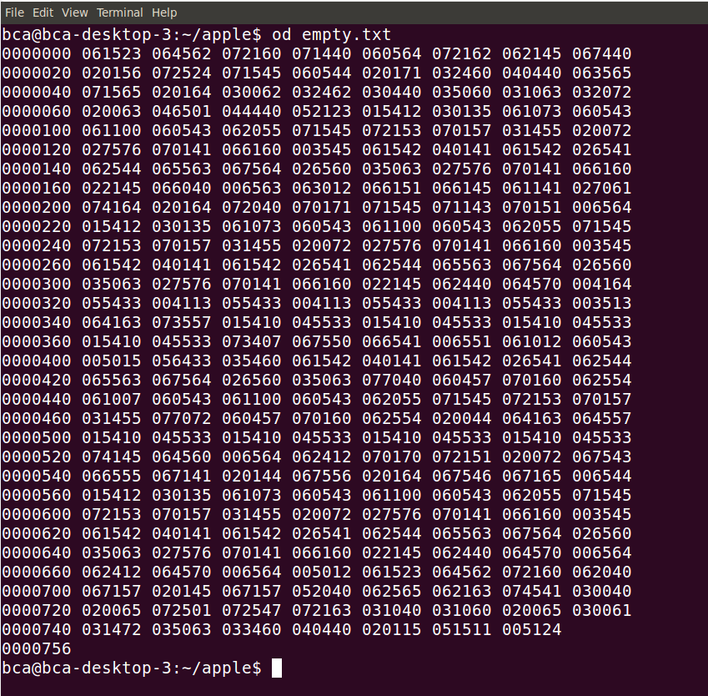

* **cmp**

**Used to compare to files and gives position of first mismatch as a result**

**Example:**



* **comm**

**Find common between two files.**

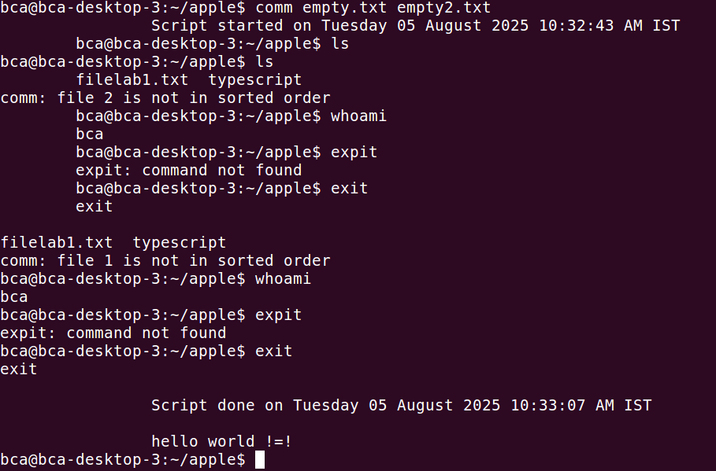

* **diff**

**Used to display file differences and also tells which lines in one file have to be changed to make the two files identical**

**Example:**

