**Assignment No. 03 – VI Editor (VIM)**

**Vi filename :**

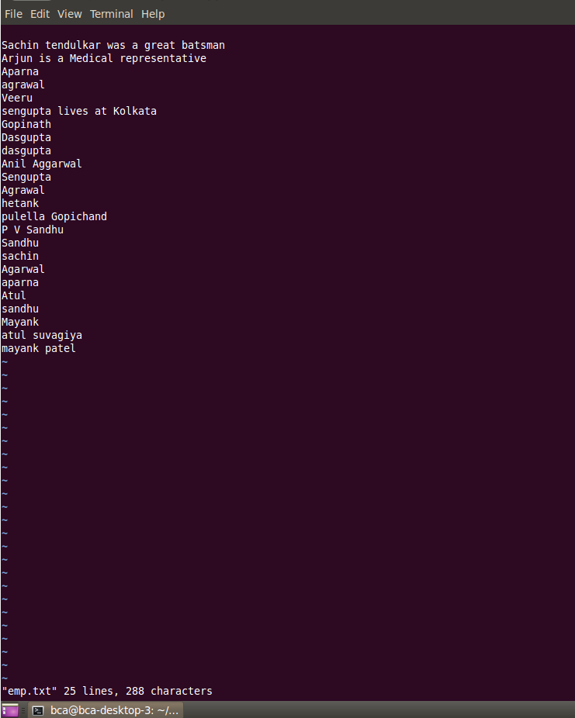

**Exit ( write and quit )**

**:wq**

**Exit :** 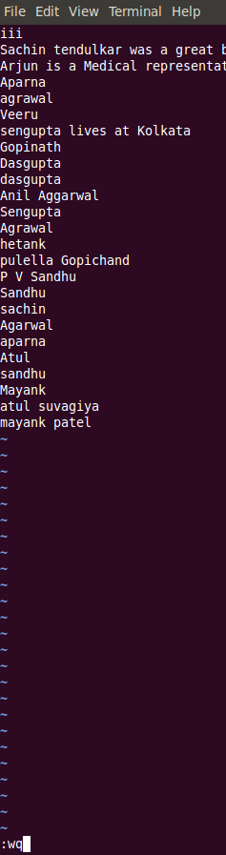

**📄 VI Editor Cheatsheet Table**

**Assignment No.03 – File Editing Using vi**

**📌 Modes in VI Editor**

|  |  |
| --- | --- |
| **Mode** | **Description** |
| **Command Mode** | Default mode for navigation, editing, saving, etc. |
| **Insert Mode** | Used to insert text; enter using i, a, o, etc. |

**🚀 Starting and Exiting vi**

|  |  |
| --- | --- |
| **Command** | **Description** |
| vi filename | Opens existing or creates a new file |
| :x | Save and exit |
| :wq | Save and quit |
| :q | Quit without saving |

**⌨️ Cursor Movement**

|  |  |
| --- | --- |
| **Command** | **Moves Cursor...** |
| h | Left |
| l | Right |
| j | Down |
| k | Up |
| 0 | To beginning of line |
| $ | To end of line |
| w | To beginning of next word |
| b | To beginning of previous word |
| :0 or 1G | To first line of file |
| :n or nG | To line number n |
| :$ or G | To last line of file |

**📝 Insert or Add Text**

|  |  |
| --- | --- |
| **Command** | **Action** |
| i | Insert before cursor |
| I | Insert at beginning of current line |
| a | Append after cursor |
| A | Append at end of current line |
| o | Open new line below |
| O | Open new line above |

**✏️ Change Text**

|  |  |
| --- | --- |
| **Command** | **Action** |
| r | Replace character under cursor |
| R | Overwrite characters from cursor onwards |
| s | Replace current character and enter insert mode |
| S | Delete entire line and enter insert mode |

**❌ Delete Text**

|  |  |
| --- | --- |
| **Command** | **Action** |
| x | Delete character under cursor |
| X | Delete character before cursor |
| D | Delete from cursor to end of line |
| dd | Delete current line |
| ndd | Delete n lines from current line |

**📋 Copy (Yank) and Paste**

|  |  |
| --- | --- |
| **Command** | **Action** |
| yy | Yank (copy) current line |
| nyy | Yank next n lines including current |
| p | Paste after cursor |
| P | Paste before cursor |

**🔍 Searching**

|  |  |
| --- | --- |
| **Command** | **Action** |
| /string | Search forward for string |
| ?string | Search backward for string |
| n | Next match in same direction |
| N | Next match in opposite direction |

**↩️ Undo**

|  |  |
| --- | --- |
| **Command** | **Action** |
| u | Undo last action |
| nu | Undo n previous actions |

**⚙️ Advanced VI Commands**

|  |  |
| --- | --- |
| **Command** | **Action** |
| J | Join current line with the next |
| :w newfile | Save buffer to newfile |
| :12,35w smallfile | Write lines 12–35 to smallfile |
| :1,10s/helo/hello/g | Replace helo with hello in lines 1–10 |