**Assignment No. 6 – GREP Commands (Simplified)**

**Date:** 17-09-2024

**1. create file emp.txt with following content,**

Sachin tendulkar was a great batsman

Arjun is a Medical representative

Aparna

agrawal

Veeru

sengupta lives at Kolkata

Gopinath

Dasgupta

Dasgupta

Anil Aggarwal

Sengupta

Agrawal

hetank

pulella Gopichand

P V Sandhu Sandhu

sachin

Agarwal

aparna

Atul

sandhu

Mayank

atul suvagiya

mayank patel

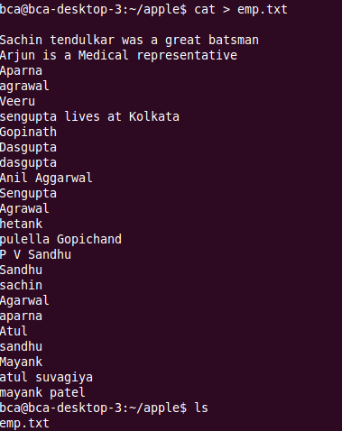

2. Find employee Veeru from emp.txt \

C:\Users\sybca69\Pictures\Screenshots\Screenshot 2025-08-12 100900.png

3. find pattern P V Sandhu from emp.txt

C:\Users\sybca69\Pictures\Screenshots\Screenshot 2025-08-12 100907.png

4. copy file emp.txt and create new file newemp.txt with copied content.

C:\Users\sybca69\Pictures\Screenshots\Screenshot 2025-08-12 100919.png

5. find Atul from file emp.txt and newemp.txt

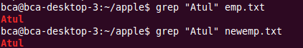

6. find Agrawal or agrawal from file.

C:\Users\sybca69\Pictures\Screenshots\Screenshot 2025-08-12 100943.png

7. display all the lines from emp.txt except those containing Agrawal.

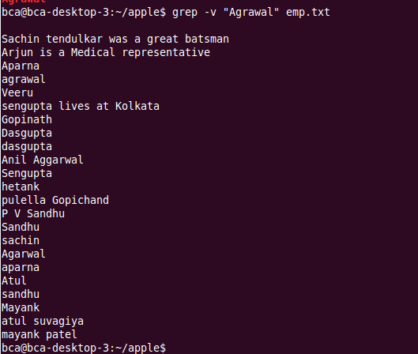

8. display the line numbers containing pattern agrawal. 17-09-2024 Page 2 of 2

C:\Users\sybca69\Pictures\Screenshots\Screenshot 2025-08-12 101010.png

9. count total number of lines containing pattern Sandhu or sandhu.

C:\Users\sybca69\Pictures\Screenshots\Screenshot 2025-08-12 101317.png

10. display name of text files containing pattern aparna

C:\Users\sybca69\Pictures\Screenshots\Screenshot 2025-08-12 101323.png

11. find agrawal or Agrawal from emp.txt using character class.

C:\Users\sybca69\Pictures\Screenshots\Screenshot 2025-08-12 101328.png

12. find multiple pattern sengupta and dasgupta from emp.txt.

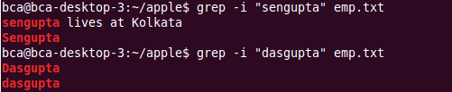

13. display lines that starts with character A.

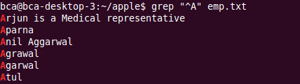

14. display line which end with character k.

C:\Users\sybca69\Pictures\Screenshots\Screenshot 2025-08-12 101346.png

15. create file pattern.txt containing Sandhu Hetank Using file pattern.txt, search the words included in emp.txt.

C:\Users\sybca69\Pictures\Screenshots\Screenshot 2025-08-12 101354.png

16. print line/s which only contains sachin word.

