
Middlesex University

Secure Web Technologies
Case Study: Hacked Website

Lecturer: Jaspreet
Module Code: CST2572
due date: 09th 10 2025
Group Members: Aneeq, Farhan, Murtaza, Rushil

Contents
Introduction 5
1. Initial Reconnaissance and Discovery 5
1.1 Data Gathering and Analysis 6
• Analyse Logs: 6
• Scan for Malware and Vulnerabilities: 6
• Identify the Entry Point: 7
• Database Inspection: 7
1.2 Scope Assessment and Potential Findings 7
• Database Inspection: 7
• Potential Findings: 7
1.3 What to Avoid 8
2. Remedy 8
1. Credential Rotation 8
2. Malicious Code Removal 8
3. Database Sanitization 9
4. Final Patching and Verification 9
3. Clean-up and Restore 9
System Rebuild and Restoration 9
• Store evidence: 9
• Full system wipe: 9
• Restore from Clean Backup: 9
• Verify backup integrity: 9
Data sanitization and patching 10
• Database cleaning: 10
• Malware removal: 10
• Patching: 10
Testing and verification 10
• Functionality testing: 10
• Security and vulnerability scans: 10
• Integrity checks: 10
Go-Live and Post-Incident Actions 10
• Secure Re-Launch: 10
• Reconnect: 10
• Monitor: 10
• Notification: 11
• Documentation: 11
• Backup Strategy: 11
4. Mitigation 11
1. System Architecture Upgrades 11
• Separation of Concerns: 11
• Database Isolation: 11
• Secure Environment: 11
2. Software Patching and Updates 11
• Operating System: 11
• PHP: 11
• WordPress: 12
3. Security Hardening 12
• Firewall: 12
• Encryption: 12
• Security headers: 12
• PHP: 12
• Service Configuration: 12
4. Access Control and Principle of Least Privilege 12
• 2FA/MFA Enforcement: 12
• Admin Access Limitation: 12
• Database Privileges: 13
• File System Privileges: 13
• User Audits: 13
5. Monitoring, Detection, and Alerting 13
• File Integrity: 13
• Intrusion Detection: 13
• Log Management: 13
• Alerting: 13
6. Backup and Recovery 13
• Backups: 13
• Testing: 13
7. Training and Governance 14
• Training: 14
• Policies: 14
• Simulations: 14
5. Diagrams 14
References 15

Introduction
This case study explores a real-world scenario in which the website of a national health conference supported by the NHS was compromised. The affected system runs on an Apache web server in a virtual machine environment with WordPress as its content management system (CMS). After a malware scan detected the breach and shut down the site, it became necessary to diagnose the issue, restore the site, and implement security improvements. This report outlines the steps taken to investigate, remediate, and secure the system against future incidents.

1. Initial Reconnaissance and Discovery
Firstly, open an incident ticket. Appoint incident lead, technical lead, communications, legal. Take screenshots of error pages/defacement/malware scanner output and note the exact time (both in UTC and local).
When dealing with a potential security incident on a virtual machine (VM), the immediate priority is isolation to prevent further damage and preserve forensic evidence. This involves two key steps:
- Network isolation – immediately contact the hosting provider to disconnect the VM from the public network (or achieve this via a host firewall or cloud console) to halt the attacks progress, stop it from spreading, and prevent further data exfiltration.
- It's crucial to keep the VM powered on if a memory image might be needed for analysis, and do not log into the VM or make changes that could destroy evidence.
- VM isolation – contact the hosting provider to quarantine the VM by disabling public access and snapshotting its current state for forensic analysis, which prevents the attacker from maintaining access or spreading malware.
The combined crucial steps for preserving evidence involve immediately contacting the hosting provider to request a full, forensically sound snapshot of the VM disk (read-only), along with the capture of a memory image if possible. Requesting this snapshot preserves the compromised state for later analysis and legal purposes, while also ensuring the collection of relevant hypervisor/host logs from the provider. Create a separate copy of the snapshot for all analysis and remedy work. The original snapshot remains untouched.
The priority is to gather all evidence in a read-only manner to preserve the state of the system, including timestamps. Do not modify or delete any files.
- Logs:
  - Apache logs: access.log, error.log (Apache, 2025a).
  - PHP / PHP-FPM logs and any WordPress plugin logs.
  - Malware scanner quarantine/log file (from the tool that shut the site down).
- File System:
  - Web root file list with metadata (filename, size, mtime).
  - Compute hashes ( SHA256 ) of suspicious files.
- Live System State (Single Snapshot):
  - crontab -l (read).
  - systemctl status for suspicious services.
  - Running processes (single snapshot).
  - netstat -tunap or ss -tunap (single snapshot).
- Application & User Data:
  - WordPress wp_users recent logins (if available) and plugin audit logs.
  - Record all admin access evidence: last login times, IP addresses, active sessions.

1.1 Data Gathering and Analysis
Use the collected artefacts and snapshots for analysis.

Analyse Logs:
  - Examine Apache access and error logs (/var/log/apache2/) for unusual activity right before the shutdown.
  - Look for spikes in traffic, suspicious POST requests to core files, repeated login failures, or file inclusions (e.g., include, require).
  - Review server system logs (e.g., dmesg, auth.log) for root/administrator logins or unexpected commands.
  - Examine WordPress logs for any administrative changes, plugin installations, unauthorized logins, file modifications, or outbound connections.
  - Use tools like grep for patterns (e.g., suspicious IPs or timestamps around the shutdown).

Scan for Malware and Vulnerabilities:
  - Run offline scans on the VM snapshot using tools like ClamAV (Cisco, 2025a) or Malwarebytes (Malwarebytes, 2025).
  - Check for backdoors, webshells (e.g., in WordPress uploads folder), or injected code in PHP files.
  - Determine the type of malware: Search for signatures or known file names of common WordPress attacks (e.g., pharma hacks, backdoors like webshells, or rootkits).
  - For WordPress-specific issues, use WPScan (Automattic, 2025) to identify outdated plugins/themes or weak passwords.

Identify the Entry Point:
  - File Integrity Check: Compare the current file system (from the working copy) against a known-good backup.
  - Use a tool (like diff or a WordPress security scanner) to identify all new, modified, or deleted files.
  - Look specifically at /wp-content/themes, /wp-content/plugins, and core WordPress files (e.g., index.php, wp-config.php).
  - User Accounts: Check the WordPress and server user databases for new, unauthorized admin accounts.
  - Configuration Files: Scrutinize wp-config.php for added malicious code, like hidden backdoors or database connection changes.
  - Entry Point Analysis: Review WordPress admin access—check for brute-force attempts or exploited vulnerabilities (e.g., via plugins).
  - Test for common exploits like SQL injection or XSS (OWASP, 2021).

Database Inspection:
  - Examine the member's database (likely MySQL/MariaDB) for unauthorized changes, such as added admin users or data dumps.
  - Query for anomalies (e.g., SELECT * FROM wp_users WHERE user_registered > 'incident_date').

1.2 Scope Assessment and Potential Findings

Database Inspection:
  - Which sites on the VM are affected?
  - Is the DB accessible/exfiltrated? Confirm if the breach affects only the conference site or both sites/databases.
  - Check for data exfiltration (e.g., via logs showing large outbound transfers).
  - Do any other VMs/hosts show signs?

Potential Findings:
  - Based on typical WordPress hacks, this could be due to an outdated plugin, weak admin credentials, or a compromised host environment⁵¹.
  - The auto-shutdown suggests the malware was detected but not fully removed.

1.3 What to Avoid
- Do not modify files in place (no edits, no deletions).
- Do not restart Apache or the VM unless instructed after forensic capture.
- Do not change passwords yet — only after the evidence snapshot is complete.

2. Remedy
Remedy and containment, which happen after reconnaissance and before full restoration, refer to the immediate corrective actions taken to stop the attack, remove the immediate threat, and fix vulnerabilities.
This phase involved several key steps:

1. Credential Rotation
A complete rotation of all credentials was initiated to revoke any access the attacker may have held.
- Database: The WordPress database password was changed via the host panel, and the wp-config.php file was updated accordingly.
- User Accounts: All user passwords for WordPress, VM SSH/admin access, the hosting control panel, and FTP were reset.
- API Keys: All API keys were regenerated.
- Security Hardening: Multi-Factor Authentication (MFA) was implemented on all administrative logins.

2. Malicious Code Removal
Two approaches were prepared for removing the malicious code.
- Primary Method (Rebuild from Clean Sources):
  - Provision a new, clean VM.
  - Install a fresh Apache environment.
  - Reinstall WordPress core and trusted themes/plugins from official repositories.
  - Remove any unnecessary or abandoned plugins to reduce the attack surface.

- Contingency Method (Manual Cleaning):
  - Manually delete any unauthorized user accounts.
  - Replace all infected core, theme, and plugin files with fresh, clean copies.

3. Database Sanitization
The integrity of the database was addressed by:
- Primary Method: Restoring the database from a clean backup taken before the compromise.
- Contingency Method: Manually removing suspicious entries, such as fake admin accounts or injected code, if a clean backup was unavailable.

4. Final Patching and Verification
To finalize the remediation, the underlying vulnerability was patched, and the environment was verified as clean.
- Patching: All WordPress, plugin, and system-level security updates were applied.
- Verification: Malware scans were run on the new environment, and file checksums were compared against official WordPress files to verify integrity.

3. Clean-up and Restore

System Rebuild and Restoration

Store evidence:
  - Store forensic evidence ( logs and snapshots ) offsite for analysis.

Full system wipe:
  - Deploy the clean VM or hosting container with latest Apache , PHP , and MySQL.
  - Ensure infected files, cron jobs, and backdoors are removed permanently.

Restore from Clean Backup:
  - Restore the entire VM, WordPress sites, and database using the LAST KNOWN CLEAN backup that pre-dates the infection.
  - Reconnect DNS only once verified secure.

Verify backup integrity:
  - Use validated sources and verify backup integrity with hashes (e.g., via sha256sum). Avoid restoring from potentially tainted backups.

Data sanitization and patching

Database cleaning:
  - Sanitize user data. Scan the members database for unauthorised injections, looking particularly at some specific tables for new admin users or malicious scripts.
  - Audit the database for integrity.

Malware removal:
  - delete any malicious content inserted into posts or pages (e.g., spam links, hidden scripts).
  - Ensure all infected files, cron jobs, and backdoors are permanently removed.

Patching:
  - After restoring the clean backup, re-apply all pending WordPress, theme, and plugin updates.

Testing and verification

Functionality testing:
  - Test the sites for functionality (e.g., load pages, submit forms). Verify that user data, logins, and transactions function correctly.

Security and vulnerability scans:
  - Perform penetration tests or vulnerability scans.

Integrity checks:
  - Monitor file integrity using any software. Perform a final, thorough scan on the restored system to ensure no remnants of the malware are present.

Go-Live and Post-Incident Actions

Secure Re-Launch:
  - Serve the site behind a Web Application Firewall (WAF) or CDN. Ensure the local firewall is active and configured correctly.

Reconnect:
  - Reconnect DNS only once the site is verified as secure.
  - Contact the host to re-connect the VM to the public network.

Monitor:
  - Closely monitor Apache and WordPress logs for any sign of a recurring attack.

Notification:
  - Notify affected users if data was exposed (complying with data breach notification laws like GDPR (EU, 2016)).

Documentation:
  - Keep a post-incident report detailing the timeline, impact, root cause, and actions taken. Review this report with all stakeholders.

Backup Strategy:
  - Ensure a new offsite, encrypted backup strategy is in place, with regular testing.

4. Mitigation

1. System Architecture Upgrades
The single VM hosting all sites and the database is the current setup (major risk) of the system. In case of a compromise, the risk to the whole system is very high, as the other components will be affected too. It is necessary to implement the following architectural changes:

Separation of Concerns:
  - Separate the health site and the conference site and run each on its VM or container.

Database Isolation:
  - Host the member database on a server with a private database that is not publicly available (for instance, a dedicated, isolated Database VM/Service) and is only accessible from Web VMs.

Secure Environment:
  - Besides upgrading the VM to a more secure hosting environment, if the budget is sufficient, also consider a containerized migration (e.g., Docker) for better isolation.

2. Software Patching and Updates
Without exception, all software components are to be updated to close the security holes already identified.

Operating System:
  - Perform security updates of Apache server and the underlying OS to their latest versions.

PHP:
  - Change to the newest PHP version that is still supported (e.g., PHP 8.x).

WordPress:
  - Allow security updates for WordPress core to be done automatically.
  - Update all themes and plugins to their latest release versions.
  - Get rid of the old and unwanted themes and plugins that might be left on the server to minimize its exposure to the risk of an attack.

3. Security Hardening
On the defensive side, layers of pro-active security measures should be there to fend off and divert the bad traffic.

Firewall:
  - Employ a Web Application Firewall (WAF) such as ModSecurity (Trustwave, 2025) or an edge solution like Cloudflare (Cloudflare, 2025) to help in filtering exploits that are common.

Encryption:
  - Enable SSL/TLS certificates and ensure that HTTPS is enforced on all the sites while
  - Using strong TLS protocols .htaccess Rules (Apache, 2025b):

Security headers:
- should be used (for instance, Content Security Policy).

PHP:
- Disallow PHP execution in the wp-content/uploads directory (WordPress.org, 2024).

Service Configuration:
- If it's not needed, turn off XML-RPC.

4. Access Control and Principle of Least Privilege
Access should be tightly controlled so as to be only necessary ones for a user or a service to operate.

2FA/MFA Enforcement:
  - Two-Factor Authentication (2FA) or Multi-Factor Authentication (MFA) should be implemented for all WordPress administrator accounts as well as for the VM's SSH access.

Admin Access Limitation:
  - Block access to the WordPress wp-admin folder and admin logins only to a set of certain, trustworthy IP addresses (IP whitelisting) via Apache configuration.
  - Thus, you can whitelist IPs and restrict admin access.

Database Privileges:
  - The WordPress database user should be changed to the one that has only SELECT, INSERT, UPDATE, DELETE privileges on its specific database (no DROP, GRANT, etc.).

File System Privileges:
  - Confirm that the web server (Apache) user is not granted the right to write to core WordPress folders/files (e.g., wp-config.php, wp-admin) (the web server user).

User Audits:
  - Conduct audits on user accounts and deactivate those admin accounts that are not in use monthly.

5. Monitoring, Detection, and Alerting
Put in place effective monitoring which can pinpoint suspiciousness and notify the concerned personnel immediately.

File Integrity:
  - Deploy a strong File Integrity Monitoring (FIM) tool (e.g., AIDE (AIDE, 2024), Wordfence FIM (Defiant Inc., 2025), OSSEC (OSSEC, 2025)) that provides an instant alert in the case of unauthorized alterations of files.

Intrusion Detection:
  - Get intrusion detection ready (e.g., OSSEC (OSSEC, 2025) or Snort (Cisco, 2025b)).

Log Management:
  - Introduce log monitoring (e.g., ELK stack (Elastic, 2025)) and also have logs forwarded to a central SIEM or log collector for detecting anomalies.

Alerting:
  - Set up instant notification of anomalies, suspicious login, or file changes.

6. Backup and Recovery
Implement a backup and recovery plan that can withstand pressure.

Backups:
  - Adopt daily snapshots with immutable, offsite backups.

Testing:
  - Practice restoration drills to be sure of recoverability on a regular basis.

7. Training and Governance
Put in place security policies and trainings to maintain security posture.

Training:
  - Help the client and the employees to learn safe methods (e.g., creating strong passwords, not falling for phishing) through yearly security awareness training.

Policies:
  - Prepare an incident response plan and keep it updated.
  - Maintain a WordPress maintenance policy (monthly patching and review).

Simulations:
  - Practice the incident response plan through tabletop exercises with NHS partners.

5. Diagrams
Figure 1: System Architecture Before Mitigation
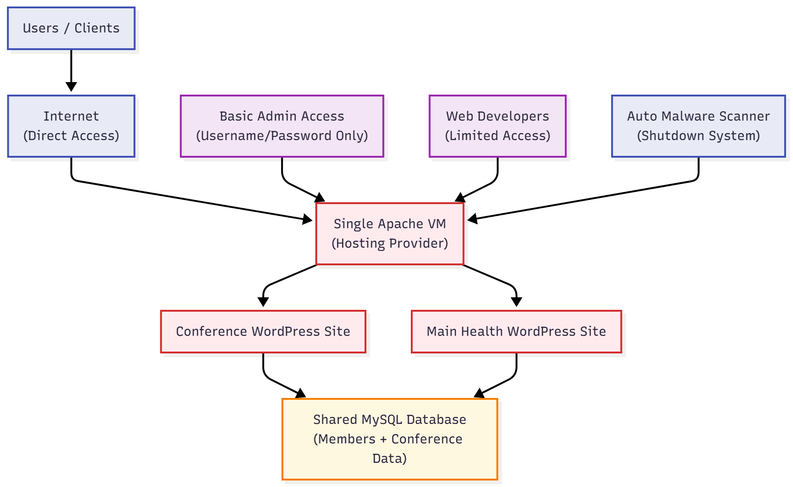

Figure 2: System Architecture After Mitigation
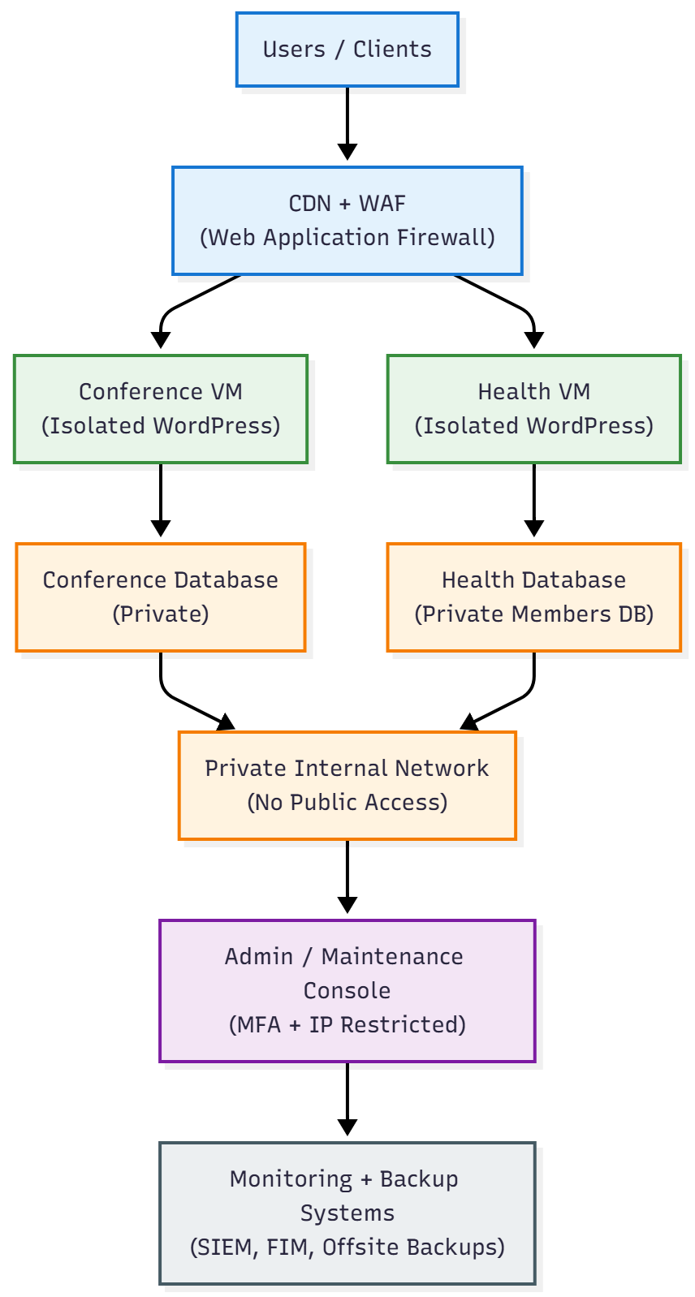

References
AIDE (2024) AIDE - Advanced Intrusion Detection Environment. Available at: https://aide.github.io/ (Accessed: 1 November 2025).
Apache (2025a) Log Files - Apache HTTP Server Version 2.4. Available at: https://httpd.apache.org/docs/2.4/logs.html (Accessed: 1 November 2025).
Apache (2025b) Configuration Files - Apache HTTP Server Version 2.4. Available at: https://httpd.apache.org/docs/2.4/configuring.html (Accessed: 1 November 2025).
Automattic (2025) WPScan - WordPress Security Scanner. Available at: https://wpscan.com/ (Accessed: 3 November 2025).
Cisco (2025a) ClamAV: Open Source Antivirus. Available at: https://www.clamav.net/ (Accessed: 4 November 2025).
Cisco (2025b) Snort - Network Intrusion Detection & Prevention System. Available at: https://www.snort.org/ (Accessed: 6 November 2025).
Cloudflare (2025) What is a WAF? | Web Application Firewall. Available at: https://www.cloudflare.com/learning/ddos/glossary/web-application-firewall-waf/ (Accessed: 4 November 2025).
Defiant Inc. (2025) Wordfence - WordPress Security. Available at: https://www.wordfence.com/ (Accessed: 4 November 2025).
Elastic (2025) The ELK Stack: Elasticsearch, Logstash, and Kibana. Available at: https://www.elastic.co/elk-stack (Accessed: 5 November 2025).
EU (2016) Regulation (EU) 2016/679 (General Data Protection Regulation). Available at: https://gdpr-info.eu/ (Accessed: 8 November 2025).
Malwarebytes (2025) Malwarebytes for Business. Available at: https://www.malwarebytes.com/business (Accessed: 4 November 2025).
OSSEC (2025) OSSEC: Host-based Intrusion Detection System. Available at: https://www.ossec.net/ (Accessed: 3 November 2025).
OWASP (2021) OWASP Top Ten 2021. Available at: https://owasp.org/www-project-top-ten/ (Accessed: 8 November 2025).
Trustwave (2025) ModSecurity - Web Application Firewall. Available at: https://www.modsecurity.org/ (Accessed: 3 November 2025).
WordPress.org (2024) Hardening WordPress. Available at: https://wordpress.org/documentation/article/hardening-wordpress/ (Accessed: 3 November 2025).

