Project Proposal

Overview
The business will be aimed at developing content to cater towards fans of comics. The team will be implementing comicbook characters from both Marvel and DC franchises into our animation and bringing comicbook art into our web pages.

We will be attempting to build a community of regular users, who will be sharing and discussing content and news from around the world as well as giving feedback for further animations.

We may eventually include some less well known comic properties if we believe there is a large enough demand, as well as hosting give-aways via our facebook page.

Target Customer:
The production teams target demographic, will be well within the sweaty nerd demographic, so the majority will be young males between 10 and 25. This market is already going to have invested plenty of time and attention in comic book franchises and properties, especially due to the popularity of movies being made by Marvel/Disney and DC/Warner Brothers. This recent explosion of interest proceeding that of “The Dark Knight” in 2008, leading up to the Avengers in a linked cinematic world of connected movies.

Because of this the team decided to develop an animation based on the most popular property at the moment which is the Avengers. The team has gathered some concepts and ideas from the source material and decided that a quick promotional video for the upcoming “Civil War” movie based on the acclaimed comic series will gather some hype.

One advantage of this Target Demographic is that they will already be quite used to navigating the internet due to their interests and age group, and that will help make designing the site easier as we will not need to compensate for illiteracy as much. The comic book reading community is actually extremely small, only reaching around 400’000 world-wide, not including the movie-going audience, the majority of which don’t read comics at all, so choosing Civil-War feeds the hype of both groups.

Problems we are solving:
The original idea had been to develop our own character, and get feedback from the fans to allow them to have input in the design, but ultimately we had problems with making a design that would animate well, be received well, and ultimately there were more benefits we saw with characters that were already popular and well received.

We decided that it would be much easier, more appropriate and more successful if we used characters that already had a big following, which is why we chose the Avengers, one of the most popular properties on the planet right now.
This plan still has the benefit of using a comic book style at a time when its popularity is at its highest peak since the late 1980s and early 1990s. The comicbook movies being made recently have been breaking box office numbers every four years or so.

“The customer is always right” is a slogan that has dictated the way we have approached any difficulties. In trying to find a niche in the market, the company has decided that rather than trying to offer something new as originally planned, we will instead be offering them exactly what they’ve been asking for.
A site where both the comic book and movie audience of both the major franchises can mingle and discuss these properties as well as see some of the original content the team develops.

Branding:
The companies plan since the start of development has been to infuse every facet of our branding with a comic book theme, through our videos and web design. Every aspect will be dripping with contrasting colours, rather than bright and vibrant ones as originally planned, as we discovered that comics have become more mature than when we were kids. The team will implement these themes by bringing in plenty of comic book artwork, covers and strips to help sell this approach. The team will also attempt to capture the pulp style of a comic in their style.

Differentiation:
Differentiating ourselves has been and will be one of our biggest hurdles, which is down to the fact that it is such a popular medium at the moment. There is almost a saturation of content. Seeing as the majority of comic book fans only watch the movies, the team has decided that they will try to incorporate the look and feel of Marvel and DC comic books as they are the biggest franchises at the moment.

There will be plenty of both styles, the light comedy will be associated with Marvel Comics, affecting the serious undertones in many of the images in our web design, as well as some choices made in the animation. Such deciding we would avoid any music or voices in our video, in order to give it more suspense.

In this way we have tried and combine the feel of both major franchises (Marvel/DC). Some adult humor was also implemented in the images in order to appeal to the slightly more mature audience of the DC franchise, but nothing that would offend. Its a big amalgamation of everything comic book related and we believe it will turn out quite different to other sites.

Functional Requirements:
1. Header animated logo
There will be a banner at the top of the screen containing the logo and there will be a small animation in which the hulk will smash through a stone wall and create the name of the site.
2. Responsive Design
The development team will be attempting to design a fully functional website which, will also be responsive in design allowing people to access it using any mobile device as well as a PC or laptop.
3. Chat Board
This will be section where fans can post videos or images while they have a naturalistic discussion about whatever is on their mind, which will most likely be something sealed in skin-tight spandex. They will be allowed make post videos and images too.
4. Multimedia Video
There will be multiple animated videos on the site, there will be a video building hype on the “Civil War” movie coming out in 2016 which will be developed using animatrons online tool. There will also be a video made in blender depicting a confrontation between a tank and Iron-Man in a city. There will also be an animated advertisement for DC comic’s upcoming movie. Most of the facets used in the design will be done using multimedia tools and some images will have animations.
5. Footer animated
This will be an animation showcasing comicbook art and advertising the website, and the brands humour.
Note: The site will also have a functioning calendar and a google maps locator for our website.

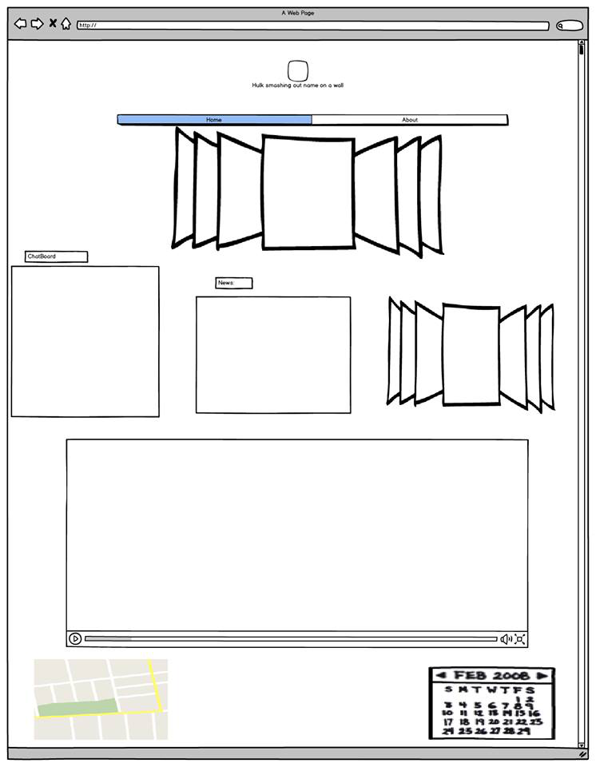
We used balsamiq to make this image. It was a rough idea of how the page would look.

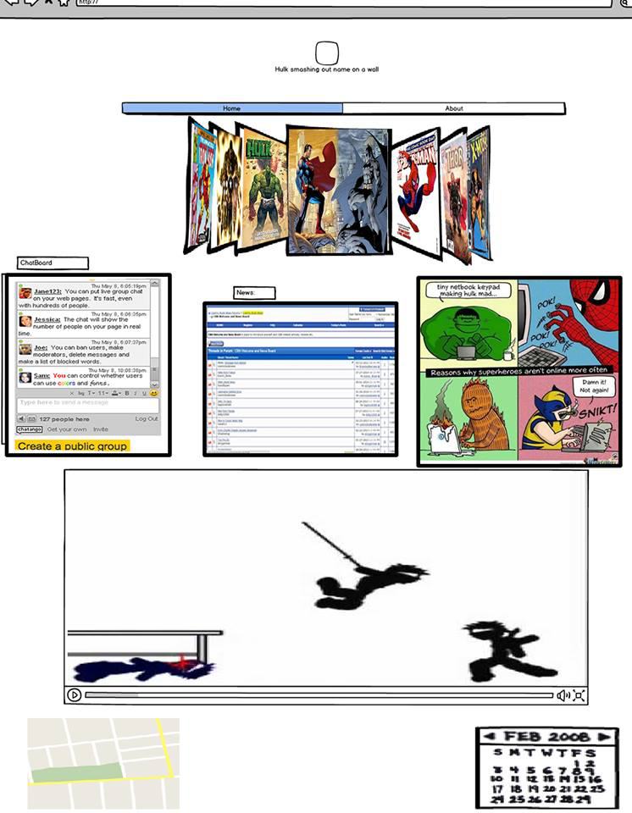
After continued working on the balsamiq as an image using fireworks, this is the result and it helped give it better shape and understanding to the developers.

