MULTIMEDIA PROJECT REPORT

Deadline: Thursday April 16th 2015 5pm

PROJECT TEAM
Student No | First Name | Surname
X14435248 | Luke | Carroll
X14378581 | John | Cahill

** Power Cosmic Responsive Website **

- OVERVIEW
Overview
The business will be aimed at developing content to cater towards fans of comics. The team will be implementing comicbook characters from both Marvel and DC franchises into our animation and bringing comicbook art into our web pages.
We will be attempting to build a community of regular users, who will be sharing and discussing content and news from around the world as well as giving feedback for further animations.
We may eventually include some less well known comic properties if we believe there is a large enough demand, as well as hosting give-aways via our facebook page.
Target Customer:
The production teams target demographic, will be well within the sweaty nerd demographic, so the majority will be young males between 10 and 25. This market is already going to have invested plenty of time and attention in comic book franchises and properties, especially due to the popularity of movies being made by Marvel/Disney and DC/Warner Brothers. This recent explosion of interest proceeding that of “The Dark Knight” in 2008, leading up to the Avengers in a linked cinematic world of connected movies.
Because of this the team decided to develop an animation based on the most popular property at the moment which is the Avengers. The team has gathered some concepts and ideas from the source material and decided that a quick promotional video for the upcoming “Civil War” movie based on the acclaimed comic series will gather some hype.
One advantage of this Target Demographic is that they will already be quite used to navigating the internet due to their interests and age group, and that will help make designing the site easier as we will not need to compensate for illiteracy as much. The comic book reading community is actually extremely small, only reaching around 400’000 world-wide, not including the movie-going audience, the majority of which don’t read comics at all, so choosing Civil-War feeds the hype of both groups.

Problems we are solving:
The original idea had been to develop our own character, and get feedback from the fans to allow them to have input in the design, but ultimately we had problems with making a design that would animate well, be received well, and ultimately there were more benefits we saw with characters that were already popular and well received. We decided that it would be much easier, more appropriate and more successful if we used characters that already had a big following, which is why we chose the Avengers, one of the most popular properties on the planet right now.
This plan still has the benefit of using a comic book style at a time when its popularity is at its highest peak since the late 1980s and early 1990s. The comicbook movies being made recently have been breaking box office numbers every four years or so.
“The customer is always right” is a slogan that has dictated the way we have approached any difficulties. In trying to find a niche in the market, the company has decided that rather than trying to offer something new as originally planned, we will instead be offering them exactly what they’ve been asking for.
A site where both the comic book and movie audience of both the major franchises can mingle and discuss these properties as well as see some of the original content the team develops.

Branding:
The companies plan since the start of development has been to infuse every facet of our branding with a comic book theme, through our videos and web design. Every aspect will be dripping with contrasting colours, rather than bright and vibrant ones as originally planned, as we discovered that comics have become more mature than when we were kids. The team will implement these themes by bringing in plenty of comic book artwork, covers and strips to help sell this approach. The team will also attempt to capture the pulp style of a comic in their style.
Differentiation:
Differentiating ourselves has been and will be one of our biggest hurdles, which is down to the fact that it is such a popular medium at the moment. There is almost a saturation of content. Seeing as the majority of comic book fans only watch the movies, the team has decided that they will try to incorporate the look and feel of Marvel and DC comic books as they are the biggest franchises at the moment. There will be plenty of both styles, the light comedy will be associated with Marvel Comics, affecting the serious undertones in many of the images in our web design, as well as some choices made in the animation.
We decided that we would avoid any music or voices in our video, in order to give it more suspense. In this way we have tried and combine the feel of both major franchises (Marvel/DC). Some adult humor was also implemented in the images in order to appeal to the slightly more mature audience of the DC franchise, but nothing that would offend. It’s a big amalgamation of everything comic book related and we believe it will turn out quite different to other sites.

Functional Requirements:
- Header animated logo
There will be a banner at the top of the screen containing the logo and there will be a small animation in which the hulk will smash through a stone wall and create the name of the site.
- Responsive Design
The development team will be attempting to design a fully functional website which, will also be responsive in design allowing people to access it using any mobile device as well as a PC or laptop.
- Chat Board
This will be section where fans can post videos or images while they have a naturalistic discussion about whatever is on their mind, which will most likely be something sealed in skin-tight spandex. They will be allowed make post videos and images too.
- Multimedia Video
There will be multiple animated videos on the site, there will be a video building hype on the “Civil War” movie coming out in 2016 which will be developed using animatrons online tool. There will also be a video made in blender depicting a confrontation between a tank and Iron-Man in a city. There will also be an animated advertisement for DC comic’s upcoming movie. Most of the facets used in the design will be done using multimedia tools and some images will have animations.
- Footer animated
This will be an animation showcasing comicbook art and advertising the website, and the brands humour.
Note: The site will also have a functioning calendar and a google maps locator for our website.

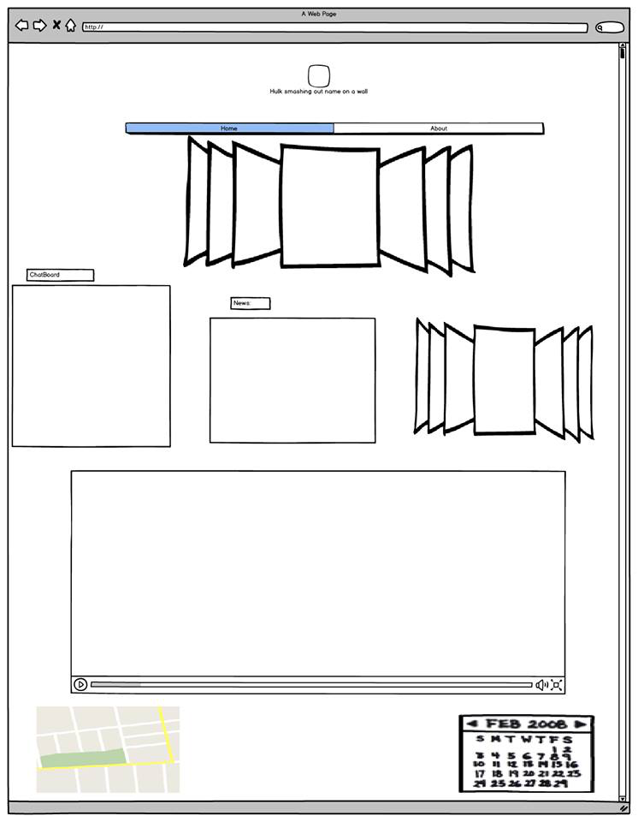

We used balsamiq to make this image. It was a rough idea of how the page would look.

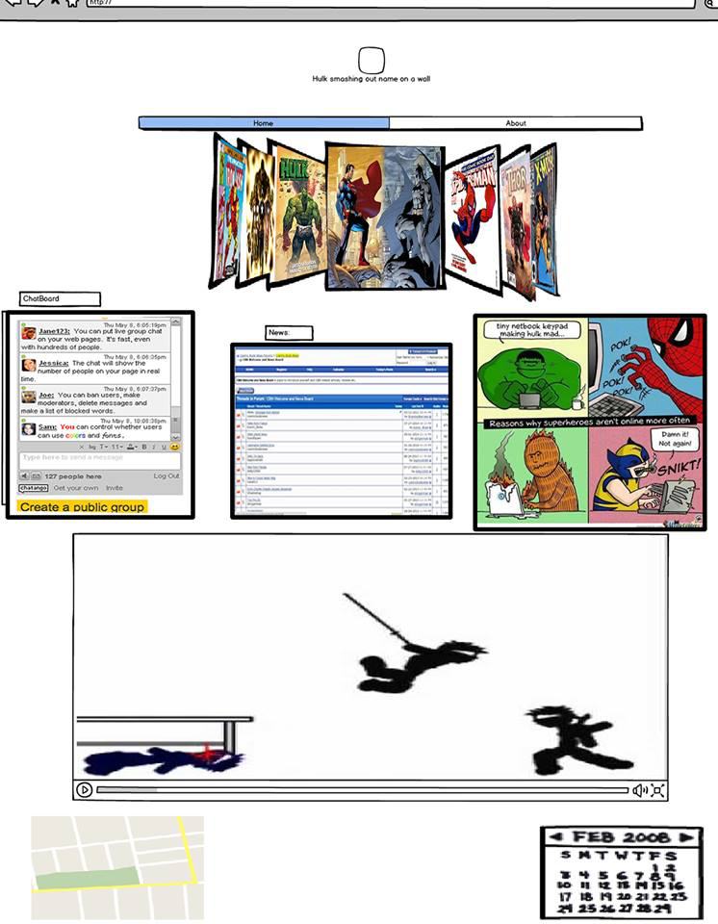

After continued working on the balsamiq as an image using fireworks, this is the result and it helped give it better shape and understanding to the developers.

STORYBOARD / WIREFRAME

User Interface WireFrame
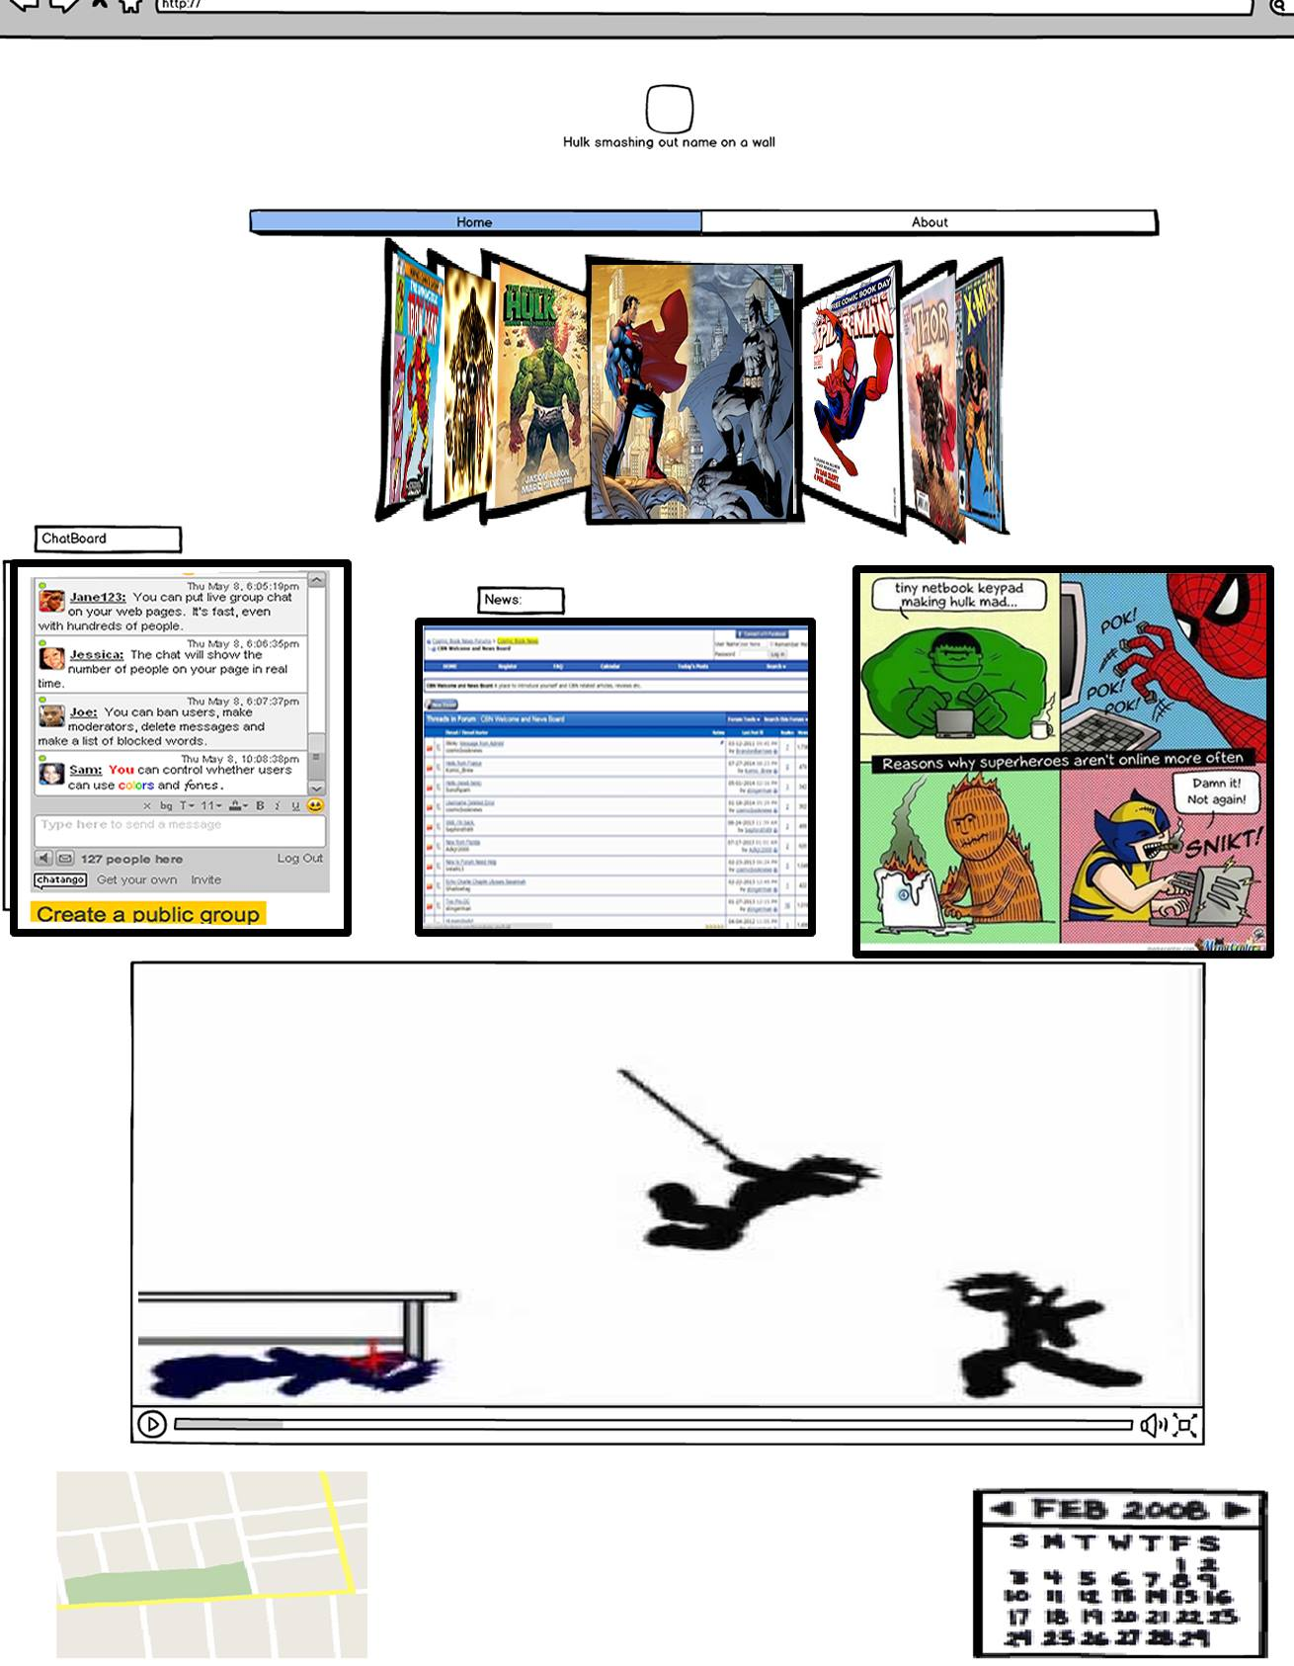
The user interface is designed to have a simple and intuitive feel, our target audience is almost definitely computer literate enough to understand the site. The “chatango” chat board we brought in is also very intuitive as it is designed to be able to be embedded into any site quite handily, allowing users to join in simply by adding a message, they are then offered to option to chat anonymously ad be assigned a number or create a permanent chatango account.
They can then add a personal photo or an image into their account. Allowing users to add an age if they choose, as well as fill in a bio section with whatever text they want and multiple other features implementing simple html. This is pretty much the only digital conceptualisation, we developed, as most other formats were written inside our copies.

- RESEARCH
Research comprised of watching some animated comic book hero t.v shows, live-action t.v shows, films and some comic books. Some of the ones that stuck out were “Avengers: Earths Mightiest heroes”, “Civil War”, “DCAU (Justice League, Justice League Unlimited, Batman The Superman/Batman animated)”. These helped with our choice in artwork, CSS colours and in how we based and developed our animations on these properties.
The Civil War comic book series will soon have a movie adaptation coming out, so the team created a video based on it due the the hype being generated by the film. It is coming out next year and there is another movie in the series which recently came out. We decided that we would benefit from the hype of the recent and movie and the upcoming movie if we chose the latter in the series.
The team members also browsed the internet for comicbook related sites such as “ComicsAlliance.com”, “Comic Book Resources”, and “Comic Vine”. We discovered some interesting set-ups, but ultimately the team decided on a style of its, but it did give us some inspiration from them, especially in the contrasted black, green and purple in our colour palette, it helps to bring out the look of a comic in its dark and macabre tone of the modern comic book. It’s far removed from what I figured would being them, since you'd expect them to be quite childish but many stories feel as if they were written for younger and relatively older adults.
Our team also tried to search for images and memes to be placed on the site to give it some humour and some choice artwork to attract users. We went for what seem to have a buzz around the world at the moment which is the Marvel and DC t.v show images of upcoming events and comicbook art in a fading slideshow. All in all the research provided us with plenty of material, as we had anticipated when choosing to build a comic book site originally.

- PRODUCTION LOG

Adobe Fireworks Elements
Almost every image used was processed via fireworks, to remove backgrounds, resize and combine elements from other images. For the “Civil War” animatron video, the Hulk logo, the footer and the banner, we used fireworks to process the comicbook elements and text.
Problems we faced were finding the right images for the videos, as to keep them consistent to look more professional. If they were stretched, or their art direction did not resemble previous images used.

Online / Social Media Elements
The online Social Media elements we implemented are Twitter and Facebook page links, as well as a Chatango chat board, helping exposure to the brand. Here users and developers can communicate, share images and videos. No issues here

Responsive Website Elements
1140px grid system was implemented as we had experience implementing it before. Though there were some minor irritations with the CSS, the team managed to implement it relatively well.
The main difficulties arose from pixel sizes on animatron videos and such being difficult to alter once developed, so we were forced to use animatron to edit the actual animation by hand, which led to some minor reduction in quality.

Other Digital Elements
Some of the other digital elements include: Animatron, Blender, SupaLogo, Bonanza- Background burner.
Animatron videos, Blender video, Supalogo was used quite a lot. It was used in the Banner, Footer, Civil War Animatron video, Dawn of Justice promotional banner, as well as in the navigation bar and Content headings. The team used background burner for some of the images, animatron videos and image slides.

- PROJECT TEAM
Who did what tasks?
John Cahill developed the blender video and the vast majority of the webpage layout and CSS as well as the hulk logo in animatron animation. Luke Carroll developed the main animatron video, a footer and banner animations, wrote the project proposal and report, made the powerpoint and added the images and text content into the web layout. Though generally we did both have a hand in eachothers work in minor ways.
Did everyone evenly participate?
Yes we divided the work out evenly, we both produced animatron videos, we both developed content for the pages, we were always attending classes and we communicated well together.
Were there any team issues?
We got a long very well, no team issues, we communicated well and made compromises when necessary. We both attended classes and met up outside of class.

- CONCLUSION
The project went very well, but we might have started work on the web development side of things a little earlier next time as we didn't anticipate the amount of planning and some of the difficulties that came with it. We feel we produced a piece of work we can be proud of in the end.
Did you achieve what you set out to do?
We achieved the majority of what we set out to do, only really missing the web app, due to time constraints.
Are you happy with the results?
Yes, we are quite happy.
Is there anything you might change if you had more time?
We might have developed a phone app to go along with the site, and spent more time on the web design, but over all we are very happy with our performance.

- REFERENCES
Comic Book Resources - Daily Comic Book News, Previews, Reviews, Commentary and Message Boards. 2015. Comic Book Resources - Daily Comic Book News, Previews, Reviews, Commentary and Message Boards. [ONLINE] Available at: http://www.comicbookresources.com/. [Accessed 13 April 2015].
ComicsAlliance - Comic book culture, news, humor and commentary.. 2015.ComicsAlliance - Comic book culture, news, humor and commentary.. [ONLINE] Available at: http://comicsalliance.com/. [Accessed 13 April 2015].
Comic Vine - Comic reviews, videos, forums and wiki.. 2015. Comic Vine - Comic reviews, videos, forums and wiki.. [ONLINE] Available at:http://www.comicvine.com/. [Accessed 13 April 2015].
Remove Image Backgrounds Free & Fast - Background Burner - Bonanza. 2015. Remove Image Backgrounds Free & Fast - Background Burner - Bonanza. [ONLINE] Available at:https://www.bonanza.com/background_burner. [Accessed 13 April 2015].
Supalogo - create nice logo. 2015. Supalogo - create nice logo. [ONLINE] Available at: http://supalogo.com/. [Accessed 13 April 2015].
YouTube. 2015. YouTube. [ONLINE] Available at:https://www.youtube.com/. [Accessed 13 April 2015].
W3Schools Online Web Tutorials. 2015. W3Schools Online Web Tutorials. [ONLINE] Available at: http://www.w3schools.com/. [Accessed 13 April 2015].
Free Sound Clips | SoundBible.com. 2015. Free Sound Clips | SoundBible.com. [ONLINE] Available at: http://soundbible.com/. [Accessed 13 April 2015].

