

Website Project

Conor Clarke x15014657 2015

A remodel of a current business website, with a responsive design and active JS, with all style pulled from a style sheet CSS

Introduction

This project is based my own part time job, working for Arelia Leisure in Temple Bar. Originally I was going to attempt to build a pc gaming review website, but on talks with our WD lecturer, is was better suited to build a website for work.

What is required from the client

Firstly, the original website was dark, gloomy and out of date by about ten years. During a meeting with the guys who built it, they gave us the name of the software (Adobe Contribute) so that we could organize the website and rebuild it ourselves. The software allows the user to build a website and puts the code in for the user. The first build was an improvement on the old, and the second release is the current version. Unfortunately with so many media devices and so many varying screen sizes a lot of changes need to be made. The client has requested the following:

1. A website that is reachable, and readable on all mobile devices.
2. Less information on the pages (there is way too much writing on the pages)
3. Keep colours dark, but clear.
4. Needs a fresh look.
5. User Friendly
6. User Accessible

The build

Using a grid system from an online web company I began working on the responsiveness of the website. (Robertson, n.d.)

Then keeping to format similar to the last builds, I kept the layout wide, rather than having the user scroll down for the information.

The client requested their logo on the front of the website, despite it looking outdated and me telling them so. I suggested trying to adjust it with Photoshop to later it slightly to which they agreed. For the final build I used the logo, and animated it so that it rotates and is not just sitting there. Using JavaScript I added a video on loop beside the logo, just to distract some attention away from it.

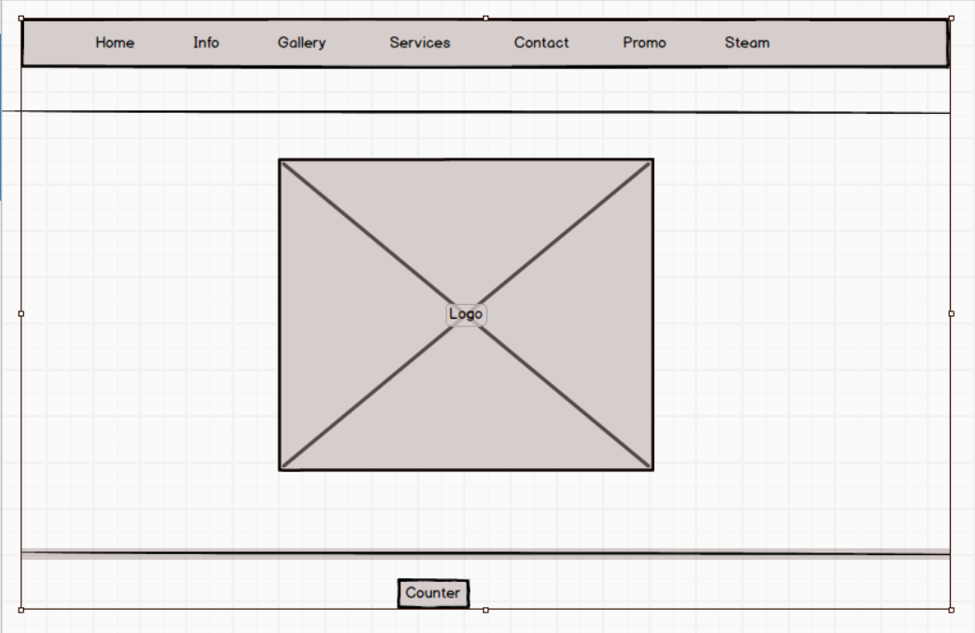I have built five builds of this website, each one had pros and cons but with each build there was always something that didn’t settle with me.

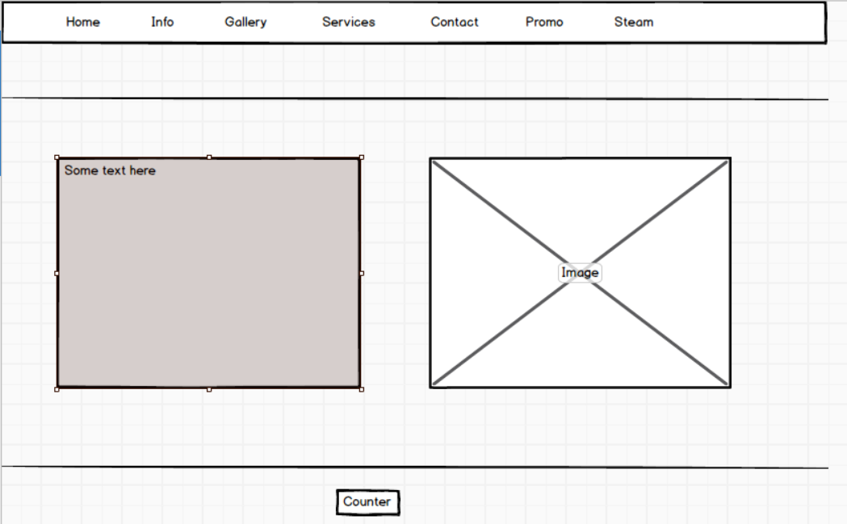

Since the website has been built twice already, I didn’t feel I needed to use Balsamiq so much and with so many default website responsive templates it can be an unnecessary step.

The page itself has seven pages, with a form page as requested by the WD module, rather than the business. This will be removed when the site goes live.

The biggest problem I had was implementing the grid system which I partially integrated and realized when I had finished the project, so it required a 22 hour rebuild. Having said that I am happy with the final build and confident it will work on a variety of screens.

I have spent hours trolling the internet and finding code in forums to get things to work, however some of the latest code, still shows up in errors on the validator. However the site seems to work on different screens so I am happy with the final product and I know that my bosses will be happy with the latest build.