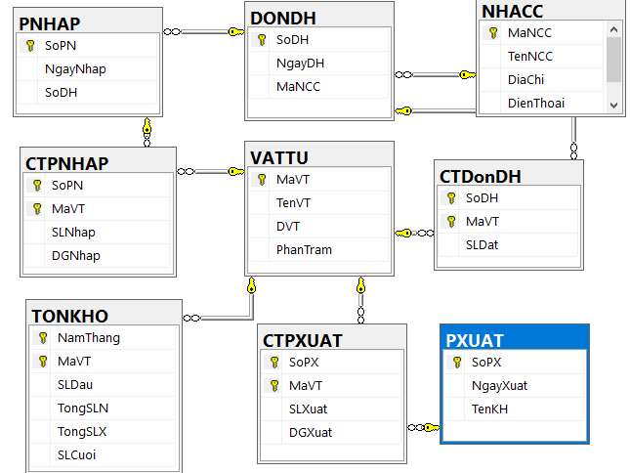

| **NHACC** | |  | |  | | |  |
| --- | --- | --- | --- | --- | --- | --- | --- |
| **Mancc varchar(10)** | | **Tennhacc:**  **nvarchar(30)** | | **Diachi: nvarchar(50)** | | | **Dienthoai: varchar(15)** |
| C01 | | Lê Minh Trí | | 54 Hậu Giang Q6 HCM | | | 8781024 |
| C02 | | Trần Minh Thạch | | 145 Hùng Vương Mỹ Tho | | | 7698154 |
| C03 | | Hồng Phương | | 154/85 Lê Lai Q1 HCM | | | 9600125 |
| C04 | | Nhật Thắng | | 198/40 Hương Lộ 14 QTB HCM | | | 8757757 |
| C05 | | Lưu Nguyệt Quế | | 178 Nguyễn Văn Luông Đà Lạt | | | 7964251 |
| C07 | | Cao Minh Trung | | 125 Lê Quang Sung Nha Trang | | | Chưa có |
| **VATTU** |  | |  | |  |
| **Mavtu: varchar(10)** | **Tenvtu:**  **nvarchar(30)** | | **DvTinh: nvarchar(20)** | | **Phantram: int** |
| DD01 | Đầu DVD Hitachi 1 đĩa | | Bộ | | 40 |
| DD02 | Đầu DVD Hitachi 3 đĩa | | Bộ | | 40 |
| TL15 | Tủ lạnh Sanyo 150 lit | | Cái | | 25 |
| TL90 | Tủ lạnh Sanyo 90 lit | | Cái | | 20 |
| TV14 | Tivi Sony 14 inches | | Cái | | 15 |
| TV21 | Tivi Sony 21 inches | | Cái | | 10 |
| TV29 | Tivi Sony 29 inches | | Cái | | 10 |
| VD01 | Đầu VCD Sony 1 đĩa | | Bộ | | 30 |
| VD02 | Đầu VCD Sony 3 đĩa | | Bộ | | 30 |

| **DONDH** | |  | |  | |
| --- | --- | --- | --- | --- | --- |
| **SoDH: varchar(10)** | | **NgayDH: Date** | | **MaNCC: varchar(10)** | |
| D001 | | 15-01-07 | | C03 | |
| D002 | | 30-01-07 | | C01 | |
| D003 | | 10-02-07 | | C02 | |
| D004 | | 17-02-07 | | C05 | |
| D005 | | 03-01-07 | | C02 | |
| D006 | | 03-12-07 | | C05 | |
| **CTDONDH** |  | |  | |
| **SoDH: varchar(10)** | **Mavtu:varchar(10)** | | **SlDat: smallint** | |
| D001 | DD01 | | 10 | |
| D001 | DD02 | | 15 | |
| D002 | VD02 | | 30 | |
| D003 | TV14 | | 10 | |
| D003 | TV29 | | 20 | |
| D004 | TL90 | | 10 | |
| D005 | TV14 | | 10 | |
| D005 | TV29 | | 20 | |
| D006 | TV14 | | 10 | |
| D006 | TV29 | | 20 | |
| D006 | VD01 | | 20 | |

|  | **PNHAP** | | |  | | | | | | |  | | | |
| --- | --- | --- | --- | --- | --- | --- | --- | --- | --- | --- | --- | --- | --- | --- |
|  | **SoPN: varchar(10)** | | | **Ngaynhap: date** | | | | | | | **Sodh: varchar(10)** | | | |
|  | N001 | | | 17-01-07 | | | | | | | D001 | | | |
|  | N002 | | | 20-01-07 | | | | | | | D001 | | | |
|  | N003 | | | 31-01-07 | | | | | | | D002 | | | |
|  | N004 | | | 15-02-07 | | | | | | | D003 | | | |
|  | **CTPNHAP** | | | |  | | | |  | | | | |  | | | |
|  | **SoPN: varchar(10)** | | | | **Mavtu: varchar(10)** | | | | **SlNhap: smallint** | | | | | **DgNhap: decimal (18:0)** | | | |
|  | N001 | | | | DD01 | | | | 8 | | | | | 2500000 | | | |
|  | N001 | | | | DD02 | | | | 10 | | | | | 3500000 | | | |
|  | N002 | | | | DD01 | | | | 2 | | | | | 2500000 | | | |
|  | N002 | | | | DD02 | | | | 5 | | | | | 3500000 | | | |
|  | N003 | | | | VD02 | | | | 30 | | | | | 2500000 | | | |
|  | N004 | | | | TV14 | | | | 5 | | | | | 2500000 | | | |
|  | N004 | | | | TV29 | | | | 12 | | | | | 3500000 | | | |
|  | **PXUAT** |  | | | | |  | | | | | | | | | | | |
|  | **Sopx: varchar(10)** | **Ngayxuat: date** | | | | | **Tenkh: nvarchar(30)** | | | | | | | | | | | |
|  | X001 | 17-01-07 | | | | | Nguyễn Ngọc Phương Nhi | | | | | | | | | | | |
|  | X002 | 25-01-07 | | | | | Nguyễn Hồng Phương | | | | | | | | | | | |
|  | X003 | 31-01-07 | | | | | Nguyễn Tuấn Tú | | | | | | | | | | | |
|  | **CTPXUAT** | | | |  | | |  | | | |  | | | |
|  | **Sopx: varchar(10)** | | | | **Mavtu: varchar(10)** | | | **SlXuat: int** | | | | **DgXuat: decimal(18:0)** | | | |
|  | X001 | | | | DD01 | | | 2 | | | | 3500000 | | | |
|  | X002 | | | | DD01 | | | 1 | | | | 3500000 | | | |
|  | X002 | | | | DD02 | | | 5 | | | | 4900000 | | | |
|  | X003 | | | | DD01 | | | 3 | | | | 3500000 | | | |
|  | X003 | | | | DD02 | | | 2 | | | | 4900000 | | | |
|  | X003 | | | | VD02 | | | 10 | | | | 3250000 | | | |
| **TONKHO** | | |  | | |  | | | |  | | |  | | | |  | | |
| **NAMTHANG** | | | **MaVT: varchar(10)** | | | **SLDau** | | | | **TongSLN** | | | **TongSLXuat** | | | | **SLCuoi** | | |
| 5/2007 | | | DD01 | | | 100 | | | | 500 | | | 300 | | | | 300 | | |
| 5/2007 | | | DD02 | | | 120 | | | | 470 | | | 50 | | | | 540 | | |
| 5/2007 | | | TL15 | | | 140 | | | | 440 | | | 20 | | | | 560 | | |
| 5/2007 | | | TL90 | | | 160 | | | | 410 | | | 40 | | | | 530 | | |
| 5/2007 | | | TV14 | | | 180 | | | | 380 | | | 70 | | | | 490 | | |
| 5/2007 | | | TV21 | | | 200 | | | | 350 | | | 140 | | | | 410 | | |
| 5/2007 | | | TV29 | | | 220 | | | | 320 | | | 250 | | | | 290 | | |