**LAB 1**

**RELATIONAL ALGEBRA**

|  |  |  |  |  |  |  |  |
| --- | --- | --- | --- | --- | --- | --- | --- |
| **Questions** | **1** | **2** | **3** | **4** | **5** | **6** | **7** |
| **Grade** |  |  |  |  |  |  |  |

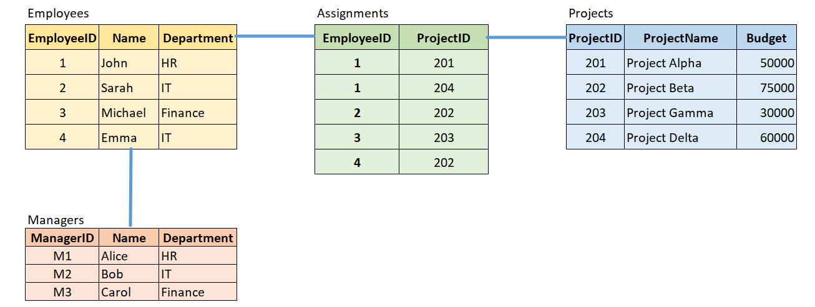

**Questions**

1) Retrieve the names of all employees in the "IT" department. **(2 point)**

2) List the project names and their budgets for projects that have a budget greater than 50000. **(1 point)**

3) Find the names of employees who are assigned to the "Project Beta." **(1 point)**

4) Identify the names of all managers in the "HR" department. **(1 point)**

5) Get the list of employees assigned to projects with a budget of less than 40000. **(2 point)**

6) Find the total budget of projects that John is assigned to. **(1 point)**

7) List the names of employees who are assigned to projects managed by Bob. **(2 point)**

$$π_{Name}(Employees⋈Assignments⋈{(Projects⋈σ}_{Name=^{'}Bob^{'}}\left(Managers\right)))$$