**EXERCISE**

**RELATIONAL ALGEBRA**

**EX01:**

Giving a database schema:

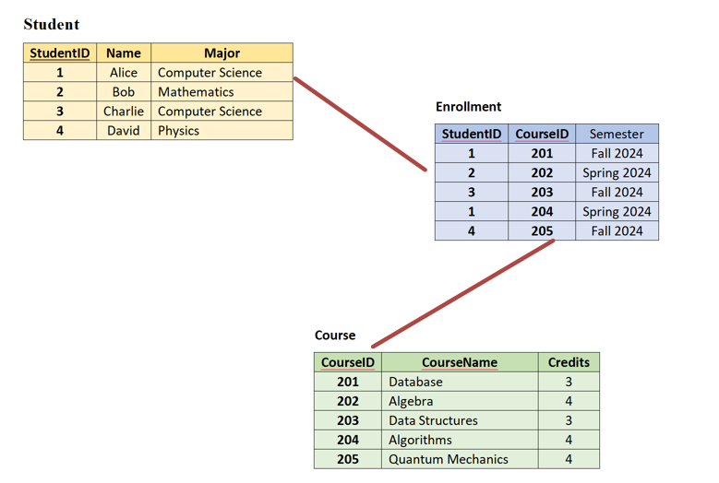

1. Find the names of all students who are majoring in Computer Science.
2. List all course names that students have enrolled in the Fall 2024 semester. 
3. Find the StudentIDs of students who are enrolled in the 'Database' course.
4. Retrieve the names of students and the course names they are enrolled in.
5. Find the course names that are taken by students majoring in 'Mathematics'.
6. List all studentIDs who are not enrolled in any courses.
7. List all the names of students who are enrolled in the 'Algebra' course.

**EX02**

**Giving a database schema:**

Customers(**CustomerID**, Name, City)

Orders(**ProductID, CustomerID**, OrderDate, Amount)

Products(**ProductID**, ProductName, Price)

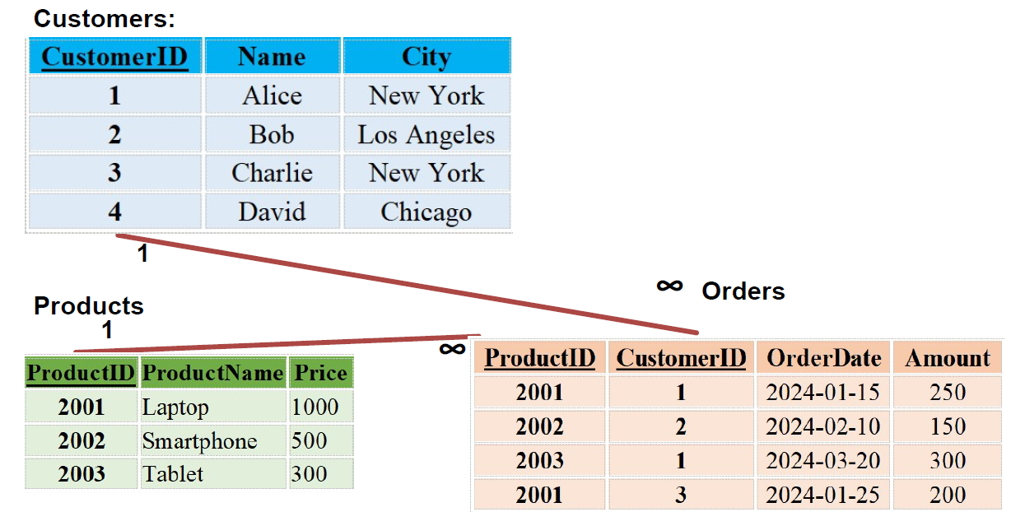

1. Find the names of all customers who have placed an order.
2. List all orders placed by customers from New York.
3. Retrieve the details of orders with an price greater than $200.
4. Find the names of customers who have not placed any orders.
5. Find the names and cities of customers who placed orders in February 2024.
6. Retrieve the names of customers who have placed more than one order.
7. List the ProductIDs, CustomerID and Amount where the order Amount greater than the average amount.