PRACTICAL EXAM - SWD392 -SP26
Date time: | 12/11/2026 (practice / model answer)
Exam Code: | SWD392 - SP26 - University Event Management System, EMS (Layered Architecture + Repository Pattern)

Question 1: Class Diagram (3.0 points)
- Your Class Diagram:
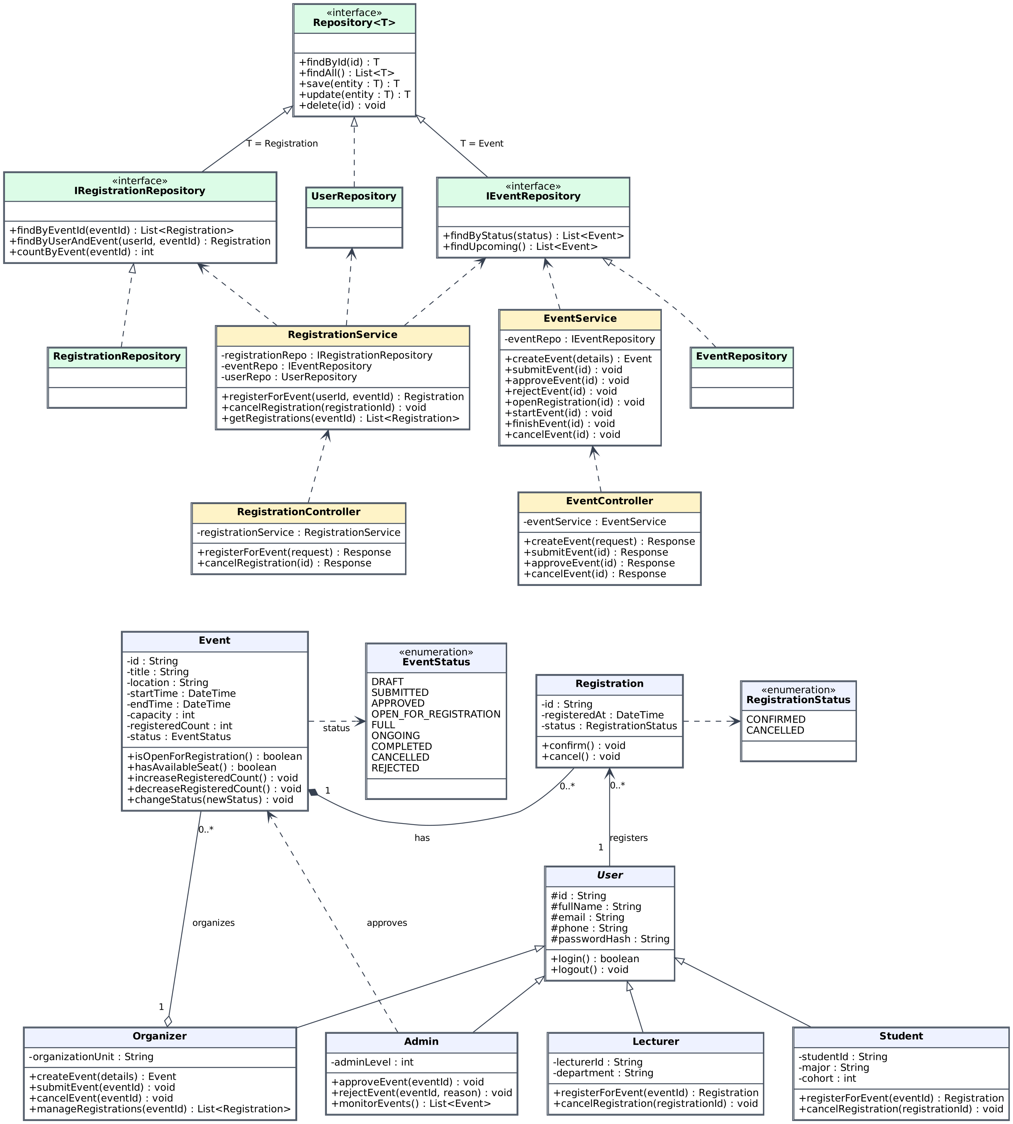

- Brief Explanation:
Architecture: Layered Architecture, used consistently in all diagrams: Controller (EventController, RegistrationController) → Service (EventService, RegistrationService) → Repository (Repository<T> and implementations) → Domain entities.
Inheritance: User is an abstract base class (id, fullName, email, phone, passwordHash, login/logout). Student, Lecturer, Organizer and Admin extend User with their own attributes and responsibilities.
Associations: User 1 → 0..* Registration (a user can register for many events); Organizer 1 o— 0..* Event (aggregation: organizer organizes events); Admin ··> Event (dependency: approves/rejects).
Composition: Event 1 ◆— 0..* Registration: a registration has no meaning without its event, and the number of registrations is limited by Event.capacity (registeredCount, hasAvailableSeat()). Event.status uses the EventStatus enum (Draft, Submitted, Approved, OpenForRegistration, Full, Ongoing, Completed, Cancelled, Rejected).
Repository Pattern: Repository<T> is a generic interface (findById, findAll, save, update, delete). UserRepository implements it directly; IEventRepository and IRegistrationRepository extend it with domain queries and are implemented by EventRepository and RegistrationRepository.
Dependencies: All business logic (create/approve/cancel events, register participants) is in service classes. Services depend only on repository interfaces (dashed arrows), and controllers depend only on services.

Question 2: Sequence diagram (4.0 points)
- Your Diagram (Sequence Diagram):
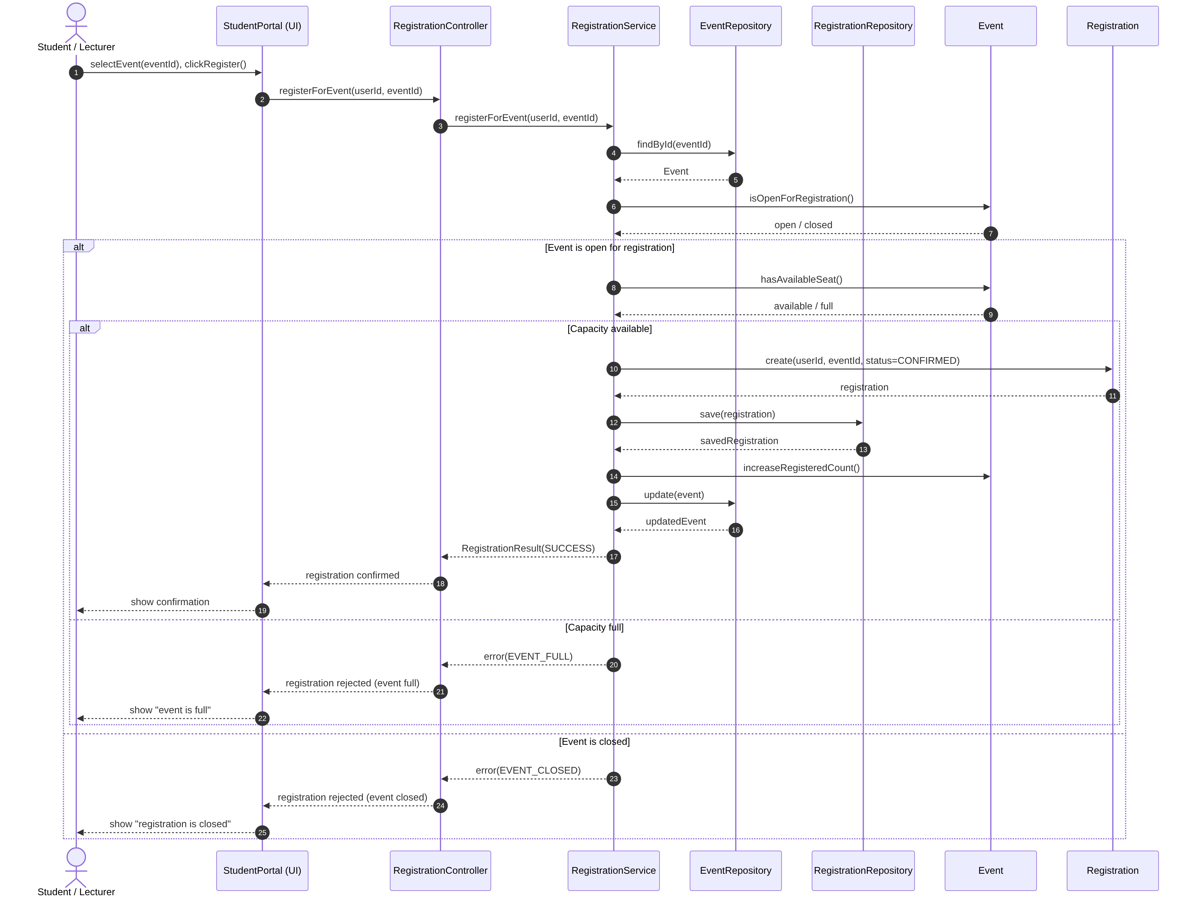

- Brief Explanation:
Participants (Layered): Student/Lecturer → StudentPortal (UI) → RegistrationController → RegistrationService → EventRepository / RegistrationRepository → entities Event and Registration.
Flow: The user selects an event and submits a registration request; the controller delegates to RegistrationService, which loads the event with EventRepository.findById and asks Event.isOpenForRegistration().
alt 1 – Event open or closed: If the event is closed, the service returns EVENT_CLOSED and the UI shows the rejection.
alt 2 – Capacity available or full: If the event is open, Event.hasAvailableSeat() is checked; when the event is full the registration is rejected with EVENT_FULL.
Success path: A Registration (CONFIRMED) is created and saved via RegistrationRepository.save, the event's registered count is increased and persisted via EventRepository.update, then the confirmation is returned to the user. All data access goes through repository method calls, which makes the Repository Pattern explicit.

Question 3: Activity Diagram/ State-chart diagram/ Component Diagram (3.0 points)
- Your Diagram (Statechart Diagram):
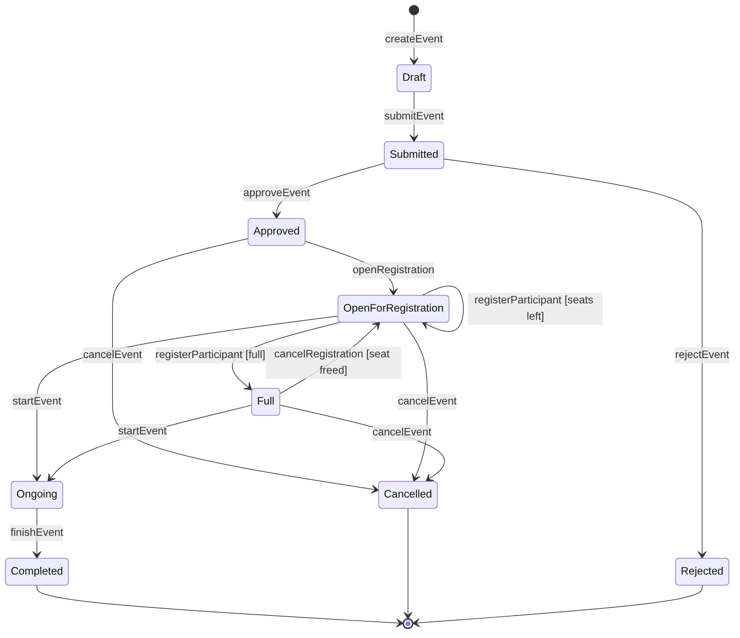

- Brief Explanation:
Scope: State diagram of the Event entity lifecycle, from creation to completion, cancellation or rejection.
Initial / final states: Initial pseudo-state → Draft (createEvent). Final states: Completed, Cancelled and Rejected.
Main path: Draft → Submitted (submitEvent) → Approved (approveEvent) → OpenForRegistration (openRegistration) → Ongoing (startEvent) → Completed (finishEvent).
Capacity handling: registerParticipant keeps the event in OpenForRegistration while seats remain and moves it to Full when capacity is reached; cancelRegistration frees a seat and returns it to OpenForRegistration. An event can start from either state.
Alternative terminations: Submitted → Rejected (rejectEvent); Approved, OpenForRegistration or Full → Cancelled (cancelEvent). These branches satisfy the cancellation/rejection requirement; the diagram has 15 labelled transitions (minimum 6).

END OF SUBMISSION

