PRACTICAL EXAM - SWD392 -SU26
Date time: | 12/11/2026 (practice / model answer)
Exam Code: | SWD392 - SU26 - MediCare Hub (Layered Architecture + Repository Pattern)

Question 1: Class Diagram (3.0 points)
- Your Class Diagram:
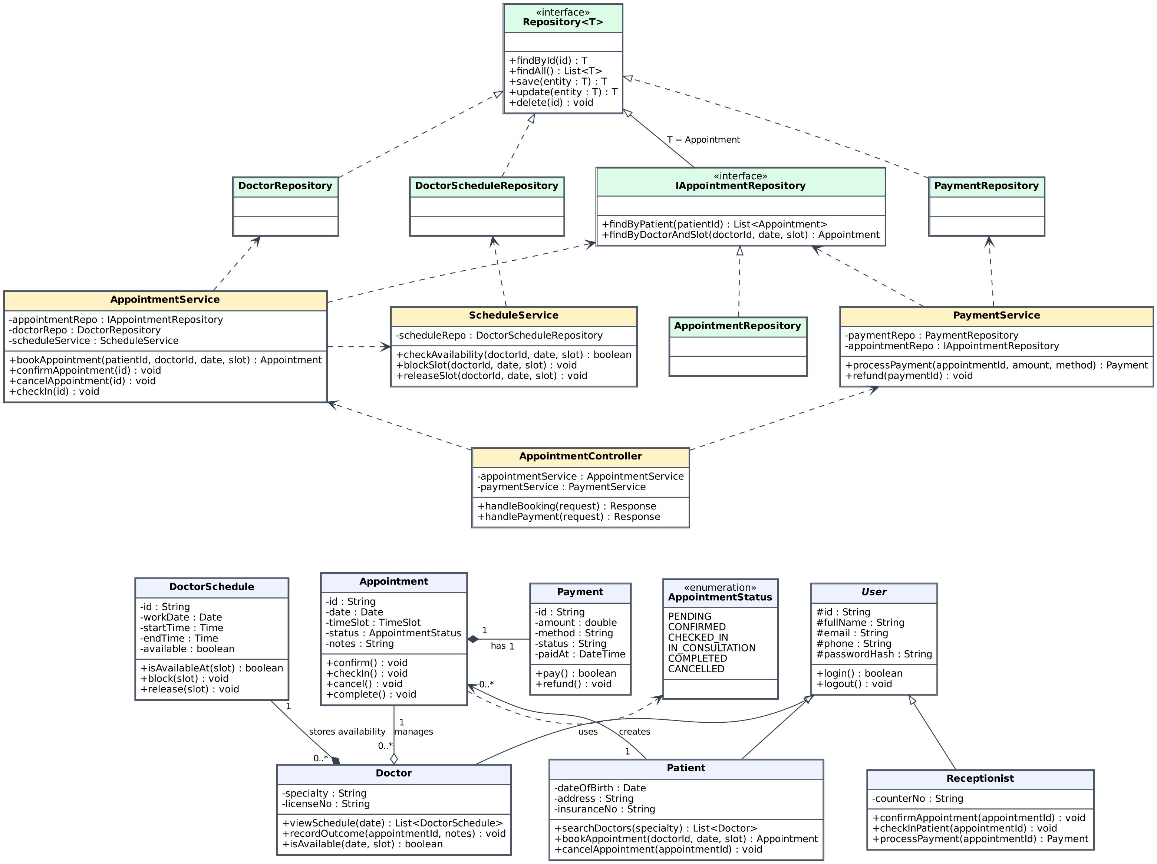

- Brief Explanation:
Architecture: Layered Architecture, applied consistently in all three diagrams: Presentation/Controller (AppointmentController) → Business (AppointmentService, PaymentService, ScheduleService) → Data Access (Repository<T> and its implementations) → Domain entities.
Inheritance: User is an abstract base class (id, fullName, email, phone, passwordHash, login/logout). Patient, Doctor and Receptionist extend User and add their own attributes and operations.
Associations: Patient 1 → 0..* Appointment (a patient creates appointments); Doctor 1 o— 0..* Appointment (aggregation: a doctor manages many appointments, which exist as records independently); each Appointment is linked to exactly one patient and one doctor.
Composition: Appointment 1 ◆— 1 Payment and Doctor 1 ◆— 0..* DoctorSchedule: payments and schedules have no meaning without their owner. Appointment depends on the AppointmentStatus enum (Pending, Confirmed, CheckedIn, InConsultation, Completed, Cancelled).
Repository Pattern: Repository<T> is a generic interface (findById, findAll, save, update, delete). DoctorRepository, PaymentRepository and DoctorScheduleRepository implement it; IAppointmentRepository extends Repository<Appointment> with domain queries and is implemented by AppointmentRepository.
Dependencies: Business logic lives in service classes only. Services depend on repository abstractions for data access (dashed arrows) and never touch the database directly; the controller depends only on services.

Question 2: Sequence diagram (4.0 points)
- Your Diagram (Sequence Diagram):
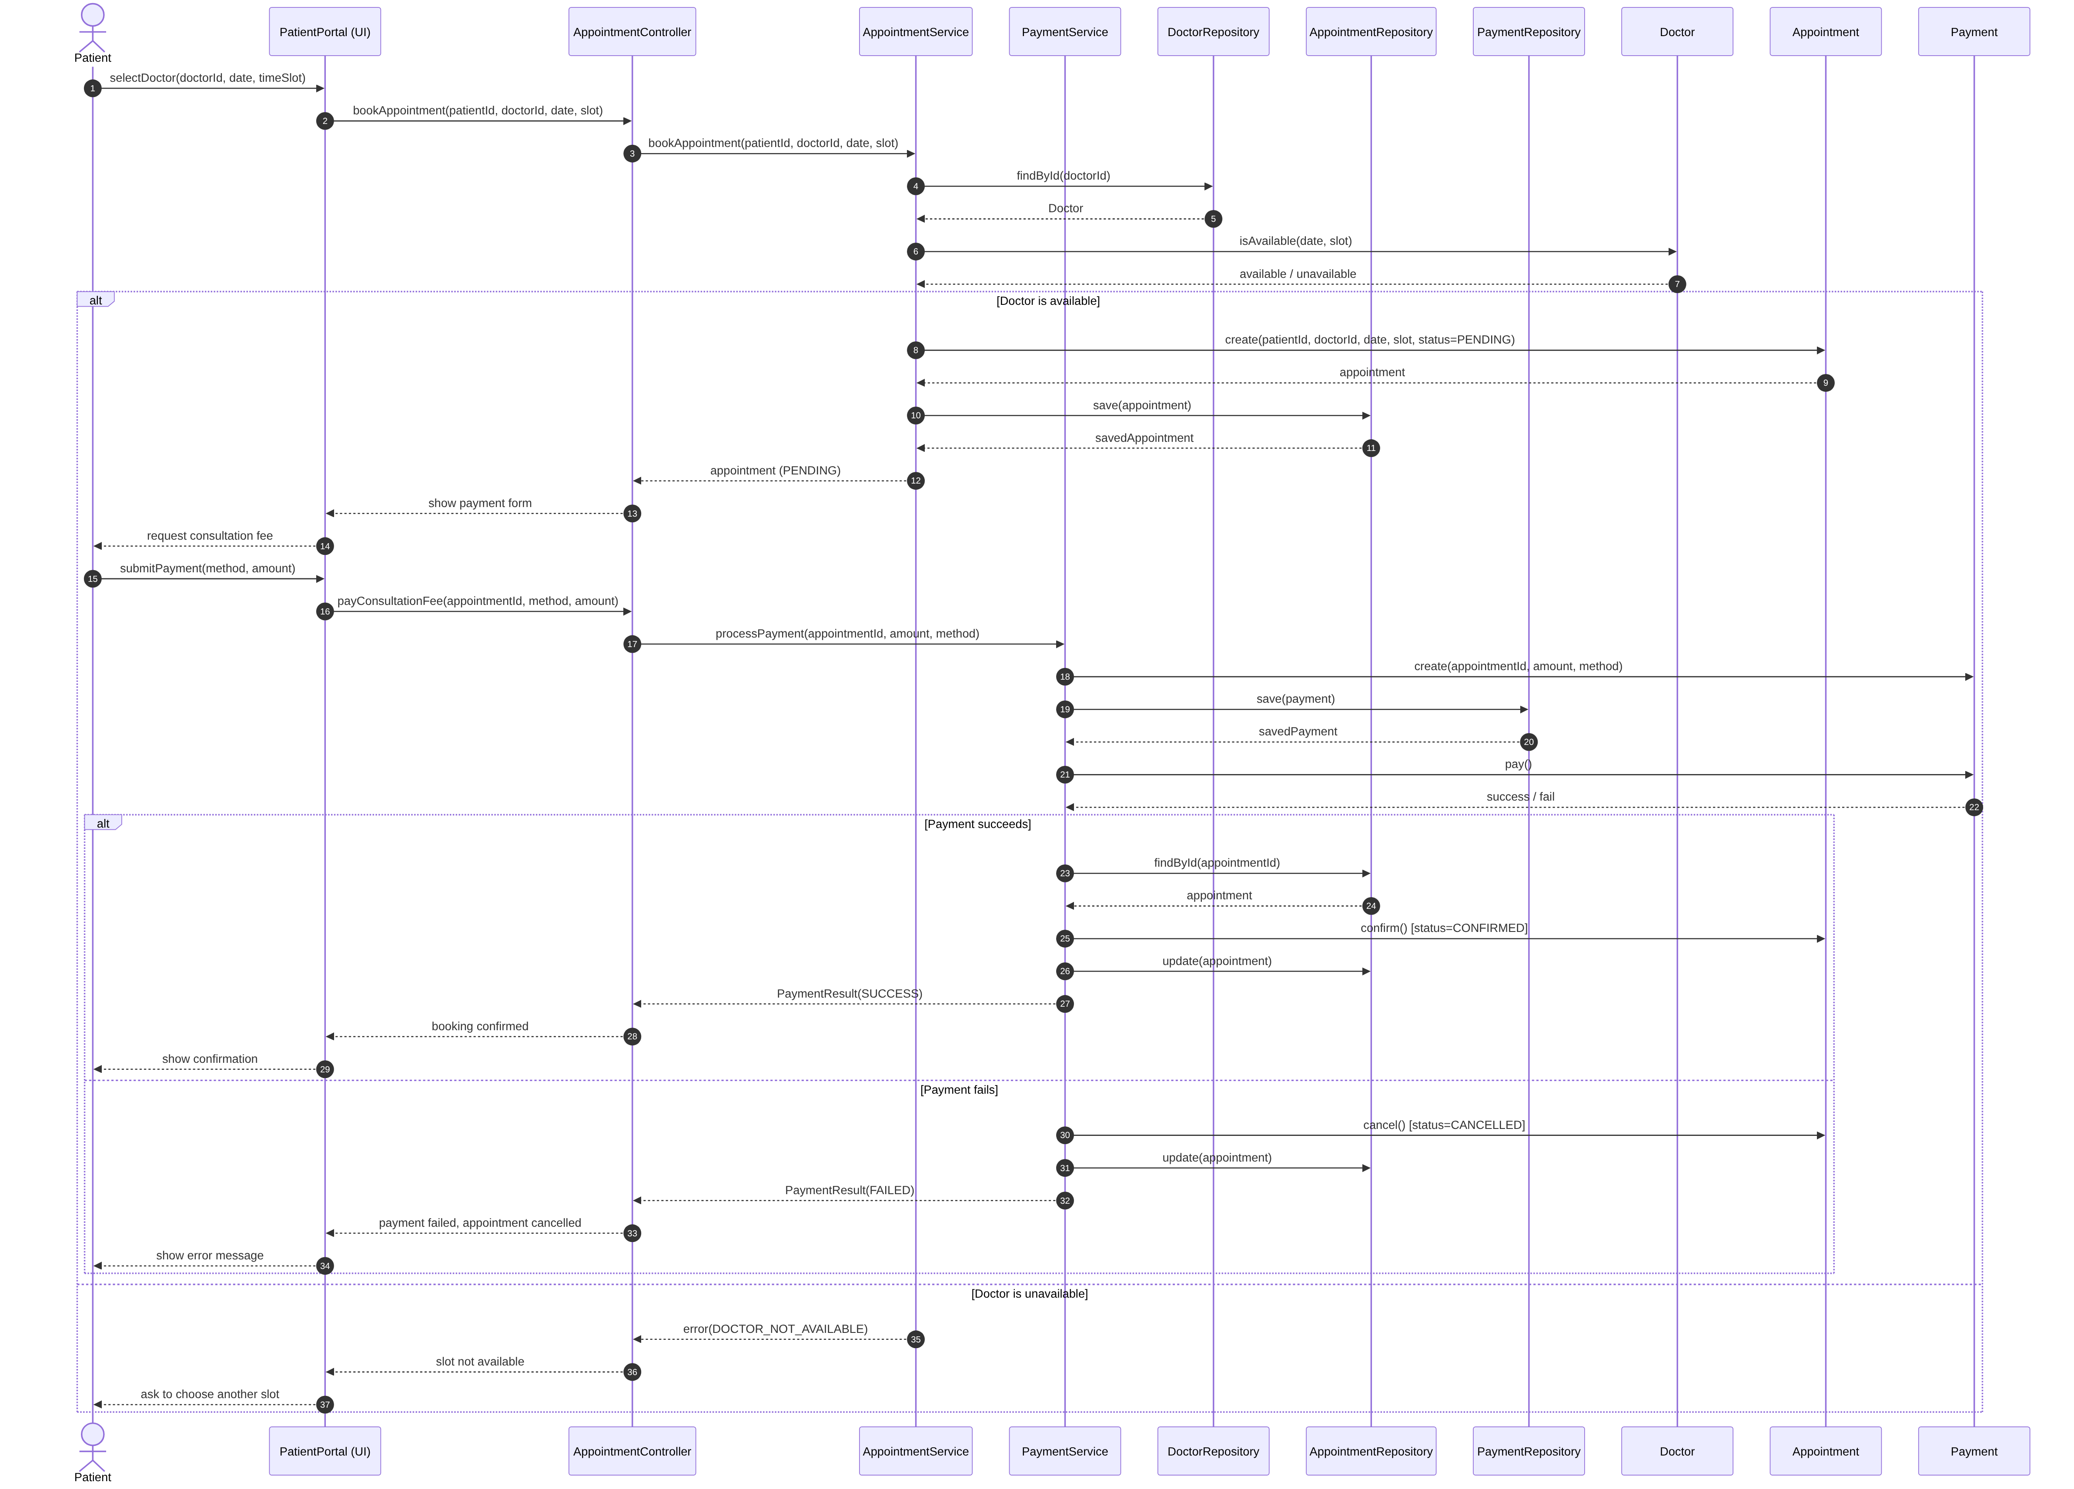

- Brief Explanation:
Participants (Layered): Patient → PatientPortal (UI) → AppointmentController → AppointmentService / PaymentService → DoctorRepository / AppointmentRepository / PaymentRepository → entities Doctor, Appointment, Payment.
Booking flow: The patient selects a doctor and slot; the controller delegates to AppointmentService, which loads the doctor through DoctorRepository.findById and asks Doctor.isAvailable(date, slot).
alt 1 – Doctor availability: If available, an Appointment is created with status PENDING and saved via AppointmentRepository.save, then the patient is asked to pay. Otherwise an error is returned and the patient is asked to choose another slot.
Payment: PaymentService creates a Payment, saves it through PaymentRepository.save and calls pay().
alt 2 – Payment result: On success the appointment is loaded, confirm() sets CONFIRMED and AppointmentRepository.update persists it. On failure cancel() sets CANCELLED, the change is persisted and the UI shows an error. All data access goes through repository method calls, so the Repository Pattern is explicit.

Question 3: Activity Diagram/ State-chart diagram/ Component Diagram (3.0 points)
- Your Diagram (Statechart Diagram):
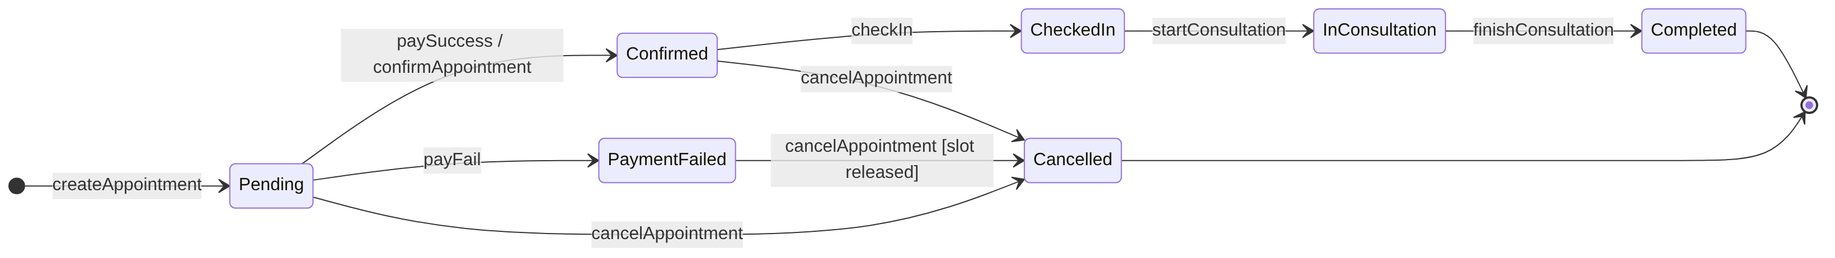

- Brief Explanation:
Scope: State diagram of the Appointment entity lifecycle, from creation to completion or cancellation.
Initial / final states: Initial pseudo-state → Pending (createAppointment). Final states: Completed and Cancelled.
Main path: Pending → Confirmed (paySuccess / confirmAppointment) → CheckedIn (checkIn) → InConsultation (startConsultation) → Completed (finishConsultation).
Alternative paths: Pending → PaymentFailed (payFail); PaymentFailed → Cancelled (cancelAppointment, the doctor's slot is released); Pending → Cancelled and Confirmed → Cancelled (cancelAppointment).
Transitions: 10 transitions, each labelled with its triggering event; the payment-failure / cancellation branch satisfies the required branching path.

END OF SUBMISSION

