PRACTICAL EXAM - SWD392 -SU26
Date time: | 12/11/2026 (practice / model answer)
Exam Code: | SWD392_SU26_PE2 - SmartPark (Layered Architecture + Repository Pattern)

Question 1: Class Diagram (3.0 points)
- Your Class Diagram:
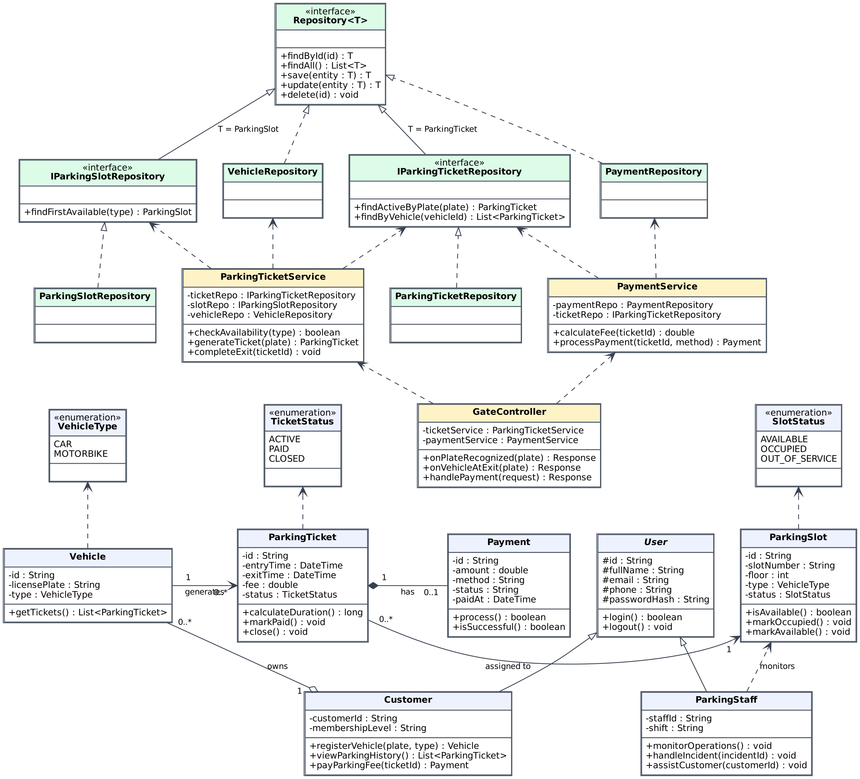

- Brief Explanation:
Architecture: Layered Architecture, applied consistently in all diagrams: GateController (Camera/Gate UI entry point) → ParkingTicketService / PaymentService (business logic) → Repository layer → domain entities.
Inheritance: Customer and ParkingStaff extend the abstract base class User (id, fullName, email, phone, passwordHash, login/logout).
Associations: Customer 1 o— 0..* Vehicle (aggregation: a customer owns many vehicles); Vehicle 1 → 0..* ParkingTicket (each vehicle can have many tickets, one per parking session); ParkingTicket 0..* → 1 ParkingSlot (each ticket is assigned to exactly one slot).
Composition: ParkingTicket 1 ◆— 0..1 Payment: a payment transaction belongs to its ticket and exists only when the vehicle exits. VehicleType, TicketStatus and SlotStatus are enumerations used by Vehicle, ParkingTicket and ParkingSlot.
Repository Pattern: Repository<T> is a generic interface (findById, findAll, save, update, delete). VehicleRepository and PaymentRepository implement it; IParkingSlotRepository and IParkingTicketRepository extend it with domain queries (findFirstAvailable, findActiveByPlate) and are implemented by ParkingSlotRepository and ParkingTicketRepository.
Dependencies: Ticket management and payment logic live in ParkingTicketService and PaymentService, which depend on repository interfaces (dashed arrows) and never access the database directly.

Question 2: Sequence diagram (4.0 points)
- Your Diagram (Sequence Diagram):
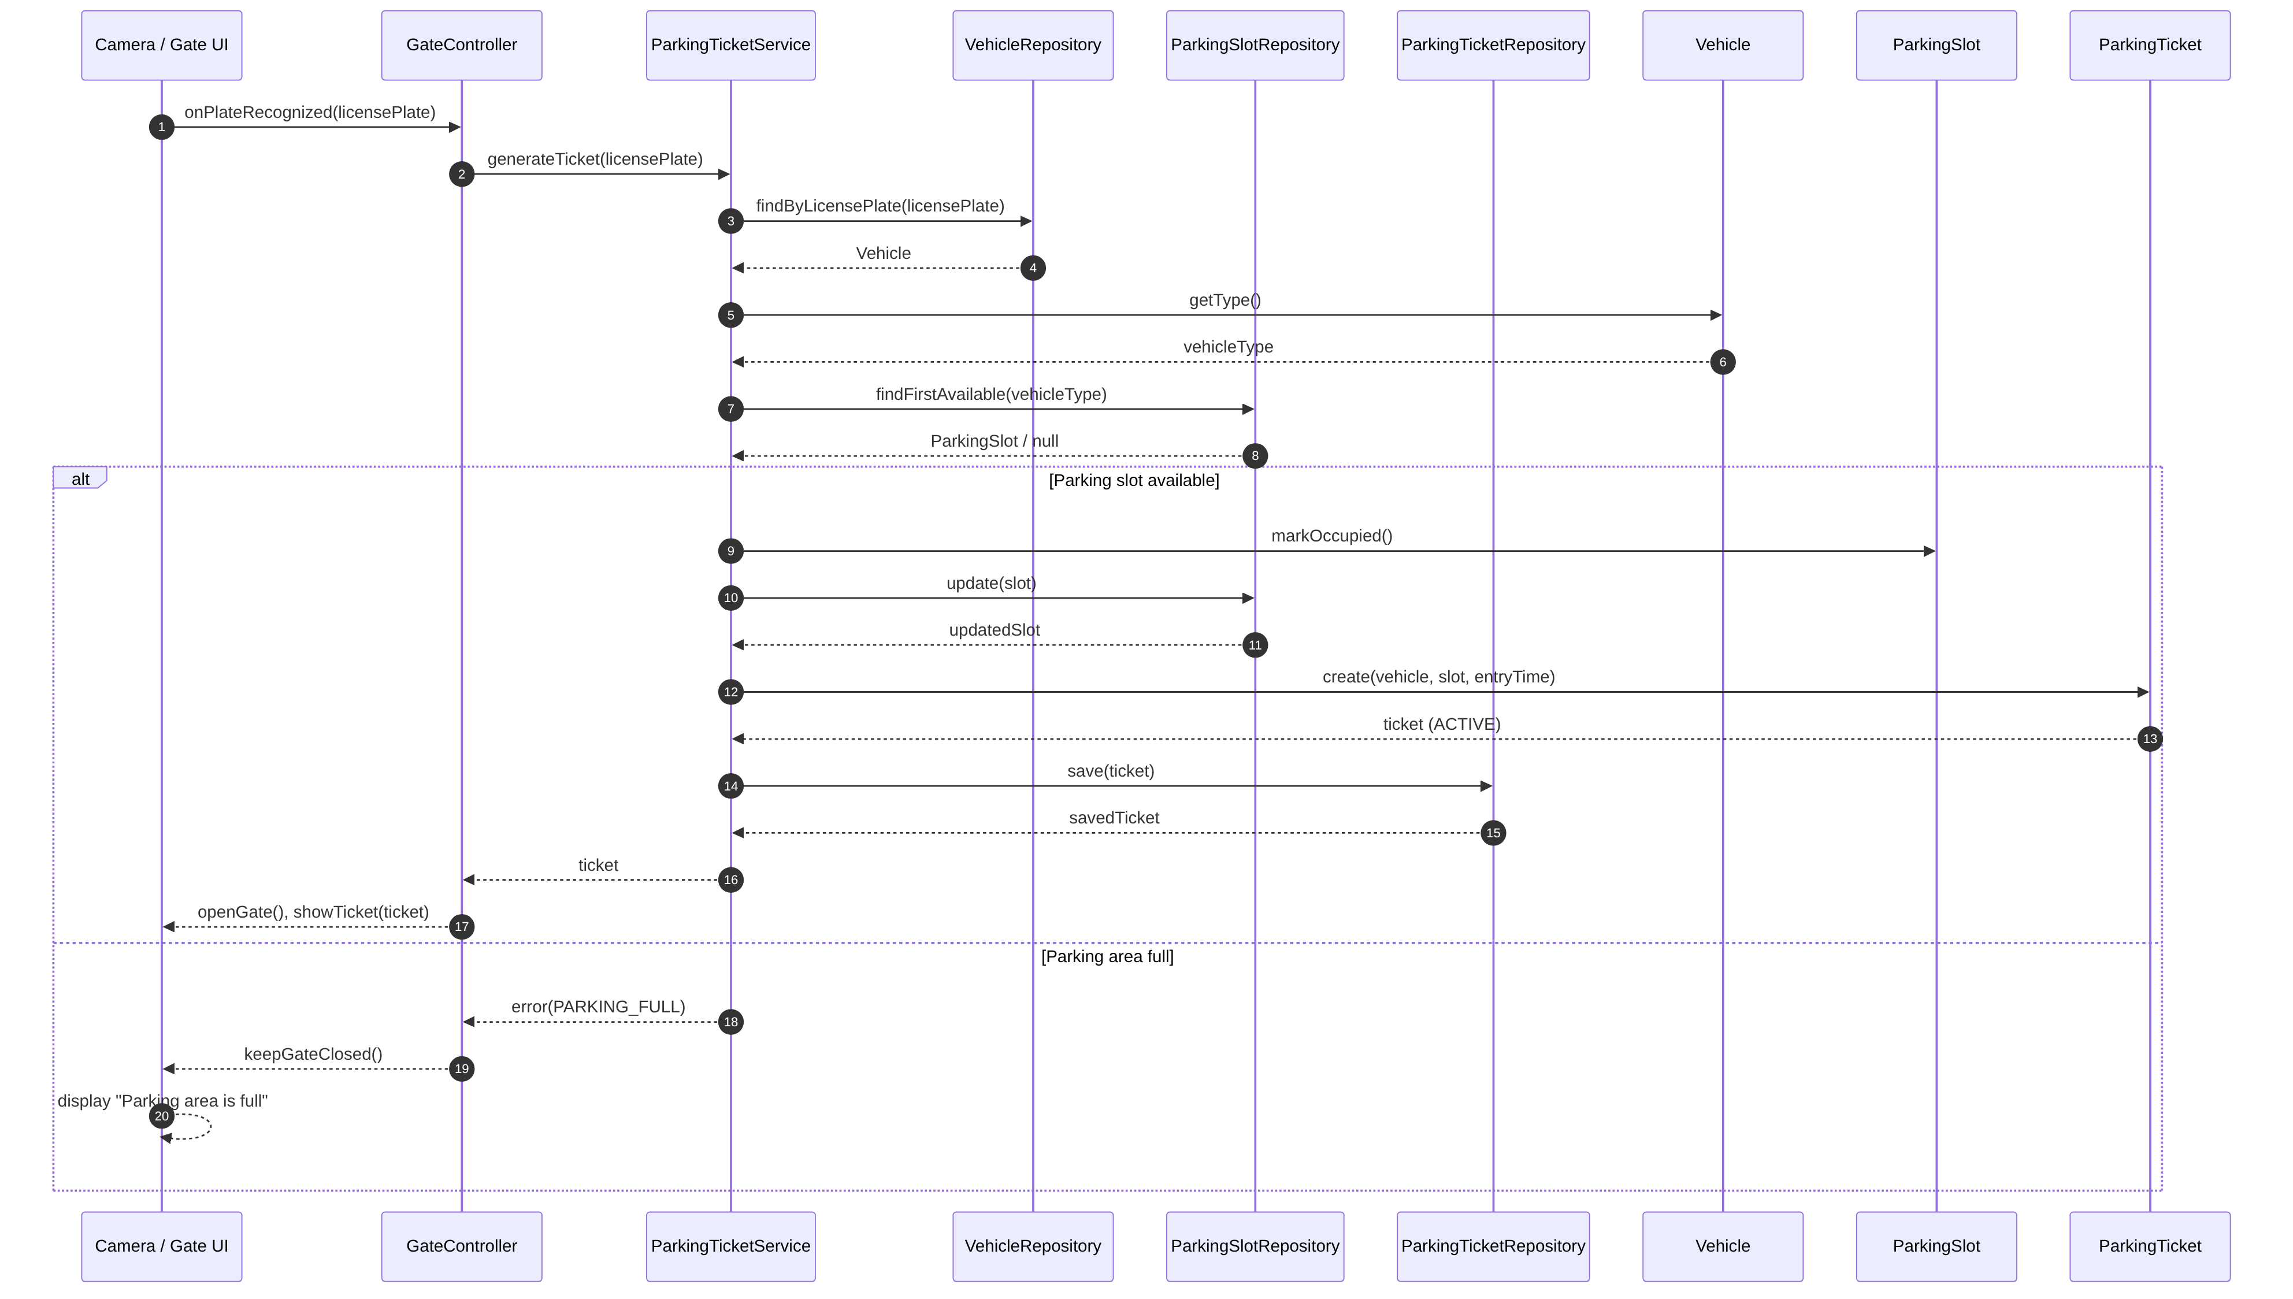

- Brief Explanation:
Participants (Layered): Camera / Gate UI → GateController → ParkingTicketService → VehicleRepository, ParkingSlotRepository, ParkingTicketRepository → entities Vehicle, ParkingSlot, ParkingTicket.
Flow: The camera recognizes the license plate and notifies GateController, which calls ParkingTicketService.generateTicket. The service loads the Vehicle via VehicleRepository.findByLicensePlate, reads its type, and asks ParkingSlotRepository.findFirstAvailable(type) for a suitable slot.
alt – Parking slot available: The slot is marked occupied and persisted (ParkingSlotRepository.update), a ParkingTicket (ACTIVE) is created and saved via ParkingTicketRepository.save, and the controller opens the gate and shows the ticket.
alt – Parking area full: The service returns PARKING_FULL, the gate stays closed and the UI displays an appropriate notification.
Repository Pattern: All data access is done through explicit repository method calls (findByLicensePlate, findFirstAvailable, update, save).

Question 3: Activity Diagram (3.0 points)
- Your Diagram (Activity Diagram):
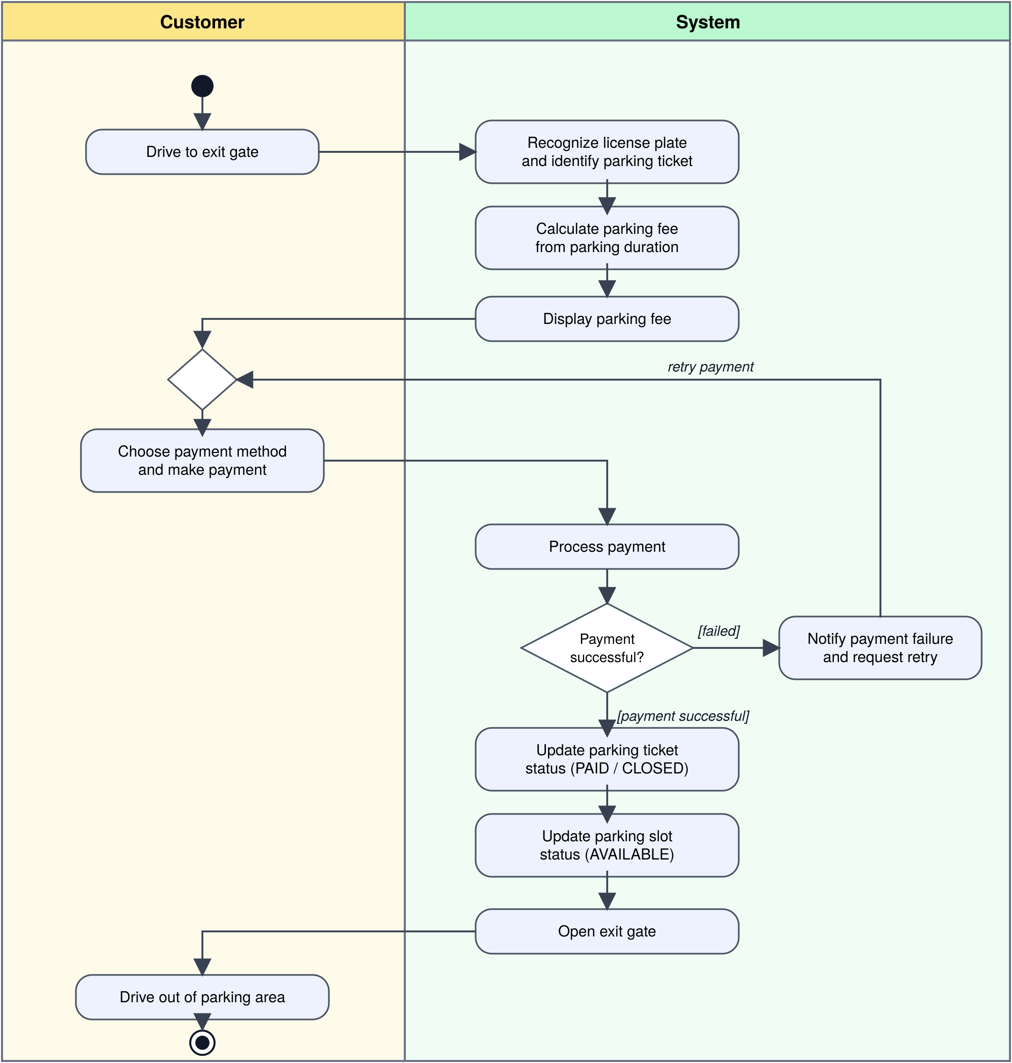

- Brief Explanation:
Use case: Vehicle Exit and Payment, modelled with two swimlanes: Customer and System.
Flow: Start → the customer drives to the exit gate → the system recognizes the plate and identifies the parking ticket → calculates the fee from the parking duration → displays the fee → the customer chooses a method and pays → the system processes the payment.
Decision node: [payment successful] → the system updates the ticket status (PAID/CLOSED), updates the parking slot status to AVAILABLE, opens the exit gate, and the customer drives out → End.
Failure path: [failed] → the system notifies the customer and requests a retry; the flow loops back (merge node) to the payment step until it succeeds.

END OF SUBMISSION

