

A Supporting Tool for Requirements and Project Progress Management in Software Project Course SWP391 Using Jira and GitHub
Software Requirement Document
Report 2 - Overall Description

– HoChiMinh, January 2026 –
Table of Contents
Record of Changes 3
II. Overall Description 4
1. Product Overview 4
2. Business Process 5

Record of Changes
Date | A*  M, D | In charge | Change Description
*A - Added M - Modified D - Deleted

II. Overall Description

1. Product Overview
The Supporting Tool for Requirements and Project Progress Management is a web-based software system developed to support requirement management and project progress monitoring for the SWP391 course.
The system is designed for use in an academic environment where student teams develop software projects under lecturer supervision. It integrates with Jira to manage software requirements and development tasks, and with GitHub to retrieve and analyze source code repositories and commit activities.
The primary users of the system are Admin, Lecturer, Team Leader, and Team Member, each interacting with the system according to assigned roles and responsibilities. The system provides centralized access to project requirements, task status, and contribution metrics to support project monitoring and evaluation.
The system depends on the availability of the Jira Cloud REST API and GitHub REST API for data access and synchronization. It assumes that users possess valid Jira and GitHub accounts and adhere to standard software development practices during project execution.
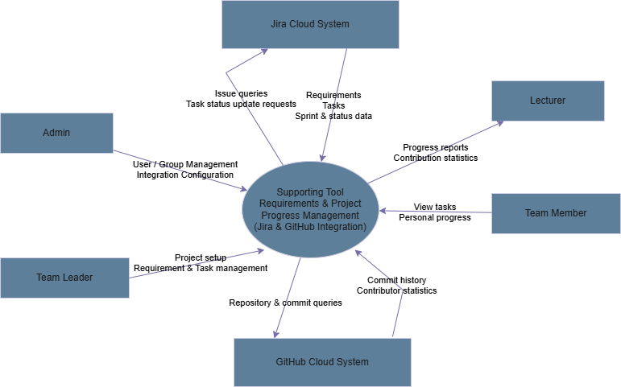

2. Business Process.
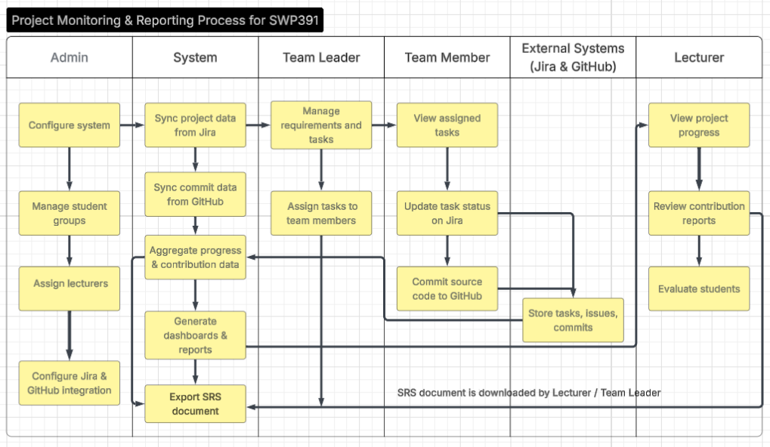
# | Process Step | Description
1 | Configure system | Admin configures the system, creates student groups, and sets up user roles and permissions
2 | Assign lecturers | Admin assigns lecturers to be responsible for specific student groups
3 | Configure Jira & GitHub integration | Admin configures API connections to integrate the system with Jira and GitHub
4 | Synchronize project data | The system automatically synchronizes epics, user stories, tasks, and sprints from Jira
5 | Manage requirements and tasks | Team Leader manages requirements and assigns tasks to team members
6 | Perform development tasks | Team Members perform the tasks assigned to them
7 | Update task status | Team Members update task status on Jira
8 | Commit source code | Team Members commit source code to GitHub repositories
9 | Collect development data | The system collects commits, pull requests, and activity history from GitHub
10 | Analyze and aggregate data | The system analyzes sprint progress and individual contribution levels
11 | View monitoring dashboard | Lecturer views dashboards to monitor project progress
12 | Generate reports | The system generates reports on team progress and individual contributions
13 | Export SRS document | The system generates and exports the Software Requirements Specification (SRS) document for download
14 | Evaluate students | Lecturer evaluates students based on generated reports and SRS data

