

<<Project name>>
Software Requirement Document

– HoChiMinh, August 2022 –
Table of Contents
Record of Changes 4
Definition and Acronyms 5
I. Introduction 6
1. Product Background 6
2. Existing Systems 6
2.1 System name1 6
2.2 System name2 6
3. Business Opportunity 6
4. Software Product Vision 6
5. Major Features 7
6. Limitations and Exclusions 7
II. Overall Description 8
1. Product Overview 8
2. Business Process 9
III. User Requirements 10
1. Actors 10
2. Use Cases 10
2.1 Diagram 10
2.2 Descriptions 11
3. Business Rules 14
IV. Functional Requirements 15
1. System Functional Overview 15
1.1 Screen Flow 15
1.2 Screen Descriptions 15
1.3 Screen Authorization 15
1.4 Non-Screen Functions 16
2. Data Requirements 16
2.1 Logical Data Model 16
2.2 Data Dictionary 17
2.3 Reports 19
2.4 State transition diagram 20
3. <<Feature Name 1>> 20
3.1 <<Function Name 1>> 20
3.2 <<Function Name 2>> 21
4. <<Feature Name 2>> 21
V. Non-Functional Requirements 22
1. External Interface Requirements 22
1.1 User Interfaces 22
1.2 Software Interfaces 22
1.3 Hardware Interfaces 23
1.4 Communications Interfaces 24
2. Quality Attributes 24
2.1 Usability 24
2.2 Performance 24
2.3 Security 25
2.4 Safety 25
2.5 Availability 25
2.6 Reliability 26
2.7 Design Contrainsts 26
2.8 [Others as relevant] 26

Record of Changes
Date | A*  M, D | In charge | Change Description
*A - Added M - Modified D - Deleted

Definition and Acronyms
[Fill all the definitions, acronyms,… used within the document] in the table format as below]
Acronym | Definition
PWM | Psychology website
AWS | Amazon Web Services
BA | Business Analysis
BR | Business Rule
ERD | Entity Relationship Diagram
GUI | Graphical User Interface
PM | Project Manager
SDD | Software Design Description
SPMP | Software Project Management Plan
SRS | Software Requirement Specification
UAT | User Acceptance Test
UC | Use Case
API | Application Program Interface

I. Introduction

1. Product Background
[This section summarizes the rationale for the new product. Provide a general description of the history or situation that leads to the recognition that this product should be built.]
<<Sample: Employees at the company Process Impact presently spend an average of 65 minutes per day going to the cafeteria to select, purchase, and eat lunch. About 20 minutes of this time is spent walking to and from the cafeteria, selecting their meals, and paying by cash or credit card. When employees go out for lunch, they spend an average of 90 minutes off-site. Some employees phone the cafeteria in advance to order a meal to be ready for them to pick up. Employees don’t always get the selections they want because the cafeteria runs out of certain items. The cafeteria wastes a significant quantity of food that is not purchased and must be thrown away. These same issues apply to breakfast and supper, although far fewer employees use the cafeteria for those meals than for lunch.>>

2. Existing Systems
[Add the system which might help solving the problems you listed above or the systems in which you can learn/refer the features for your system design]

2.1 System name1
[Write the brief descriptions of the system, the link, the system actors, features, pros, cons, etc.]

2.2 System name2
…

3. Business Opportunity
[Describe the market opportunity that exists or the business problem that is being solved. Describe the market in which a commercial product will be competing or the environment in which an information system will be used. This may include a brief comparative evaluation of existing products and potential solutions, indicating why the proposed product is attractive. Identify the problems that cannot currently be solved without the product, and how the product fits in with market trends or corporate strategic directions.]
<<Sample: Many employees have requested a system that would permit a cafeteria user to order meals (defined as a set of one or more food items selected from the cafeteria menu) on line, to be picked up at the cafeteria or delivered to a company location at a specified time and date. Such a system would save employees time, and it would increase the chance of their getting the items they prefer. Knowing what food items customers want in advance would reduce wastage in the cafeteria and would improve the efficiency of cafeteria staff. The future ability for employees to order meals for delivery from local restaurants would make a wide range of choices available to employees and provide the possibility of cost savings through volume discount agreements with the restaurants.>>

4. Software Product Vision
[Write a concise vision statement that summarizes the purpose and intent of the new product and describes what the world will be like when it includes the product. The vision statement should reflect a balanced view that will satisfy the needs of diverse customers as well as those of the developing organization. It may be somewhat idealistic, but it should be grounded in the realities of existing or anticipated customer markets, enterprise architectures, organizational strategic directions, and cost and resource limitations.]
<<Sample: For employees who want to order meals from the company cafeteria or from local restaurants on-line, the Cafeteria Ordering System is an Internet-based and smartphone-enabled application that will accept individual or group meal orders, process payments, and trigger delivery of the prepared meals to a designated location on the Process Impact campus. Unlike the current telephone and manual ordering processes, employees who use the Cafeteria Ordering System will not have to go to the cafeteria to get their meals, which will save them time and will increase the food choices available to them.>>

5. Major Features
<Include a numbered list of the major features of the new product, emphasizing those features that distinguish it from previous or competing products. Specific user requirements and functional requirements may be traced back to these features.>
<<Sample:
FE-01: Order and pay for meals from the cafeteria menu to be picked up or delivered.
FE-02: Order and pay for meals from local restaurants to be delivered.
FE-03: Create, view, modify, and cancel meal subscriptions for standing or recurring meal orders, or for daily special meals.
FE-04: Create, view, modify, delete, and archive cafeteria menus.
FE-05: View ingredient lists and nutritional information for cafeteria menu items.
>>

6. Limitations and Exclusions
<Identify any product features or characteristics that a stakeholder might anticipate, but which are not planned to be included in the new product.>
<<Sample:
LI-1: Some food items that are available from the cafeteria will not be suitable for delivery, so the menus available to patrons of the COS must be a subset of the full cafeteria menus.
LI-2: The COS shall be used only for the cafeteria at the Process Impact campus in Clackamas, Oregon.
>>

II. Overall Description

1. Product Overview
[Content part 1: presents a high-level overview of the product and the environment in which it will be used, the users, and known constraints, assumptions, and dependencies]
[Content part 2: describes the product's context in the form of a context diagram in which you present the boundary and connections between the system you’re developing and everything else in the universe. This identifies external entities (or terminators – software, hardware, human components, and other systems) outside the system that interface to it in some way, as well as data, control, and material flows between the terminators and the system]
<<Sample: The Cafeteria Ordering System is a new software system that replaces the current manual and telephone processes for ordering and picking up meals in the Process Impact cafeteria. The system is expected to evolve over several releases, ultimately connecting to the Internet ordering services for several local restaurants and to credit and debit card authorization services.
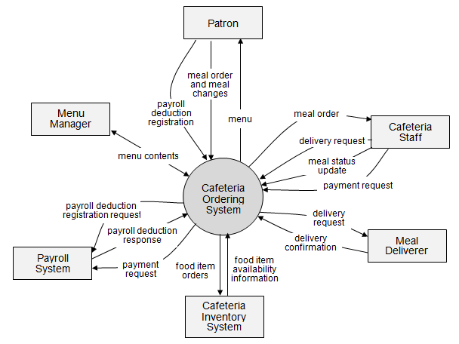>>

2. Business Process
[This part shows business processes of the system, using swimlane diagram]
<<Sample: shows a partial swimlane diagram for the CTS. The swimlanes in this example are roles or departments, showing which group executes each step in the business process to order a chemical from a vendor.
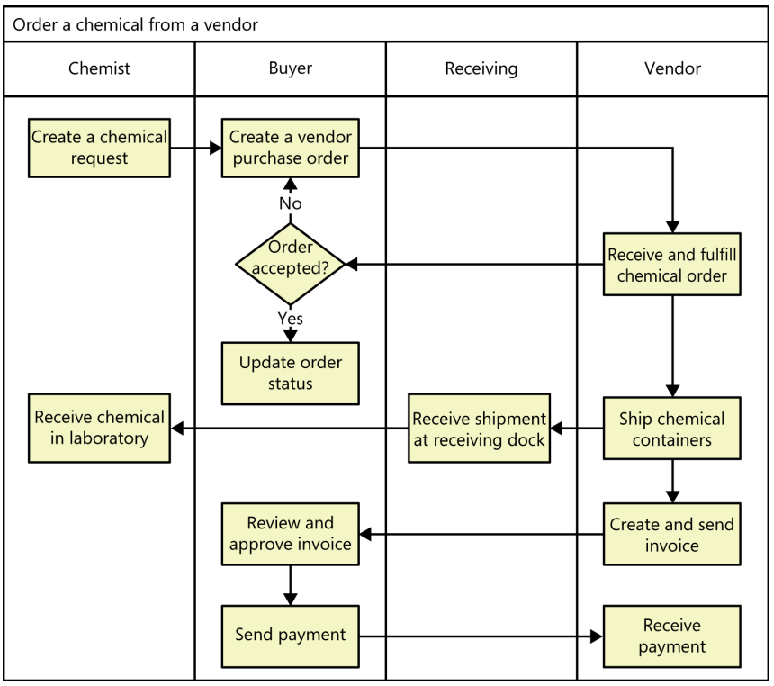
# | Process Step | Description
1 | Create a chemical request | <<Process Step description>>
2 | Create a vendor purchase order
3 | …
>>

III. User Requirements

1. Actors
[An actor is a person (or sometimes another software system or a hardware device) that interacts with the system to perform a use case. Following are some questions you might ask to help user representatives identify actors
- Who (or what) is notified when something occurs within the system?
- Who (or what) provides information or services to the system?
- Who (or what) helps the system respond to and complete a task?
This part gives the description of system actors, you can follow the table form as below]
<<Sample:
# | Actor | Description
1 | Patron (favored) | A Patron is a Process Impact employee who wants to order meals to be delivered from the company cafeteria. There are about 600 potential Patrons, of which 300 are expected to use the COS an average of 5 times per week each. Patrons will sometimes order multiple meals for group events or guests. An estimated 60 percent of orders will be placed using the corporate Intranet, with 40 percent of orders being placed from home or by smartphone or tablet apps.
2 | Cafeteria Staff | The Process Impact cafeteria employs about 20 Cafeteria Staff, who will receive orders from the COS, prepare meals, package them for delivery, and request delivery. Most of the Cafeteria Staff will need training in the use of the hardware and software for the COS.
3 | Menu Manager | The Menu Manager is a cafeteria employee who establishes and maintains daily menus of the food items available from the cafeteria. Some menu items may not be available for delivery. The Menu Manager will also define the cafeteria’s daily specials. The Menu Manager will need to edit existing menus periodically.
4 | Meal Deliverer | As the Cafeteria Staff prepare orders for delivery, they will issue delivery requests to a Meal Deliverer's smartphone. The Meal Deliverer will pick up the food and deliver it to the Patron. A Meal Deliverer’s other interactions with the COS will be to confirm that a meal was (or was not) delivered.
5 | …
>>

2. Use Cases
[A use case (UC) describes a sequence of interactions between a system and an external actor that results in the actor being able to achieve some outcome of value. The names of use cases are always written in the form of a verb followed by an object. Select strong, descriptive names to make it evident from the name that the use case will deliver something valuable for some user]

2.1 Diagram
[Provide the UC diagram(s) to show the actor-UCs and UC-UC relationships like the sample below. You can have multiple UC diagrams for the system]
<<Sample:
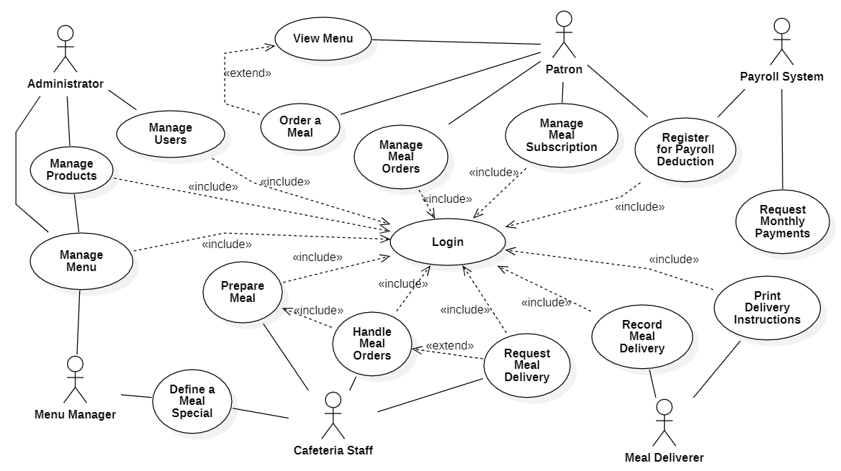
>>

2.2 Descriptions
[This part describes the use cases, you can follow the table form as below]
<<Sample:
ID | Use Case | Actors | Use Case Description
UC-01 | Order a Meal | Patron  Cafeteria Inventory System | <<Use Case Brief description>>
UC-02 | Register for Payroll Deduction | Patron  Payroll System
…

ID and Name: | UC-01 Order a Meal
Created By: | Prithvi Raj | Date Created: | 10/4/13
Primary Actor: | Patron | Secondary Actors: | Cafeteria Inventory System
Description: | A Patron accesses the Cafeteria Ordering System from the corporate intranet or from home, views the menu for a specific date if desired, selects food items, and places an order for a meal to be delivered to a specified location within a specified 15-minute time window.
Trigger: | A Patron indicates that he wants to order a meal
Preconditions: | PRE-1. Patron is logged into COS.  PRE-2. Patron is registered for meal payments by payroll deduction.
Postconditions: | POST-1. Meal order is stored in COS with a status of “Accepted”.  POST-2. Inventory of available food items is updated to reflect items in this order.  POST-3. Remaining delivery capacity for the requested time window is updated.
Normal Flow: | 1.0 Order a Single Meal  - Patron asks to view menu for a specific date. (see 1.0.E1, 1.0.E2)  - COS displays menu of available food items and the daily special.  - Patron selects one or more food items from menu. (see 1.1)  - Patron indicates that meal order is complete. (see 1.2)  - COS displays ordered menu items, individual prices, and total price, including taxes and delivery charge.  - Patron either confirms meal order (continue normal flow) or requests to modify meal order (return to step 2).  - COS displays available delivery times for the delivery date.  - Patron selects a delivery time and specifies the delivery location.  - Patron specifies payment method.  - COS confirms acceptance of the order.  - COS sends Patron an email message confirming order details, price, and delivery instructions.  - COS stores order, sends food item information to Cafeteria Inventory System, and updates available delivery times.
Alternative Flows: | 1.1 Order multiple identical meals  - Patron requests a specified number of identical meals. (see 1.1.E1)  - Return to step 4 of normal flow.  1.2 Order multiple meals  - Patron asks to order another meal.  - Return to step 1 of normal flow.
Exceptions: | 1.0.E1 Requested date is today and current time is after today’s order cutoff time  1. COS informs Patron that it’s too late to place an order for today.  2a. If Patron cancels the meal ordering process, then COS terminates use case.  2b. Else if Patron requests another date, then COS restarts use case.  1.0.E2 No delivery times left  1. COS informs Patron that no delivery times are available for the meal date.  2a. If Patron cancels the meal ordering process, then COS terminates use case.  2b. Else if Patron requests to pick the order up at the cafeteria, then continue with normal flow, but skip steps 7 and 8.  1.1.E1 Insufficient inventory to fulfill multiple meal order  1. COS informs Patron of the maximum number of identical meals he can order, based on current available inventory.  2a. If Patron modifies number of meals ordered, then Return to step 4 of normal flow.  2b. Else if Patron cancels the meal ordering process, then COS terminates use case.
Priority: | High
Frequency of Use: | Approximately 300 users, average of one usage per day. Peak usage load for this use case is between 9:00 A.M. and 10:00 A.M. local time.
Business Rules: | BR-1, BR-2, BR-3, BR-4, BR-11, BR-12, BR-33
Other Information: | - Patron shall be able to cancel the meal ordering process at any time prior to confirming it.  - Patron shall be able to view all meals he ordered within the previous six months and repeat one of those meals as the new order, provided that all food items are available on the menu for the requested delivery date. (Priority = M)  - The default date is the current date if the Patron is using the system before today’s order cutoff time. Otherwise, the default date is the next day that the cafeteria is open.
Assumptions: | Assume that 15 percent of Patrons will order the daily special (source: previous 6 months of cafeteria data).

ID and Name: | UC-02 Register for Payroll Deduction
Created By: | Nancy Anderson | Date Created: | 9/15/13
Primary Actor: | Patron | Secondary Actors: | Payroll System
Description: | Cafeteria patrons who use the COS and have meals delivered must be registered for payroll deduction. For noncash purchases made through the COS, the cafeteria will issue a payment request to the Payroll System, which will deduct the meal costs from the next scheduled employee payday direct deposit.
Trigger: | Patron requests to register for payroll deduction, or Patron says yes when COS asks if he wants to register
Preconditions: | PRE-1. Patron is logged into COS.
Postconditions: | POST-2. Patron is registered for payroll deduction.
Normal Flow: | 5.0 Register for Payroll Deduction  - COS asks Payroll System if Patron is eligible to register for payroll deduction.  - Payroll System confirms that Patron is eligible to register for payroll deduction.  - COS asks Patron to confirm his desire to register for payroll deduction.  - If so, COS asks Payroll System to establish payroll deduction for Patron.  - Payroll System confirms that payroll deduction is established.  - COS informs Patron that payroll deduction is established.
Alternative Flows: | None
Exceptions: | 5.0.E1 Patron is not eligible for payroll deduction  5.0.E2 Patron is already enrolled for payroll deduction
Priority: | High
Business Rules: | BR-86 and BR-88 govern an employee’s eligibility to enroll for payroll deduction.
Other Information: | Expect high frequency of executing this use case within first 2 weeks after system is released.
>>

3. Business Rules
[Provide common business rules that you must follow. The information can be provided in the table format as the sample below]
<<Sample:
ID | Rule Definition
BR-01 | Delivery time windows are 15 minutes, beginning on each quarter hour.
BR-02 | Deliveries must be completed between 10:00 A.M. and 2:00 P.M. local time, inclusive.
BR-03 | All meals in a single order must be delivered to the same location.
BR-04 | All meals in a single order must be paid for by using the same payment method.
BR-11 | If an order is to be delivered, the patron must pay by payroll deduction.
BR-12 | Order price is calculated as the sum of each food item price times the quantity of that food item ordered, plus applicable sales tax, plus a delivery charge if a meal is delivered outside the free delivery zone.
BR-24 | Only cafeteria employees who are designated as Menu Managers by the Cafeteria Manager can create, modify, or delete cafeteria menus.
BR-33 | Network transmissions that involve financial information or personally identifiable information require 256-bit encryption.
BR-86 | Only regular employees can register for payroll deduction for any company purchase.
BR-88 | An employee can register for payroll deduction payment of cafeteria meals if no more than 40 percent of his gross pay is currently being deducted for other reasons.
>>

IV. Functional Requirements

1. System Functional Overview
[Provide functionality overview of software system: screen flow, screen descriptions, system user roles, screen authorization, non-screen functions, ERD]

1.1 Screen Flow
[This part shows the system screens and the relationship among screens. You can draw the Screens Flow for the system in the form of diagram as below]
<<Sample:
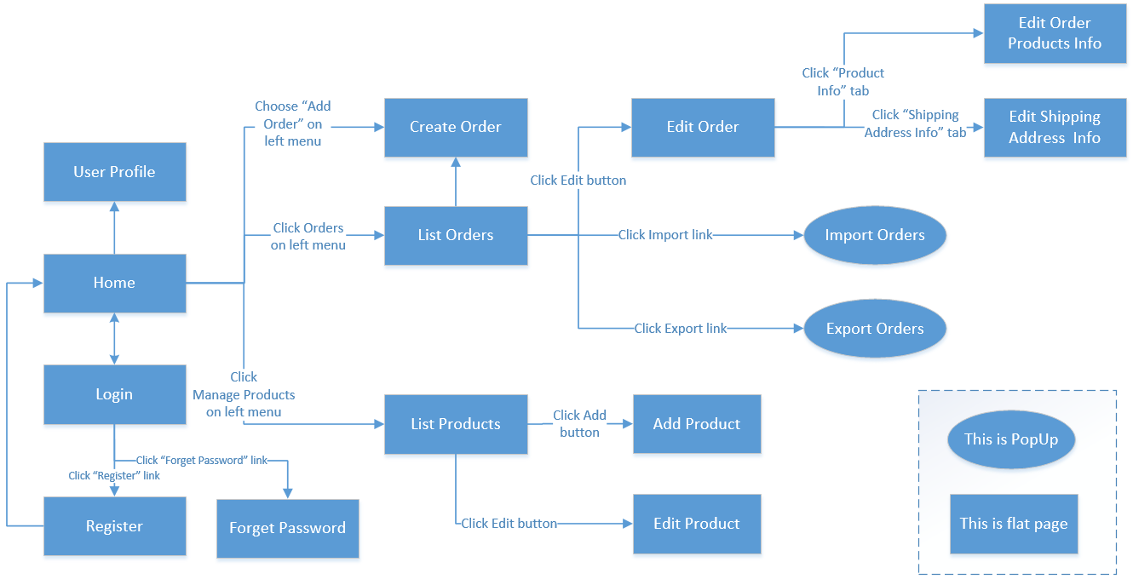
>>

1.2 Screen Descriptions
[Provide the descriptions for the screens in the Screens Flow above]
<<Sample:
# | Screen | Feature | Description
FR-01 | Create Order | Order Meals | <<Screen Brief description>>
FR-02 | Change Order | Order Meals
FR-03 | ..
>>

1.3 Screen Authorization
[Provide the system roles authorization to the system features (down to screens, and event to the screen activities if applicable) in the table form as below – replace Role1, Role2,… with the specific system user role names]
<<Sample:
Screen | Role1 | Role2 | Role3 | Role4 | RoleX
<<Screen Name1>> | X |  |  | X | X
<<Screen Activity>> |  |  |  | X | X
<<Screen Name2>> | X |  |  | X
Query All Data | X
Query Own Data |  |  |  | X
Query Managed Data |  |  |  | X
Add New Data |  |  |  | X | X
Update All Data |  |  |  |  | X
Update Own Data |  |  |  |  | X
Update Managed Data |  |  |  |  | X
Delete Data
…
In which:
- Role1: <<role1 description>>
- Role2: <<role2 description>>
- …
>>

1.4 Non-Screen Functions
[Provide the descriptions for the non-screen system functions, i.e batch/cron job, service, API, etc.]
<<Sample:
# | System Function | Feature | Description
FR-11 | <<Function Name1>> | <<Feature Name>> | <<Function Name1 Description>>
FR-12 | …
>>

2. Data Requirements

2.1 Logical Data Model
[A data model is a visual representation of the data objects and collections the system will process and the relationships between them. Include a data model for the business operations being addressed by the system, or a logical representation for the data that the system itself will manipulate. Data models are most commonly created as an entity-relationship diagram.]
<<Sample:
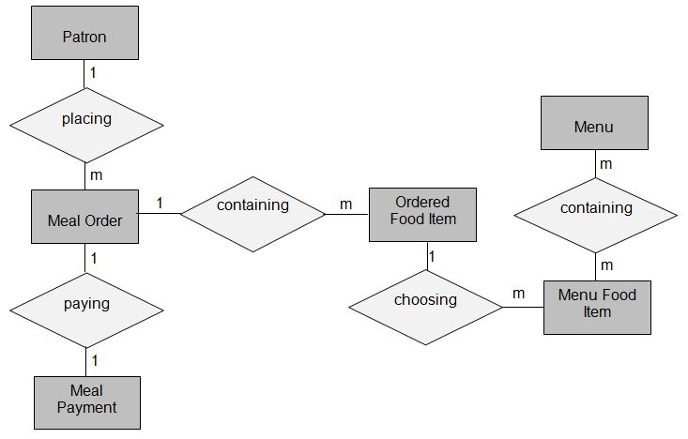
>>

2.2 Data Dictionary
[The data dictionary defines the composition of data structures and the meaning, data type, length, format, and allowed values for the data elements that make up those structures. In many cases, you're better off storing the data dictionary as a separate artifact, rather than embedding it in the middle of an SRS. That also increases its reusability potential in other projects.]
<<Sample:
Data Element | Description | Composition or Data Type | Length | Values
delivery instruction | where and to whom a meal is to be delivered, if it isn't being picked up in the cafeteria | patron name  +patron phone number  +meal date  +delivery location  +delivery time window
delivery location | building and room to which an ordered meal is to be delivered | alphanumeric | 50 | hyphens and commas permitted
delivery time window | beginning time of a 15-minute range on the meal date during which an ordered meal is to be delivered; | time | hh:mm | local time; hh = 0-23 inclusive; mm = 00, 15, 30, or 45
employee ID | company ID number of the employee who placed a meal order | integer | 6
food item description | ext description of a food item on a menu | alphabetic | 100
food item price | pre-tax cost of a single unit of a menu food item | numeric, dollars and cents | dd.cc
meal date | the date the meal is to be delivered or picked up | date, MM/DD/YYYY | 10 | default = current date if the current time is before the order cutoff time, else the next day; cannot be prior to current date
meal order | details about a meal a Patron ordered | meal order number  + order date  + meal date  + 1:m{ordered food item}  + delivery instruction  + meal order status
meal order number | unique ID that COS assigns to each accepted meal order | integer | 7 | initial value is 1
meal order status | status of a meal order that a Patron initiated | alphabetic | 16 | incomplete, accepted, prepared, pending delivery, delivered, canceled
meal payment | information about a payment COS accepted for a meal | payment amount  + payment method  + transaction number
menu | list of food items available for purchase on a specific date | menu date  + 1:m{menu food item}
menu date | the date for which a specific menu is available | date, MM/DD/YYYY | 10
menu food item | description of a menu item | food item description  + food item price
order cutoff time | the time of day before which all meal orders for that date must be placed | time, HH:MM | 5
order date | the date on which a patron placed a meal order | date, MM/DD/YYYY | 10
ordered food item | one menu food item that a Patron requested as part of a meal order | menu food item  + quantity ordered
patron | a Process Impact employee who is authorized to order a meal | patron name  + employee ID  + patron phone number  + patron location  + patron email
patron email | email address of the employee who placed a meal order | alphanumeric | 50
patron location | building and room numbers of the employee who placed a meal order | alphanumeric | 50 | hyphens and commas permitted
patron name | name of the employee who placed a meal order | alphabetic | 30
patron phone number | telephone number of the employee who placed a meal order | AAA-EEE-NNNN xXXXX for area code (A), exchange (E), number (N), and extension (X) | 18
payment amount | total price of an order in dollars and cents, calculated per BR-12 | numeric, dollars and cents | dddd.cc
payment method | how the Patron is paying for a meal he ordered | alphabetic | 16 | payroll deduction, cash, credit card, debit card
quantity ordered | the number of units of each food item that the Patron is ordering in a single meal order | integer | 4 | default = 1; maximum = quantity presently in inventory
transaction number | unique sequence number that COS assigns to each payment transaction | integer | 12
>>

2.3 Reports
[If your application will generate any reports, identify them here and describe their characteristics. If a report must conform to a specific predefined layout you can specify that here as a constraint, perhaps with an example. Otherwise, focus on the logical descriptions of the report content, sort sequence, totaling levels, and so forth, deferring the detailed report layout to the design stage.]
<<Sample:
# | Report Name | Description
RPT-01 | Ordered Meal History | Patron wants to see a list of all meals that he had previously ordered from the Process Impact cafeteria or local restaurants over a specified time period up to six months prior to the current date, so he can reorder a particular meal he liked.
RPT-02 | …

Report ID: | RPT-01
Report Title: | Ordered Meal History
Report Purpose: | Patron wants to see a list of all meals that he had previously ordered from the Process Impact cafeteria or local restaurants over a specified time period up to six months prior to the current date, so he can reorder a particular meal he liked.
Priority: | Medium
Report Users: | Patrons
Data Sources: | Database of previously placed meal orders
Frequency and Disposition; | Report is generated on demand by a Patron. Data in the report is static. Report is displayed on user's web browser screen on a computer, tablet, or smartphone. It can be printed if the display device permits printing.
Latency: | Complete report must be displayed to Patron within 3 seconds after it is requested.
Visual Layout: | Landscape mode
Header and Footer: | Report header shall contain the report title, Patron's name, and date range specified. If printed, report footer shall show the page number.
Report Body: | Fields shown and column headings:  - Order Number  - Meal Date  - Ordered From ("Cafeteria" or restaurant name)  - Items ordered (list all items in the meal order, their quantity, and their prices)  - Total Food Price  - Tax  - Delivery Charge  - Total Price (sum of food item prices, tax, and delivery charge)  Selection Criteria: date range specified by Patron, inclusive of end points  Sort Criteria: reverse chronological order
End-of-Report Indicator: | None
Interactivity: | Patron can drill down to see ingredients and nutritional information for each item in the order
Security Access Restrictions: | A Patron may retrieve only his own meal order history

>>

2.4 State transition diagram
[This part shows state transition of main entities in the system]
<<Sample: a state-transition diagram that shows the possible meal order statuses and the allowed changes in status.
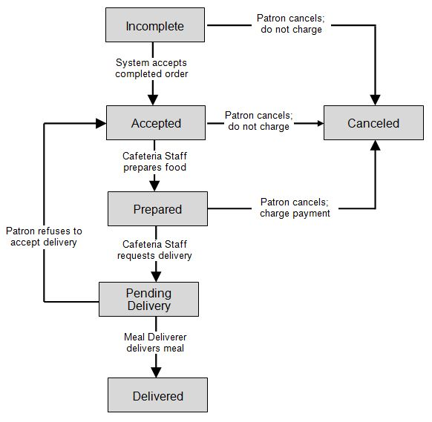
>>

3. <<Feature Name 1>>

3.1 <<Function Name 1>>
[A function can be a screen or a non-screen function (listed in the part 5.1 above). In this part, you need to provide the details on the related function, focus on mentioning below information
- Function trigger: how this function is triggered (navigation path, a timing frequency, etc.
- Function description: actors/roles, purpose, interface, data processing, etc.
- Screen layout: mockup prototype of the screen, sample below is for Manage Products screen
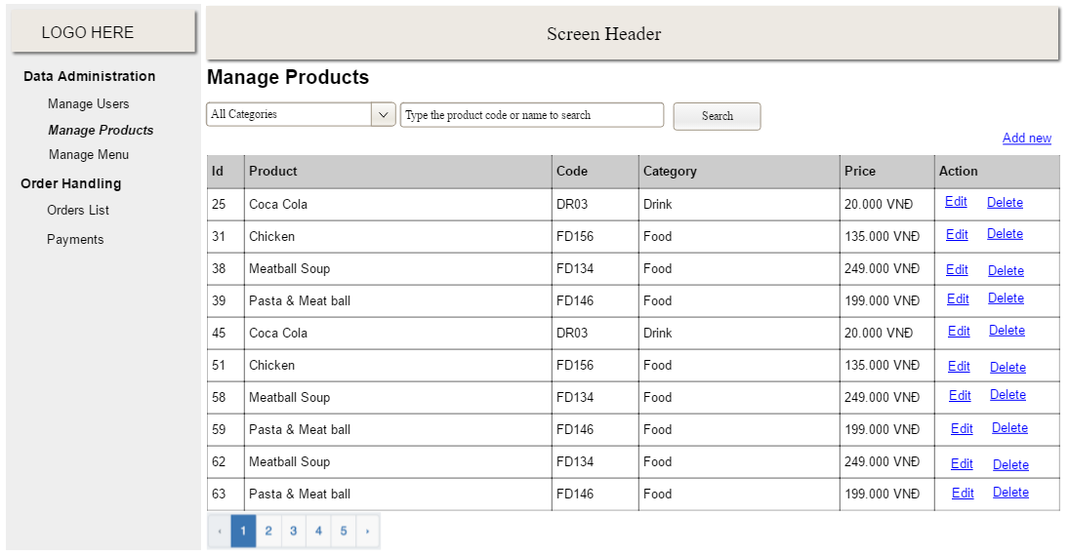
- Function Details: provide explanation for the data, validation, business logics, functionalities (for both normal cases and abnormal cases), etc. of the function so that the reader can image how it work.
]

3.2 <<Function Name 2>>
…

4. <<Feature Name 2>>
…

V. Non-Functional Requirements

1. External Interface Requirements
[This section provides information to ensure that the system will communicate properly with users and with external hardware or software elements.]

1.1 User Interfaces
[Describe the logical characteristics of each interface between the software product and the users. This may include sample screen images, any GUI standards or product family style guides that are to be followed, screen layout constraints, standard buttons and functions (e.g., help) that will appear on every screen, keyboard shortcuts, error message display standards, and so on. Define the software components for which a user interface is needed. Details of the user interface design should be documented in a separate user interface specification.]
<<Sample:
UI-1: The Cafeteria Ordering System screen displays shall conform to the Process Impact Internet Application User Interface Standard, Version 2.0 [3].
UI-2: The system shall provide a help link from each displayed webpage to explain how to use that page.
UI-3: The webpages shall permit complete navigation and food item selection by using the keyboard alone, in addition to using mouse and keyboard combinations.
>>

1.2 Software Interfaces
[Describe the connections between this product and other software components (identified by name and version), including other applications, databases, operating systems, tools, libraries, websites, and integrated commercial components. State the purpose, formats, and contents of the messages, data, and control values exchanged between the software components. Specify the mappings of input and output data between the systems and any translations that need to be made for the data to get from one system to the other. Describe the services needed by or from external software components and the nature of the intercomponent communications. Identify data that will be exchanged between or shared across software components. Specify nonfunctional requirements affecting the interface, such as service levels for responses times and frequencies, or security controls and restrictions.]
<<Sample:
SI-1: Cafeteria Inventory System
SI-1.1: The COS shall transmit the quantities of food items ordered to the Cafeteria Inventory System through a programmatic interface.
SI-1.2: The COS shall poll the Cafeteria Inventory System to determine whether a requested food item is available.
SI-1.3: When the Cafeteria Inventory System notifies the COS that a specific food item is no longer available, the COS shall remove that food item from the menu for the current date.
SI-2: Payroll System
The COS shall communicate with the Payroll System through a programmatic interface for the following operations:

SI-2.1: To allow a Patron to register and unregister for payroll deduction.
SI-2.2: To inquire whether a Patron is registered for payroll deduction.
SI-2.3: To inquire whether a Patron is eligible to register for payroll deduction.
SI-2.4: To submit a payment request for a purchased meal.
SI-2.5: To reverse all or part of a previous charge because a patron rejected a meal or wasn’t satisfied with it, or because the meal was not delivered per the confirmed delivery instructions.
>>

1.3 Hardware Interfaces
[Describe the characteristics of each interface between the software and hardware (if any) components of the system. This description might include the supported device types, the data and control interactions between the software and the hardware, and the communication protocols to be used. List the inputs and outputs, their formats, their valid values or ranges, and any timing issues developers need to be aware of. If this information is extensive, consider creating a separate interface specification document.]
<<Sample:
HI-1: Server Configuration
Application Server
CPU : Intel Xeon 8 Core 2.40 GHz
Memory Space : 128 GB RAM 1333 MHz
Storage Space : 2 TB
Operating System : MS Windows Server 2012 R2
Software : Microsoft IIS 8.x, .NET Framework 4.5
Database Server
CPU : Intel Xeon 12 Core 2.40 GHz
Memory Space : 256 GB RAM 1333 MHz
Storage Space : 3 TB
Operating System : MS Windows Server 2012 R2
Software : Microsoft SQL Server 2000
HI-2: Client Configuration
PC Device
CPU : Intel Core 2 Dual 2.00 GHz
Memory Space : 4 GB RAM 1333MHz
Storage Space : HDD: 500GB, 2.5" SATA x 2, RAID 1
Operating System : Windows Win7/Win8/Win10
Operator Display : 18.5-inch widescreen, 16:9 format
1280 x 720 pixel, 1024 x 768 pixel
POS Device
CPU : Intel® Celeron® Processor G1820TE (2.2GHz, Dual Core)
Memory Space : 2GB (Max. 4GB), DDR3 SO-DIMM slot x 2 (1 open)
Storage Space : HDD: 500GB, 2.5" SATA x 2, RAID 1
Operating System : Windows Embedded POS Ready 7
Operator Display : 15" XGA TFT color LCD with resistive touch screen (TeamTouch), Integrated
1024 x 768 pixel
Proximity Sensor
Option: Integrated Camera/Mic
Mobility Device
CPU : Quad-Core 1.2 GHz
Memory Space : 1.5 GB
Storage Space : 8 GB
Operating System : Android 8.0
Wifi Standard : 5GHz Wi-fi
Operator Display : 7.0 inches
1280 x 800 Pixels
HI-3: Network
LAN Network : Speed ≥ 1 Gbps
WAN Network : Speed ≥ 2Mbps/10 Users operate together
>>

1.4 Communications Interfaces
[State the requirements for any communication functions the product will use, including e-mail, Web browser, network protocols, and electronic forms. Define any pertinent message formatting. Specify communication security or encryption issues, data transfer rates, handshaking, and synchronization mechanisms. State any constraints around these interfaces, such as whether e-mail attachments are acceptable or not.]
<<Sample:
CI-1: The COS shall send an email or text message (based on user account settings) to the Patron to confirm acceptance of an order, price, and delivery instructions.
CI-2: The COS shall send an email or text message (based on user account settings) to the Patron to report any problems with the meal order or delivery.
>>

2. Quality Attributes

2.1 Usability
[Specify any requirements regarding characteristics that will make the software appear to be “user-friendly.” Usability encompasses ease of use, ease of learning; memorability; error avoidance, handling, and recovery; efficiency of interactions; accessibility; and ergonomics. Sometimes these can conflict with each other, as with ease of use over ease of learning. Indicate any user interface design standards or guidelines to which the application must conform.]
<<Sample:
USE-1: The COS shall allow a Patron to retrieve the previous meal ordered with a single interaction.
USE-2: 95% of new users shall be able to successfully order a meal without errors on their first try.
>>

2.2 Performance
[State specific performance requirements for various system operations. If different functional requirements or features have different performance requirements, it's appropriate to specify those performance goals right with the corresponding functional requirements, rather than collecting them in this section.]
<<Sample:
PER-1: The system shall accommodate a total of 400 users and a maximum of 100 concurrent users during the peak usage time window of 9:00 A.M. to 10:00 A.M. local time, with an estimated average session duration of 8 minutes.
PER-2: 95% of webpages generated by the COS shall download completely within 4 seconds from the time the user requests the page over a 20Mbps or faster Internet connection.
PER-3: The system shall display confirmation messages to users within an average of 3 seconds and a maximum of 6 seconds after the user submits information to the system.
>>

2.3 Security
[Specify any requirements regarding security or privacy issues that restrict access to or use of the product. These could refer to physical, data, or software security. Security requirements often originate in business rules, so identify any security or privacy policies or regulations to which the product must conform. If these are documented in a business rules repository, just refer to them.]
<<Sample:
SEC-1: All network transactions that involve financial information or personally identifiable information shall be encrypted per BR-33.
SEC-2: Users shall be required to log on to the COS for all operations except viewing a menu.
SEC-3: Only authorized Menu Managers shall be permitted to work with menus, per BR-24.
SEC-4: The system shall permit Patrons to view only orders that they placed.
>>

2.4 Safety
[Specify requirements that are concerned with possible loss, damage, or harm that could result from use of the product. Define any safeguards or actions that must be taken, as well as potentially dangerous actions that must be prevented. Identify any safety certifications, policies, or regulations to which the product must conform.]
<<Sample:
SAF-1: The user shall be able to see a list of all ingredients in any menu items, with ingredients highlighted that are known to cause allergic reactions in more than 0.5 percent of the North American population.
>>

2.5 Availability
[Availability is a measure of the planned up time during which the system’s services are available for use and fully operational. Formally, availability equals the ratio of up time to the sum of up time and down time. Still more formally, availability equals the mean time between failures (MTBF) for the system divided by the sum of the MTBF and the mean time to repair (MTTR) the system after a failure is encountered. Scheduled maintenance periods also affect availability. Availability is closely related to reliability and is strongly affected by the maintainability subcategory of modifiability. ]
<<Sample:
AVL-1: The COS shall be available at least 98% of the time between 5:00 A.M. and midnight local time and at least 90% of the time between midnight and 5:00 A.M. local time, excluding scheduled maintenance windows.
>>

2.6 Reliability
[The probability of the software executing without failure for a specific period of time is known as reliability.]
<<Sample:
REL-1: No more than 5 experimental runs out of 1,000 can be lost because of software failures.
REL-2: The mean time between failures of the card reader component shall be at least 90 days.
>>

2.7 Design Contrainsts
[Describe constraints in the software development process]
<<Sample:
DES-1: Programming languages: ASP.NET (VB), VB.NET
DES-2: Web server: IIS 5.0
DES-3: Web browser: IE 6.0
DES-4: Database: SQL Server 2000
DES-5: Report: Crystal Report 10 + Excel
DES-6: Design tools: Power Designer 10, ERWin 4.1, Rational Rose
DES-7: Programming Tool: MS Visual Studio .Net 2003
>>

2.8 [Others as relevant]
[Create a separate section in the SRS for each additional product quality attribute to describe characteristics that will be important to either customers or developers. Possibilities include efficiency, installability, integrity, interoperability, modifiability, portability, reusability, robustness, scalability, and verifiability. Write these to be specific, quantitative, and verifiable. Clarify the relative priorities for various attributes, such as security over performance.]
<<Sample:
…
>>

