Đề 1: Write an argumentative essay of 350 - 400 words on the following question:
Should first-year academic writing courses be compulsory for all students—not just for international students or those whose first language is not English?
In many universities, domestic students do not have to take basic writing classes because people think native speakers are already good at writing. However, this idea is incorrect. First-year academic writing courses should be compulsory for all students because writing for university is a special skill that everyone needs to learn.
First of all, speaking a language naturally does not mean a person can write good academic essays. Daily conversation uses simple words and friendly tones. In contrast, university writing requires clear arguments, strong evidence, and correct citation styles. Many native speakers can talk very well, but they still find it hard to organize research papers or analyze information logically. Therefore, native students also need formal writing training.
Second, making this course compulsory for everyone creates fairness and removes bad stereotypes. If only international students have to take writing classes, people might think non-native speakers are weak at learning. When the course is required for all students, writing becomes a normal and important subject for everyone—just like math or science. This helps all students learn together without feeling embarrassed.
Finally, good writing skills are very important for future careers. After graduation, students need to write clear business emails, professional reports, and project proposals. A mandatory writing course helps every student practice these useful skills before they enter the job market.
In conclusion, academic writing is a skill that must be taught step by step. Universities should make first-year writing classes compulsory for all students to ensure fairness and help everyone succeed in their future jobs.

Đề 2: Write an argumentative essay of 350 - 400 words on the following question:
“Prisons: Rehabilitation or Punishment?”
In your essay, consider both sides of the argument, and state your own position clearly.
The primary purpose of the prison system, whether it should focus on penalizing criminals or reforming them, is a topic that receives much consideration among public. People have different views about whether prisons should focus on punishing offenders or rehabilitating them into better citizens. Although it can be argued that strict punishment is necessary to deter crime, I believe that rehabilitation is a more effective approach for long-term social safety.
On the one hand, it is argued by some that the main role of prisons should be to punish those who break the law. Firstly, heavy sentences serve as a powerful deterrent, making potential criminals think twice before committing illegal acts due to the fear of harsh consequences. If the prison environment is perceived as a place of suffering and deprivation, individuals may be less likely to engage in activities that could lead to incarceration. Secondly, imprisonment ensures justice for the victims and their families, providing a sense of closure when the offender pays for their wrongdoings. From this perspective, the legal system has a moral obligation to impose a penalty that is proportionate to the harm caused to society.
On the other hand, I would side with those who believe that rehabilitation programs within prisons are more beneficial for society in the long run. To begin with, providing inmates with vocational training and education helps them acquire useful skills, which increases their chances of finding a job after being released. Many crimes are driven by poverty or a lack of opportunity; therefore, giving former prisoners the means to support themselves legally is crucial to breaking the cycle of crime. Furthermore, psychological counseling helps prisoners understand the root causes of their behavior, significantly reducing the rates of re-offending compared to those who only receive punishment. A system that focuses solely on retribution often releases individuals who are more resentful and unskilled than when they entered, which ultimately poses a greater threat to the community.
In conclusion, while strict punishment can act as a warning to others, I completely agree with those who believe that rehabilitation is the best way to help offenders reintegrate into society and prevent future crimes. By focusing on reform rather than just revenge, the justice system can create a safer and more productive environment for everyone.

Đề 3:

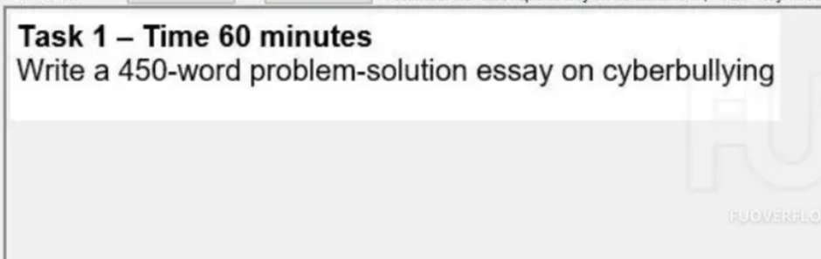
In the modern digital age, the internet has become an indispensable part of daily life. However, alongside its benefits, a disturbing trend known as cyberbullying has emerged as a serious concern in the society. This phenomenon, involving the use of digital communication to offend or intimidate others which poses significant risks. This essay will examine the primary causes of cyberbullying and propose/ suggest effective solutions to address this pressing issue.
One of the most significant causes of cyberbullying is the anonymity provided by online platforms. Unlike traditional bullying, which occurs face-to-face, the digital environment allows individuals to hide behind fake profiles or screen names. This sense of invisibility often encourages people to engage in cruel behavior that they would be less likely to display in real-life interactions. In addition, the lack of strict regulations and loose monitoring on social media platforms have also contributed to worsening the problem. When individuals face little risk of being identified or having their accounts banned, they feel emboldened to engage in abusive behavior. This absence of consequences lowers the barrier to such actions, allowing cyberbullying to occur more frequently.
To address this issue, a multi-faceted approach is necessary. Firstly, education plays a crucial role in prevention. Schools and parents should collaborate to teach children about digital etiquette and the real-life consequences of their online actions. By fostering empathy and a sense of responsibility from an early age, the likelihood of engaging in or tolerating cyberbullying can be reduced. Secondly, technological and legal measures are essential. Technology companies must take greater responsibility by developing advanced AI tools to detect harmful content and improving reporting systems to remove abusive material quickly. At the same time, governments should strengthen and enforce cyber-safety laws to ensure that offenders face serious legal consequences. This would deter individuals from engaging in cyberbullying, knowing that their online actions can lead to real-world punishment.
In conclusion, while cyberbullying is a complex problem fueled by online anonymity and the constant reach of technology, it is not insurmountable. Through a combination of early education, improved platform monitoring, and stricter legal frameworks, society can create a safer and more respectful online environment. We must act now to protect the mental well-being of future internet users.
Đề 4:
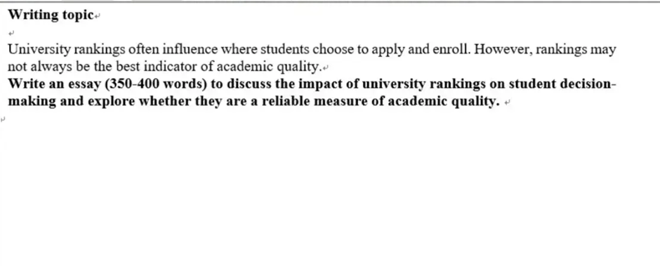
In this day and age, university rankings play a major role when high school students choose where to apply and study. Many students and parents believe that higher rankings mean better education and higher career opportunities. However, while rankings offer a quick way to compare universities, they are not always a completely reliable measure of actual academic quality.
On the one hand, university rankings have a strong impact on student decision-making. First, rankings make the application process much easier and faster. Students usually feel overwhelmed by thousands of universities worldwide, so ranking lists give them a simple starting point to filter top options. Second, a high rank creates a strong sense of trust and prestige. Students often believe that graduating from a top-ranked institution will improve their resume and increase their chances of getting good jobs after graduation. For international students, rankings are especially important because they usually do not have the opportunity to visit campuses in person before applying.
On the other hand, university rankings are not always accurate indicators of true educational quality. To begin with, most ranking systems focus heavily on research output, scientific publications, and international reputation. These factors show how famous a university's professors are in research, but they do not guarantee excellent teaching quality or good support for undergraduate students. Furthermore, rankings often ignore essential practical factors such as teaching methods, campus culture, student mental health support, and career guidance. A university with a lower ranking might offer smaller class sizes, more helpful professors, and better practical training for specific majors.
In conclusion, university rankings clearly influence student choices by offering an easy guide and a recognized brand name. However, students should not rely solely on these scores to determine educational quality. Instead of focusing only on numbers, students should consider other crucial factors like program content, teaching quality, and personal career goals to make the best decision for their future.
Đề 5:
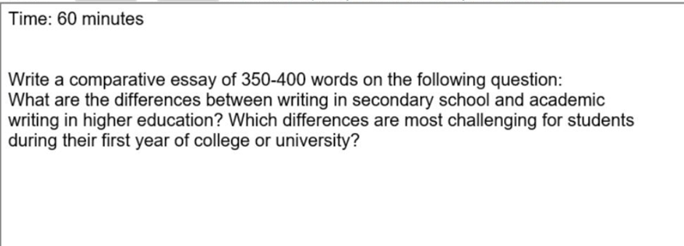

It is true that the transition from secondary school to higher education/tertiary education has several notable differences especially in terms of writing. While both levels require students to express their ideas clearly, there are significant differences in how information is presented and analyzed. This essay will discuss these differences and identify which aspects are most challenging for first-year students.
Firstly, the main difference lies in the purpose and depth of writing. In secondary school, students are often asked to summarize stories or describe events. The focus is usually on showing that they understand the basic facts. However, in higher education, writing becomes much more analytical. Instead of just repeating what they have read, students must use critical thinking to evaluate different viewpoints and build their own arguments. Another difference is the structure and tone. Secondary school essays often follow a simple 1-2 page format with a personal tone. In contrast, university assignments require a formal, objective style and a more complex structure to support detailed discussions.
Among these differences, two aspects are considered as the most challenging for freshmen. The first is referencing and avoiding plagiarism. In secondary school, students might not be strictly required to cite every source they use. At university, however, they must follow specific systems such as APA or MLA. Failing to cite sources correctly can lead to serious academic mistakes. For many first-year students, learning how to manage citations while maintaining their own voice is a confusing and time-consuming task.
The second challenge is the shift from subjective to objective writing. Many students are used to starting sentences with "I think" or "In my opinion." At the university level, they are expected to remove personal feelings and base their claims entirely on evidence and research. This change in mindset requires a lot of practice and can be quite stressful during the first few months of college.
In conclusion, academic writing in higher education is much more demanding than writing in secondary school due to its analytical nature and formal requirements. Although the transition is difficult, especially regarding citation rules and objective thinking, mastering these skills is essential. With enough practice and support, students can successfully adapt to these new academic standards.

Đề 6:
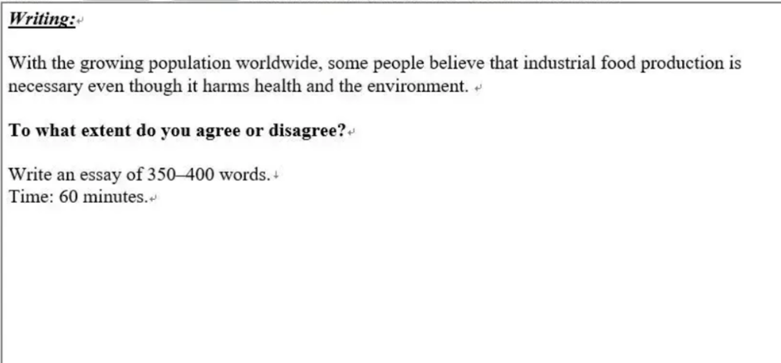
In the modern era, as the global population rises rapidly, many people argue that industrial food production is essential, despite its negative effects on health and the environment. While I agree that industrial food production is necessary to meet the demands of a rising population, I also believe that its negative impacts on health and ecosystems cannot be ignored.
On the one hand, I believe that there are clear reasons why industrial food production is vital today. Firstly, industrial farming is the only way to provide enough food for billions of people at an affordable price. Because traditional farming is often slow and small-scale, it cannot keep up with the massive global demand. Secondly, advanced technology ensures faster harvests and is less dependent on weather conditions compared to traditional farming. This stability is crucial for ensuring that there is always enough food available, regardless of natural disasters or seasonal changes.
On the other hand, I also argue that the serious drawbacks of this system must be considered. Regarding health, the use of chemicals and preservatives in processed foods can lead to long-term health issues. For example, many companies use artificial additives to make food last longer, which may contribute to chronic diseases like obesity or heart problems. In addition, overusing pesticides and chemical fertilizers by industrial factories contributes to water and soil pollution, making it harder to grow healthy crops in the future. These environmental issues are much more considered to human than convenient meals.
In conclusion, while I am side with the view that industrial food production is unavoidable to meet global demand and ensure food security, its harmful effects should not be ignored. It is a necessary part of our world, but it must be managed carefully. In my opinion, governments and food companies need to implement regulatory measures to improve this situation and protect both human health and the planet.

Đề 7:
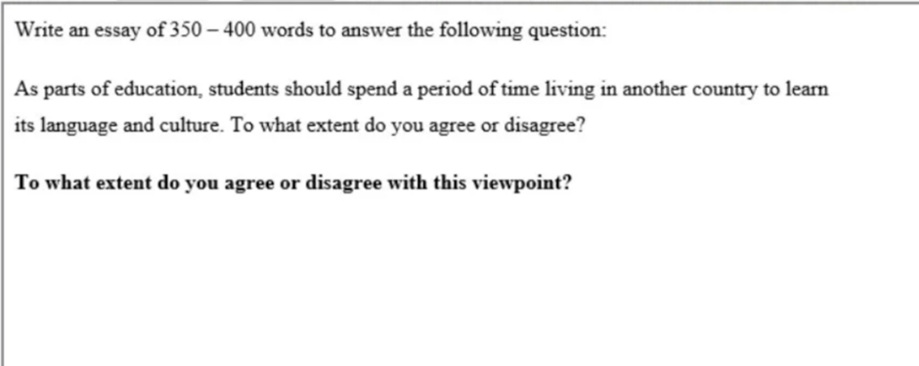
In modern education, many universities and schools encourage students to study abroad for a short period to experience a new language and culture. I completely agree with this viewpoint because living in another country helps students build language skills naturally, develop cultural understanding, and become more independent for their future careers.
First, living abroad provides the most effective environment for learning a foreign language. When students live in a foreign country, they must use the local language every day to communicate with native speakers, buy food, and attend classes. This daily practice helps them improve their listening and speaking skills much faster than studying only from textbooks in a classroom. Over time, students gain confidence and natural fluency because they use the language in real-life situations.
Second, experiencing a new culture firsthand helps students broaden their perspectives. By living with local people and joining daily activities, students learn to appreciate different traditions, lifestyles, and ways of thinking. This real experience reduces cultural misunderstandings and teaches students how to respect diversity. In an interconnected world, understanding different cultures is a vital quality for anyone working in international environments.
Finally, spending time in a foreign country fosters personal independence and self-confidence. Living far away from home forces students to manage their time, budget their money, and solve daily problems by themselves. These practical life lessons prepare them well for future adult life and career challenges. Employers highly value job candidates who have international experience because it shows adaptability and strong communication skills.
In conclusion, spending a period of time living in another country is an essential part of modern education. It not only improves language abilities and cultural knowledge but also builds independence and career readiness. Therefore, educational institutions should create more opportunities for all students to participate in study abroad programs.
Đề 8:
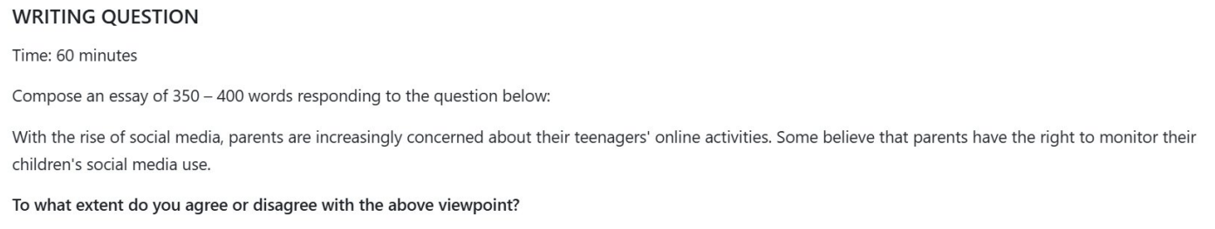
In the modern digital age, social media platforms have become an essential part of teenager’s daily lives. Consequently, many parents are worried about the potential dangers (mối nguy hiểm tiềm ẩn) their children might encounter online. While some people argue that monitoring teenagers’ social media use is an invasion of privacy (xâm phạm riêng tư), I completely agree that parents should have the right to supervise their children’s online activities to protect them from harm and guide their digital behavior.

The reason why parental supervision is necessary is to protect teenagers from social threats/ online threats. The internet is filled with dangerous risks such as inappropriate content, cyberbullying, online hackers, and so on. Teenagers are often emotionally vulnerable and lack the life experience which is needed to recognize hidden dangers. For instance, many young people/adolescents fall victim to online scams or harassment because they trust strangers easily. If parents monitor their account, they can detect suspicious interactions and intervene early before emotional or physical harm occurs.
In addition to protection, parental monitoring helps teenagers develop healthy digital habits. Due to the eye-catching design of social platforms, many teenagers spend excessive hours scrolling screen endlessly, which leads to sleep deprivation, poor academic performance, and mental health issues like anxiety. By keeping track of screen time and online activities ò their children, they can help their children balance online leisure with real-world activities such as studying and physical exercise. If parents do not set limitations for their children’s screentime, teenagers will be easily affected negatively regarding social skills and academic performance.

However, it is important to acknowledge that monitoring should be done with care and respect. Overly strict surveillance without communication openly can damage mutual trust between parents and teenagers, making teenagers become defensive or secretive. Therefore, parents should not spy strictly on their children. Instead, they should openly discuss the reasons for monitoring, explain the safety rules, and gradually reduce supervision as the teenagers grow older and demonstrate greater responsibility.

In conclusion, I strongly believe that parents have rights to monitor their teenagers’ social media activity. Because of the numerous dangers in the digital environment, parental supervision is essential to ensure safety and foster healthy habits. As long as this monitoring is combined with open communication and respect, it serves as a protective shield rather than an unnecessary restriction.

Đề 9:
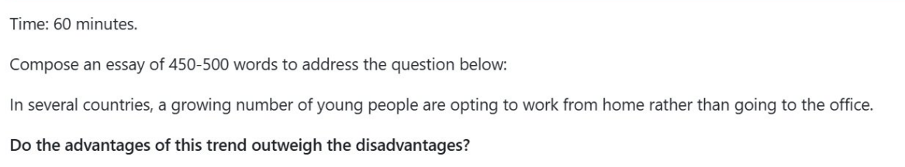
In recent years, an increasing number of young professionals have chosen to work remotely from home rather than commuting to traditional offices. Although working from home presents a few clear drawbacks regarding social interaction, I completely agree that its benefits far outweigh the disadvantages.
On the one hand, remote work admittedly brings certain challenges for young employees. The primary disadvantage is the feeling of social isolation. When working alone in front of a computer all day, young people lack direct face-to-face interaction with colleagues, which can weaken teamwork and cause stress. Additionally, working at home makes it difficult to separate professional work from personal life, leading many employees to work extra hours without proper rest.
On the other hand, the individual benefits of working from home are far more significant. First and foremost, remote work saves valuable time and reduces travel expenses. Young employees no longer have to spend hours stuck in traffic jams during rush hours or waste money on transport. Instead, they can use this saved time to rest, exercise, and focus better on their tasks, which increases overall daily productivity.
Furthermore, remote working creates massive global career opportunities for the younger generation. In the past, young workers were limited to job openings in their local areas. With digital technology today, they can work for international companies from home and earn better salaries without moving to expensive foreign cities. At the same time, companies save money on office rent, and having fewer daily commuters helps reduce urban pollution.
In conclusion, while working from home can cause feelings of isolation and make work-life balance harder to manage, these issues can be solved with good self-discipline. The total freedom, time savings, and global career opportunities offered by remote work make it a clearly positive trend. Therefore, the advantages of this shift completely outweigh its disadvantages.
Đề 10
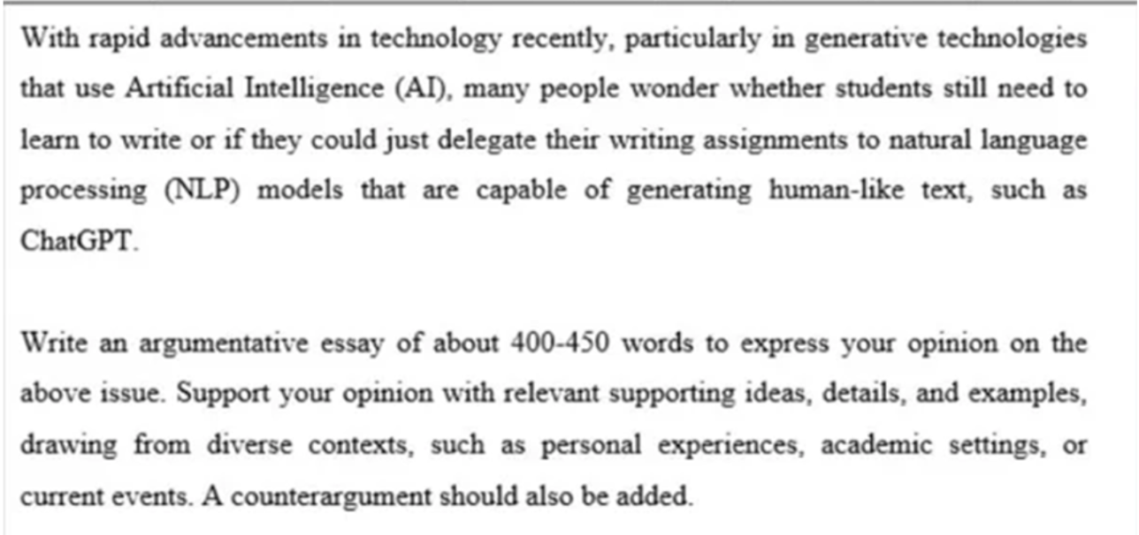

In recent years, generative AI tools like ChatGPT have become very popular because they can write essays quickly. Some people think students no longer need to learn writing and can let AI do all their assignments. However, I strongly believe that learning to write is still essential, as it helps students develop logical thinking, express personal ideas, and maintain academic honesty.
On the one hand, using AI for writing tasks has some benefits regarding speed and convenience. Supporters argue that NLP tools can generate well-structured essays in just a few seconds. For busy students, especially in technical majors, AI can help fix grammar errors, translate complex terms, and summarize long technical documents quickly. Using AI as a smart assistant can save time and improve productivity in research.
On the other hand, letting AI write the entire essay creates serious problems for students. First, writing is not just about producing words on paper; it is a process of thinking. When students write an essay by themselves, they must analyze facts, connect ideas, and build logical arguments. If students always rely on ChatGPT, their critical thinking skills will slowly decrease, making them unable to solve complex problems independently in their future engineering careers.
Second, AI cannot replace real human experience and personal creativity. AI models only copy existing data from the internet, so their answers are often general and lack personal voice. In university, teachers want to evaluate a student's own understanding, not an algorithm's output. Furthermore, copying work directly from AI leads to academic dishonesty, which harms a student's reputation and professional ethics.
In conclusion, while AI tools like ChatGPT are helpful assistants for editing and brainstorming, they should never replace the core skill of human writing. Learning to write is a vital exercise for the brain that builds logical reasoning and personal integrity. Universities should guide technical students to use AI responsibly as a supportive tool rather than a replacement for their own thinking.

