ASM02 INSTRUCTIONS
Follow the steps below to complete ASM02:
- Create a folder to save given projects, e.g. CSD_given (1). Download the given materials to (1).
- Complete the requirements of the test.
- Before submission:
  - Clean and Build Project (Shift+F11),
  - Then rename the folder dist to run. (If the folder run already exists, delete it before renaming).
  - Copy run folder to Q1 folder.
  - Submission folder should be like this:
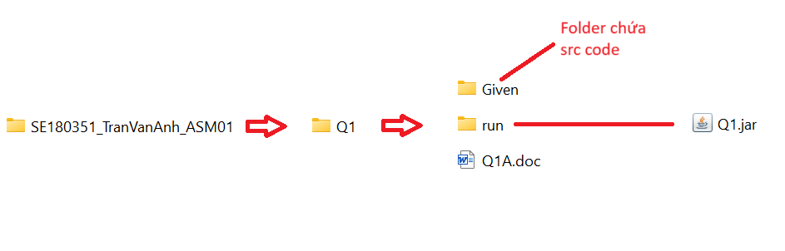
- Submission:
  - The folder should be named like this:
RollNumber_StudentName_ASMCode
Ex:
SE180351_TranVanAnh_ASM02
SE180351-TranVanAnh-ASM02
  - Then zip it to ZIP FILE (Do not use RAR).
  - Now you can submit to LMS.
- Do not use accented Vietnamese when writing comments in programs.
- Do not add new import statement(s) to given files.
- Software tools must be used: NetBeans IDE 8.x and Java JDK 1.8.
If at least one of the above requirements is not followed, the exam will get ZERO.
- Notes:
  - The input and expected output below are only used to test your codes.
  - The input and expected output in the real testcases (for marking) are different with in the examples below.
  - Do not hardcode with the given expected results.

Troubleshooting:
If the given project (e.g. Q1) runs with error, you need to run "Clean and Build Project" (Shift+F11). If still error, try to rename or copy the project to other one, e.g. from Q1 to Q1X or Q1Y.

The given files already contain statements to implement a program for managing a computer store. The structure of the main classes is as follows:
- Class Order: contains information about an Order object, including orderID, customerName, and totalPrice.
- Class Node: includes an Order object and a next pointer for linking.
- Class TreeNode: includes an Order object and left, right pointer for tree structure.
- Class OrderQueue: is a queue structure (implemented as a linked list), where the Node contains complete Order data. This Queue is used to manage all the items in FIFO (First In – First Out) rule.
- Class OrderBST: is a Binary Search Tree structure, where the Node also contains complete Order data. This Tree’s role is to store, search and sort data (alphabetically) in ascending order (inOrder traversal)
- Class ComputerStore: is the main class of the program, containing an orderQueue and an orderTree.
Students are required to carefully read the provided code segments to fully understand the relationships between the classes and the functions within each class. The specific task of the test is to execute the following requirements:
- f1(): To complete the requirement f1, students need to fulfill these two specific tasks: implement the function enQueue() in the orderQueue structure and the function insert() in the orderTree structure. The expected output used to test your code are as follows:
Order Queue: (Computer,A,2000.0) (Tablet,B,300.0) (Keyboard,C,100.0) (Mouse,D,3000.0) (Tablet,E,3000.0) (Phone,F,2000.0) (Monitor,G,3000.0)
Order BST: (Computer,A,2000.0) (Keyboard,C,100.0) (Monitor,G,3000.0) (Mouse,D,3000.0) (Phone,F,2000.0) (Tablet,B,300.0) (Tablet,E,3000.0)

- f2(): To complete the requirement f2, students need to perform this specific task: implement the search() function of the OrderTree structure with the user input searchID, then:
  - Print the returned result as a found Order, or
  - If the id is not found, then return null.
  - If there are two order with the same id with the found id, return the first one founded in inOrder traversal.

The expected output used to test your code are as follows:
Case of found ID:
Order Queue: (Computer,A,2000.0) (Tablet,B,300.0) (Keyboard,C,100.0) (Mouse,D,3000.0) (Tablet,E,3000.0) (Phone,F,2000.0) (Monitor,G,3000.0)
Order BST: (Computer,A,2000.0) (Keyboard,C,100.0) (Monitor,G,3000.0) (Mouse,D,3000.0) (Phone,F,2000.0) (Tablet,B,300.0) (Tablet,E,3000.0)
Found Order: (Tablet,B,300.0) ←
Case of ID not found:
Order Queue: (Computer,A,2000.0) (Tablet,B,300.0) (Keyboard,C,100.0) (Mouse,D,3000.0) (Tablet,E,3000.0) (Phone,F,2000.0) (Monitor,G,3000.0)
Order BST: (Computer,A,2000.0) (Keyboard,C,100.0) (Monitor,G,3000.0) (Mouse,D,3000.0) (Phone,F,2000.0) (Tablet,B,300.0) (Tablet,E,3000.0)
Not found ←

- f3(): In this task, students need to perform the findMax() function in OrderTree. This function will printout the Order with the highest “alphabetical” orderID, which is the last order in the inOrder traversal. The expected output used to test your code are as follows:

Order Queue: (Computer,A,2000.0) (Tablet,B,300.0) (Keyboard,C,100.0) (Mouse,D,3000.0) (Tablet,E,3000.0) (Phone,F,2000.0) (Monitor,G,3000.0)
Order BST: (Computer,A,2000.0) (Keyboard,C,100.0) (Monitor,G,3000.0) (Mouse,D,3000.0) (Phone,F,2000.0) (Tablet,B,300.0) (Tablet,E,3000.0)
Highest Alphabetical ID Order: (Tablet,E,3000.0)

- f4(): In this task, students need to perform the remove() function in both OrderQueue and OrderTree. This function will remove the Order in orderQueue and orderBST with input orderID. You also need to call them in the f4() function.
- If orders have same orderID, the first one encountered with the same id as deleteID will be removed, which will be the same node in both structures.
The expected output used to test your code are as follows:

Order Queue: (Computer,A,2000.0) (Tablet,B,300.0) (Keyboard,C,100.0) (Mouse,D,3000.0) (Tablet,E,3000.0) (Phone,F,2000.0) (Monitor,G,3000.0)
Order BST: (Computer,A,2000.0) (Keyboard,C,100.0) (Monitor,G,3000.0) (Mouse,D,3000.0) (Phone,F,2000.0) (Tablet,B,300.0) (Tablet,E,3000.0)
Order Queue: (Computer,A,2000.0) (Keyboard,C,100.0) (Mouse,D,3000.0) (Tablet,E,3000.0) (Phone,F,2000.0) (Monitor,G,3000.0)
Order BST: (Computer,A,2000.0) (Keyboard,C,100.0) (Monitor,G,3000.0) (Mouse,D,3000.0) (Phone,F,2000.0) (Tablet,E,3000.0)

**In this case, the Order with orderID “Tablet” is removed from both order queue and order BST.

