

A Supporting Tool for Requirements and Project Progress Management in Software Project Course SWP391 Using Jira and GitHub

Software Requirement Document

– HoChiMinh, March 2026 –
Table of Contents
Record of Changes 5
Definition and Acronyms 6
I. Introduction 7
1. Product Background 7
2. Existing Systems 7
2.1 Jira Cloud 7
Jira Software Cloud is a project and requirement management tool developed by Atlassian. It is widely used in software enterprises as well as in the SWP391 course. 7
In practice, Jira is used to: 7
Manage software requirements through issues such as Stories, Tasks, and Bugs. 7
Plan and track work progress using backlogs and sprints. 7
Assign tasks to team members. 7
This system can be demonstrated directly by accessing a real Jira project, showing the project board, issue statuses, and sprint progress. However, Jira does not support the automatic generation of academic documents such as Software Requirements Specification (SRS) or evaluation reports required for the course. 7
2.2 GitHub Cloud 7
3. Business Opportunity 7
4. Software Product Vision 8
5. Major Features 8
6. Limitations and Exclusions 9
II. Overall Description 10
1. Product Overview 10
2. Business Process 11
III. User Requirements 13
1. Actors 13
2. Use Cases 15
2.1 Diagram 15
2.2 Descriptions 16
3. Business Rules 21
IV. Functional Requirements 23
1. System Functional Overview 23
1.1 Screen Flow 23
1.2 Screen Descriptions 25
1.3 Screen Authorization 28
1.4 Non-Screen Functions 29
2. Data Requirements 30
2.1 Logical Data Model 30
2.2 Data Dictionary 30
2.3 Reports 32
2.4 State transition diagram 36
3. Manual Jira Data Synchronization 36
3.1 Configure Jira project information for each group 36
3.2 Trigger manual synchronization from Jira Software Cloud 37
3.3 Retrieve epics from Jira project 37
3.4 Retrieve user stories, tasks, and bugs from Jira project 37
3.5 Update issue status and sprint data after synchronization 38
3.6 View synchronization history and status log 38
4. GitHub Development Activity Statistics 38
4.1 Configure GitHub repository for each project group 38
4.2 Synchronize commit history from GitHub repository 39
4.3 Retrieve pull request information 40
4.4 Retrieve contributor information 40
4.5 Calculate commit statistics for each member 40
4.6 Display GitHub activity statistics 41
5. Project Monitoring Dashboard 41
5.1 Display integrated project monitoring dashboard 41
5.2 Show Jira issue progress overview 42
5.3 Display GitHub development activity overview 42
5.4 Display project status summary for each group 43
5.5 Filter dashboard data by group or course 43
6. Course Progress and Contribution Reports 44
6.1 Generate group progress report 44
6.2 Generate individual contribution report 45
6.3 Generate final project report 45
6.4 Export reports for course presentation or evaluation 46
7. Role-Based Access Control 46
7.1 Authenticate users into the system 46
7.2 Assign user roles (Admin, Lecturer, Leader, Member) 47
7.3 Control access to system features based on roles 47
7.4 Provide role-specific dashboards and views 48
7.5 Restrict access to group data based on role permissions 49
8. Student Task and Contribution Visualization 49
8.1 Visualize task assignment for each student 49
8.2 Display task completion status for each member 50
8.3 Display individual contribution charts 50
8.4 Provide team workload distribution overview 51
V. Non-Functional Requirements 52
1. External Interface Requirements 52
1.1 User Interfaces 52
1.2 Software Interfaces 52
1.3 Hardware Interfaces 53
1.4 Communications Interfaces 53
2. Quality Attributes 53
2.1 Usability 53
2.2 Performance 54
2.3 Security 54
2.4 Safety 54
2.5 Availability 54
2.6 Reliability 54
2.7 Design Constraints 54
2.8 Scalability 54

Record of Changes
Date | A*  M, D | In charge | Change Description
*A - Added M - Modified D - Deleted

Definition and Acronyms
Acronym | Definition
PWM | Psychology website
AWS | Amazon Web Services
BA | Business Analysis
BR | Business Rule
ERD | Entity Relationship Diagram
GUI | Graphical User Interface
PM | Project Manager
SDD | Software Design Description
SPMP | Software Project Management Plan
SRS | Software Requirement Specification
UAT | User Acceptance Test
UC | Use Case
API | Application Program Interface

I. Introduction

1. Product Background
In the SWP391 – Software Project course, students are required to apply commonly used project management and software development tools in real-world practice in order to simulate a professional working process in the Software Engineering industry. Specifically, Jira Software is used to manage requirements and tasks, while GitHub is used to manage source code and track the software development process.
However, using these tools independently causes difficulties for students in aggregating data, preparing academic documentation, and reporting project progress to instructors. Therefore, there is a need for a supporting tool that integrates and leverages existing data from Jira and GitHub to better serve the educational objectives of the course.

2. Existing Systems

2.1 Jira Cloud
Link website: https://www.atlassian.com/

Jira Software Cloud is a project and requirement management tool developed by Atlassian. It is widely used in software enterprises as well as in the SWP391 course.

In practice, Jira is used to:

Manage software requirements through issues such as Stories, Tasks, and Bugs.

Plan and track work progress using backlogs and sprints.

Assign tasks to team members.

This system can be demonstrated directly by accessing a real Jira project, showing the project board, issue statuses, and sprint progress. However, Jira does not support the automatic generation of academic documents such as Software Requirements Specification (SRS) or evaluation reports required for the course.

2.2 GitHub Cloud
Link website: https://github.com/
GitHub is a popular source code management platform based on the Git version control system. It is widely used in software development and programming education.
In the SWP391 course, GitHub is used to:
Store and manage the project’s source code.
Track commit history and development activities of each team member.
Support collaboration through pull requests and issues.
GitHub can be demonstrated directly by opening a real repository and displaying the commit history, list of contributors, and contribution statistics. However, GitHub only provides raw data and does not support the aggregation of evaluation reports on individual contributions in accordance with academic requirements.

3. Business Opportunity
In the Software Project course (SWP391), students are required to work in teams and apply Agile practices to develop a software product. During the project execution, multiple tools such as Jira and GitHub are commonly used to manage requirements, tasks, and source code. However, these tools are often used independently, which causes difficulties in tracking project progress and evaluating individual contributions in an academic environment.
From the students’ perspective, it is time-consuming to manually summarize requirements, sprint progress, and contribution data for weekly reports and final presentations. Team leaders also face challenges in monitoring team performance and identifying potential issues early. From the lecturers’ perspective, it is difficult to obtain a clear and consistent overview of each team’s progress, especially when managing multiple projects at the same time.
Although Jira and GitHub are powerful industry-standard tools, they are designed for professional software development rather than educational purposes. They do not directly provide a unified view tailored to academic evaluation, such as linking requirements, task completion, and individual contribution in a simple and transparent manner.
Therefore, there is a strong opportunity to develop a supporting tool that integrates data from Jira and GitHub and presents it in an academic-oriented dashboard. This tool can help bridge the gap between industrial project management tools and the specific needs of the SWP391 course. By providing clear visibility into requirements, project progress, and individual contributions, the system can improve project transparency, reduce manual reporting effort, and support fair and objective assessment.

4. Software Product Vision
The vision of this software product is to provide a centralized and easy-to-use supporting platform for managing requirements and tracking project progress in the SWP391 course by integrating Jira and GitHub data.
The system aims to support students, team leaders, and lecturers by offering a clear overview of project status, including requirements implementation, sprint progress, and individual contributions. Instead of replacing existing tools such as Jira or GitHub, the product focuses on collecting and visualizing essential information in a way that is suitable for academic projects.
For students, the system helps them understand their responsibilities, track their assigned tasks, and monitor their own contributions throughout the project lifecycle. For team leaders, it provides a consolidated view of team progress and workload distribution, enabling better coordination and decision-making. For lecturers, the system offers a transparent and consistent method to monitor multiple projects, evaluate team performance, and assess individual contributions more objectively.
Overall, the product aims to enhance learning outcomes in the SWP391 course by promoting effective requirement management, improving project progress visibility, and supporting fair evaluation through data-driven insights.

5. Major Features
FE-01: Manually synchronize project request data from Jira Software Cloud used in course SWP391, including epics, user stories, tasks, bugs, issue status, and sprint information for each student project team.
FE-02: Statistical analysis of software development activity data from GitHub repositories of SWP391 course projects, including commit history, pull requests, contributors, and individual student contribution metrics.
FE-03: Provide an academic-oriented project monitoring dashboard that presents an integrated view of project requirements, sprint progress, and source code development status to support learning and project supervision in the SWP391 course
FE-04: Create course-oriented reports, including group progress reports and individual contribution reports, to support weekly tracking, mid-term evaluation, final reports, and course presentations for SWP391.
FE-05: Support role-based access and views in a university environment, including students, team leaders, and lecturers, ensuring that each role can access information relevant to their learning, team management, and teaching responsibilities in the SWP391 course.
FE-06: Visualize task assignment, task completion status, and participation levels of individual students within each project team to support fair assessment by lecturers and effective task coordination by team leaders.

6. Limitations and Exclusions
LI-1: The system does not replace Jira Software or GitHub. It functions solely as a supporting and integration tool that aggregates, analyzes, and visualizes data from these platforms for academic and learning purposes.
LI-2: The system does not allow users to manually modify project requirements or source code within the system. All requirement and development data must originate from the officially integrated Jira projects and GitHub repositories, in accordance with SWP391 course regulations.
LI-3: Automated grading, scoring, or AI-based performance evaluation is not included in the initial version of the system. The system provides data and visualizations to support manual evaluation by lecturers.
LI-4: The system is designed exclusively for university course projects and is initially limited in scope to the SWP391 course, with no guarantee of applicability to commercial or large-scale software development environments.

II. Overall Description

1. Product Overview
The Supporting Tool for Requirements and Project Progress Management is a web-based software system developed to support requirement management and project progress monitoring for the SWP391 course.
The system is designed for use in an academic environment where student teams develop software projects under lecturer supervision. It integrates with Jira to manage software requirements and development tasks, and with GitHub to retrieve and analyze source code repositories and commit activities.
The primary users of the system are Admin, Lecturer, Team Leader, and Team Member, each interacting with the system according to assigned roles and responsibilities. The system provides centralized access to project requirements, task status, and contribution metrics to support project monitoring and evaluation.
The system depends on the availability of the Jira Cloud REST API and GitHub REST API for data access and synchronization. It assumes that users possess valid Jira and GitHub accounts and adhere to standard software development practices during project execution.
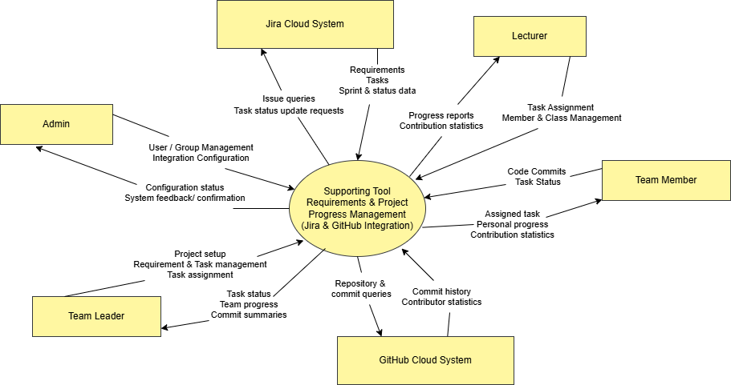

2. Business Process
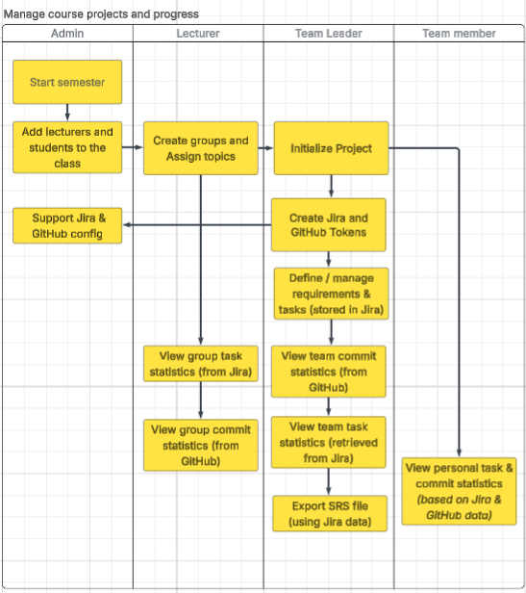
# | Process Step | Description
1 | Start semester | The administrator initializes a new academic semester in the system.
2 | Add lecturers and students to the class | The administrator adds lecturers and students to the class for the semester.
3 | Create groups and assign topics | The lecturer creates student groups and assigns project topics to each group.
4 | Start project | The team leader initializes the project for the assigned group.
5 | Support Jira and GitHub configuration | The administrator supports the team leader in configuring Jira and GitHub integration.
6 | Create Jira and GitHub tokens | The team leader creates and configures Jira and GitHub access tokens for integration.
7 | Define and manage requirements and tasks | The team leader defines and manages project requirements and tasks, which are stored in Jira.
8 | View group task statistics | The lecturer views group-level task statistics retrieved from Jira.
9 | View group commit statistics | The lecturer views group-level commit statistics retrieved from GitHub.
10 | View team task statistics | The team leader views team task statistics retrieved from Jira.
11 | View team commit statistics | The team leader views team commit statistics retrieved from GitHub.
12 | Export SRS file | The team leader exports the SRS document using requirement data retrieved from Jira.
13 | View personal task and commit statistics | The team member views personal task and commit statistics based on data from Jira and GitHub.

III. User Requirements

1. Actors
# | Actor | Description
1 | Admin | The Admin is responsible for managing and configuring the overall system. The Admin creates and manages student groups, manages lecturers, assigns lecturers to groups, and configures the integration with Jira and GitHub.  The Admin ensures that the system is properly set up and that data synchronization between the system and external platforms functions correctly. The Admin has full access to all system features.
2 | Lecturer | The Lecturer is responsible for supervising assigned student groups in the SWP391 course. The Lecturer manages students within assigned groups, views project requirements and tasks, monitors project progress, and reviews reports generated from Jira and GitHub data.  The Lecturer uses the system to evaluate project completion status and individual student contributions based on task tracking and commit statistics.
3 | Team Leader | The Team Leader is a student who represents a project group and is responsible for managing project requirements and coordinating team activities.  The Team Leader can create and manage project requirements, create and assign tasks to team members, monitor task progress, and view group commit summaries retrieved from GitHub. The Team Leader acts as the main contact point between the group and the Lecturer.
4 | Team Member | A Team Member is a student who participates in the project development process. Each Team Member is assigned specific tasks and is responsible for completing and updating the status of those tasks.  The Team Member can view assigned tasks, update task status, commit source code to GitHub, and view personal task and commit statistics. The system tracks contribution data to reflect individual participation in the project.
5 | Jira (External System) | Jira is an external project management system integrated with the application. The system synchronizes project requirements and tasks from Jira to support requirement tracking and progress monitoring.  Jira provides issue and task data that are used for reporting and evaluation purposes within the system.
 | GitHub (External System) | GitHub is an external source code management platform integrated with the system. The system retrieves commit data and repository statistics from GitHub to measure individual and team contributions.  GitHub provides commit history and contribution data used for progress tracking and performance evaluation.

2. Use Cases

2.1 Diagram
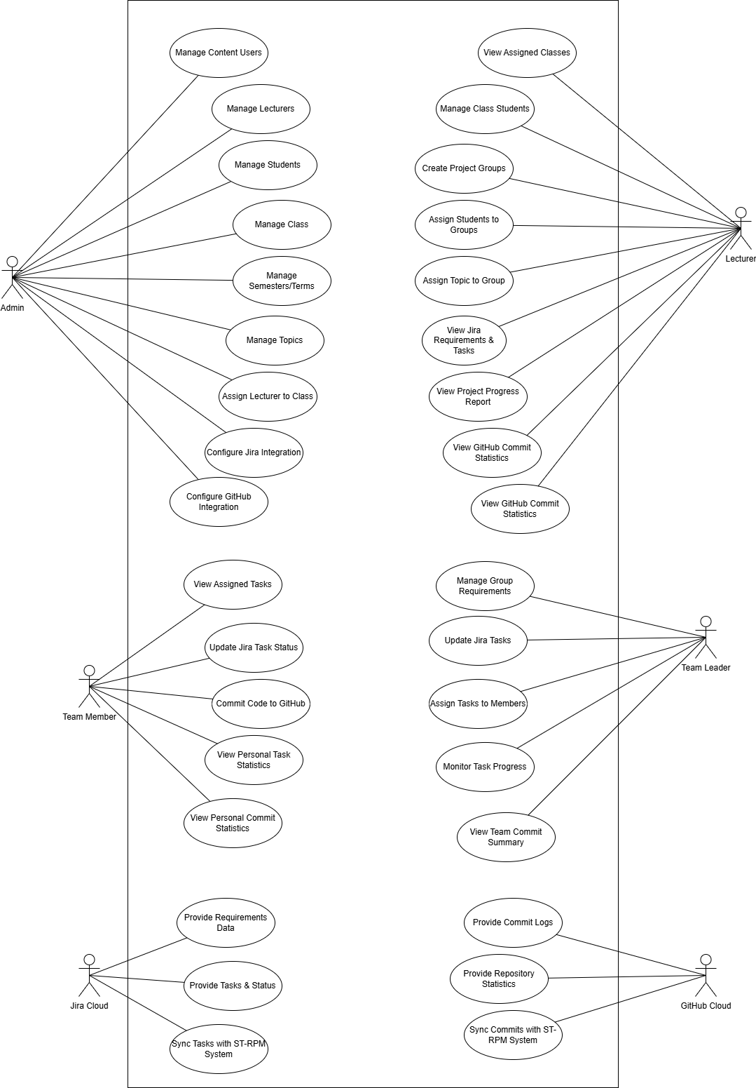

2.2 Descriptions
ID | Use Case | Actors | Use Case Description
UC-01 | Manage Content Users | Admin | Administers user accounts and permissions for content management within the system.
UC-02 | Manage Lecturers | Admin | Handles the creation, updates, and removal of Lecturer profiles and accounts.
UC-03 | Manage Students | Admin | Maintains the database of student records and their system access.
UC-04 | Manage Class | Admin | Creates and manages administrative details for different classes.
UC-05 | Manage Semesters/Terms | Admin | Configures the academic timeline, including semesters and specific terms.
UC-06 | Manage Topics | Admin | Curates and maintains the repository of project topics available for selection.
UC-07 | Assign Lecturer to Class | Admin | Links a specific Lecturer to a class they will be responsible for supervising.
UC-08 | Configure Jira Integration | Admin | Sets up API connections and synchronization rules with Jira Cloud.
UC-09 | Configure GitHub Integration | Admin | Sets up repository access and synchronization rules with GitHub Cloud.
UC-10 | View Assigned Classes | Lecturer | Allows the lecturer to see the list of classes they have been assigned to supervise.
UC-11 | Manage Class Students | Lecturer | Manages the specific roster of students within their assigned classes.
UC-12 | Create Project Groups | Lecturer | Divides the students in a class into specific project teams.
UC-13 | Assign Students to Groups | Lecturer | Allocates individual students to their respective project groups.
UC-14 | Assign Topic to Group | Lecturer | Formally assigns a project topic to a specific group for execution.
UC-15 | View Jira Requirements & Tasks | Lecturer | Monitors the project backlog and task distribution on Jira for their groups.
UC-16 | View Project Progress Report | Lecturer | Reviews comprehensive reports on the completion status of group projects.
UC-17 | View GitHub Commit Statistics | Lecturer | Tracks the coding activity and frequency of group contributions via GitHub data.
UC-18 | Manage Group Requirements | Team Leader | Defines and refines the specific requirements for the team's assigned project.
UC-19 | Update Jira Tasks | Team Leader | Edits, adjusts, or updates task details and priorities on the Jira board.
UC-20 | Assign Tasks to Members | Team Leader | Delegates specific Jira tasks to individual members of the project team.
UC-21 | Monitor Task Progress | Team Leader | Tracks the real-time status of all tasks assigned to the team.
UC-22 | View Team Commit Summary | Team Leader | Reviews a consolidated summary of the team's code contributions.
UC-23 | View Assigned Tasks | Team Member | Accesses a list of work items specifically assigned to the member.
UC-24 | Update Jira Task Status | Team Member | Updates the workflow status (e.g., In Progress to Done) for their own tasks.
UC-25 | Commit Code to GitHub | Team Member | Pushes source code changes to the project repository on GitHub.
UC-26 | View Personal Task Statistics | Team Member | Reviews personal productivity data and task completion metrics.
UC-27 | View Personal Commit Statistics | Team Member | Analyse individual coding contribution history and frequency.
UC-28 | Sync Tasks & Status | Jira Cloud | Automatically synchronizes requirements and task updates with the ST-RPM system.
UC-29 | Sync Commits & Statistics | GitHub Cloud | Automatically pulls commit logs and repository data into the ST-RPM system.

ID and Name: | UC01-UC07: System Entity & Assignment Management
Created By: | Pham Tuan Anh | Date Created: | February 26, 2026
Primary Actor: | Admin | Secondary Actors: | Lecturer, Team Leader, Team Member
Description: | Managing core system data including Users, Lecturers, Students, Classes, Semesters, and Topics, and assigning Lecturers to Classes.
Trigger: | Admin accesses the administrative dashboard menus.
Preconditions: | PRE-1. Admin is authenticated with full access
Postconditions: | POST-1. System database is updated (CRUD operations completed).
Normal Flow: | - Admin selects the entity to manage (e.g., Manage Lecturers).  - System displays the current record list.  - Admin performs Add/Edit/Delete or Assigns a Lecturer to a Class (UC07).  - System validates inputs and saves changes to the database.
Alternative Flows: | 1.1 Batch Import  - Admin uploads a CSV/Excel file for Students/Lecturers instead of manual entry.
Exceptions: | 1.0.E1 Duplicate Entry  1. System detects a duplicate Email or ID; shows error "Record already exists."
Priority: | High
Frequency of Use: | Low
Business Rules: | BR-00, BR-04
Other Information: | Admin has "Full Access" override for all data across all groups.
Assumptions: | Admin provides valid data conforming to the system's schema.

ID and Name: | UC08 - UC09: Integration Configuration (Jira & GitHub)
Created By: | Pham Tuan Anh | Date Created: | February 26, 2026
Primary Actor: | Admin | Secondary Actors: | Team Leader
Description: | Setting up API tokens, project keys, and repository URLs for data synchronization.
Trigger: | User initiates the setup or update of external tool integrations.
Preconditions: | PRE-1. Valid Jira/GitHub accounts exist.  PRE-2. User has configuration permissions
Postconditions: | POST-1. Integration settings are saved to Integration Config.
Normal Flow: | - User enters API credentials/URLs.  - System tests connection.  - System saves settings.
Alternative Flows: | 1.1 Configuration Update  - User updates an existing API Token if the old one expired
Exceptions: | 1.0.E1 Connection Failed  1. System displays the specific HTTP error (e.g., 401 Unauthorized) and refuses to save the config.  1.0.E2 Insufficient Permission  1. System redirects to "Access Denied" page
Priority: | Critical
Frequency of Use:
Business Rules: | BR-14
Other Information:
Assumptions: | External services are online during the test connection.

ID and Name: | UC10 - UC14: Group Setup & Topic Assignment
Created By: | Pham Tuan Anh | Date Created: | February 26, 2026
Primary Actor: | Lecturer | Secondary Actors: | Team Leader, Team Member
Description: | Group formation and Team Leader designation.
Trigger: | Lecturer prepares for a new project-based course term.
Preconditions: | PRE-1. Lecturer is assigned to the class
Postconditions: | POST-1. Student groups established with 1 Leader and 1 Topic.
Normal Flow: | - Lecturer creates group.  - Adds students.  - Designates 1 Leader.  - Assigns Topic.
Alternative Flows: | 1.1 Swap Leader  - Lecturer removes Leader role from Student A and assigns it to Student B
Exceptions: | 1.0.E1 Already in Group  1. System blocks the addition and shows BR-01 error.  1.0.E2 Leader Limit  1. System prompts to "Remove existing leader first
Priority: | High
Frequency of Use:
Business Rules: | BR-01, BR-02, BR-02a, BR-04.
Other Information:
Assumptions: | Students are already imported into the class roster by the Admin.

ID and Name: | UC15 - UC17: Academic Supervision
Created By: | Pham Tuan Anh | Date Created: | February 26, 2026
Primary Actor: | Lecturer | Secondary Actors: | Jira Cloud, GitHub Cloud
Description: | Monitoring group progress and code activity.
Trigger: | Lecturer performs periodic progress reviews or grading.
Preconditions: | PRE-1. Lecturer is assigned to the class
Postconditions: | POST-1. Dashboard displays latest synced data.
Normal Flow: | - Lecturer selects group.  - System displays Jira/GitHub stats.
Alternative Flows: | 1.1 Detailed History  - Lecturer clicks on a task to see TaskStatusHistory
Exceptions: | 1.0.E1 Data Mismatch  1. System displays a "Flag" icon and warning text  1.0.E2 Missing Dates  1. System tags it with MISSING_COMPLETED_AT flag
Priority: | High
Frequency of Use:
Business Rules: | BR-04, BR-07, BR-08, BR-09.
Other Information: | Displays data using standardized internal statuses (TODO/IN_PROGRESS/DONE).
Assumptions:

ID and Name: | UC18 - UC22: Team Operations & Leadership
Created By: | Pham Tuan Anh | Date Created: | February 26, 2026
Primary Actor: | Team Leader | Secondary Actors: | Team Member, Jira Cloud
Description: | Managing requirements, distributing tasks among members, and monitoring internal team progress.
Trigger: | Team Leader plans a sprint or coordinates daily tasks.
Preconditions: | PRE-1. User is the designated Team Leader
Postconditions: | POST-1. Tasks are delegated.  POST-2. Requirement/Task relationships are established
Normal Flow: | - TL creates Requirements  - TL creates/updates Tasks  - TL assigns tasks to members.  - TL initiates manual "Sync Now"
Alternative Flows: | 1.1 SRS Export  - TL generates an SRS file based on filtered Jira data
Exceptions: | 1.0.E1 Sync Conflict  1. Returns 409 error
Priority: | High
Frequency of Use: | Daily
Business Rules: | BR-02, BR-03, BR-05, BR-06, BR-14, BR-15, BR-16, BR-17.
Other Information:
Assumptions: | Team Leader has valid credentials on the group's Jira board.

ID and Name: | UC23 - UC24: Individual Tasks & Execution
Created By: | Pham Tuan Anh | Date Created: | February 26, 2026
Primary Actor: | Team Member | Secondary Actors: | Jira Cloud, GitHub Cloud
Description: | Viewing personal task assignments and updating work status through Jira and code commits.
Trigger: | Member begins work or completes a development task.
Preconditions: | PRE-1. Member is assigned to a Student Group.
Postconditions: | POST-1. Task status is updated.  POST-2. Completion timestamp recorded
Normal Flow: | - Member views assigned tasks.  - Member updates task status on Jira  - Member pushes code to GitHub.
Alternative Flows: | 1.1 Ghost Commit  - Member uses an email not in the system; statistics are saved via author_name
Exceptions: | 1.0.E1 Status DONE missing date  1. System flags MISSING_COMPLETED_AT
Priority: | High
Frequency of Use: | Daily
Business Rules: | BR-03, BR-07, BR-08, BR-09, BR-12, BR-13.
Other Information:
Assumptions: | Members update Jira statuses in a timely manner.

3. Business Rules
ID | Rule Definition
BR-00 | Admin has full access permissions (Superuser).
BR-01 | Each Student can belong to a maximum of one group per course_code and semester.
BR-02 | Each group is limited to exactly one Team Leader at any given time.
BR-02A | Only the Lecturer assigned to the group (or the Admin) has the authority to designate or change the Team Leader.
BR-03 | Users are restricted to interacting only with data belonging to their respective groups (excluding Admin).
BR-04 | Lecturers are permitted to perform operations only within the groups specifically assigned to them.
BR-05 | Each Requirement must belong to exactly one StudentGroup.
BR-06 | Each Task must belong to exactly one Requirement.
BR-07 | (Jira Assignment Validation): Following Jira synchronization, the system must verify that the Task assignee belongs to the same StudentGroup. Validation prioritizes the stored jira_account_id. If a mismatch is detected, the system must flag the task or display an "Assignee Outside Group" warning on the dashboard.
BR-08 | (Status Normalization): The system shall map and display Jira task statuses using a standardized internal set: {TODO, IN_PROGRESS, DONE}. Any Jira status that cannot be mapped must be assigned as UNKNOWN/OTHER and explicitly highlighted.
BR-09 | (Completion Tracking): For tasks synchronized with a DONE equivalent status, the system must record a completion timestamp for reporting purposes. If Jira does not provide a direct field, the system infers the time from updated_at or resolution_date; otherwise, it marks the record as "Missing Data."
BR-09A | (Inference Logic): If fields.resolutiondate exists, use it as completed_at. If null, use fields.updated and apply the flag COMPLETED_AT_INFERRED_FROM_UPDATED.
BR-09B | (Validation): If the mapped status is DONE but completed_at remains null, apply the flag MISSING_COMPLETED_AT for data cleaning and reporting.
BR-09C | (Status History Enhancement): If the Jira sync includes expand=changelog, the system shall extract all "status" field changes occurring since the last SyncLog(JIRA)=SUCCESS. These changes must be mapped to the internal status set and inserted into the TaskStatusHistory table.
BR-10 | (Deduplication): During Jira synchronization, the system must prevent duplicate entries by using the jira_issue_key as the unique identifier to update existing records rather than creating new ones.
BR-11 | (Upsert Principle): Synchronization must follow the Upsert logic: if a record exists for a given key, perform an UPDATE; otherwise, perform an INSERT.
BR-12 | (Commit Uniqueness): The sha (commit hash) must be unique within the scope of a single repository.
BR-13 | (Unmapped Authors): If a GitHub author cannot be mapped to an internal system user, the system must still store the author_name and author_email to allow for data statistics based on these values.
BR-14 | (Privileged Access): Only the Admin or Team Leader roles are authorized to configure IntegrationConfig or trigger the "Sync Now" action.
BR-15 | (Concurrency and Logging): Every manual synchronization attempt must generate a SyncLog entry with a status of RUNNING, SUCCESS, or FAILED. If a sync process is already RUNNING for the same group and source, subsequent requests must be blocked (returning a 409 Conflict status). The system must display the synchronization results or specific error messages to the user.
BR-16 | (SRS Export Filtering): The SRS Export feature shall retrieve data from Jira based on user-defined filters, including All, Sprint, Version, or Label.
BR-17 | (Stateless Export): The SRS Export process must be stateless regarding the database; the system shall generate the file for immediate download without storing the export history or the generated file in the database.

IV. Functional Requirements

1. System Functional Overview

1.1 Screen Flow
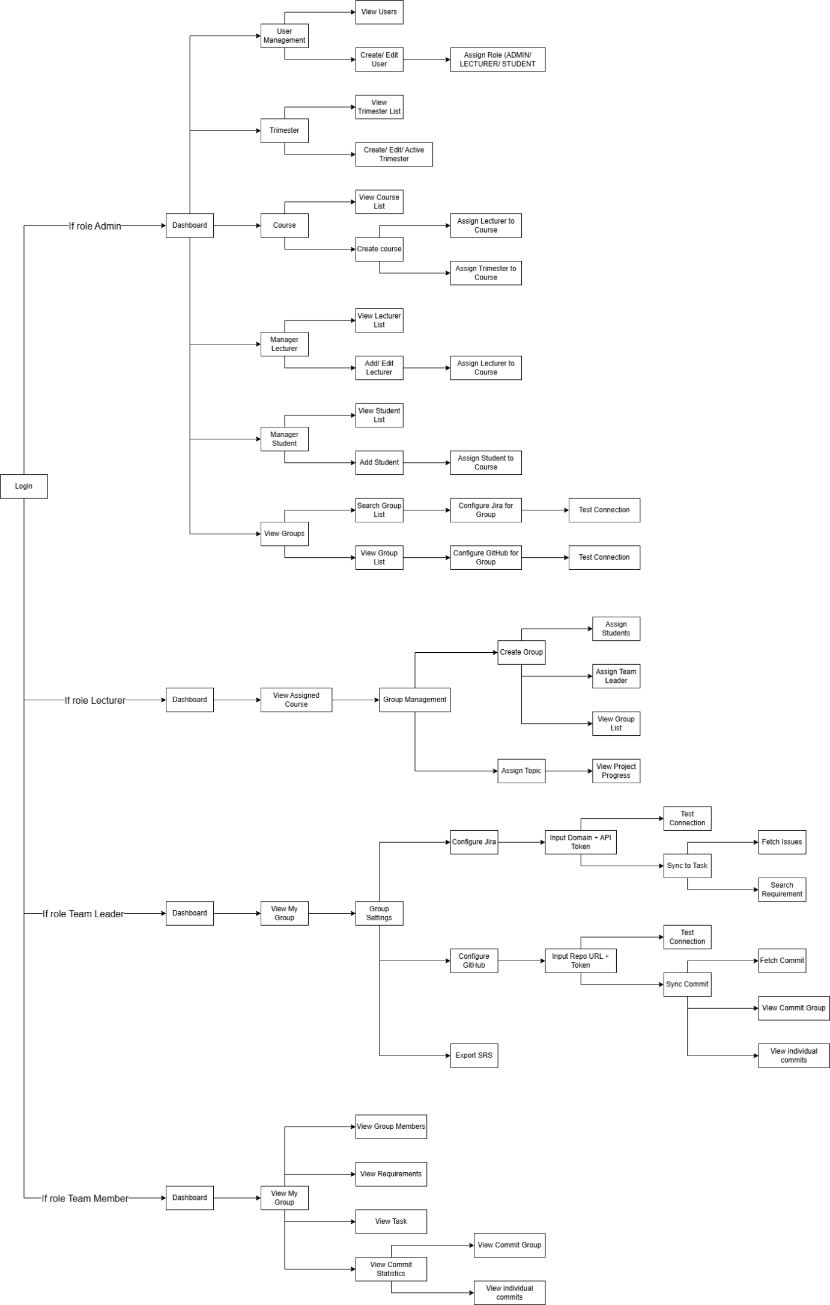

1.2 Screen Descriptions
# | Screen | Feature | Description
FR-01 | Login | User Login | The system allows users to log in using their account credentials.
FR-02 | Dashboard | Role-based Dashboard | The system displays a dashboard based on the user's role (Admin, Lecturer, Team Leader, Team Member).
FR-03 | User Management | View Users | Admin can view the list of all users in the system.
FR-04 | User Management | Create User | Admin can create a new user account.
FR-05 | User Management | Assign Role | Admin can assign roles to users (Admin, Lecturer, Student).
FR-06 | User Management | System Overview | Displays the system overview and provides access to administrative management functions.
FR-07 | Trimester Management | View Trimester List | Admin can view the list of trimesters.
FR-08 | Trimester Management | Create Trimester | Admin can create a new trimester.
FR-09 | Trimester Management | Edit Trimester | Admin can edit trimester information.
FR-10 | Trimester Management | Trimester Management | Admin can activate or deactivate a trimester.
FR-11 | Course Management | View Course List | Admin can view the list of courses.
FR-12 | Course Management | Create Course | Admin can create a new course.
FR-13 | Course Management | Assign Lecturer to Course | Admin can assign lecturers to courses.
FR-14 | Course Management | Assign Trimester to Course | Admin can assign a trimester to a course.
FR-15 | Lecturer Management | View Lecturer List | Admin can view the list of lecturers.
FR-16 | Lecturer Management | Add Lecturer | Admin can add a new lecturer.
FR-17 | Lecturer Management | Edit Lecturer | Admin can edit lecturer information.
FR-18 | Lecturer Management | Assign Lecturer to Course | Admin can assign lecturers to specific courses.
FR-19 | Student Management | View Student List | Admin can view the list of students.
FR-20 | Student Management | Add Student | Admin can add a new student.
FR-21 | Student Management | Assign Student to Course | Admin can assign students to courses.
FR-22 | Group Management | View Groups | Admin can view all groups in the system.
FR-23 | Group Management | Search Groups | Admin can search groups by criteria.
FR-24 | Jira Integration | Configure Jira for Group | Admin can configure Jira integration for a group.
FR-25 | Jira Integration | Test Jira Connection | Admin can test the connection to the Jira API.
FR-26 | GitHub Integration | Configure GitHub for Group | Admin can configure GitHub integration for a group.
FR-27 | GitHub Integration | Test GitHub Connection | Admin can test the connection to the GitHub API.
FR-28 | Lecturer Dashboard | View Assigned Courses | Lecturer can view courses assigned to them.
FR-29 | Group Management | Create Group | Lecturer can create a student group within a course.
FR-30 | Group Management | Assign Students to Group | Lecturer can assign students to groups.
FR-31 | Group Management | Assign Team Leader | Lecturer can assign a team leader for a group.
FR-32 | Group Management | View Group List | Lecturer can view the list of groups in their course.
FR-33 | Topic Management | Assign Topic | Lecturer can assign project topics to groups.
FR-34 | Project Monitoring | View Project Progress | Lecturer can view the progress of each group’s project.
FR-35 | Team Leader Dashboard | View My Group | Team leader can view the group they belong to.
FR-36 | Group Settings | Configure Jira | Team leader can configure Jira integration for their group.
FR-37 | Jira Integration | Input Domain and API Token | Team leader can input Jira domain and API token.
FR-38 | Jira Integration | Test Jira Connection | Team leader can test Jira API connection.
FR-39 | Jira Integration | Sync Jira Tasks | Team leader can synchronize issues/tasks from Jira.
FR-40 | Jira Integration | Fetch Issues | The system fetches issues from Jira.
FR-41 | Requirement Management | Search Requirements | Team leader can search requirements from synced Jira issues.
FR-42 | GitHub Integration | Configure GitHub | Team leader can configure GitHub repository integration.
FR-43 | GitHub Integration | Input Repo URL and Token | Team leader can input GitHub repository URL and token.
FR-44 | GitHub Integration | Test GitHub Connection | Team leader can test GitHub API connection
FR-45 | GitHub Integration | Sync Commits | Team leader can synchronize commit data from GitHub.
FR-46 | GitHub Integration | Fetch Commits | The system fetches commits from GitHub repository.
FR-47 | Commit Statistics | View Group Commits | Team leader can view commit statistics of the group.
FR-48 | Commit Statistics | View Individual Commits | Team leader can view commits of each member.
FR-49 | Document Export | Export SRS | Team leader can export the SRS document generated from requirements.
FR-50 | Team Member Dashboard | View My Group | Team member can view their group information.
FR-51 | Group Information | View Group Members | Team member can view members of their group.
FR-52 | Requirement Management | View Requirements | Team member can view project requirements.
FR-53 | Task Management | View Tasks | Team member can view tasks assigned in the project.
FR-54 | Commit Statistics | View Commit Statistics | Team member can view commit statistics of the group.
FR-55 | Commit Statistics | View Group Commits | Team member can view group commits.
FR-56 | Commit Statistics | View Individual Commits | Team member can view commits of each member.

  - Screen Authorization
Screen | Admin | Lecturer | Team Leader | Member
Login | X | X | X | X
Dashboard | X | X | X | X
User Management | X
Trimester Management | X
Course Management | X
Lecturer Management | X
Student Management | X
View Groups | X
Jira Configuration | X |  | X
GitHub Configuration | X |  | X
View Assigned Courses | X | X
Group Management |  | X
Assign Topic |  | X
Project Progress |  | X
My Group |  |  | X | X
Group Settings |  |  | X
Export SRS |  |  | X
Group Members |  |  | X | X
Requirements |  |  | X | X
Task |  |  | X | X
Commit Statistics | X |  | X | X
Group Commits | X |  | X | X
Individual Commits |  |  | X | X
In which:
- Admin
System administrator responsible for managing users, student groups, lecturer assignments, and integration configurations.
- Lecturer
Lecturer assigned to supervise student groups, manage group members, and monitor project progress.
- Team Leader
Student leader responsible for managing integrations, synchronizing Jira/GitHub data, assigning tasks, and exporting SRS documents.
- Member
Student group member who can view requirements, tasks, and personal commit contributions.

Non-Screen Functions
# | System Function | Feature | Description
NSF-01 | Authentication | User Authentication | The system authenticates users based on their credentials during login.
NSF-02 | Authorization | Role-Based Access Control | The system restricts system functions based on user roles (Admin, Lecturer, Team Leader, Member).
NSF-03 | Jira Integration | Jira API Connection | The system connects to Jira Cloud using domain and API token.
NSF-04 | Jira Integration | Test Jira Connection | The system verifies the validity of Jira API credentials before saving configuration.
NSF-05 | Jira Integration | Fetch Jira Issues | The system retrieves issues (epics, stories, tasks, bugs) from the configured Jira project.
NSF-06 | Jira Integration | Sync Jira Issues | The system synchronizes Jira issues to the system database for project monitoring.
NSF-07 | Requirement Processing | Requirement Extraction | The system extracts requirement information from synchronized Jira issues.
NSF-08 | GitHub Integration | GitHub API Connection | The system connects to GitHub using repository URL and access token.
NSF-09 | GitHub Integration | Test GitHub Connection | The system validates GitHub repository access using the provided token.
NSF-10 | GitHub Integration | Fetch Repository Commits | The system retrieves commit history from the configured GitHub repository.
NSF-11 | GitHub Integration | Sync Commit Data | The system synchronizes commit data from GitHub into the system database.
NSF-12 | Commit Analysis | Commit Statistics Calculation | The system calculates commit statistics for groups and individual members.
NSF-13 | Data Filtering | Role-based Data Filtering | The system filters project data based on user role and assigned group/course.
NSF-14 | Export Service | SRS Export Generation | The system generates and exports SRS documents based on project requirements.
NSF-15 | Logging | Integration Activity Logging | The system logs synchronization activities with Jira and GitHub.
NSF-16 | Error Handling | API Error Handling | The system handles API errors and returns appropriate error messages when integration fails.
NSF-17 | Background Processing | Data Synchronization Process | The system processes synchronization tasks between external tools and the internal database.
NSF-18 | Data Consistency | Duplicate Data Prevention | The system prevents duplication when synchronizing issues or commits.

2. Data Requirements

2.1 Logical Data Model
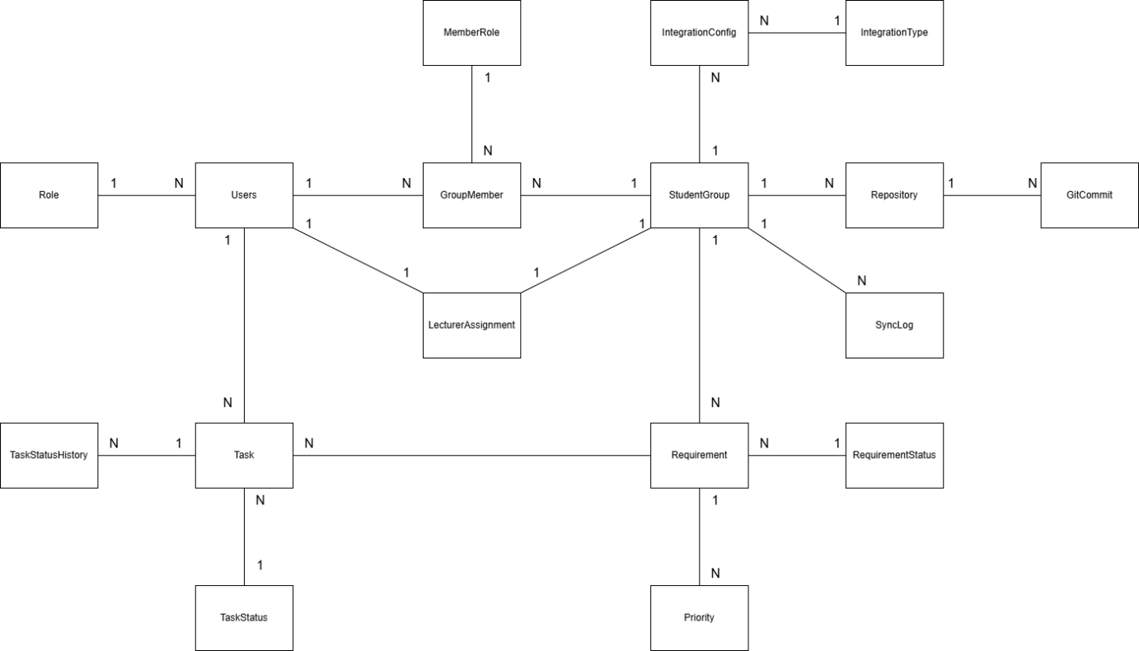

2.2 Data Dictionary
Entity/Table | Data Element | Description | Data Type | Length | Values
Role | role_id | Primary key for user roles. | INT |  | Identity (1,1)
Role | role_code | Unique code for the user role. | NVARCHAR | 30 | ADMIN, LECTURER, STUDENT
Users | user_id | Unique identifier for each user. | INT |  | Identity (1,1)
Users | username | Unique login name for the user. | NVARCHAR | 50 | Unique string
Users | full_name | Full legal name of the user. | NVARCHAR | 100 | Any string
Users | email | Unique contact email address. | NVARCHAR | 120 | Unique email format
Users | role_id | Foreign key linking to the Role table. | INT |  | Valid Role IDs
StudentGroup | group_id | Unique identifier for a student group. | INT |  | Identity (1,1)
StudentGroup | class_code | Code identifying the specific class. | NVARCHAR | 50 | Any string
StudentGroup | group_name | Display name of the student group. | NVARCHAR | 120 | Any string
StudentGroup | course_code | Identifier for the academic course. | NVARCHAR | 30 | Any string
StudentGroup | semester | Current academic term name. | NVARCHAR | 30 | Any string
GroupMember | group_id | Part of composite PK linking to StudentGroup. | INT |  | Valid Group IDs
GroupMember | user_id | Part of composite PK linking to Users. | INT |  | Valid User IDs
GroupMember | member_role_id | FK defining the user's role in the group. | INT |  | 1 (LEADER), 2 (MEMBER)
LecturerAssignment | group_id | PK and FK linking to StudentGroup. | INT |  | Unique Group IDs
LecturerAssignment | lecturer_id | FK linking to the assigned lecturer in Users. | INT |  | Valid Lecturer IDs
Requirement | requirement_id | Unique identifier for a project requirement. | INT |  | Identity (1,1)
Requirement | group_id | FK linking the requirement to a group. | INT |  | Valid Group IDs
Requirement | priority_id | FK linking to the priority level. | INT |  | 1 (LOW), 2 (MEDIUM), 3 (HIGH)
Requirement | status_id | FK linking to the requirement's status. | INT |  | 1 (ACTIVE), 2 (DONE)
Requirement | jira_issue_key | Key of the corresponding issue on Jira. | NVARCHAR | 50 | Unique string
Task | task_id | Unique identifier for a specific task. | INT |  | Identity (1,1)
Task | requirement_id | FK linking the task to a requirement. | INT |  | Valid Requirement IDs
Task | parent_task_id | FK for self-reference to identify sub-tasks. | INT |  | Valid Task IDs or NULL
Task | assignee_id | FK linking to the user assigned to the task. | INT |  | Valid User IDs
Task | status_id | FK linking to the task's current status. | INT |  | 1 (TODO), 2 (IN_PROGRESS), 3 (DONE)
Repository | repo_id | Unique identifier for a code repository. | INT |  | Identity (1,1)
Repository | group_id | FK linking the repository to a group. | INT |  | Valid Group IDs
Repository | full_name | Full name of the repository on GitHub. | NVARCHAR | 200 | Unique string
GitCommit | commit_id | Unique identifier for a code commit. | INT |  | Identity (1,1)
GitCommit | repo_id | FK linking the commit to a repository. | INT |  | Valid Repo IDs
GitCommit | author_user_id | FK linking the commit to a specific user. | INT |  | Valid User IDs or NULL
GitCommit | sha | Unique hash identifier for the commit. | VARCHAR | 64 | Unique 64-char string
IntegrationConfig | config_id | Unique identifier for a tool configuration. | INT |  | Identity (1,1)
IntegrationConfig | integration_type_id | FK defining the tool type. | INT |  | 1 (JIRA), 2 (GITHUB)

2.3 Reports
# | Report Name | Description
RPT-01 | Project Progress Report | Displays the overall progress of each project including completed tasks, pending tasks, and project status.
RPT-02 | Student Contribution Report | Shows the contribution statistics of each student based on GitHub commits and completed tasks.
RPT-03 | Task Status Report | Lists all tasks in a project along with their current status and assigned members.
RPT-04 | Requirement Tracking Report | Displays all project requirements and their implementation progress.

Report ID: | RPT-01
Report Title: | Project Progress Report
Report Purpose: | Lecturer wants to monitor the overall progress of each project in the course. The report displays information about project status, number of completed tasks, and remaining tasks so that the lecturer can evaluate whether the project is progressing according to the planned schedule and identify teams that may be falling behind.
Priority: | High
Report Users: | Lecturers, Team Leaders
Data Sources: | Database tables containing project and task information (Project, Task, Requirement, Team).
Frequency and Disposition; | Report is generated on demand when requested by the lecturer. Data in the report is retrieved from the system database and reflects the most recent project progress information.
Latency: | Complete report must be displayed within 3 seconds after it is requested.
Visual Layout: | Landscape mode
Header and Footer: | Report header shall contain the report title, course name, and report generation date.  If printed, the report footer shall display the page number.
Report Body: | Fields shown and column headings:  Project Name  Team Name  Total Requirements  Completed Requirements  Total Tasks  Completed Tasks  Project Status  Project Deadline  Selection Criteria: course selected by lecturer.  Sort Criteria: projects sorted by project deadline.
End-of-Report Indicator: | None
Interactivity: | Lecturers can drill down to view detailed task and requirement information of each project.
Security Access Restrictions: | Only lecturers assigned to the course and team leaders of the project are allowed to access this report.
Report ID: | RPT-02
Report Title: | Student Contribution Report
Report Purpose: | Lecturer wants to evaluate the contribution of each student participating in a project. The report summarizes the development activities of each team member based on GitHub commits and completed tasks, helping the lecturer identify the level of participation and contribution of each student during the project development process.
Priority: | High
Report Users: | Lecturers
Data Sources: | Database tables containing contribution information (GitHubCommit, Task, TeamMember, User).
Frequency and Disposition; | Report is generated on demand when requested by the lecturer. Data displayed in the report reflects the most recent contribution records collected from the GitHub repository and system task management database..
Latency: | Complete report must be displayed within 3 seconds after it is requested..
Visual Layout: | Landscape mode
Header and Footer: | Report header shall contain the report title, project name, and report generation date.  If printed, the report footer shall display the page number.
Report Body: | Fields shown and column headings:  Student Name  Team Name  Number of GitHub Commits  Lines Added  Lines Deleted  Tasks Completed  Last Commit Date  Selection Criteria: project selected by lecturer.  Sort Criteria: students sorted by number of commits in descending order.
End-of-Report Indicator: | None
Interactivity: | Lecturers can drill down to view detailed commit history and task information for each student.
Security Access Restrictions: | Only lecturers assigned to the course are allowed to access this report.

Report ID: | RPT-03
Report Title: | Task Status Report
Report Purpose: | Lecturer or team leader wants to view a list of all tasks belonging to a specific project. The report shows task information including assigned members, status, and deadlines, so that the lecturer or team leader can monitor the implementation progress of tasks and identify overdue tasks that may affect the project schedule.
Priority: | Medium
Report Users: | Lecturers, Team Leaders
Data Sources: | Database tables containing project task information (Task, User, Project).
Frequency and Disposition; | Report is generated on demand when requested by the lecturer or team leader. The data displayed in the report reflects the most recent task information stored in the system database
Latency: | Complete report must be displayed to within 3 seconds after it is requested.
Visual Layout: | Landscape mode
Header and Footer: | Report header shall contain the report title, project name, and report generation date.  If printed, the report footer shall display the page number.
Report Body: | Fields shown and column headings:  Task Title  Project Name  Assigned Student  Task Status  Start Date  Due Date  Task Priority  Selection Criteria: project selected by lecturer or team leader.  Sort Criteria: tasks sorted by due date in ascending order.
End-of-Report Indicator: | None
Interactivity: | Lecturers and team leaders can drill down to view detailed task information such as task description, task history, and related requirements.
Security Access Restrictions: | Only lecturers assigned to the course and team leaders of the corresponding project are allowed to view this report.

Report ID: | RPT-04
Report Title: | Requirement Tracking Report
Report Purpose: | Lecturer wants to monitor the progress of project requirements and ensure that each requirement defined in the project has been implemented and linked to corresponding tasks. The report provides an overview of requirement status and helps lecturers evaluate whether the development process is aligned with the planned requirements..
Priority: | Medium
Report Users: | Lecturers
Data Sources: | Database tables containing requirement and task information (Requirement, Task, Project).
Frequency and Disposition; | Report is generated on demand when requested by the lecturer. Data displayed in the report is retrieved directly from the project requirement and task records stored in the system database
Latency: | Complete report must be displayed to within 3 seconds after it is requested.
Visual Layout: | Landscape mode
Header and Footer: | Report header shall contain the report title, course name, and report generation date.  If printed, the report footer shall display the page number.
Report Body: | Fields shown and column headings:  Requirement Title  Project Name  Requirement Status  Number of Related Tasks  Requirement Created Date  Selection Criteria: project selected by lecturer.  Sort Criteria: requirements sorted by creation date in chronological order.
End-of-Report Indicator: | None
Interactivity: | Lecturers can drill down to view detailed task information associated with each requirement.
Security Access Restrictions: | Only lecturers assigned to the course are allowed to access this report.

2.4 State transition diagram
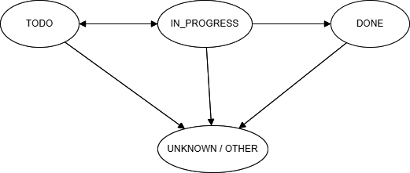

3. Manual Jira Data Synchronization

3.1 Configure Jira project information for each group
Trigger:
Team Leader selects the Configure Jira Integration function in the Group Settings screen.
Description:
This function allows the team leader to configure the connection between the system and the Jira Software Cloud project associated with the group. The configuration includes the Jira domain, API token, email account, and project key.
Screen Layout:
Input field: Jira Domain
Input field: Email Account
Input field: API Token
Input field: Project Key
Button: Test Connection
Button: Save Configuration
Function Details:
Users enter Jira connection information.
The system stores the configuration securely.
The system verifies the Jira API connection before saving.
Data Involved:
Group ID
Jira Domain
Jira Email
Jira API Token
Jira Project Key
Validation Rules:
Jira Domain must follow valid URL format.
API Token cannot be empty.
Project Key must match Jira project format.
Business Logic:
Each group can configure only one Jira project.
Configuration must be validated before synchronization is allowed.
Normal Case:
- Team leader enters Jira configuration data.
- Clicks Test Connection.
- System verifies the connection successfully.
- Team leader clicks Save.
- Configuration is stored.
Abnormal Case:
API connection fails → system displays error message.
Invalid token → authentication error.
Missing fields → system prevents saving.

3.2 Trigger manual synchronization from Jira Software Cloud
Trigger:
Team Leader clicks the Sync Jira Tasks button.
Description:
This function allows the system to manually retrieve project issues from the configured Jira project.
Screen Layout:
Button: Sync Jira Tasks
Progress Indicator
Synchronization Result Message
Function Details:
Send request to Jira API.
Retrieve issue data.
Store data in the system database.
Data Involved:
Project Key
Issue ID
Issue Type
Issue Status
Sprint Information
Validation Rules:
Jira configuration must exist.
API connection must be valid.
Business Logic:
Synchronization must be executed manually.
Only team leaders can trigger synchronization.
Normal Case:
- User clicks Sync Jira Tasks.
- System connects to Jira API.
- System retrieves issues.
- Data is stored in database.
- System shows synchronization success.
Abnormal Case:
Network error → synchronization fails.
Jira API rate limit exceeded.
Invalid configuration.

3.3 Retrieve epics from Jira project
Trigger:
Part of the synchronization process.
Description:
The system retrieves all Epic issues from the configured Jira project.
Function Details:
Call Jira REST API
Filter issue type = Epic
Store epic information
Data Involved:
Epic ID
Epic Name
Epic Description
Epic Status
Business Logic:
Epics are stored as high-level project requirements.

3.4 Retrieve user stories, tasks, and bugs from Jira project
Trigger:
During synchronization.
Description:
The system retrieves issues including user stories, tasks, and bugs from the Jira project.
Data Involved:
Issue ID
Issue Type
Summary
Assignee
Status
Sprint
Business Logic:
Each issue is mapped to a system requirement or task.

3.5 Update issue status and sprint data after synchronization
Trigger:
Executed after retrieving issue data.
Description:
The system updates issue status and sprint information to reflect the latest project progress.
Business Logic:
If issue exists → update status
If issue does not exist → insert new record

3.6 View synchronization history and status log
Trigger:
User selects Synchronization History.
Description:
Allows users to view past synchronization activities.
Screen Layout:
Sync Date
Triggered By
Status
Number of Issues Synced
Data Involved:
Sync ID
User ID
Sync Timestamp
Result Status
Normal Case:
User opens history screen
System displays synchronization logs.
Abnormal Case:
No synchronization history → system displays empty state.

4. GitHub Development Activity Statistics

4.1 Configure GitHub repository for each project group
Trigger:
Team Leader selects the Configure GitHub Integration function in the Group Settings screen.
Description:
This function allows the team leader to configure the connection between the system and the GitHub repository used by the project group. The configuration includes the repository URL and the GitHub personal access token.
Screen Layout:
Input field: Repository URL
Input field: GitHub Access Token
Button: Test Connection
Button: Save Configuration
Function Details:
Users enter the repository URL and access token.
The system verifies the GitHub API connection.
Configuration is stored for future synchronization.
Data Involved:
Group ID
Repository URL
GitHub Access Token
Repository Name
Validation Rules:
Repository URL must follow GitHub repository format.
Access token must not be empty.
Repository must exist and be accessible.
Business Logic:
Each group can configure only one GitHub repository.
GitHub connection must be verified before saving.
Normal Case:
- Team leader enters repository URL and token.
- Clicks Test Connection.
- System verifies GitHub API access.
- Team leader clicks Save.
- Configuration is stored successfully.
Abnormal Case:
Repository does not exist.
Invalid GitHub token.
API request fails due to network error

4.2 Synchronize commit history from GitHub repository
Trigger:
Team Leader clicks the Sync GitHub Data button.
Description:
This function retrieves commit history from the configured GitHub repository and stores the information in the system database for further analysis.
Screen Layout:
Button: Sync GitHub Data
Synchronization progress indicator
Result notification message
Function Details:
Send request to GitHub API.
Retrieve commit data.
Store commit records in the system.
Data Involved:
Commit ID
Commit Message
Commit Author
Commit Date
Repository Name
Validation Rules:
GitHub repository configuration must exist.
API token must be valid.
Business Logic:
Only team leaders can trigger synchronization.
Duplicate commits should not be stored.
Normal Case:
- Team leader clicks Sync GitHub Data.
- System sends API request to GitHub.
- Commit history is retrieved.
- Data is saved into the database.
- System displays synchronization success message.
Abnormal Case:
GitHub API request fails.
Invalid token.
Rate limit exceeded.

4.3 Retrieve pull request information
Trigger:
Executed during GitHub synchronization.
Description:
The system retrieves pull request data from the GitHub repository to analyze development activities and collaboration within the project team.
Function Details:
Call GitHub API endpoint for pull requests.
Retrieve pull request metadata.
Data Involved:
Pull Request ID
Pull Request Title
Author
Status (Open / Closed / Merged)
Creation Date
Business Logic:
Pull request data helps track collaboration and code review activities.

4.4 Retrieve contributor information
Trigger:
Executed during GitHub synchronization.
Description:
The system retrieves contributor information from the GitHub repository to identify active developers in the project.
Function Details:
Retrieve list of contributors via GitHub API.
Store contributor data for statistics.
Data Involved:
Contributor Username
Contributor ID
Number of Contributions
Business Logic:
Contributors are mapped to system users if possible.

4.5 Calculate commit statistics for each member
Trigger:
Executed after commit data is synchronized.
Description:
The system calculates statistics of development activities for each member based on commit data retrieved from GitHub.
Function Details:
Aggregate commit data per user.
Calculate contribution metrics.
Data Involved:
User ID
Commit Count
Contribution Percentage
Last Commit Date
Validation Rules:
Commit author must match system user if available.
Business Logic:
Contribution percentage is calculated based on total commits of the group.
Normal Case:
- System aggregates commit data by author.
- Total commits are calculated.
- Contribution percentages are generated.
Abnormal Case:
Commit author cannot be matched with system user.
Repository contains no commit data.

4.6 Display GitHub activity statistics
Trigger:
User opens the GitHub Statistics Dashboard.
Description:
The system displays GitHub development activity statistics in graphical and tabular formats to support monitoring of project contributions.
Screen Layout:
Commit count chart
Contribution percentage chart
Table of commits per member
Function Details:
Retrieve aggregated statistics from the database.
Display charts and summary tables.
Data Involved:
Member name
Number of commits
Contribution percentage
Business Logic:
Statistics are updated after each synchronization.
Normal Case:
- User opens statistics dashboard.
- System retrieves commit statistics.
- Charts and tables are displayed.
Abnormal Case:
No GitHub data available.
Synchronization has not been performed yet.

5. Project Monitoring Dashboard

5.1 Display integrated project monitoring dashboard
Trigger:
User logs into the system and navigates to the Dashboard page.
Description:
The system displays an integrated project monitoring dashboard that combines information from Jira requirements and GitHub development activities. The dashboard provides an overview of project progress for each group and supports lecturers in supervising student projects.
Screen Layout:
Dashboard summary panel
Jira issue progress chart
GitHub commit activity chart
Group project status table
Filter options (Course / Group)
Function Details:
Retrieve project data from the database.
Aggregate Jira and GitHub data.
Display summarized statistics.
Data Involved:
Group ID
Project topic
Issue progress data
Commit statistics
Contribution metrics
Validation Rules:
User must be authenticated.
Dashboard content must be filtered based on user role.
Business Logic:
Lecturers can view all groups in their course.
Team leaders can view only their group.
Team members can view only their group information.
Normal Case:
- User logs into the system.
- User opens the dashboard.
- System retrieves project monitoring data.
- Dashboard charts and summaries are displayed.
Abnormal Case:
No project data available.
Synchronization from Jira or GitHub has not been performed.

5.2 Show Jira issue progress overview
Trigger:
Dashboard loads project progress data.
Description:
The system displays an overview of Jira issue progress, including the number of issues in each status such as To Do, In Progress, and Done.
Screen Layout:
Issue status bar chart
Issue progress percentage indicator
Function Details:
Retrieve issue status data from the database.
Calculate number of issues per status.
Data Involved:
Issue ID
Issue Type
Issue Status
Sprint
Business Logic:
Issue progress is calculated based on the percentage of completed tasks.
Normal Case:
- Dashboard loads issue data.
- System calculates issue statistics.
- Progress charts are displayed.
Abnormal Case:
No issues available from Jira synchronization.

5.3 Display GitHub development activity overview
Trigger:
Dashboard retrieves GitHub statistics data.
Description:
The system displays GitHub development activity including commit counts, contributor participation, and repository activity trends.
Screen Layout:
Commit activity chart
Contributor statistics chart
Commit summary table
Function Details:
Retrieve commit statistics from database.
Aggregate commits by user.
Data Involved:
Commit ID
Commit Author
Commit Date
Commit Count
Business Logic:
Development activity reflects coding contributions of project members.
Normal Case:
- System retrieves commit statistics.
- Commit charts are generated.
- Data is displayed on dashboard.
Abnormal Case:
No GitHub data synchronized.

5.4 Display project status summary for each group
Trigger:
Lecturer views course dashboard.
Description:
The system displays the overall project status summary for each student group in the course.
Screen Layout:
Group project table including:
  - Group Name
  - Project Topic
  - Progress Percentage
  - Last Activity Date
Function Details:
Retrieve project progress data per group.
Calculate overall completion percentage.
Data Involved:
Group ID
Project Topic
Issue Completion Rate
Commit Activity
Business Logic:
Project completion is calculated based on issue completion and development activity.
Normal Case:
- Lecturer opens dashboard.
- System retrieves group data.
- Group progress summary is displayed.
Abnormal Case:
Group data is missing.
No project activity recorded.

5.5 Filter dashboard data by group or course
Trigger:
User selects a filter option on the dashboard.
Description:
The system allows users to filter dashboard information by course or by project group to view more specific project monitoring data.
Screen Layout:
Dropdown: Course selection
Dropdown: Group selection
Filter button
Function Details:
Apply selected filters to dashboard data.
Reload charts and tables accordingly.
Data Involved:
Course ID
Group ID
Dashboard statistics
Validation Rules:
Selected course or group must exist in the system.
Business Logic:
Lecturer can filter by any group in their course.
Team leaders and members can filter only within their group.
Normal Case:
- User selects a course or group.
- User clicks Apply Filter.
- System reloads dashboard data.
Abnormal Case:
No data available for selected filter.

6. Course Progress and Contribution Reports

6.1 Generate group progress report
Trigger:
Lecturer selects the Generate Group Progress Report function from the Reports menu.
Description:
This function allows lecturers to generate a report summarizing the development progress of each project group. The report includes information from Jira issue tracking and GitHub development activities.
Screen Layout:
Dropdown: Course selection
Dropdown: Group selection
Button: Generate Report
Report preview section
Function Details:
Retrieve project data from the database.
Aggregate Jira issue progress and GitHub activity data.
Generate a progress summary for the selected group.
Data Involved:
Course ID
Group ID
Project topic
Issue completion rate
Commit statistics
Validation Rules:
Course and group must exist.
Synchronization data from Jira and GitHub must be available.
Business Logic:
Group progress is calculated based on completed issues and development activity.
Normal Case:
- Lecturer selects a course and group.
- Clicks Generate Report.
- System aggregates project data.
- Group progress report is generated and displayed.
Abnormal Case:
No synchronization data available.
Selected group has no recorded activities.

6.2 Generate individual contribution report
Trigger:
Lecturer selects the Generate Individual Contribution Report option.
Description:
This function generates a report showing the contribution of each student in a project group based on task completion and commit activity.
Screen Layout:
Dropdown: Course selection
Dropdown: Group selection
Button: Generate Report
Contribution statistics table
Function Details:
Retrieve commit statistics and task data.
Calculate contribution metrics for each member.
Data Involved:
Student ID
Student Name
Commit Count
Completed Tasks
Contribution Percentage
Validation Rules:
Student must belong to the selected group.
Contribution data must exist.
Business Logic:
Contribution percentage is calculated based on commit count and task completion.
Normal Case:
- Lecturer selects course and group.
- System retrieves student contribution data.
- Individual contribution report is generated.
Abnormal Case:
No commit data available.
Student participation data missing.

6.3 Generate final project report
Trigger:
Lecturer selects Generate Final Project Report.
Description:
This function generates a final report summarizing the overall project performance of each group at the end of the course.
Screen Layout:
Course selection dropdown
Group selection dropdown
Button: Generate Final Report
Function Details:
Retrieve complete project data.
Combine issue tracking, commit statistics, and contribution metrics.
Produce a final project summary.
Data Involved:
Group ID
Project topic
Issue completion statistics
Commit activity summary
Individual contributions
Validation Rules:
Final report can be generated only after sufficient project activity data is available.
Business Logic:
Final project performance reflects both task completion and development activity.
Normal Case:
- Lecturer selects a group.
- System retrieves project data.
- Final report is generated.
Abnormal Case:
Project data incomplete.
Missing synchronization records.

6.4 Export reports for course presentation or evaluation
Trigger:
User clicks the Export Report button after generating a report.
Description:
This function allows users to export generated reports for course presentations, evaluations, or documentation purposes.
Screen Layout:
Export button
File format options (PDF / Excel)
Function Details:
Convert report data into exportable format.
Generate downloadable file.
Data Involved:
Report ID
Report content
Export format
Validation Rules:
Report must be generated before exporting.
Business Logic:
Reports can be exported only by authorized users (Lecturer or Team Leader).
Normal Case:
- User generates a report.
- Clicks Export Report.
- Selects file format.
- System generates and downloads the report file.
Abnormal Case:
Export format not supported.
Report data unavailable.

7. Role-Based Access Control

7.1 Authenticate users into the system
Trigger:
User accesses the system login page and submits login credentials.
Description:
This function allows users to authenticate themselves in order to access the system. Users must provide valid login credentials to enter the system.
Screen Layout:
Input field: Email or Username
Input field: Password
Button: Login
Error message display area
Function Details:
Validate user credentials.
Verify account existence in the system database.
Grant access to the system upon successful authentication.
Data Involved:
User ID
Username / Email
Password
User Role
Validation Rules:
Username or email must exist in the system.
Password must match the stored credentials.
Business Logic:
Authentication is required before accessing any system features.
After login, users are redirected to their role-specific dashboard.
Normal Case:
- User enters login credentials.
- System verifies username and password.
- Authentication succeeds.
- User is redirected to the dashboard.
Abnormal Case:
Incorrect username or password.
User account does not exist.
System authentication service unavailable.

7.2 Assign user roles (Admin, Lecturer, Leader, Member)
Trigger:
Admin performs role assignment through the User Management module.
Description:
This function allows the administrator to assign roles to system users. Roles determine the level of access and available system features.
Screen Layout:
User list table
Role selection dropdown
Save changes button
Function Details:
Retrieve user accounts.
Allow role assignment or modification.
Save role configuration.
Data Involved:
User ID
User Name
Role ID
Role Type
Validation Rules:
Only administrators can modify roles.
A valid role must be selected.
Business Logic:
Each user must have exactly one role in the system.
Normal Case:
- Admin selects a user.
- Admin assigns a role.
- System updates role information.
Abnormal Case:
Unauthorized user attempts role modification.
Invalid role selection.

7.3 Control access to system features based on roles
Trigger:
User attempts to access a system feature.
Description:
The system controls user access to features based on assigned roles. Each role has a specific set of permissions.
Screen Layout:
Access control implemented at system level (no specific UI).
Function Details:
Check user role.
Verify permission for requested feature.
Grant or deny access accordingly.
Data Involved:
User Role
Feature ID
Access Permission
Validation Rules:
User must be authenticated.
Role must have permission to access the requested feature.
Business Logic:
Admin has full access.
Lecturers manage courses and project monitoring.
Team leaders manage group-level integration and synchronization.
Team members can view project information and statistics.
Normal Case:
- User requests a feature.
- System verifies role permissions.
- Access is granted.
Abnormal Case:
Unauthorized access attempt.
System blocks feature access and displays error message.

7.4 Provide role-specific dashboards and views
Trigger:
User successfully logs into the system.
Description:
The system displays different dashboard interfaces depending on the user’s role. Each role has access to information relevant to their responsibilities.
Screen Layout:
Admin Dashboard
Lecturer Dashboard
Team Leader Dashboard
Team Member Dashboard
Function Details:
Detect user role after authentication.
Load role-specific dashboard components.
Data Involved:
User Role
Dashboard Data
Business Logic:
Admin dashboard displays system management functions.
Lecturer dashboard displays course and project monitoring.
Team leader dashboard displays group project data and integrations.
Team member dashboard displays project tasks and contributions.
Normal Case:
- User logs in.
- System identifies role.
- Appropriate dashboard is displayed.
Abnormal Case:
Role information missing or invalid.

7.5 Restrict access to group data based on role permissions
Trigger:
User attempts to view group-related data.
Description:
The system restricts access to project group data to ensure that users can only view information relevant to their role and assigned groups.
Screen Layout:
Group information pages with restricted access.
Function Details:
Verify user role and group membership.
Filter group data accordingly.
Data Involved:
User ID
Group ID
Role Information
Validation Rules:
User must belong to the group or have lecturer privileges.
Business Logic:
Lecturers can access all groups within their course.
Team leaders can access only their group.
Team members can access only their group information.
Normal Case:
- User requests group data.
- System verifies role and group membership.
- Data is displayed if authorized.
Abnormal Case:
Unauthorized access attempt.
System denies access and displays an error message.

8. Student Task and Contribution Visualization

8.1 Visualize task assignment for each student
Trigger:
User opens the Task Visualization page for a project group.
Description:
This function displays task assignments for each student in a project group. It helps lecturers and team leaders understand how tasks are distributed among members.
Screen Layout:
Task assignment chart
Table showing tasks per student
Group member list
Function Details:
Retrieve task data from synchronized Jira issues.
Group tasks by assigned student.
Display task distribution using charts or tables.
Data Involved:
Task ID
Task Title
Assigned Student
Task Status
Validation Rules:
Task data must exist in the system.
Tasks must be assigned to group members.
Business Logic:
Each task should be associated with one responsible member.
Task distribution should reflect actual assignments from Jira.
Normal Case:
- User opens the task visualization page.
- System retrieves task assignment data.
- Task distribution charts and tables are displayed.
Abnormal Case:
No tasks available.
Tasks have no assigned members

8.2 Display task completion status for each member
Trigger:
User views the group task overview.
Description:
This function shows the completion status of tasks assigned to each member in the project group.
Screen Layout:
Task completion chart
Table listing completed and pending tasks per student
Function Details:
Retrieve task status data.
Calculate completed vs pending tasks.
Data Involved:
Task ID
Assigned Student
Task Status (To Do, In Progress, Done)
Validation Rules:
Task status must exist.
Business Logic:
Completion rate is calculated based on completed tasks divided by total assigned tasks.
Normal Case:
- User opens group task overview.
- System retrieves task status data.
- Completion statistics are calculated and displayed.
Abnormal Case:
No task data available.

8.3 Display individual contribution charts
Trigger:
User opens the Contribution Analysis section.
Description:
This function visualizes individual student contributions based on GitHub commit activity and task completion data.
Screen Layout:
Contribution bar chart
Pie chart showing contribution percentages
Member contribution table
Function Details:
Retrieve commit statistics from GitHub synchronization.
Combine with task completion data.
Calculate contribution percentage.
Data Involved:
Student ID
Commit Count
Completed Tasks
Contribution Percentage
Validation Rules:
Commit statistics must exist.
Business Logic:
Contribution is calculated using both development activity and task completion metrics.
Normal Case:
- User opens contribution analysis page.
- System retrieves commit and task data.
- Contribution charts are generated.
Abnormal Case:
No commit or task data available.

8.4 Provide team workload distribution overview
Trigger:
User opens the Team Workload Overview page.
Description:
This function provides an overview of workload distribution among team members. It helps lecturers and team leaders identify imbalanced task assignments.
Screen Layout:
Workload distribution chart
Member workload table
Function Details:
Analyze number of tasks per member.
Compare workload distribution within the group.
Data Involved:
Member ID
Number of assigned tasks
Completed tasks
Validation Rules:
Group must contain at least one member.
Business Logic:
Workload distribution should help detect uneven task allocation.
Normal Case:
- User opens workload overview.
- System retrieves task distribution data.
- Workload chart is displayed.
Abnormal Case:
No task data available for the group.

V. Non-Functional Requirements

1. External Interface Requirements

1.1 User Interfaces
UI-1: The system shall provide a web-based graphical user interface developed using ReactJS for all users including Admin, Lecturer, Team Leader, and Team Member.
UI-2: The system shall provide role-based dashboards that display different information depending on the user's role, including administrative management functions, project monitoring dashboards, and personal contribution statistics.
UI-3: The user interface shall support responsive web design, allowing users to access the system through desktop and laptop web browsers.
UI-4: The system shall display interactive charts and visualizations to present project progress, task completion status, and commit statistics.
UI-5: The system shall provide search, filtering, and sorting functions for managing users, courses, students, groups, and requirements.
UI-6: The system shall display clear error messages and input validation feedback when invalid data is entered.

1.2 Software Interfaces
SI-1: Backend Application
SI-1.1: The backend system shall be implemented using Java Spring Boot framework.
SI-1.2: The frontend ReactJS application shall communicate with the backend through RESTful APIs using JSON format.
SI-1.3: All communication between frontend and backend shall use HTTP or HTTPS protocols.
SI-2: Database System
SI-2.1: The system shall use Microsoft SQL Server as the primary relational database management system.
SI-2.2: The backend application shall interact with the database using JPA/Hibernate ORM framework.
SI-2.3: The database shall store system data including:
- User accounts and roles
- Courses and semesters
- Student groups and topics
- Jira requirements and tasks
- GitHub commit statistics
SI-3: Jira Software Cloud Integration
SI-3.1: The system shall connect to Jira Software Cloud REST APIs to retrieve project requirements and tasks.
SI-3.2: The system shall synchronize the following data from Jira:
- Epics
- User stories
- Tasks
- Bugs
- Sprint
- Issue status
SI-3.3: Jira integration shall require Jira domain and API token authentication.
SI-4: GitHub Integration
SI-4.1: The system shall connect to GitHub REST APIs to retrieve repository activity data.
SI-4.2: The system shall synchronize the following GitHub data:
- Commit history
- Contributors
- Pull requests
SI-4.3: GitHub integration shall require repository URL and access token authentication.

1.3 Hardware Interfaces
HI-1: Server Environment
Device : Asus Tuf Gaming F15
CPU : Intel Core i7-12700H
Memory Space : 16 GB RAM
Storage Space : 512 GB SSD
Operating System : Window 11
Software : JDK21, Node.js runtime environment, Microsoft SQL Server
HI-2: Client Device
PC Device
CPU : Intel Core i3
Memory Space : 4 GB RAM
Storage Space : 128 GB SSD
Operating System : Windows 10, 11, macOS, Linux
Web Browser : Google Chrome, Microsoft Edge, Firefox, or Safari

1.4 Communications Interfaces
CI-1: The system shall communicate with Jira Cloud and GitHub services using REST APIs over HTTPS protocol.
CI-2: Data exchanged between the system and external services shall use JSON data format.
CI-3: API requests shall use token-based authentication mechanisms.
CI-4: The system shall ensure secure transmission of API tokens and credentials when communicating with external systems.

2. Quality Attributes

2.1 Usability
USE-1: The system shall provide a simple and intuitive interface suitable for students and lecturers.
USE-2: New users shall be able to understand the basic functions of the system within 10 minutes of usage.
USE-3: At least 90% of users shall be able to successfully perform common tasks such as viewing project progress or commit statistics without assistance.
USE-4: The system shall provide visual charts and dashboards to help lecturers quickly evaluate group performance.

2.2 Performance
PER-1: The system shall support at least 200 registered users.
PER-2: The system shall support at least 50 concurrent users during peak usage.
PER-3: 95% of user requests shall receive responses within 3 seconds.
PER-4: Project dashboard data shall load within 5 seconds.
PER-5: Synchronization with Jira and GitHub APIs shall complete within 30 seconds per project repository.

2.3 Security
SEC-1: The system shall require user authentication with username and password before accessing system features.
SEC-2: The system shall implement role-based access control for Admin, Lecturer, Team Leader, and Team Member roles.
SEC-3: Users shall only access data relevant to their assigned courses and project groups.
SEC-4: All communication between client and server shall use HTTPS encryption.
SEC-5: API tokens for Jira and GitHub shall be securely stored on the server and not exposed to unauthorized users.

2.4 Safety
SAF-1: The system shall validate all user inputs to prevent invalid or malicious data.
SAF-2: The system shall provide mechanisms to prevent accidental deletion of critical system data.
SAF-3: The system shall maintain log records of synchronization and system operations for troubleshooting.

2.5 Availability
AVL-1: The system shall maintain at least 99% system availability during normal operating hours.
AVL-2: Scheduled maintenance shall be performed during off-peak hours.
AVL-3: The system shall recover from system failures within 30 minutes.

2.6 Reliability
REL-1: The system shall operate continuously without critical failures for at least 30 days.
REL-2: The probability of data synchronization failure shall be less than 1%.
REL-3: ailed API requests shall automatically retry up to three times.

2.7 Design Constraints
DES-1: Backend Framework: Java Spring Boot
DES-2: Frontend Framework: ReactJS
DES-3: Database Management System: Microsoft SQL Server
DES-4: Programming Languages: Java and JavaScript
DES-5: External APIs: Jira REST API and GitHub REST API
DES-6: Development Tools: IntelliJ IDEA / Visual Studio Code

2.8 Scalability
SCA-1: The system architecture shall support expansion to more than 400 users.
SCA-2: The system shall allow integration with additional repository platforms such as GitLab or Bitbucket in the future.
SCA-3: The system shall support deployment on cloud infrastructure if required in the future.

