

A Supporting Tool for Requirements and Project Progress Management in Software Project Course SWP391 Using Jira and GitHub
Software Requirement Document
Report 2 - Overall Description

– HoChiMinh, January 2026 –
Table of Contents
Record of Changes 3
II. Overall Description 4
1. Product Overview 4
2. Business Process 5

Record of Changes
Date | A*  M, D | In charge | Change Description
*A - Added M - Modified D - Deleted

II. Overall Description

1. Product Overview
The Supporting Tool for Requirements and Project Progress Management is a web-based software system developed to support requirement management and project progress monitoring for the SWP391 course.
The system is designed for use in an academic environment where student teams develop software projects under lecturer supervision. It integrates with Jira to manage software requirements and development tasks, and with GitHub to retrieve and analyze source code repositories and commit activities.
The primary users of the system are Admin, Lecturer, Team Leader, and Team Member, each interacting with the system according to assigned roles and responsibilities. The system provides centralized access to project requirements, task status, and contribution metrics to support project monitoring and evaluation.
The system depends on the availability of the Jira Cloud REST API and GitHub REST API for data access and synchronization. It assumes that users possess valid Jira and GitHub accounts and adhere to standard software development practices during project execution.
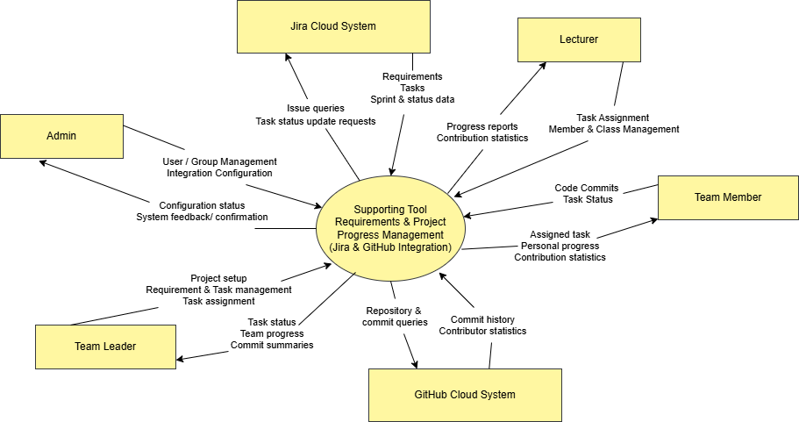
5

2. Business Process.
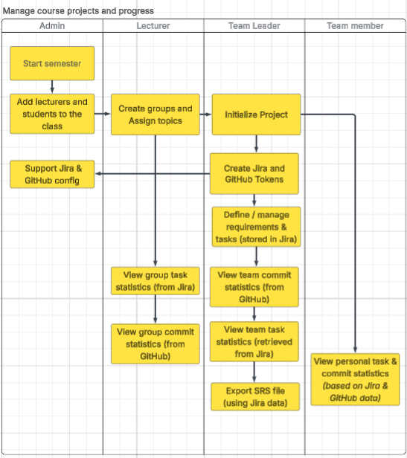
# | Process Step | Description
1 | Start semester | The administrator initializes a new academic semester in the system.
2 | Add lecturers and students to the class | The administrator adds lecturers and students to the class for the semester.
3 | Create groups and assign topics | The lecturer creates student groups and assigns project topics to each group.
4 | Start project | The team leader initializes the project for the assigned group.
5 | Support Jira and GitHub configuration | The administrator supports the team leader in configuring Jira and GitHub integration.
6 | Create Jira and GitHub tokens | The team leader creates and configures Jira and GitHub access tokens for integration.
7 | Define and manage requirements and tasks | The team leader defines and manages project requirements and tasks, which are stored in Jira.
8 | View group task statistics | The lecturer views group-level task statistics retrieved from Jira.
9 | View group commit statistics | The lecturer views group-level commit statistics retrieved from GitHub.
10 | View team task statistics | The team leader views team task statistics retrieved from Jira.
11 | View team commit statistics | The team leader views team commit statistics retrieved from GitHub.
12 | Export SRS file | The team leader exports the SRS document using requirement data retrieved from Jira.
13 | View personal task and commit statistics | The team member views personal task and commit statistics based on data from Jira and GitHub.

