

A Supporting Tool for Requirements and Project Progress Management in Software Project Course SWP391 Using Jira and GitHub
Software Requirement Document
Report 3 - User Requirements

– HoChiMinh, February 2026 –
Table of Contents
Record of Changes 3
III. User Requirements 4
1. Actors 4
2. Use Cases 6
2.1 Diagram 6
2.2 Descriptions 7
3. Business Rules 12

Record of Changes
Date | A*  M, D | In charge | Change Description
*A - Added M - Modified D - Deleted

III. User Requirements

1. Actors
# | Actor | Description
1 | Admin | The Admin is responsible for managing and configuring the overall system. The Admin creates and manages student groups, manages lecturers, assigns lecturers to groups, and configures the integration with Jira and GitHub.  The Admin ensures that the system is properly set up and that data synchronization between the system and external platforms functions correctly. The Admin has full access to all system features.
2 | Lecturer | The Lecturer is responsible for supervising assigned student groups in the SWP391 course. The Lecturer manages students within assigned groups, views project requirements and tasks, monitors project progress, and reviews reports generated from Jira and GitHub data.  The Lecturer uses the system to evaluate project completion status and individual student contributions based on task tracking and commit statistics.
3 | Team Leader | The Team Leader is a student who represents a project group and is responsible for managing project requirements and coordinating team activities.  The Team Leader can create and manage project requirements, create and assign tasks to team members, monitor task progress, and view group commit summaries retrieved from GitHub. The Team Leader acts as the main contact point between the group and the Lecturer.
4 | Team Member | A Team Member is a student who participates in the project development process. Each Team Member is assigned specific tasks and is responsible for completing and updating the status of those tasks.  The Team Member can view assigned tasks, update task status, commit source code to GitHub, and view personal task and commit statistics. The system tracks contribution data to reflect individual participation in the project.
5 | Jira (External System) | Jira is an external project management system integrated with the application. The system synchronizes project requirements and tasks from Jira to support requirement tracking and progress monitoring.  Jira provides issue and task data that are used for reporting and evaluation purposes within the system.
 | GitHub (External System) | GitHub is an external source code management platform integrated with the system. The system retrieves commit data and repository statistics from GitHub to measure individual and team contributions.  GitHub provides commit history and contribution data used for progress tracking and performance evaluation.

2. Use Cases

2.1 Diagram
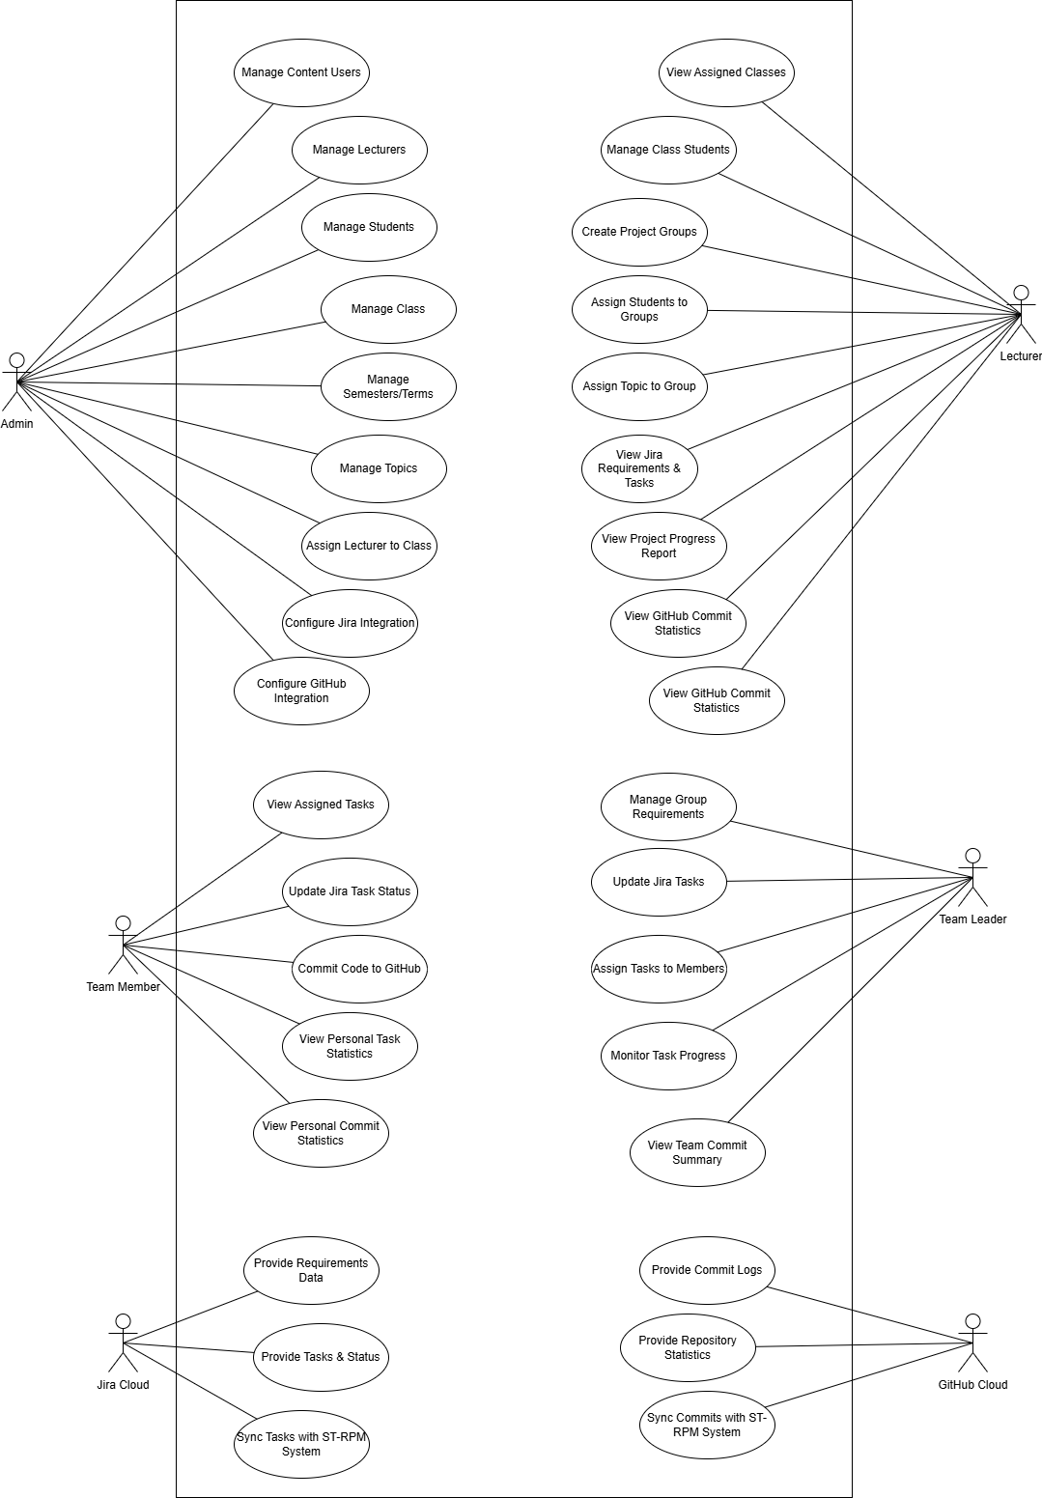

2.2 Descriptions
ID | Use Case | Actors | Use Case Description
UC-01 | Manage Content Users | Admin | Administers user accounts and permissions for content management within the system.
UC-02 | Manage Lecturers | Admin | Handles the creation, updates, and removal of Lecturer profiles and accounts.
UC-03 | Manage Students | Admin | Maintains the database of student records and their system access.
UC-04 | Manage Class | Admin | Creates and manages administrative details for different classes.
UC-05 | Manage Semesters/Terms | Admin | Configures the academic timeline, including semesters and specific terms.
UC-06 | Manage Topics | Admin | Curates and maintains the repository of project topics available for selection.
UC-07 | Assign Lecturer to Class | Admin | Links a specific Lecturer to a class they will be responsible for supervising.
UC-08 | Configure Jira Integration | Admin | Sets up API connections and synchronization rules with Jira Cloud.
UC-09 | Configure GitHub Integration | Admin | Sets up repository access and synchronization rules with GitHub Cloud.
UC-10 | View Assigned Classes | Lecturer | Allows the lecturer to see the list of classes they have been assigned to supervise.
UC-11 | Manage Class Students | Lecturer | Manages the specific roster of students within their assigned classes.
UC-12 | Create Project Groups | Lecturer | Divides the students in a class into specific project teams.
UC-13 | Assign Students to Groups | Lecturer | Allocates individual students to their respective project groups.
UC-14 | Assign Topic to Group | Lecturer | Formally assigns a project topic to a specific group for execution.
UC-15 | View Jira Requirements & Tasks | Lecturer | Monitors the project backlog and task distribution on Jira for their groups.
UC-16 | View Project Progress Report | Lecturer | Reviews comprehensive reports on the completion status of group projects.
UC-17 | View GitHub Commit Statistics | Lecturer | Tracks the coding activity and frequency of group contributions via GitHub data.
UC-18 | Manage Group Requirements | Team Leader | Defines and refines the specific requirements for the team's assigned project.
UC-19 | Update Jira Tasks | Team Leader | Edits, adjusts, or updates task details and priorities on the Jira board.
UC-20 | Assign Tasks to Members | Team Leader | Delegates specific Jira tasks to individual members of the project team.
UC-21 | Monitor Task Progress | Team Leader | Tracks the real-time status of all tasks assigned to the team.
UC-22 | View Team Commit Summary | Team Leader | Reviews a consolidated summary of the team's code contributions.
UC-23 | View Assigned Tasks | Team Member | Accesses a list of work items specifically assigned to the member.
UC-24 | Update Jira Task Status | Team Member | Updates the workflow status (e.g., In Progress to Done) for their own tasks.
UC-25 | Commit Code to GitHub | Team Member | Pushes source code changes to the project repository on GitHub.
UC-26 | View Personal Task Statistics | Team Member | Reviews personal productivity data and task completion metrics.
UC-27 | View Personal Commit Statistics | Team Member | Analyzes individual coding contribution history and frequency.
UC-28 | Sync Tasks & Status | Jira Cloud | Automatically synchronizes requirements and task updates with the ST-RPM system.
UC-29 | Sync Commits & Statistics | GitHub Cloud | Automatically pulls commit logs and repository data into the ST-RPM system.

ID and Name: | UC01-UC07: System Entity & Assignment Management
Created By: | Pham Tuan Anh | Date Created: | February 26, 2026
Primary Actor: | Admin | Secondary Actors: | Lecturer, Team Leader, Team Member
Description: | Managing core system data including Users, Lecturers, Students, Classes, Semesters, and Topics, and assigning Lecturers to Classes.
Trigger: | Admin accesses the administrative dashboard menus.
Preconditions: | PRE-1. Admin is authenticated with full access
Postconditions: | POST-1. System database is updated (CRUD operations completed).
Normal Flow: | - Admin selects the entity to manage (e.g., Manage Lecturers).  - System displays the current record list.  - Admin performs Add/Edit/Delete or Assigns a Lecturer to a Class (UC07).  - System validates inputs and saves changes to the database.
Alternative Flows: | 1.1 Batch Import  - Admin uploads a CSV/Excel file for Students/Lecturers instead of manual entry.
Exceptions: | 1.0.E1 Duplicate Entry  1. System detects a duplicate Email or ID; shows error "Record already exists."
Priority: | High
Frequency of Use: | Low
Business Rules: | BR-00, BR-04
Other Information: | Admin has "Full Access" override for all data across all groups.
Assumptions: | Admin provides valid data conforming to the system's schema.

ID and Name: | UC08 - UC09: Integration Configuration (Jira & GitHub)
Created By: | Pham Tuan Anh | Date Created: | February 26, 2026
Primary Actor: | Admin | Secondary Actors: | Team Leader
Description: | Setting up API tokens, project keys, and repository URLs for data synchronization.
Trigger: | User initiates the setup or update of external tool integrations.
Preconditions: | PRE-1. Valid Jira/GitHub accounts exist.  PRE-2. User has configuration permissions
Postconditions: | POST-1. Integration settings are saved to IntegrationConfig.
Normal Flow: | - User enters API credentials/URLs.  - System tests connection.  - System saves settings.
Alternative Flows: | 1.1 Conf iguration Update  - User updates an existing API Token if the old one expired
Exceptions: | 1.0.E1 Connection Failed  1. System displays the specific HTTP error (e.g., 401 Unauthorized) and refuses to save the config.  1.0.E2 Insufficient Permission  1. System redirects to "Access Denied" page
Priority: | Critical
Frequency of Use:
Business Rules: | BR-14
Other Information:
Assumptions: | External services are online during the test connection.

ID and Name: | UC10 - UC14: Group Setup & Topic Assignment
Created By: | Pham Tuan Anh | Date Created: | February 26, 2026
Primary Actor: | Lecturer | Secondary Actors: | Team Leader, Team Member
Description: | Group formation and Team Leader designation.
Trigger: | Lecturer prepares for a new project-based course term.
Preconditions: | PRE-1. Lecturer is assigned to the class
Postconditions: | POST-1. Student groups established with 1 Leader and 1 Topic.
Normal Flow: | - Lecturer creates group.  - Adds students.  - Designates 1 Leader.  - Assigns Topic.
Alternative Flows: | 1.1 Swap Leader  - Lecturer removes Leader role from Student A and assigns it to Student B
Exceptions: | 1.0.E1 Already in Group  1. System blocks the addition and shows BR-01 error.  1.0.E2 Leader Limit  1. System prompts to "Remove existing leader first
Priority: | High
Frequency of Use:
Business Rules: | BR-01, BR-02, BR-02a, BR-04.
Other Information:
Assumptions: | Students are already imported into the class roster by the Admin.

ID and Name: | UC15 - UC17: Academic Supervision
Created By: | Pham Tuan Anh | Date Created: | February 26, 2026
Primary Actor: | Lecturer | Secondary Actors: | Jira Cloud, GitHub Cloud
Description: | Monitoring group progress and code activity.
Trigger: | Lecturer performs periodic progress reviews or grading.
Preconditions: | PRE-1. Lecturer is assigned to the class
Postconditions: | POST-1. Dashboard displays latest synced data.
Normal Flow: | - Lecturer selects group.  - System displays Jira/GitHub stats.
Alternative Flows: | 1.1 Detailed History  - Lecturer clicks on a task to see TaskStatusHistory
Exceptions: | 1.0.E1 Data Mismatch  1. System displays a "Flag" icon and warning text  1.0.E2 Missing Dates  1. System tags it with MISSING_COMPLETED_AT flag
Priority: | High
Frequency of Use:
Business Rules: | BR-04, BR-07, BR-08, BR-09.
Other Information: | Displays data using standardized internal statuses (TODO/IN_PROGRESS/DONE).
Assumptions:

ID and Name: | UC18 - UC22: Team Operations & Leadership
Created By: | Pham Tuan Anh | Date Created: | February 26, 2026
Primary Actor: | Team Leader | Secondary Actors: | Team Member, Jira Cloud
Description: | Managing requirements, distributing tasks among members, and monitoring internal team progress.
Trigger: | Team Leader plans a sprint or coordinates daily tasks.
Preconditions: | PRE-1. User is the designated Team Leader
Postconditions: | POST-1. Tasks are delegated.  POST-2. Requirement/Task relationships are established
Normal Flow: | - TL creates Requirements  - TL creates/updates Tasks  - TL assigns tasks to members.  - TL initiates manual "Sync Now"
Alternative Flows: | 1.1 SRS Export  - TL generates an SRS file based on filtered Jira data
Exceptions: | 1.0.E1 Sync Conflict  1. Returns 409 error
Priority: | High
Frequency of Use: | Daily
Business Rules: | BR-02, BR-03, BR-05, BR-06, BR-14, BR-15, BR-16, BR-17.
Other Information:
Assumptions: | Team Leader has valid credentials on the group's Jira board.

ID and Name: | UC23 - UC24: Individual Tasks & Execution
Created By: | Pham Tuan Anh | Date Created: | February 26, 2026
Primary Actor: | Team Member | Secondary Actors: | Jira Cloud, GitHub Cloud
Description: | Viewing personal task assignments and updating work status through Jira and code commits.
Trigger: | Member begins work or completes a development task.
Preconditions: | PRE-1. Member is assigned to a Student Group.
Postconditions: | POST-1. Task status is updated.  POST-2. Completion timestamp recorded
Normal Flow: | - Member views assigned tasks.  - Member updates task status on Jira  - Member pushes code to GitHub.
Alternative Flows: | 1.1 Ghost Commit  - Member uses an email not in the system; statistics are saved via author_name
Exceptions: | 1.0.E1 Status DONE missing date  1. System flags MISSING_COMPLETED_AT
Priority: | High
Frequency of Use: | Daily
Business Rules: | BR-03, BR-07, BR-08, BR-09, BR-12, BR-13.
Other Information:
Assumptions: | Members update Jira statuses in a timely manner.

3. Business Rules
ID | Rule Definition
BR-00 | Admin has full access permissions (Superuser).
BR-01 | Each Student can belong to a maximum of one group per course_code and semester.
BR-02 | Each group is limited to exactly one Team Leader at any given time.
BR-02A | Only the Lecturer assigned to the group (or the Admin) has the authority to designate or change the Team Leader.
BR-03 | Users are restricted to interacting only with data belonging to their respective groups (excluding Admin).
BR-04 | Lecturers are permitted to perform operations only within the groups specifically assigned to them.
BR-05 | Each Requirement must belong to exactly one StudentGroup.
BR-06 | Each Task must belong to exactly one Requirement.
BR-07 | (Jira Assignment Validation): Following Jira synchronization, the system must verify that the Task assignee belongs to the same StudentGroup. Validation prioritizes the stored jira_account_id. If a mismatch is detected, the system must flag the task or display an "Assignee Outside Group" warning on the dashboard.
BR-08 | (Status Normalization): The system shall map and display Jira task statuses using a standardized internal set: {TODO, IN_PROGRESS, DONE}. Any Jira status that cannot be mapped must be assigned as UNKNOWN/OTHER and explicitly highlighted.
BR-09 | (Completion Tracking): For tasks synchronized with a DONE equivalent status, the system must record a completion timestamp for reporting purposes. If Jira does not provide a direct field, the system infers the time from updated_at or resolution_date; otherwise, it marks the record as "Missing Data."
BR-09A | (Inference Logic): If fields.resolutiondate exists, use it as completed_at. If null, use fields.updated and apply the flag COMPLETED_AT_INFERRED_FROM_UPDATED.
BR-09B | (Validation): If the mapped status is DONE but completed_at remains null, apply the flag MISSING_COMPLETED_AT for data cleaning and reporting.
BR-09C | (Status History Enhancement): If the Jira sync includes expand=changelog, the system shall extract all "status" field changes occurring since the last SyncLog(JIRA)=SUCCESS. These changes must be mapped to the internal status set and inserted into the TaskStatusHistory table.
BR-10 | (Deduplication): During Jira synchronization, the system must prevent duplicate entries by using the jira_issue_key as the unique identifier to update existing records rather than creating new ones.
BR-11 | (Upsert Principle): Synchronization must follow the Upsert logic: if a record exists for a given key, perform an UPDATE; otherwise, perform an INSERT.
BR-12 | (Commit Uniqueness): The sha (commit hash) must be unique within the scope of a single repository.
BR-13 | (Unmapped Authors): If a GitHub author cannot be mapped to an internal system user, the system must still store the author_name and author_email to allow for data statistics based on these values.
BR-14 | (Privileged Access): Only the Admin or Team Leader roles are authorized to configure IntegrationConfig or trigger the "Sync Now" action.
BR-15 | (Concurrency and Logging): Every manual synchronization attempt must generate a SyncLog entry with a status of RUNNING, SUCCESS, or FAILED. If a sync process is already RUNNING for the same group and source, subsequent requests must be blocked (returning a 409 Conflict status). The system must display the synchronization results or specific error messages to the user.
BR-16 | (SRS Export Filtering): The SRS Export feature shall retrieve data from Jira based on user-defined filters, including All, Sprint, Version, or Label.
BR-17 | (Stateless Export): The SRS Export process must be stateless regarding the database; the system shall generate the file for immediate download without storing the export history or the generated file in the database.

