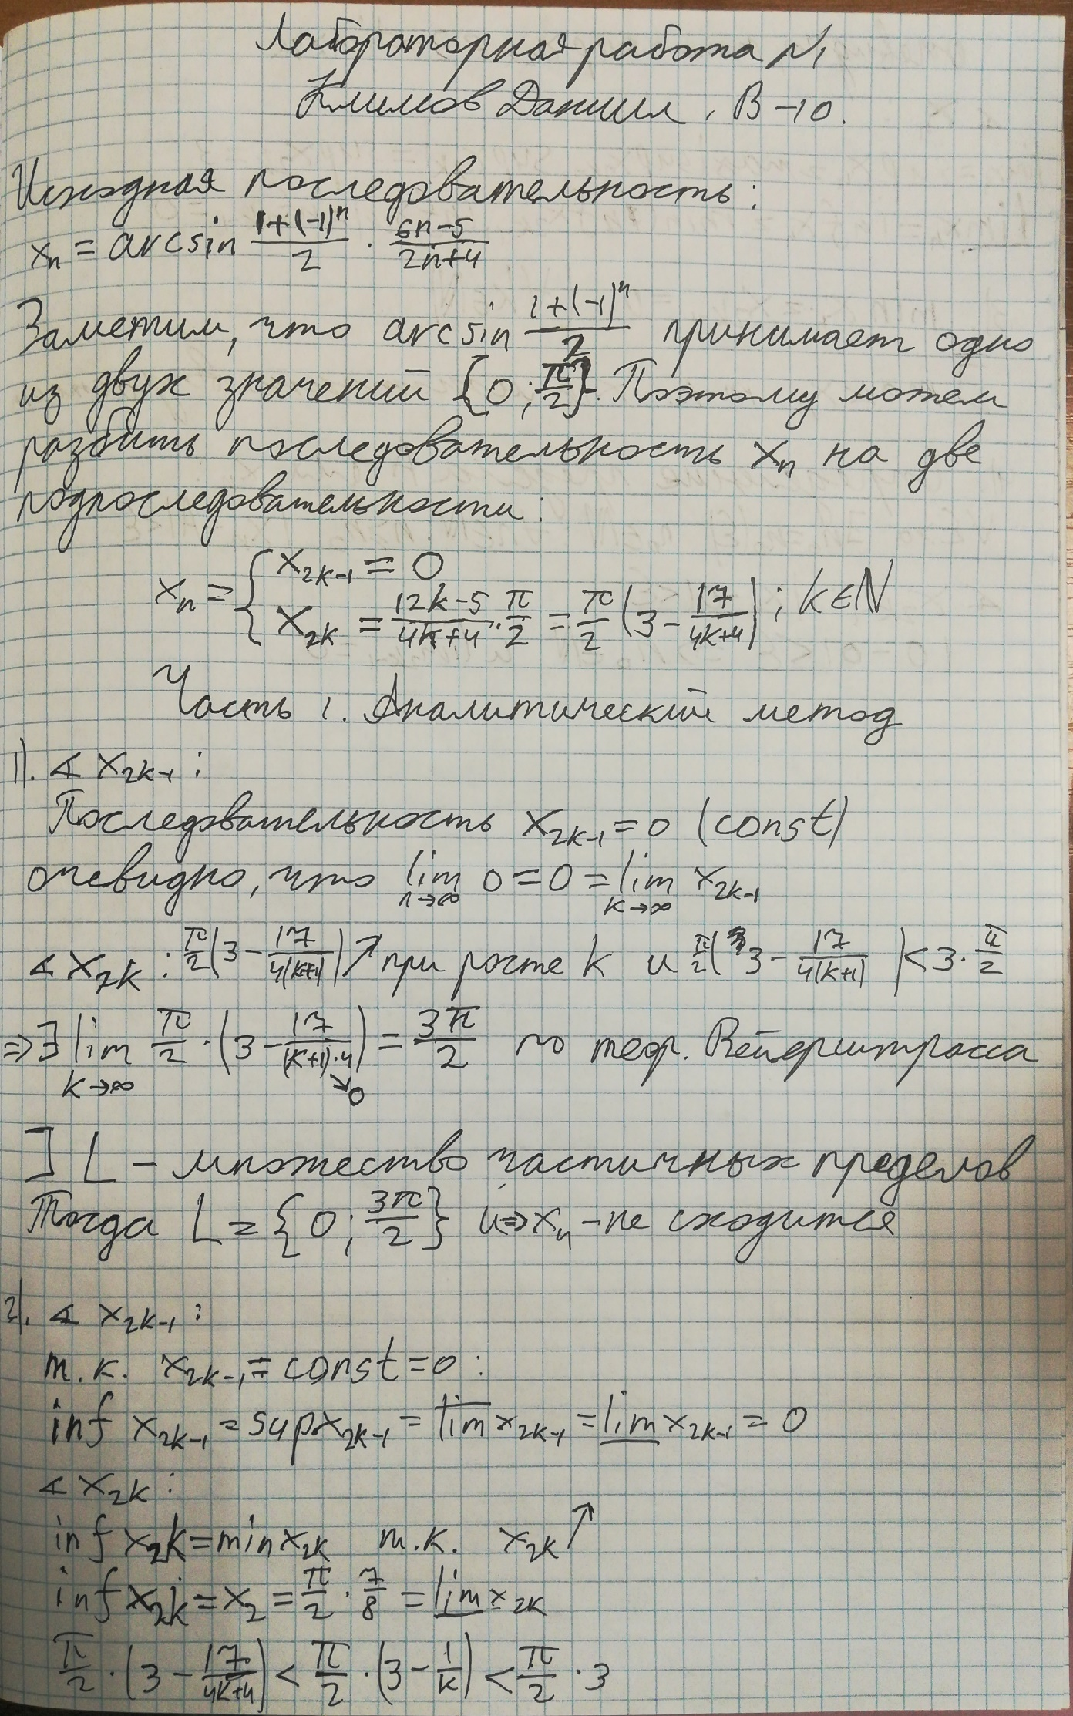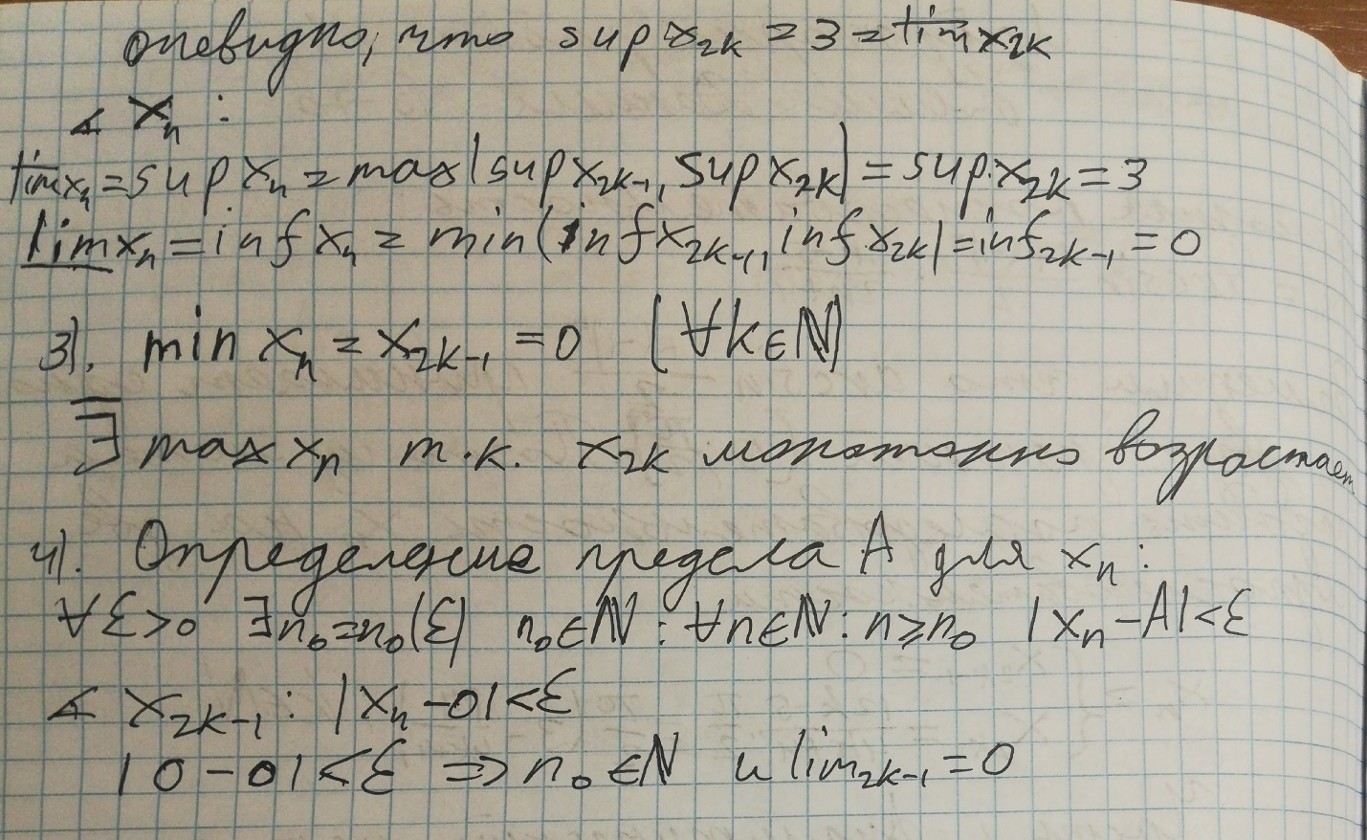

Исходный код программы на Python 3.11:

from cmath import pi

from matplotlib import pyplot as plt

def sequence_value(*, number):

return pi / 2 * (6 * number - 5) / (2 * number + 4) if number % 2 == 0 else 0

def get_graphic_of_sequence(*, sequence):

"""

graphic of the sequence

:param sequence: sequence

:return: picture

"""

plt.figure(figsize=(20, 8), dpi=80)

plt.title("график последовательности")

plt.xlabel("n")

plt.ylabel("значение члена последовательности")

for point in range(1, len(sequence)):

if point % 2 == 0:

plt.scatter(point, sequence[point], color='red', s=100)

else:

plt.scatter(point, sequence[point], color='blue', s=100)

plt.hlines(3 * pi / 2, 0, len(sequence), colors='black')

plt.annotate('supremum and superior limit = 3/2 * pi', xy=(0, 3 * pi / 2), xytext=(0, 3 * pi / 2 + 0.05))

plt.hlines(0, 0, len(sequence), colors='black')

plt.annotate('infinum and inferior limit = 0', xy=(0, 0), xytext=(0, 0.2))

# plt.show()

plt.savefig('original_sequence.png', bbox_inches='tight')

def get_graphic_of_subsequence(*, sequence):

"""

k0 = [(17*pi)/(8*epsilon)]+1

graphic of the subsequence

:param sequence: subsequence

:return:

"""

epsilon = 0.0001

plt.figure(figsize=(20, 8), dpi=80)

plt.title("график подпоследовательности x_2k")

plt.xlabel("n")

plt.ylabel("значение члена подпоследовательности")

k0 = (round((17 * pi) / (8 * epsilon)) + 1) * 2

plt.xlim(k0 - 10, k0 + 200)

plt.ylim(3 * pi / 2 - 0.001, 3 * pi / 2 + 0.001)

for point in range(k0, k0 + 200, 2):

plt.scatter(point, sequence_value(number=point), color='blue', s=100)

plt.hlines(3 * pi / 2, 0, k0 + 200, colors='black')

plt.annotate('superior limit = 3/2 * pi', xy=(k0, 3 * pi / 2), xytext=(k0, 3 * pi / 2 + 0.0001))

plt.annotate(f'k0 = [(17*pi)/(8*ԑ)]+1 = {k0}', xy=(k0, 3 * pi / 2), xytext=(k0, 3 * pi / 2 - 0.0002))

plt.annotate(f'epsilon={epsilon}', xy=(k0, 3 * pi / 2), xytext=(k0, 3 * pi / 2 - 0.0004))

plt.savefig('subsequence.png', bbox_inches='tight')

def get_graphic_of_supremum(*, sequence, epsilon):

"""

graphic of supremum

:param sequence:

:param epsilon:

:return:

"""

plt.figure(figsize=(20, 8), dpi=80)

plt.title("график супремума")

plt.xlabel("n")

plt.ylabel("значение члена последовательности")

m = 0

while True:

m += 1

if sequence_value(number=m) > 3 * pi / 2 - epsilon:

break

plt.xlim(m - 10, m + 200)

plt.ylim(3 * pi / 2 - 0.001, 3 * pi / 2 + 0.001)

for point in range(m, m + 200, 2):

plt.scatter(point, sequence_value(number=point), color='blue', s=100)

plt.hlines(3 * pi / 2, 0, m + 200, colors='black')

plt.annotate('supremum = 3/2 * pi', xy=(m, 3 * pi / 2), xytext=(m, 3 * pi / 2 + 0.0001))

plt.annotate(f'm = {m}', xy=(m, 3 * pi / 2), xytext=(m, 3 * pi / 2 - 0.0002))

plt.annotate(f'epsilon={epsilon}', xy=(m, 3 * pi / 2), xytext=(m, 3 * pi / 2 - 0.0004))

plt.savefig('supremum.png', bbox_inches='tight')

def main():

original_sequence = [sequence_value(number=n) for n in range(101)]

get_graphic_of_sequence(sequence=original_sequence)

get_graphic_of_subsequence(sequence=original_sequence)

get_graphic_of_supremum(sequence=original_sequence, epsilon=0.0001)

if __name__ == '__main__':

main()