UDPtoDMX Protocol:

The commands have to be sent by UDP to Port 7000.
Easy way to send and receive UDP Packets for testing is https://packetsender.com/.

General Format:

header | typ | # | channel | # | value | # | speed_S | # | curve | # | speed_F

DMX | P | # | 1 | # | 100 | # | 7 | # | 3 | # | 1

Orange is Optional

Examples:

DMXC2#129
DMXP3#55#1
DMXP3#56#2#2
DMXR1#3066012#1#1
DMXR1#3066012
DMXK1#302700

Header:
always DMX

Typ:
P: percent (0-100)
C: direct (0-255)
R: RGB (loxone format: R + G * 1000 + B * 1000000)
V: tunable white (0-100): channel: WW, channel+1: CW
W: tunable white (0-100): channel: CW, channel+1: WW
K: direct Kelvin mode for tunable white (works best for high resolution dimmers like H801) 302700 => 30% at 2700K, 655000 => 65% at 5000K (recommended)
Y: tunable white with direct setting of each channel (40100 => channel: 40% WW, channel+1: 100% CW)
Z: tunable white with direct setting of each channel (40100 => channel: 40% CW, channel+1: 100% WW)

Value:
Integer Value

speed_S:
Integer Value (0-255)

255: set Value immediately (no Fading)
1: Fast
99: Slow

+100: 4-times faster
+200: 8-times faster

see Time-Table

curve: (dimming curve)
Integer Value (0-3)
0: linear (0%=0, 50%=128, 100%=255)
1-3: “logarithmic” curve

see dimming curve graph

speed_F:
like speed_S, but it is used when dim-step is more than 10%
will be set so speed_S if the value is missing
this is for fast dimming (e.g. from 0% to 100%)

Time-Table:
(from 0% to 100% or 100% to 0%)
Speed ms
1 591
2 1176
3 1749
4 2350
5 2890
6 3495
7 4061
…
98 57262

101 147
102 293
103 434
104 583
…

201 72
202 145
…
254 3691
255 0

Dimming curve:
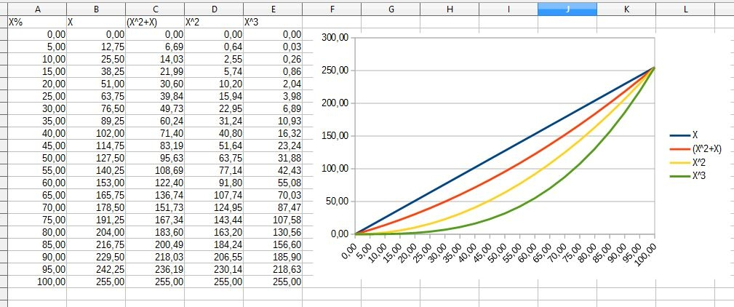

Tunable white mode:

