**LAB3: Finite State Machine**

Group Member: Rui Chen/Mengxi Wang

Complete Time: 10/01/2017

**Task1: 8-bit counter**

1. Waveform:

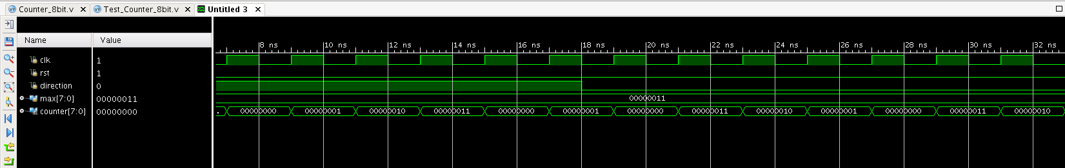

Img1: 8-bit counter waveform

1. Vivado Schematic:

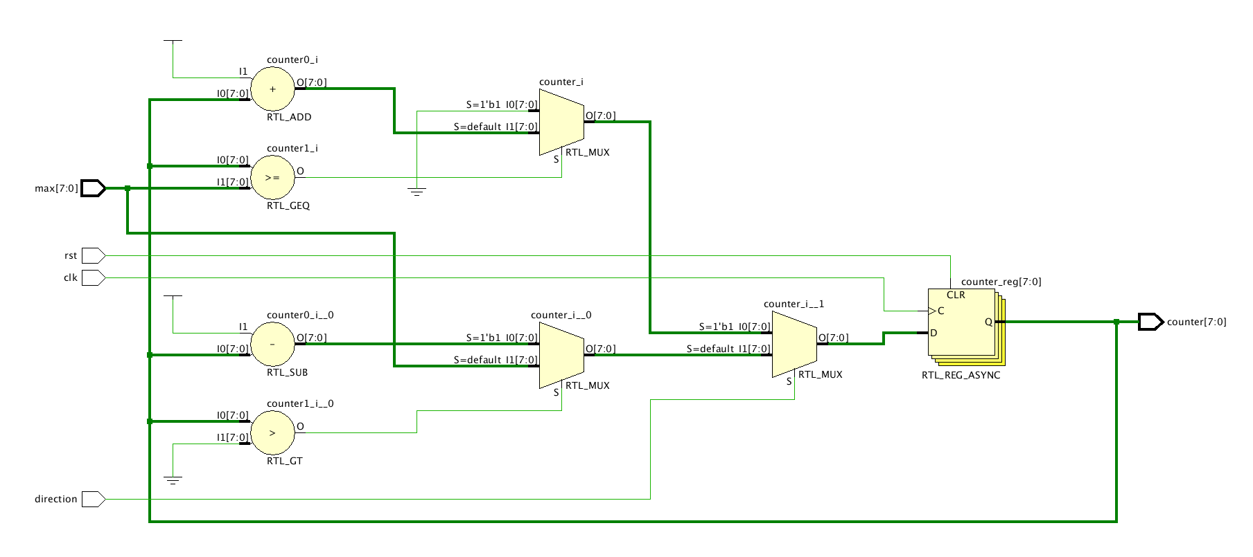

Img2: 8-bit counter schematic

1. Description:

* We set max=00000011 in testbench.
* When direction=1, the counter counts up from 00000000 to max. whenever the clock changes positively from 0 to 1.
* When direction=0, the counter counts down from the max=00000011 to 0 whenever the clock changes positively from 0 to 1.
* It’s positive edge trigger
* We set the rst as positive-trigger, when reset equals 1, output is set to be 0 no matter what inputs are.

**Task2: Clock Divider**

1. Waveform:

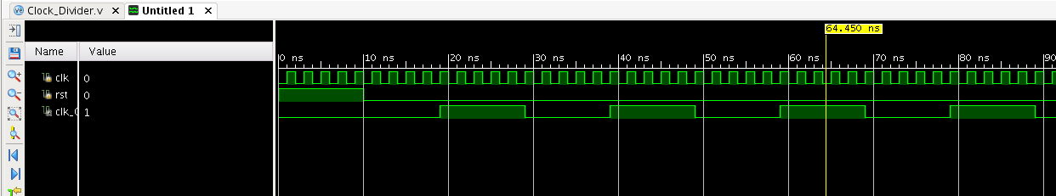

Img3: clock divider waveform

1. Vivado Schematic:

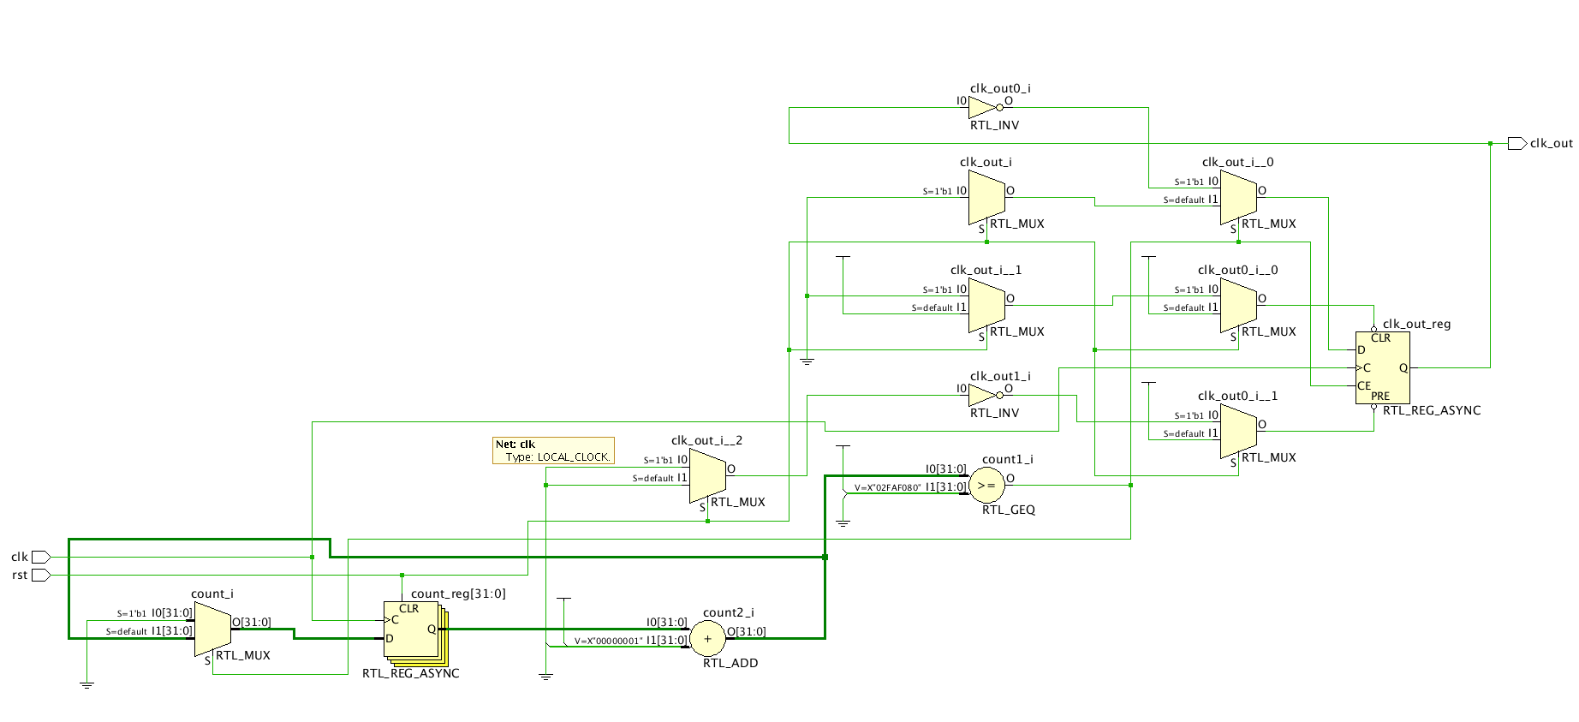

Img4: clock divider schematic

1. Description:

* If we stick to the task to do 100MHz-1Hz, it will take a lot of time to generate the waveform. In order to show the logic of clock divider, we receive 100MHz and outputs 10MHz.

**Task3：Wrap-around LEDs**

**Because of the ambiguous description of the Task3, we prepared two versions of reports of this part. The difference is : when the switch change(like from switch0=1,switch1=0 to switch0=0,switch1=1) during the process of led lighting from led0 to led3, what will show in version one is that the led direction changes immediately and in version two, it will complete the remaining lighting led and then direction changes.**

**Version ONE:**

1. Waveform:(We just set switch0=1，max=2, to show the logic)

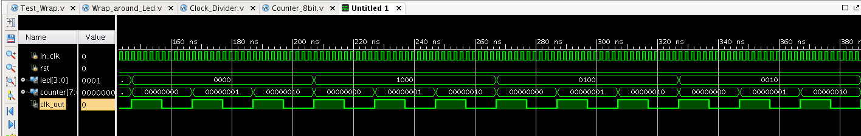

Img5: wrap-around leds waveform

1. Vivado Schematic:

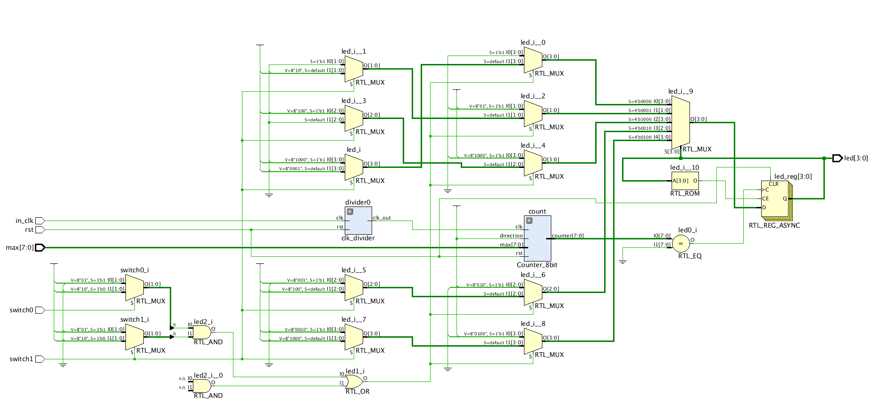

Img6: wrap-around leds schematic

1. State Diagram:

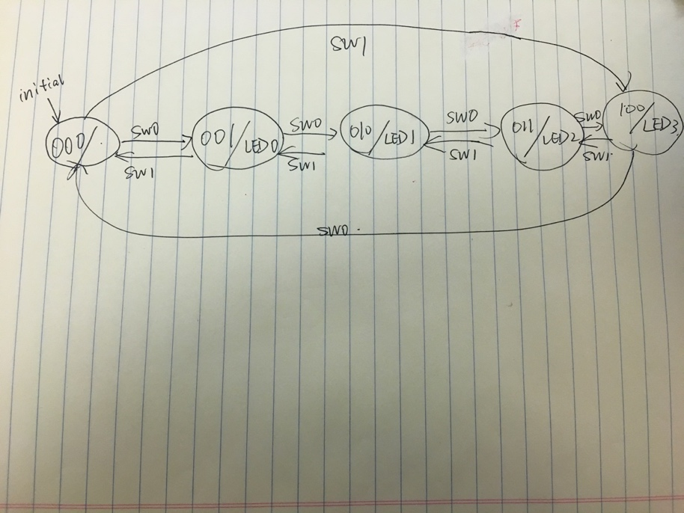

Img7: wrap-around led state diagram

1. Description:

Simulation Part

* We apply the design of 8-bit counter and clock divider from previous tasks.
* In order to show the logic, Clock divider transfer 100MHz to 10MHz and it controls the counter, and the output of the counter is used as input to wrap-around LEDs.
* When switch0 (switch1) is on, the LED lights up from LED0(LED3) to LED3(LED0), and in the middle of this process, if you change switches, the direction changes.(will not come back to initial state and instead change according to the current state)
* There is no detail about how it should be when both switches are 0 or 1. So in both cases, we stop the led and keep the current state.

Download to the board:

* When max is set to 1, LED will light up every two seconds. So

generally, when max is set to x, LED will light up every x+1 seconds. Explanation : when max is set to 1, counter should wait for two clk changing from 0 to 000000001that’s why it is two seconds not one.

**Version TWO :**

1. Waveform

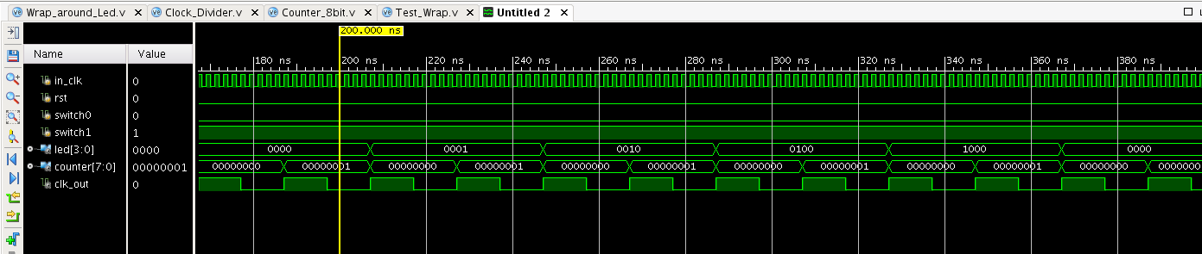

1. State diagram:



1. Description:

State00: no leds light up

State10: led light up one by one from led0 to led3

State01: led light up one by one from led3 to led0