**photo2pdf operation manual**

* This manual is a translated version.

# Environment information

1.1. This operating manual is based on photo2pdf version 22.01.

1.2. The photo2pdf used in the examples in this operation manual is installed on Windows 10 Professional, the version number is 20H2, and the OS internal version number is 19042.1466.

1.3. The basic hardware information of the computer installed with photo2pdf used in the example in this operation manual is:

(1) Processor: Intel(R) Core(TM) i7-9700 CPU @ 3.00GHz

(2) Memory: 16.0 GB (15.8 GB available)

(3) System type: 64-bit operating system, x64-based processor

1.4. This operation manual is also applicable to photo2pdf Version (22.02, 23.01, 23.02).

# 2. Feature list

### 2.1. Generate PDF

A PDF file can be generated from multiple image formats and multiple images according to a certain layout.

**scenes to be used:**

1. You can collect your wonderful photos of the past few months or years into a PDF, which is convenient for you to recall the wonderful things of Homecoming at any time;

2. It is easier to store on various devices, and the compatibility is stronger;

3. The overall file size is smaller;

4. Compared with pictures, PDF files can be encrypted, which can effectively protect the privacy of your file content;

5. It can be easily used to assist in managing your archive of thousands of photos;

### 2.2. Merge PDF

Multiple PDF files can be directly merged into one PDF file.

### 2.3. Encrypt PDF

A password can be added to a single PDF file to enhance the privacy protection of the content of the PDF file.

### 2.4. Extract pictures from PDF files

If there is content in the form of pictures in the PDF, the application can extract the pictures in the PDF file.

### 2.5. Language switching of the app

The interface language of this application is available in Simplified Chinese and English. Simplified Chinese is the default.

### 2.6. Image format conversion (experimental)

Convert multiple image formats (jpg/jpeg/png/bmp/jfif/gif) to new images in jpg/jpeg/png format.

### 2.7. Compress pictures (experimental)

By default, images can be compressed to produce new, smaller images at a slight reduction in image quality.

### 2.8. Proportional scaling of image resolution (experimental)

Based on the original image, a new image with a proportional change in resolution can be generated.

Note: This feature does not effectively enhance the picture quality when using a zoom setting greater than 1.

### 2.9. Custom zoom image resolution (experimental)

You can manually input the width and height of the desired resolution of the image to generate a specified resolution image.

Note: This feature does not effectively enhance the picture quality when using a larger value than the original pixel.

# 3. Use steps and diagrams

### 3.1. Example of using the function of generating PDF

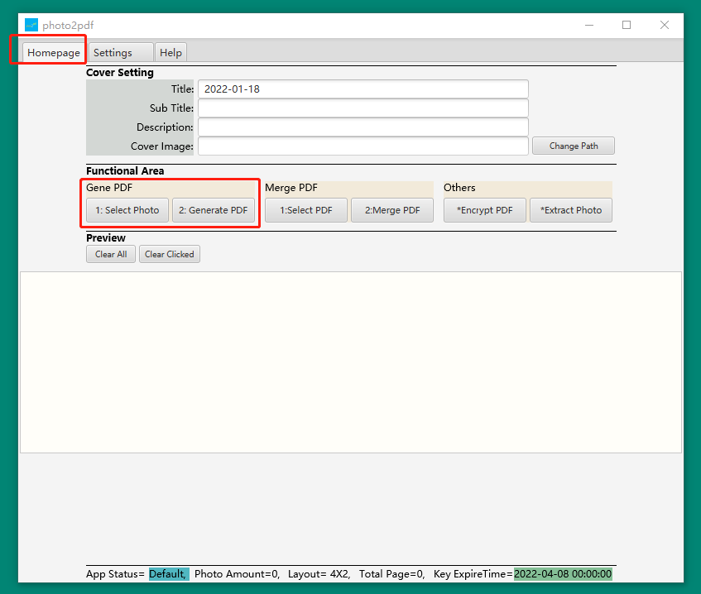

(1) Click "Homepage", switch to the home page, and then click the "1: Select Photo" button, as shown in the figure above;

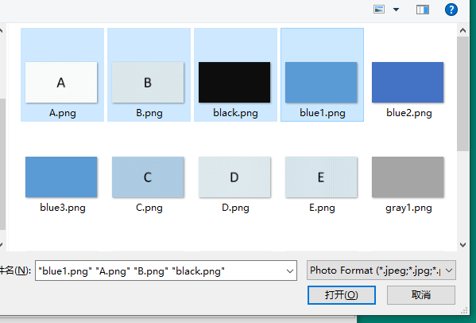

1. After clicking the "1: Select Photo" button on the home page of the application, the application will pop up a picture selection box, where you can select the picture you want to display in the generated PDF file, support to select multiple pictures or all Select the picture, as shown above;

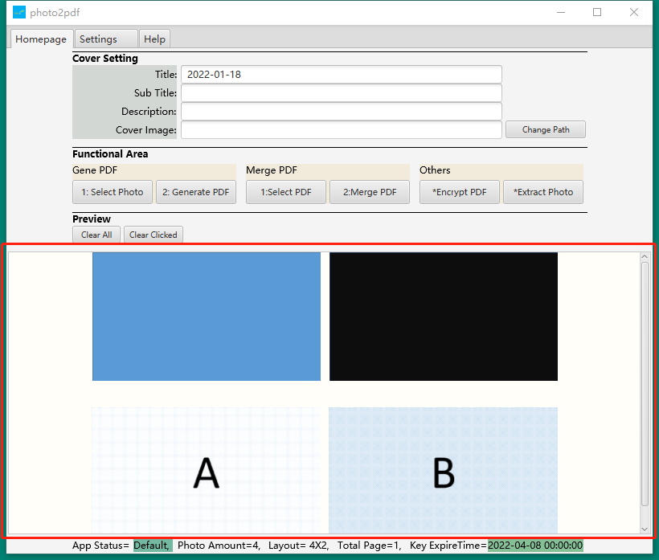

(3) By default, the app will display all the selected pictures in the preview area below, and the pictures will be displayed in the order of the creation date from the past to the most recent time by default, as shown in the figure above;

(4) If you need to add more pictures, just click the "1: Select Photo" button again, and then select more pictures in the picture selection box again according to this;

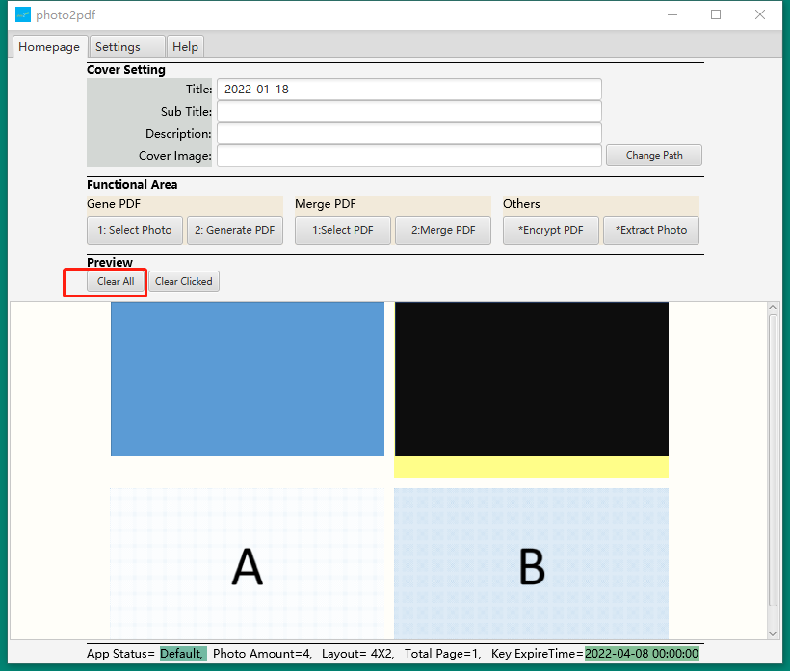

(5) If you need to re-select the images required to generate the PDF file, you can click the "Clear All" button in the preview area, and all the selected images will be cleared. After clearing, you can click again on the application home page interface. "1: Select Photo" button, re-select the picture, as shown above;

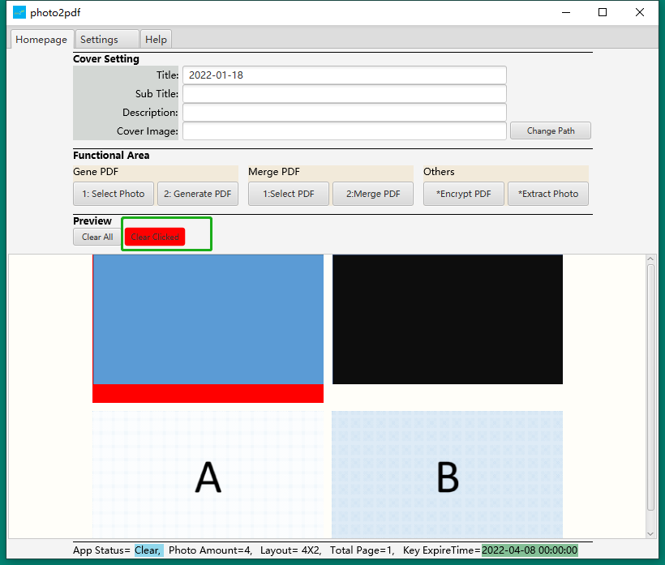

(6) If you do not need to include an image in the preview image into the generated PDF file, you only need to click the "Clear Clicked" button in the preview area, and the button will turn red, indicating that it is currently being cleared. In the function state of a single picture, you only need to move the cursor (mouse) over the picture you want to remove, and then click the cursor (mouse) (the background color of the picture will turn red), the picture will be will be removed. If all the pictures you need to remove have been removed, please click the "Clear Clicked" button in the preview area again to avoid the situation of removing pictures by mistake. This function may cause the application to freeze when there are a large number of preview images, please be patient;

(7) If you need to change the position of the pictures in the preview, you can exchange the positions of any two pictures. The operation is as follows, you need to place the cursor (mouse) on one of the pictures, then click on the picture and drag it to the top of the other picture without letting go, and finally release the cursor (mouse), the two pictures are completed position swap. This function may cause the application to freeze when there are a large number of preview images, please be patient;

(8) If it is confirmed that the picture has been selected, you can click the "2: Generate PDF" button, and the application will start generating the selected picture into a PDF file;

(9) After the application generates a PDF and receives it, a pop-up window will prompt the save location of the generated PDF file.

### 3.2. Merge PDF

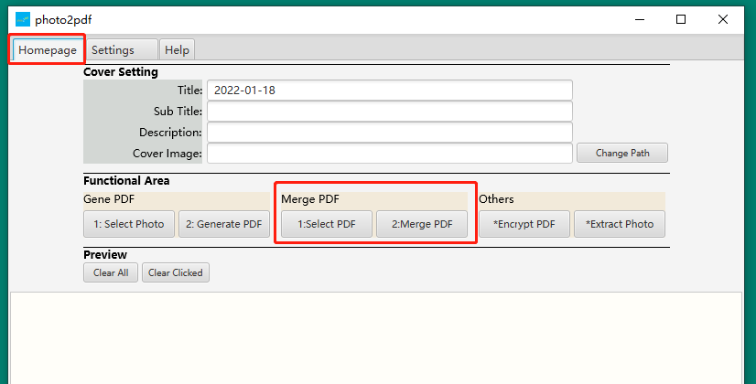

(1) Click "Home", switch to the home page, and then click the "1: Select PDF" button, as shown in the figure above;

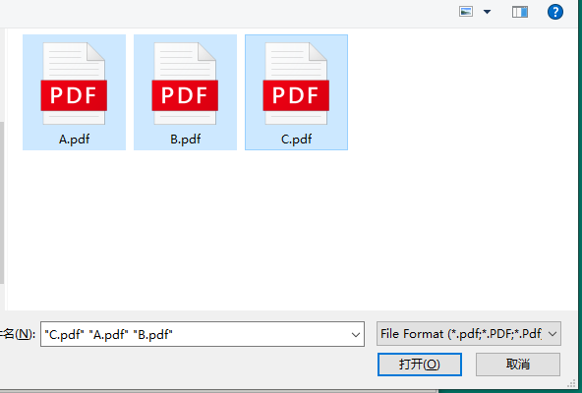

(2) The application will pop up the PDF selection box, select the PDF file you need to merge, as shown in the figure above;

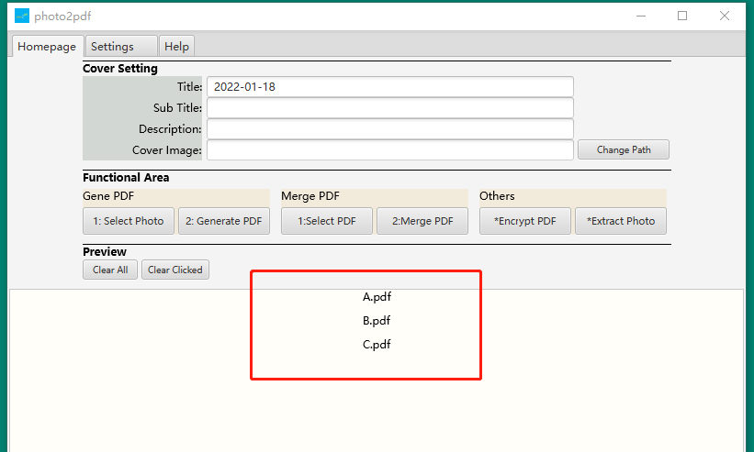

1. After selecting the PDF file, the application will return to the main interface, and you can preview it below to confirm whether the name and quantity of the selected PDF are correct, as shown in the figure above;

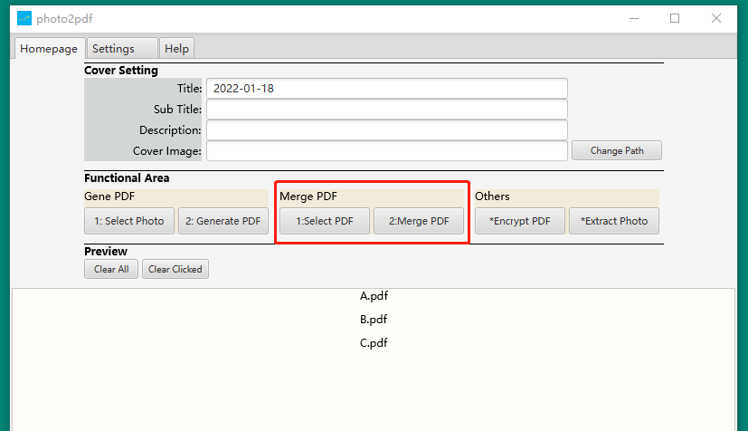

(4) Then click the "2: Merge PDF" button, the application will start to merge the selected PDF files and generate a new PDF file, as shown in the figure above;

(5) After the application merge PDF is completed, a pop-up window will prompt the save location of the merged PDF file.

### 3.3. Encrypt PDF

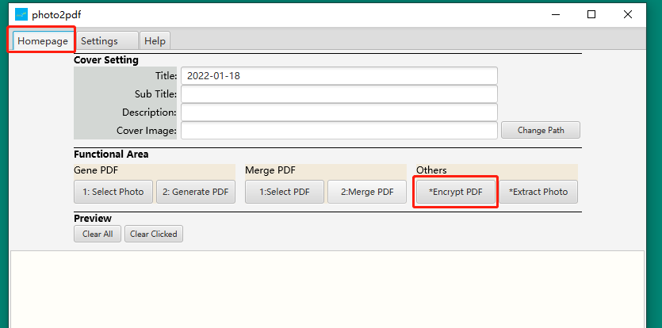

(1) Click the "*Encrypt PDF" button, as shown above;

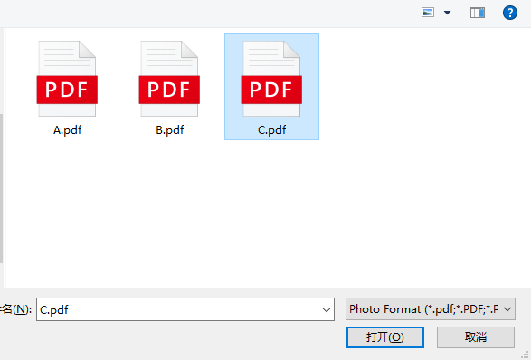

(2) Select the PDF file you need to encrypt, as shown in the figure above (the example selects the C.pdf file);

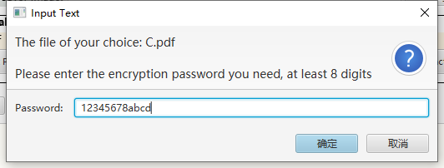

(3) Enter the password for PDF encryption, as shown in the figure above (the password entered in the example is: 12345678abcd);

(4) After the application of encrypted PDF is completed, a pop-up window will prompt you to save the encrypted PDF file.

### 3.4. Extract pictures from PDF files

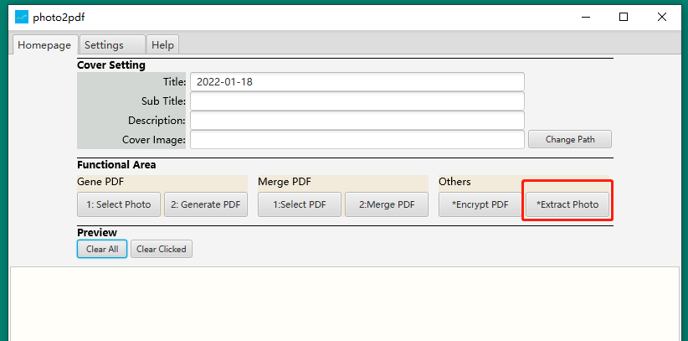

(1) Click the "*Extract PDF image" button, as shown in the figure above;

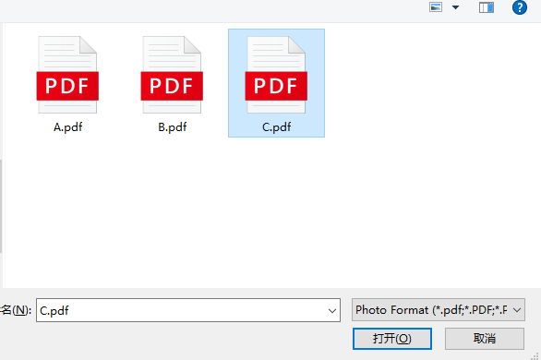

(2) Select the PDF file from which you need to extract the image, as shown in the figure above (the example selects the C.pdf file);

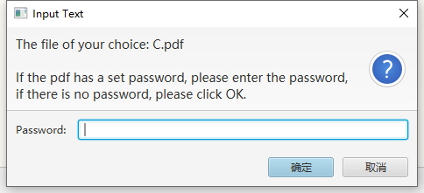

(3) Enter the password for PDF encryption (if the PDF you selected has a set password), click OK, as shown in the figure above;

(4) After the application of encrypted PDF is completed, a pop-up window will prompt the save location of the encrypted PDF file (if the application cannot extract images from the PDF, the save location will not contain any images).

### 3.5. Image format conversion (experimental function)

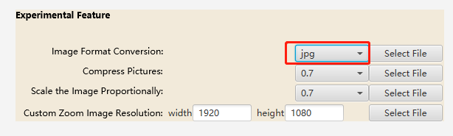

(1) Click the drop-down selection box corresponding to the picture format conversion function, and select the picture format you want to convert the picture into, as shown in the figure above;

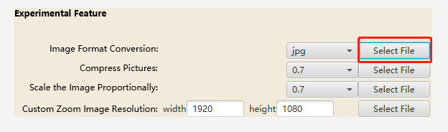

(2) Click the "Select File" button, select the picture you need to convert the format, and support to select multiple pictures for processing at one time, as shown in the figure above;

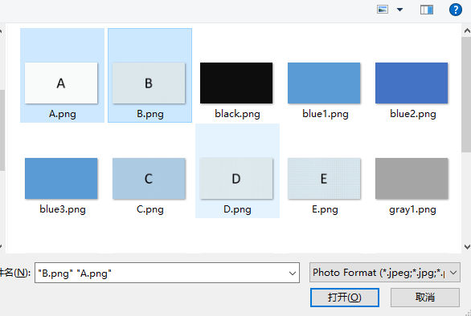

(3) Select the picture you are processing, as shown in the picture above;

(4) After the application processing is completed, a pop-up window will prompt the save location of the file.

### 3.6. Compress pictures (experimental feature)

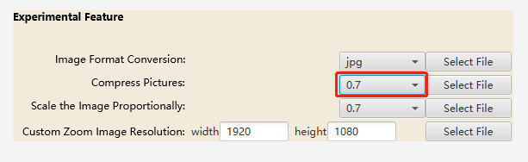

(1) Click the drop-down selection box corresponding to the compressed image function, and select the ratio you want to compress the image. The closer the selected value is to 1, the smaller the compression effect is, but the better the image quality is preserved; the closer the selected value is to 0, the better the compression effect. Larger, but the image quality declines more obviously, as shown in the figure above;

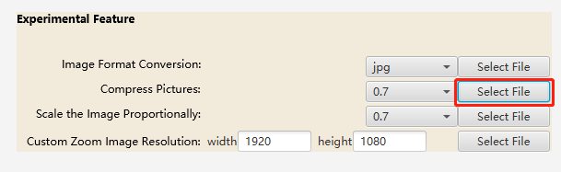

(2) Click the "Select File" button, select the picture you need to compress, and support to select multiple pictures for processing at one time, as shown in the figure above;

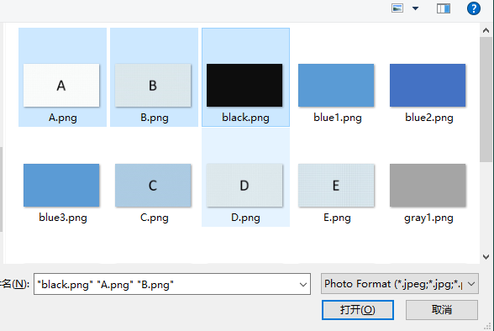

(3) Select the picture you process

(4) After the application processing is completed, a pop-up window will prompt the save location of the file.

### 3.7. Proportional scaling of image resolution (experimental feature)

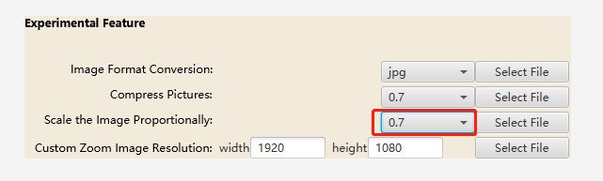

(1) Click the drop-down selection box corresponding to the proportional zoom image resolution function, and select the ratio you want to zoom the image, as shown in the figure above;

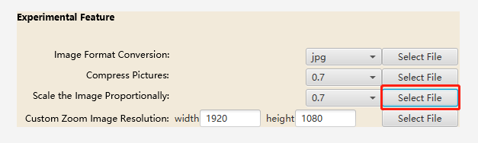

(2) Click the "Select File" button, select the picture you need to scale the resolution of the picture proportionally, and support to select multiple pictures for processing at one time, as shown in the figure above;

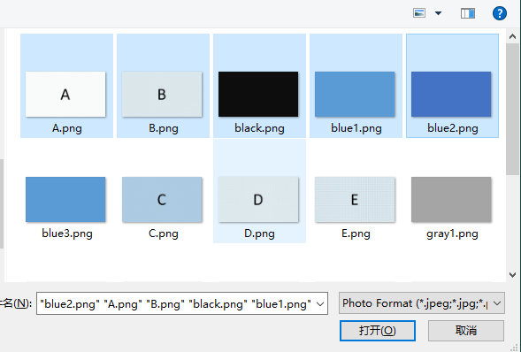

(3) Select the picture you are processing, as shown in the picture above;

(4) After the application processing is completed, a pop-up window will prompt the save location of the file.

### 3.8. Custom zoom image resolution (experimental feature)

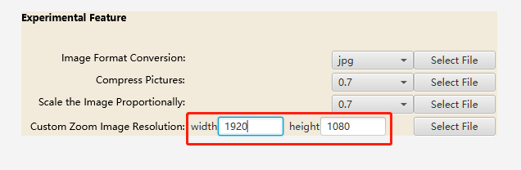

(1) Click the input box corresponding to the custom zoom image resolution, and enter the width and height data of the image, as shown in the figure above;

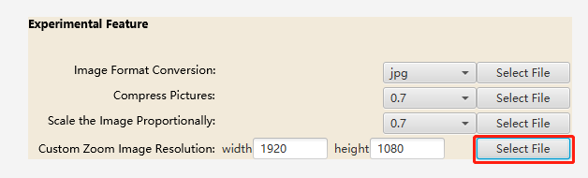

(2) Click the "Select File" button, select the picture you need to customize the zoomed picture resolution, and support to select multiple pictures for processing at one time, as shown in the figure above;

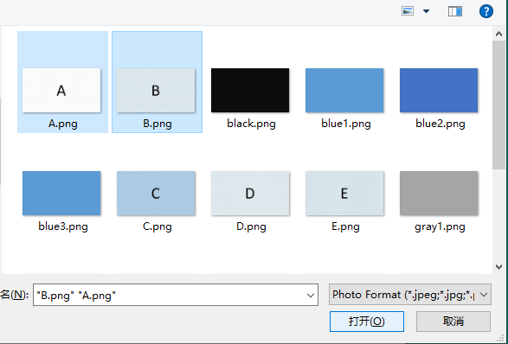

(3) Select the picture you are processing, as shown in the picture above;

(4) After the application processing is completed, a pop-up window will prompt the save location of the file.

# 4. Setup instructions and related instructions

### 4.1. Cover settings for the main page

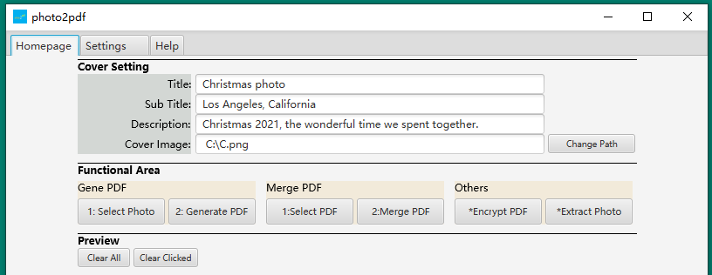

**Title** - the title of the cover page of the generated PDF, the default is the current date, not required

**Subtitle** - the subtitle of the cover page of the generated PDF, optional item

**Description** - a description of the cover page of the generated PDF, optional

**Cover image** - the cover image of the generated PDF cover, optional item

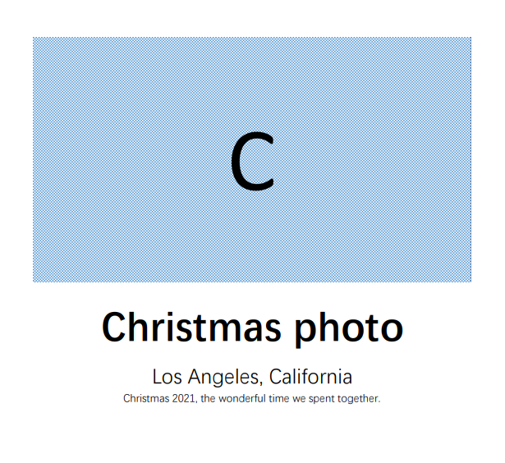

For example, the cover page of the PDF is shown above.

### 4.2. Settings page settings

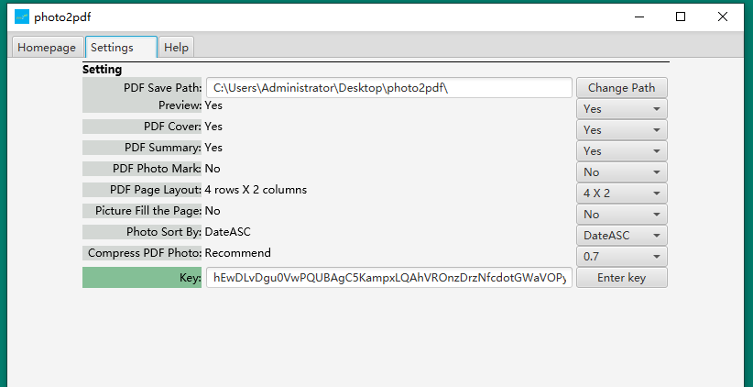

**PDF save path**

The location where the PDF file and related files are saved is the default photo2pdf folder on the user's desktop. You can click the "Change Path" button on the right to select the location where you want to save the file.

**preview**

The available options are: Yes and No.

Default is: Yes

When Yes is selected, during the PDF generation process, after the user selects an image, the image selected by the user can be displayed in the preview area at the bottom of the main page; if No is selected, the preview area at the bottom of the main page after the user selects the image User-selected images will not be displayed.

**PDF cover**

The available options are: Yes and No.

Default is: Yes

When Yes is selected, the first page of the generated PDF will be the cover page.

When No is selected, the generated PDF will not have a cover page, and the first page will be the user image page directly.

**PDF back cover**

The available options are: Yes and No.

Default is: Yes

When Yes is selected, the PDF generator will add the last page as a single back cover page.

When No is selected, the generated PDF will have no back cover page.

**PDF image description**

The available options are: Yes and No.

Default is: No

When Yes is selected, the description information of the image will be displayed below each image in the generated PDF, and the information defaults to the image name. Users can click to modify the description of the picture.

When No is selected, there is no description information below the image in the generated PDF.

**PDF single page layout**

Available options are: 4 X 2, 4 X 1, 2 X 1, 8 X 4, 1 X 1, 1 X 2.

Default value: 4 X 2

For example, when 4 X 2 is selected, the meaning of this option is that in the generated PDF file, the picture layout of each page of PDF is 4 rows and 2 columns, that is, one page of PDF can accommodate 8 pictures; when 8 X is selected 4, the meaning of this option is that in the generated PDF file, the layout of pictures on each page is 8 rows and 4 columns, that is, a page of PDF can hold 32 pictures. Other options are the same.

**Pictures fill the page**

The available options are: Yes and No.

Default is: No

When No is selected, the gap between the pictures and pictures in the generated PDF will be preserved, and the entire PDF page will not be filled.

When Yes is selected, there will be no gaps between the pictures and pictures in the generated PDF, and they will be closely connected, and the pictures will fill the entire PDF page without gaps; at the same time, when the option is Yes, the application will It is no longer supported for users to fill in the picture description information. At this time, the option of "PDF picture description" will be set to No.

**Sort images by**

The available options are: Date Ascending, Date Descending, Name Ascending, Name Descending, Default

Default is: Date Ascending

When you select ascending date by date, the app will sort the pictures created earlier in the first page of the PDF according to the creation (or shooting) time of the pictures, and sort the pictures created recently in the last page of the PDF. For example, from 2021-01-01 to take a picture every day until 2021-12-31, then when the above picture is selected to generate PDF, the picture taken on 2021-01-01 will be on the first page of the picture page , and the pictures taken on 2021-12-31 will be listed on the last page of the picture page.

When the date descending order is selected, the sorting method at this time is opposite to that of the ascending date order.

When you select Ascending by name, the app will sort the images in ascending order based on their names. For example A.jpg, B.jpg, C.jpg, D.jpg

When you select Descending by name, the app will sort the images in ascending order based on their names. For example D.jpg, C.jpg, B.jpg, A.jpg

When default is selected, the application will sort the pictures according to the order in which the user added pictures. For example, when a user selects a picture, he first clicks black.png, then white.png, and finally green.jpg, then the preview interface and the pictures in the generated PDF are sorted according to black.png, white.png, green.jpg.

**Compress PDF Photo**

Available options are: 1, 0.9, 0.8, 0.7, 0.6, 0.5, 0.4, 0.3, 0.2, 0.2, 0

Default value: 0.7

When 1 is selected, the application will use the original image selected by the user to generate the PDF during the process of generating PDF (the original image of the user will not be affected in any way), and the application will not perform any compression processing on the image selected by the user.

When 0.7 is selected, in the process of generating PDF, the application will compress the original image selected by the user (the original image of the user will not be affected in any way) while retaining 70% of the quality of the original image to generate a new image ( including image format conversion and/or pixel scaling) to reduce the size of the generated PDF file, and then use the new image to generate the PDF. 0.7 is the recommended value, and users can choose the appropriate value according to the actual situation.

When 0.3 is selected, in the process of generating PDF, the application will compress the image selected by the user (the user's original image will not be affected in any way) while retaining 30% of the quality of the original image to generate a new image (including Image format conversion and/or pixel scaling) to reduce the size of the generated PDF file, and then use the new image to generate the PDF.

The other options are the same.

Note: No matter which parameter the user chooses, the application will not compress the user's original image, and the application actually compresses the original image by reading the original image to form a new image to achieve the compression effect.

**Key**

Some functions or options require the user to enter a key before the user can use the corresponding function or change options, etc.

### 4.3. Suggestion

1. When the application generates the first PDF, it will take a little longer than the subsequent PDF generation, please be patient.

2. If the performance of the computer hardware installed by the application is not particularly good, you can optimize the use experience by setting the preview to No.

3. When the number of pictures you select is larger, the file size of the picture is larger, the resolution is higher, and the parameter for compressing PDF pictures in the settings is closer to 1, the application will run more stutteringly, and the application may even crash.

4. In the process of generating PDF, depending on the hardware of your computer and the number of pictures contained in the generated PDF, the waiting time will be different. If you click the Generate button for more than 30 minutes, the application still does not pop up the file to save. The information of the location pop-up window, the program may have crashed, please reopen the application according to the situation.

5. Some usage suggestions for PDF single-page layout selection:

4 X 2 - Default option, suitable for most scenarios.

4 X 1 - suitable for PDF generation of some panoramic photos.

2 X 1 - The pictures are rich in content (including pictures with a lot of text) and can be read clearly.

8 X 4 - suitable for PDF generation with a large number of images, you can generate wonderful photos from the past decades into a single PDF for use.

1 X 1 - Suitable for scenes with high fidelity pictures, more text or high reading requirements (such as the case where the picture is a receipt or bill).

1 X 2 - suitable for long screenshots of mobile phones and web pages to make PDFs.

### 4.4. Instruction

1. The image format in the experimental function supports the following formats to be converted to jpg, jpeg, png. After the conversion, the background color, resolution, and (some or all) characteristics of the previous image format will be changed. For example, gif -> jpg may produce a picture with an orange background color, and the animation effect of gif will disappear.

(1) jpeg (2) jpg (3) png (4) jfif (5) bmp (6) gif

2. The key of the PDF encryption function provided by the application is set to: AES256.

3. The source code of this application (photo2pdf version 22.01) does not contain any explicit external network link settings, and does not have network link capability. All file processing of the user is performed in the user's local environment, and the application will not upload any files of the user to the outside. surroundings.

4. "Picture fills page" option in app settings

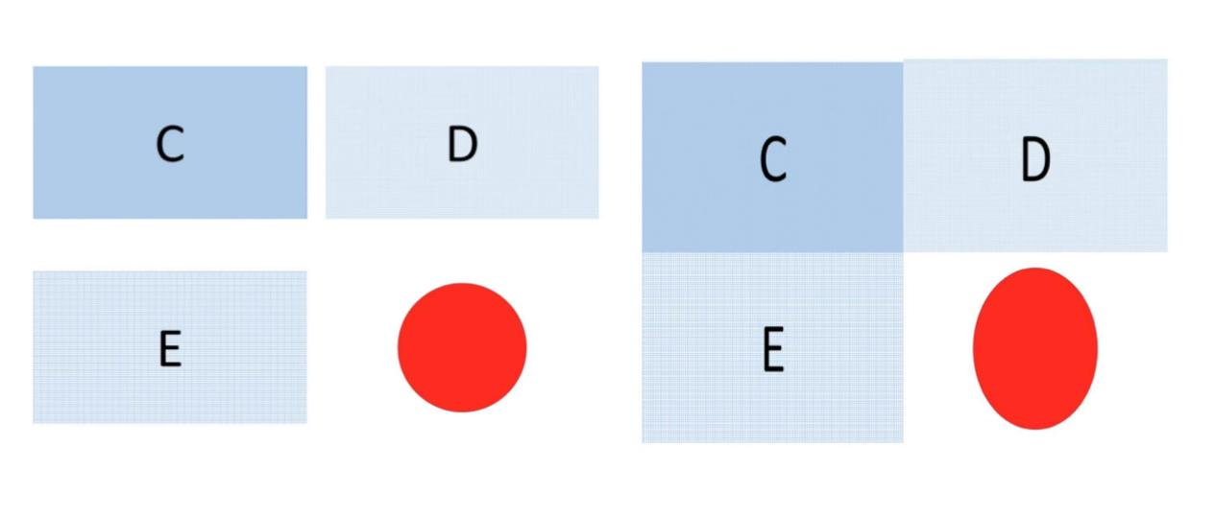

When Yes is selected, the image selected by the user may be forced to stretch (landscape or portrait orientation) to fit the effect requirements of the page. As shown in the figure above, the four pictures on the left side of the picture are the effect that the picture fills the page = No, and the right side of the picture is the effect that the picture fills the page = Yes (the picture on the right is forced to be stretched in the vertical direction).

5. The experimental functions provided by the application do not fully guarantee that the functions can complete the tasks as expected. For example, when using the function of compressing pictures, it is possible that the file size of the compressed pictures may become larger.

6. The file selection pop-up window of this app only supports files in the file format that the app can process. Files that do not support processing will not be displayed in the pop-up window.

7. Some test data of the processing speed of the application in the process of generating PDF, the actual situation will have different processing speed according to the performance of the computer where the application is installed.

(1) Picture preview loading speed (including the function of selecting pictures and clearing clicked items):

①53 images, 66 MB, time consuming 1673 ms

②100 pictures, 160 MB, time consuming 4396 ms

③1000 pictures, 1560 MB, time consuming 42960 ms

(2) The speed of generating PDF files for the first time:

①53 pictures, 56 MB, time consuming 10288 ms

②100 pictures, 160 MB, time consuming 13669 ms

③1000 images, 1560 MB, time consuming 98163 ms

(3) Non-first-time PDF file generation speed:

①53 pictures, 66 MB, time consuming 5951 ms

②100 images, 160 MB, time consuming 9909 ms

③1000 pictures, 1560 MB, time consuming 95376 ms

(4) The size of the generated PDF file (under the default setting of the program):

①53 images, 66 MB, generated PDF file size: 9.79 MB

②100 images, 160 MB, generated PDF file size: 51.5 MB

③1000 images, 1560 MB, the size of the generated PDF file: 515 MB

# Statement

This manual is a translated version. Thank you for your understanding if the description is unclear.

If the description is unclear, the description is inconsistent or even the description is wrong, please forgive me.

If the description does not match the actual function, please refer to the actual version function of the application.

Please understand that the description of this operation manual is not comprehensive.

The relevant tests of this application have been verified as much as possible. Please understand if there are any omissions or even related problems.

The operating environment on which this application depends and the rights and obligations of all code-related external libraries (dependencies) belong to the original author.

All Rights Reserved.