# photo2pdf introduction

**Vision**

Combine great images into PDF so you can use them wherever you want.

1. **Simplify the complex**

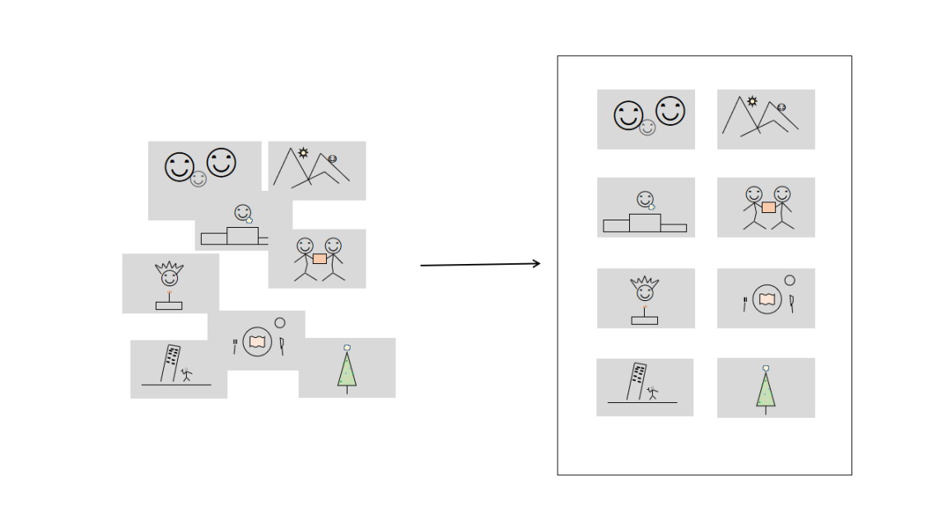

All kinds of good memories and wonderful, normalized for you.

1. **To connect, to be together**

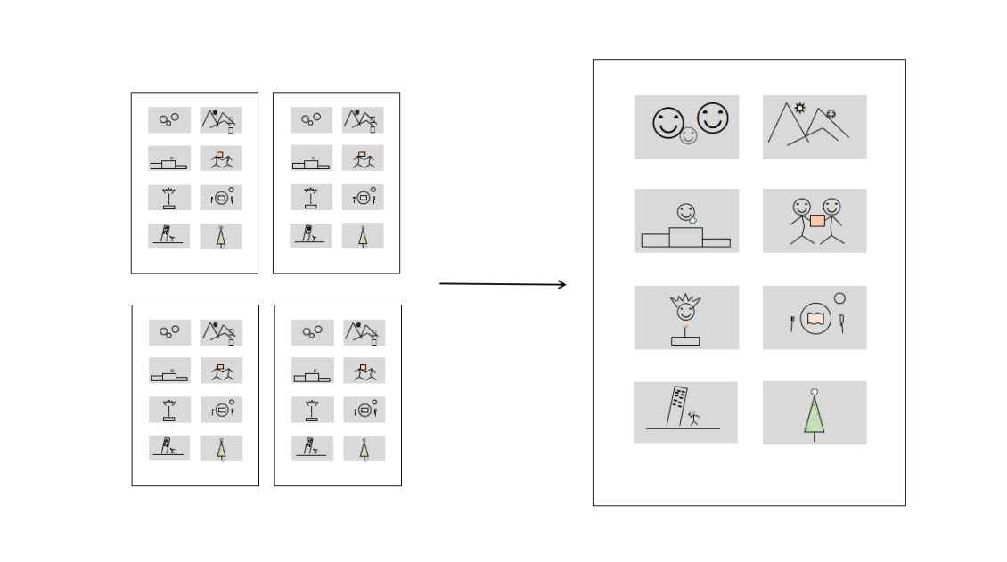

All kinds of beauty, one after another, finally come together.

1. **Privacy, your freedom**

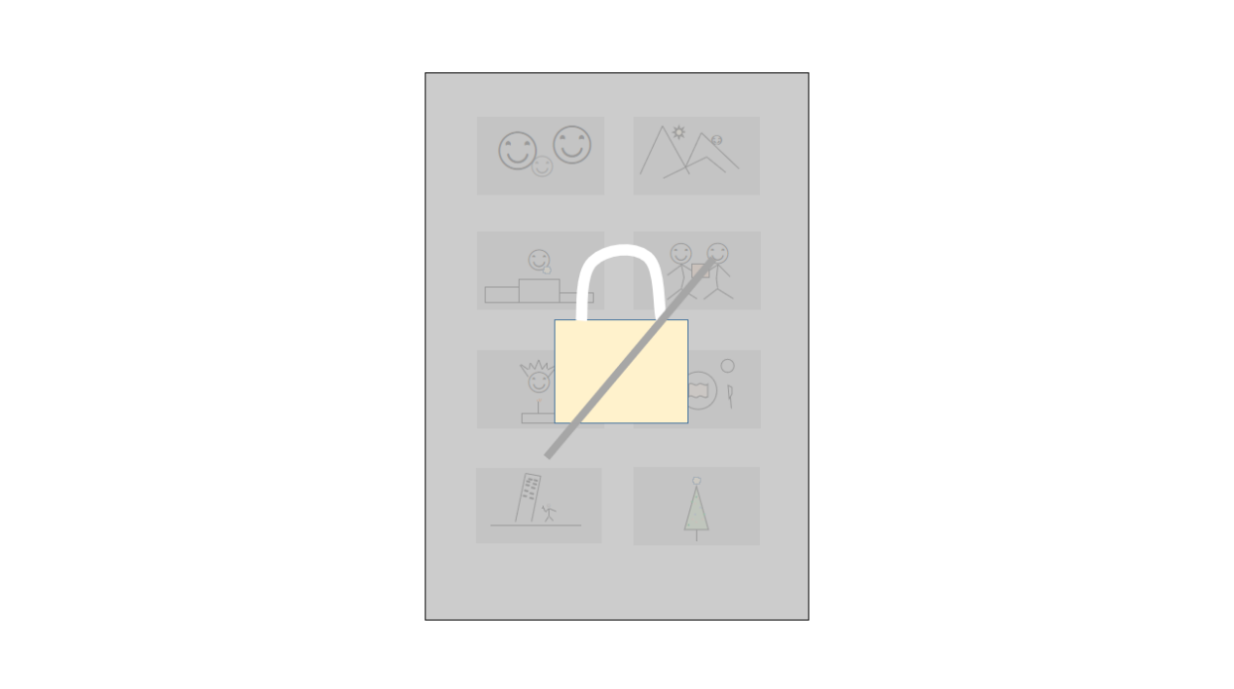

You know your password, you control your privacy.

1. **Come and go, freely**

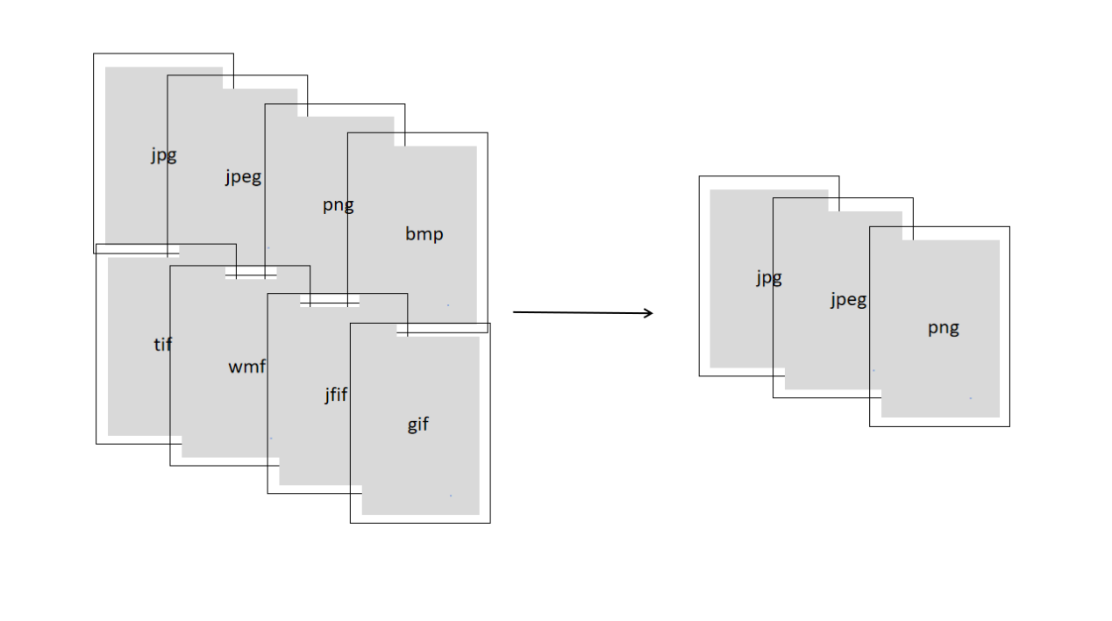

A variety of formats can be freely transformed, and the beautiful picture is always the same.

## Statement

This manual is a translated version. Thank you for your understanding if the description is unclear.

Please forgive me for the unclear, inconsistent, and incomplete descriptions in this introduction manual.

The illustrations in this introduction manual are only schematic representations and cannot fully represent the real situation.

All Rights Reserved.