Depth Map Analysis
- Outline
First, position and orientation data(in NDI coordinates) of 4 objects(‘sugarbox’, ‘softscrub’, ‘foambrick’, ‘mustard’) are collected. Then, combining with the grasp data(in NDI frame), grasp coordinates with respect to object are calculated. Finally, produce depth maps and do analysis.
- Data collection
When collecting data, 2 markers are attached on sides of the objects. Assuming the origin of the object is at the centre of the object bottom, relation between the marker and the bottom centre of the object is recorded which then could be used to calculate the transformation matrix. Which marker used for each image is recorded too which is used when calculating the orientation of the object. The coordinates of the table is recorded every day.
- Transformation
First, the relation between marker and bottom center of the object is used to calculate the coordinates of object in NDI frame. Then coordinates of table is used to transfer from NDI frame to table frame. Finally, since the data for grasp is also in table frame, coordinates of grasps in object frame are obtained. However, when implementing this in Matlab, it is noticed that the origin of the mesh is not located at the bottom center of the object. Therefore one more transformation is needed to transfer from object frame to the mesh frame.
- Depth map
The depth map is produced by shooting rays from -35 degrees to 35 degrees with respect to the z axis of the TCP in both x and y direction. There’re 50 rays in both direction which gives a 50 by 50 depth map.
- Analysis
  - Analysis across different objects
For each pixel, the mean, standard deviation, maximum and minimum are calculated.
    - Mean
When calculate the mean, the value for the pixels that the ray does not hit the object is set to be 300 mm. The result is shown in Figure 1.
It could be observed that the objects are most likely to locate at the centre area. Compared to the upper part, the lower part has higher value which means when grabbing objects, the upper part of the TCP is closer to the object than the lower part.
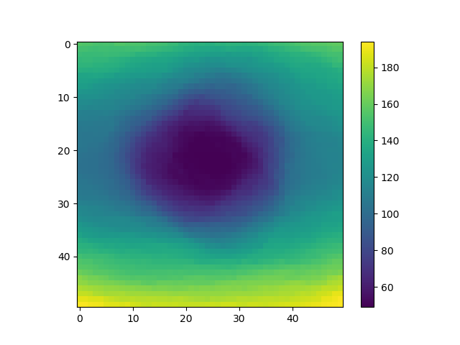Figure 1: The mean of depth maps across different objects
A Gaussian filter is then added to the depth map, results with sigma equals 5 and 10 are shown respectively in Figure 2 and Figure 3. From these two figures, a dark horizontal band around the centre could be seen which indicates that the objects are more likely to be alone this direction.

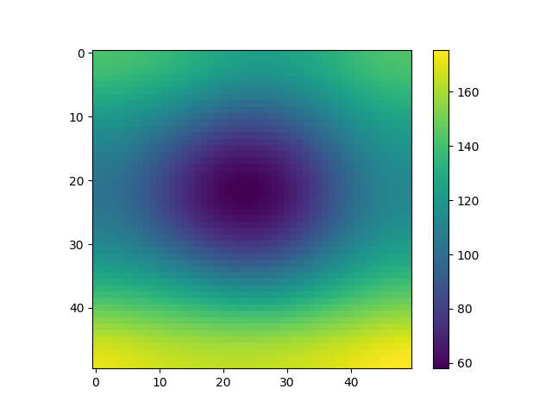Figure 2: The mean of Gaussian filtered depth maps with sigma equals 5
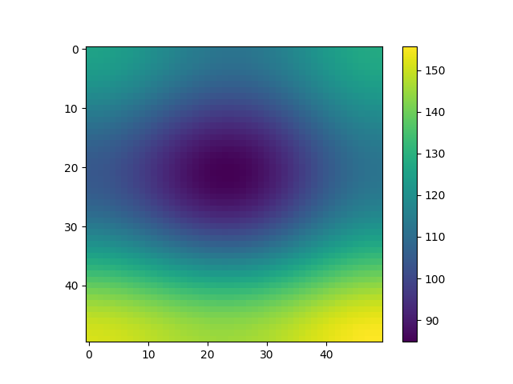Figure 3: The mean of Gaussian filtered depth maps with sigma equals 10
    - Standard deviation
Similar to the mean,the value for the pixels that the ray does not hit the object is set to be 300 mm. The result is shown in Figure 4, Figure 5 and Figure 6.

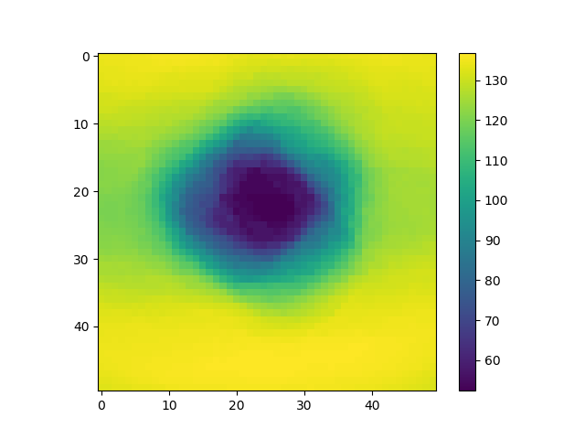Figure 4: The standard deviation of depth maps across different objects

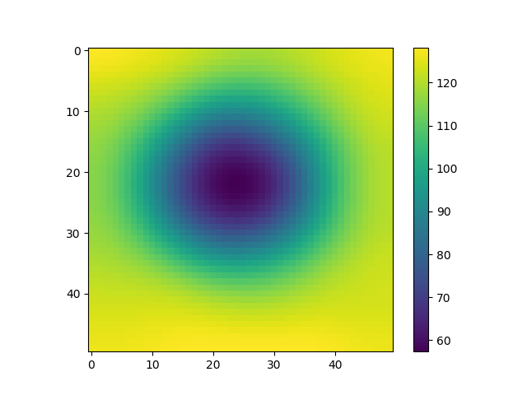Figure 5: The standard deviation of Gaussian filtered depth maps with sigma equals 5
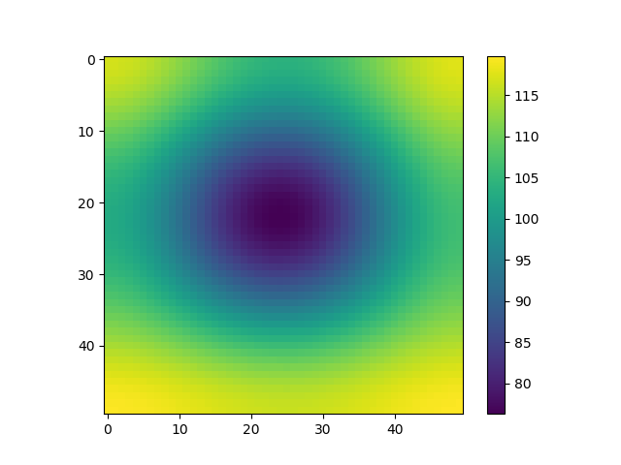Figure 6: The standard deviation of Gaussian filtered depth maps with sigma equals 10

    - Maximum
When calculate the maximum, the value for the pixels that the ray does not hit the object is set to be 0mm, the result is shown in
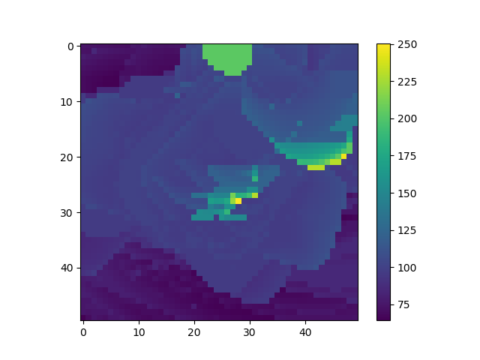Figure 7: The maximum of depth maps across different objects
It could be seen that there are points with extremely high values caused by the geometry of the ‘softscrub’ object. Those noise could be eliminated by taking out the maximum values in each pixel and then plot the maximum value of what left in each pixel as shown in Figure 8 and Figure 9. It shows that the centre area has a higher maximum depth than the surrounding area. This makes sense because when object is far away from the TCP, it is more likely to only cover the centre area. While when the object covers the surrounding area too, it is more likely to be close to the TCP.

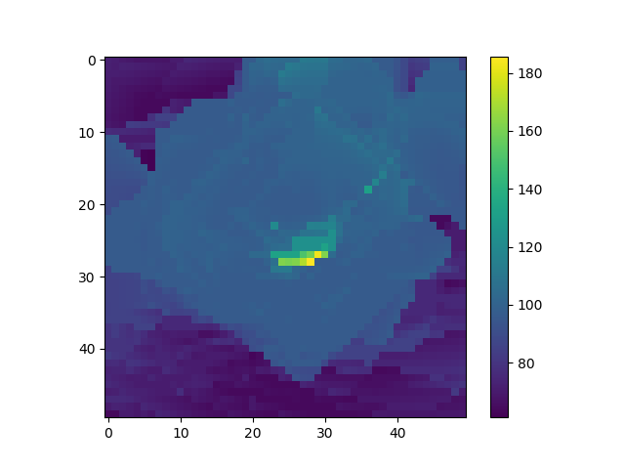Figure 8: The Second maximum of depth maps across different objects
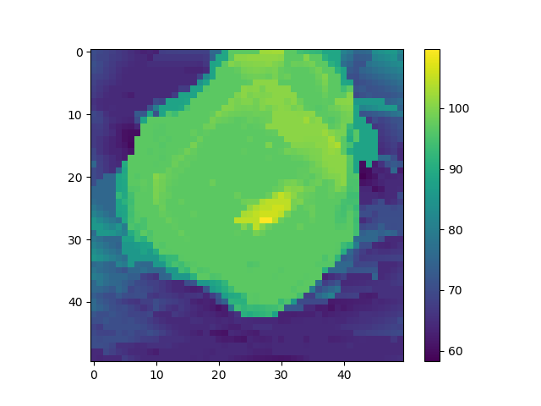Figure 9: The Fourth maximum of depth maps across different objects

    - Minimum
When calculate the maximum, the value for the pixels that the ray does not hit the object is set to be 300mm, the result is shown in Figure 10.
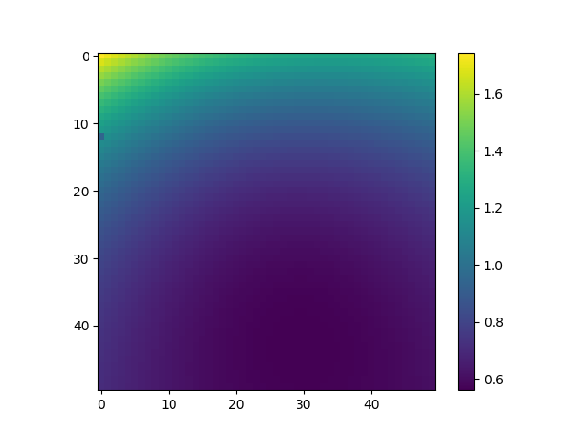Figure 10: The minimum of depth maps across different objects

