---------------------------------------------------------------
Install IIS
---------------------------------------------------------------

Control Panel > Programs and Features > Turn Windows features on

Check:

[v] Internet Information Services

Make sure that these options are also checked:

[v] NET.Extensibility 4.5
[v] ASP.NET 4.5
[v] ISAPI Extensions
[v] ISAPI Filters

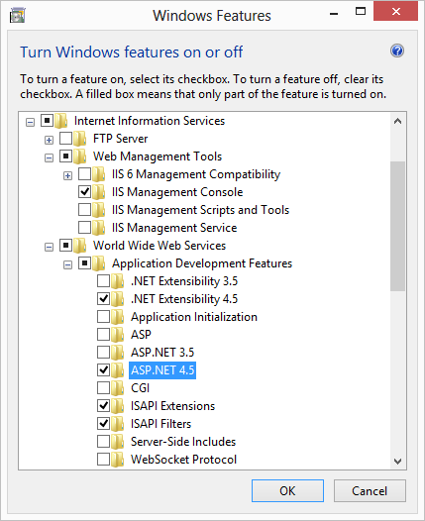

---------------------------------------------------------------
Install URL Rewrite Module
---------------------------------------------------------------

Go to: http://www.microsoft.com/web/downloads/platform.aspx
Download and launch: Microsoft Web Platform Installer 4.5

Install Server\URL Rewrite 2.0 Module:

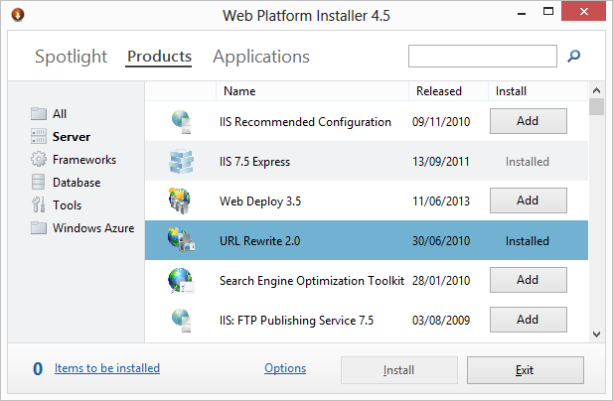

To configure to log rewritten URLs into the IIS log files, instead of logging the original URLs requested by HTTP client run the following command from an elevated command prompt:

reg add HKEY_LOCAL_MACHINE\SOFTWARE\Microsoft\InetStp\Rewrite /v LogRewrittenUrl /t REG_DWORD /d 1

and

iisreset

Check help: http://learn.iis.net/page.aspx/517/url-rewriting-for-aspnet-web-forms/

You can repair URL rewriter installtion by using manual installers:
http://www.iis.net/downloads/microsoft/url-rewrite#additionalDownloads

---------------------------------------------------------------
URL Rewrite intellisense for Visual Studio
---------------------------------------------------------------

Racer_S\x360ce\x360ce.Web\Resources\Rewrite_Intellisense_VS2012\Install.bat

---------------------------------------------------------------
Configure Web Site
---------------------------------------------------------------

Control Panel > Administrative Tools:

1. Open Computer Management
Services and Applications\Internet Information Services
2. Expand [Computer] name on other side and select 'Sites' node
3. Add Website...

Point 'Physical path' to x360ce.Web folder on your comuter:

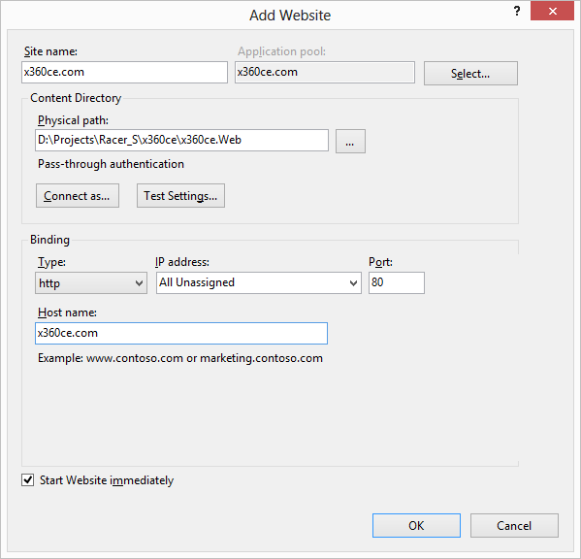

Select x360ce.com website and and update 'Bindings...' by adding 'www.x360ce.com' and 'localhost.x360ce.com' names:

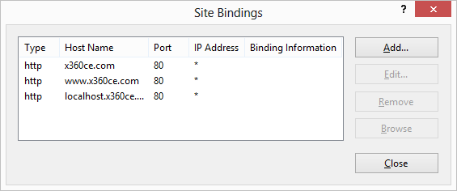

localhost.x360ce.com will be pointed to 127.0.0.1 IP address by default

---------------------------------------------------------------
Update Microsoft .NET 4.0 on IIS
---------------------------------------------------------------

1. Run the command prompt as administrator
2. Type the line in the command prompt below
On 32-bit Windows:
%windir%\Microsoft.NET\Framework\v4.0.30319\aspnet_regiis.exe -i
On 64-bit Windows:
%windir%\Microsoft.NET\Framework64\v4.0.30319\aspnet_regiis.exe –i

---------------------------------------------------------------
Enable 32-bit Applications
---------------------------------------------------------------

Control Panel > Administrative Tools:

1. Open Computer Management
Services and Applications\Internet Information Services
2. Expand [Computer] name on other side and select 'Application Pools' node
3. Select x360ce.com application pool on the right side and
4. Edit Advanced Settings…
5. Set Enable 32-Bit Applications to: true

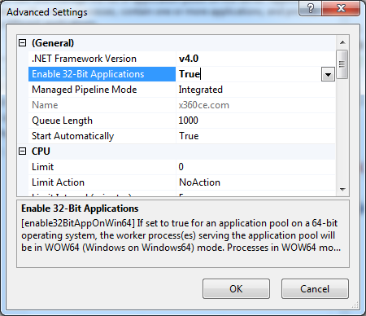

---------------------------------------------------------------
Unlock web.config modules and handlers
---------------------------------------------------------------

IIS implements "Configuration Locking". This is to help with IIS administration. The IIS Administrator can lock down Configuration Sections, Section Elements and Attributes at the IIS level.

You have to unlock web.config section by executing these two commands inside "Command Prompt" with administrator rights:

%windir%\system32\inetsrv\appcmd.exe unlock config -section:system.webServer/handlers

%windir%\system32\inetsrv\appcmd.exe unlock config -section:system.webServer/modules

---------------------------------------------------------------
Fix SQL Login after restoring database
---------------------------------------------------------------

Run this SQL script after restoring database from backup:

---------------------------------------------------------------
-- Fix SQL Login.
---------------------------------------------------------------
USE [x360ce]
GO
-- If SQL Server Login doesn't exist then...
IF NOT EXISTS (SELECT [loginname] FROM [master].[dbo].[syslogins] WHERE [name] = 'x360ceAdmin')
BEGIN
-- Create SQL Server Login.
CREATE LOGIN [x360ceAdmin] WITH
PASSWORD=N'localdev',
DEFAULT_DATABASE=[x360ce],
DEFAULT_LANGUAGE=[us_english],
CHECK_EXPIRATION=OFF,
CHECK_POLICY=OFF
END
-- Disable login.
ALTER LOGIN [x360ceAdmin] DISABLE
-- Map SQL 'Server Login' to 'Database User'
EXEC sp_change_users_login 'AUTO_FIX', 'x360ceAdmin'
-- Enable login.
ALTER LOGIN [x360ceAdmin] ENABLE;

---------------------------------------------------------------
How to Open *.SQLPROJ Projects
---------------------------------------------------------------

If your Visual Studio can't open *.sqlproj projects then you don't have "Microsoft SQL Server Data Tools" installed. Go here and download them for your version of Visual Studio:

http://msdn.microsoft.com/en-us/data/tools.aspx
You can download these tools as an ISO image (~1.7GB)

