**Challenge  
Booger**

SOLUTION:

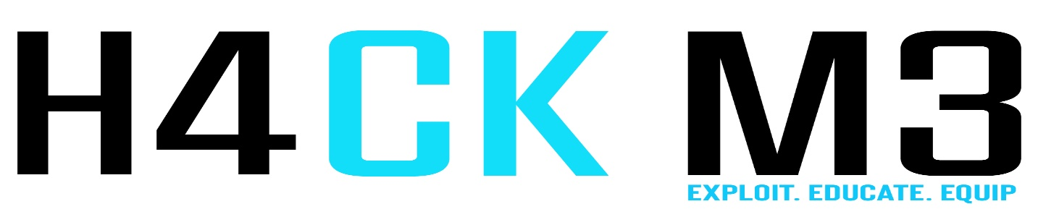Tools:

Stegsolve

And you will see the qr code

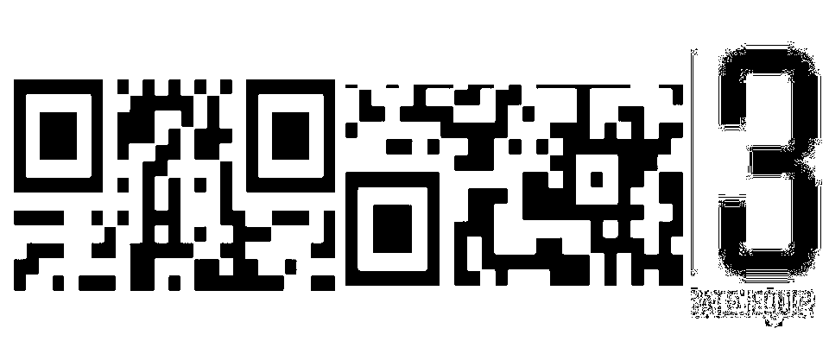

Since the Qr code is being crop, So arrange first the Qr code and you will get the flag

Flag : **HM3CTF{e4sy_QrCod3}**

**Challenge:  
BLIND STUFF**

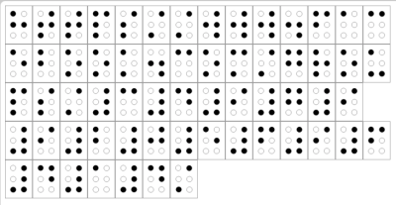

Tools:

Search for the Braille alphabet

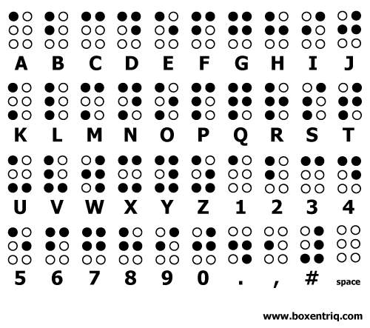

And you will get facebook group page link

<https://www.facebook.com/groups/349799205696414/>

and the flag.

**Flag: HM3CTF{T00K_Y0U_L0NG_3N0UGH}**

**Challenge**

**Brain Muscle**



**As you can see there’s esoteric language there like "[", "]", "+", "=", "-", ".", ",", "<", ">"**

**And decode it so that you will get the flag.**

**Flag: HM3CTF{br4in_mu5cl3#}**