Compass
Using the magnetometer on the MICA platform
Author: Peter Volgyesi, ISIS / Vanderbilt University

How the magnetometer works ?
The MICA sensor board has a magnetometer and some accessory ICs (amplifiers and digital potentiometers) mounted on it. The magnetometer is a HMC1002 chip maid by Honeywell with two axes (X, Y), resolution of ~30 μGauss (Earth’s field is 0.5 μGauss) and range of -2 to 2 Gauss. The resistance of the axes depends on the direction and strength of the magnetic field around them.
Between the two outputs of each axis there is a small voltage that represents the measured strength of the magnetic field in the given direction. (The voltage is “produced” by a Wheatstone bridge). A typical (healthy) device produces 10mV/Gauss difference. This small voltage is amplified as it is described in the 1.Figure.
10 bits
0 – 3 V

Va1 = 0.92V – 2.08V
290mV/Gauss

Vm1 = 1.5V ± 20mV
10mV/Gauss

Vm2 = 1.5V ± 20mV
Vref = 1.36V – 1.94V
256 steps, 1 step = 5.8mV

Digital potentiometer
A/D
HMC 1002

Magnetometer
AMP
X 29
AMP
X 78
Low Pass Flt
500 Hz
VCC
Figure 1

Values on the figure are based on calculations only !
The amplification is quite large, especially after the second op. amp. Therefore it is very important to set the output of digital potentiometer very close the Va1 voltage. Otherwise, the A/D converter won’t be able to measure the voltage on its output.
Now, to measure the earth’s magnetic filed we will do the following trick:
- We want to set the bias of the whole system to have a measured voltage of ~1.5 V on the ADC. So, we would like to see a digital value around 512 (BIAS_CENTER) coming from the ADC.
- The achieve our first goal, increase the value of the potentiometer while the ADC value is less then BIAS_CENTER. Every step on the potentiometer will increase or decrease (if we are stepping down) the ADC value by about 32 (BIAS_SCALE).
- Now, the final measured value: ADC_VAL + BIAS_SCALE * BIAS_STEP, where ADC_VAL is the current value measured by the ADC and BIAS_STEP is the digital value of the potentiometer.
Using the previously described simple iteration, we will get a digital value between 0-9000. However, in practice typical values will be between 1500-4500. Unfortunately, every device and every axis will have its own distinct offset and range. (And the sensitivity is degrading by time, also)
So, to build a compass we need a second algorithm, which calibrates itself by measuring the min and max values we have seen on the axes:
- Get the axis readings (magx, magy).
- If ,
- Execute step 2. for 
- Calculate 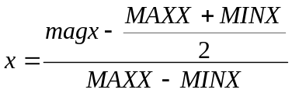
- Execute step 2. for
- 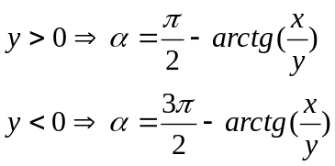
Now, is our direction (in radians).

Software Components
The first algorithm is implemented in TinyOS. The module called SmartMagC gives you pairs of values produced by that algorithm. You can set the BIAS_CENTER and BIAS_SCALE (empirical values) on its interface (calibrate(…)).
The second algorithm is implemented in Java (in the GUI subdirectory). You can set the BIAS_CENTER and BIAS_SCALE values from the GUI also.
To use the compass, follow this procedure:
- Compile and install the Compass TinyOS application on a MOTE with sensorboard. (Make sure, that the magnetometer is installed on the board)
- Compile and install the GenericBase TinyOS application on another MOTE. The first MOTE will send its measurements through radio.
- Compile the java application (Compass.java)
- Turn on the first MOTE and wait 5-10 seconds (it’s going to calibrate itself, and in this period all the values sent by the MOTE are faulty)
- Start the java application, and turn the MOTE around slowly. A whole (360 degree) turn must calibrate the second algorithm.
- Play with the BIAS values, if you wish and have fun. (When you set a new value, the compass MOTE will toggle its yellow LED when it receives these values)
- Enhance the algorithms, and my implementation
