CENS

Mica2 Data Acquisition Board

FEATURS

- Mica2 daughter Board
- 7 single ended 12bit ADC channels
Range 0-2.5V, precision 0.6mV
- 3 differential 12bit ADC channels
Range 0-2.5V, precision 0.6mV
- 4 differential 12bit ADC channels with high gain
Range ±12.5mV, precision 6μV
- 3 Excitation
2.5V, 3.3V, 5.0V
- 6 Interrupt driven digital Input
- 6 Digital output
- One relay normally closed
- One relay normally open
- One high speed counter channel
- Low power sleep
- On board temperature and humidity sensor
- On-board E2PROM for channel configuration
- Miniature terminals for easy sensor
connection
- Software driver for TinyOS

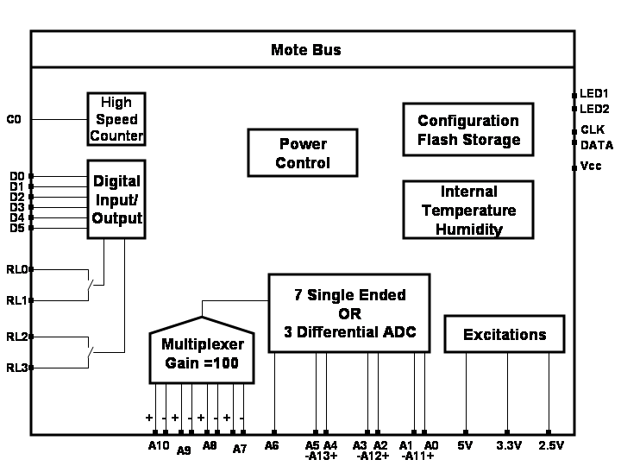

Draft – Aug 2003

MDA300CA

APPLICATIONS

- Wireless Low power instrumentation
- Weather measurement systems
- Precision Agriculture and irrigation control
- Habitat monitoring
- Soil analysis
- Remote process control

Description

MDA300CA is designed as a general measurement platform for Mica2. Analog sensors can be attached to different channels based on the expected precision and dynamic range. Digital sensors can be attached to the provided digital or counter channels. Mote samples analog, digital or counter channels and can actuate via digital outputs or relays. The combination of the Mote (MPR400CB) and MDA300CA can be used as a low power wireless Data acquisition device or process control machine.

CENS
This board can be damaged by ESD. ESD damage can range from subtle performance degradation to complete device failure.

Absolute Maximum Ratings:
+VDD to GND...............................–0.3V to +5.5V
Operating Temperature Range ...40°C to +105°C
Digital Lines:
Input voltage range*………...-0.5 V to V_{DD}+ 0.5 V
Continuous output low current…………….50 mA Continuous output high current……………–4 mA
Analog Lines:
Input voltage range. ………-0.2 V to V_{CC} + 0.5 V
Counter Line:
Input voltage range ………………….0 V to 5.5V
Relays:
Maximum Contact Voltage………………….100V
Maximum Contact Current………………..150mA
*The input negative-voltage ratings may be exceeded if the input and output current ratings are observed.
Electrical Characteristics: +2.7V

Analog channels
PARAMETER | CONDITIONS | MIN TYP MAX | UNITS
ANALOG INPUT (A0-A6;A11-A13)  Full-Scale Input Scan  Absolute Input Range  Capacitance  Leakage Current | Positive Input - Negative Input  Positive Input  Negative Input | - 2.5V  -0.2 VDD+0.2  -0.2 +0.2  25  ±1 | V  V  V  pF  μA
SYSTEM PERFORMANCE  No Missing Codes  Integral Linearity Error  Differential Linearity Error  Offset Error  Offset Error Match  Gain Error  Gain Error Match  Noise  Power-Supply Rejection |  | 12  ±0.5 ±1  ±0.5 -1,+2  ±0.75 ±2  ±0.2 ±1  ±0.75 ±3  ±0.2 ±1  33  82 | Bits  LSB*  LSB  LSB  LSB  LSB  LSB  μVrms  dB
Precision Differential Channels (A7-A10)  Offset Error  Gain Error  Input Impedance | Software Calibration | ±1  ±0.2  1.0 | LSB  %  MΩ
*LSB means Least Significant Bit. For channels A0-A6 and A11-A13 it is 0.6mv and for A7-A10 it is 6μv.

Internal channels
PARAMETER | CONDITIONS | MIN TYP MAX | UNITS
TEMPRATURE INPUT  Range  Accuracy | @ 5-40°C  @ <5°C or >40°C | -40 85  ±0.4  ±1.5 | °C  °C  °C
HIMIDITY INPUT  Range  Accuracy  Hystersis | @ 10-90% non-condensing  @ >10% or <90% | - 100  ±2  ±4 | %  %  %  %
BATTERY VOLTAGE INPUT  Accuracy* | Using Internal Mica2 circuit | 5 | mV
*For correct voltage reading Mica2’ JTAG should be disabled. Consult the “BatteryM.nc” inside tos/sensorboards/mda300ca for instruction or consult with manufacturer at Xbow (http://www.xbow.com).

Digital channels
PARAMETER | CONDITIONS | MIN TYP MAX | UNITS
VIH High-level input voltage  VIL Low-level input voltage  IOH High-level output current  IOL Low-level output current |  | 0.7×VCC VCC + 0.5V  –0.5 0.3 ×VCC  –1  25 | V  V  mA  mA

Draft – Aug 2003

MDA300CA

Parts in yellow are not in current implementation.

Draft – Aug 2003

MDA300CA

CENS

Counter channel
PARAMETER | CONDITIONS | MIN TYP MAX | UNITS
Recommended Range  VT+ Positive-going input threshold voltage  VT- Negative-going input threshold voltage | It also depend on the mote working load | 200  - 2.2  0.9 1.9 | Hz  V  V

Excitation
PARAMETER | COMPONENT | MIN TYP MAX | UNITS
5.0V*  Output drive**  Short circuit current  Accuracy |  | ±22  ±59  ±2 | mA  mA  %
3.325V*  Output drive**  Short circuit current  Accuracy |  | ±22  ±59  ±2 | mA  mA  %
2.5*  Output drive**  Short circuit current  Accuracy |  | ±22  ±59  ±2 | mA  mA  %
*Excitations are proportional to the ADC reference for maximum accuracy.
**Driving Capacitive Load needs special consideration for prevention from oscillation. Refer to excitation section.

Power Consumption
PARAMETER | COMPONENT | ACTIVE (TYP) POWER DOWN(TYP) | UNITS
Part Break-down  TLV2473IDGQR  TLV2473IDGQR  MAX1795EUA  SN74AHC1G86DBVR  PCF8574APWR  PS7112L-1A  PS7141L-1B  ADS7828EB  INA321E  TLV2370IDBVR  SHT15  ADG715BRU  24LC64-I/SN  SN74AHC1G14DBVR | U11  U12  U10  U6  U8  RL1  RL2  U1  U2  U3  U5  U4  U9  U7 | 1100 1  1100 1  0.1  1 1  40 2.5  2500-3500 0  2500-3500 0  150-300 0.4  40 0.01  470 25  550 0.3  10 10  1000-3000 30  1 1 | μA  μA  μA  μA  μA  μA  μA  μA  μA  μA  μA  μA  μA  μA
MDA300CA | Complete Board | 73 | μA

Timing Parameters
PARAMETER | CONDITIONS | MIN TYP MAX | UNITS
I2C Clock  ADC Conversion Time  ADC Throughput Frequency  Digital Lines delay (Input/Output)  Relay ON/OFF time | Hardware I2C | 80  6  2  4  0.4 | KHz  μSec  KHz  ΜSec  mSec

CENS
PIN DESCRIPTION
A0 | Single-ended analog channel 0 or analog channel 11 positive side
A1 | Single-ended analog channel 1 or analog channel 11 negative side
A2 | Single-ended analog channel 2 or analog channel 11 positive side
A3 | Single-ended analog channel 3 or analog channel 11 negative side
A4 | Single-ended analog channel 4 or analog channel 11 positive side
A5 | Single-ended analog channel 5 or analog channel 11 negative side
A6 | Single-ended analog channel 6
A7+ A7- | Differential analog channels 7
A8+ A8- | Differential analog channels 8
A9+ A9- | Differential analog channels 9
A10+ A10- | Differential analog channels 10
DATA | I2C Data
CLK | I2C Clock
D0 - D6 | Digital Lines D0 to D6
C | Counter Channel
LED1 | RED LED
LED2 | GREEN LED
E5.0 | 5.0 V excitation
E3.3 | 5.0 V excitation
E2.5 | 5.0 V excitation
Vcc | Vcc of the Mote
RL1 | Relay one sides (Normally-Open)
RL2 | Relay two sides (Normally-Closed)

Theory of Operation:

Single Ended Analog Channels

Channels A0-A6 are single ended successive approximation A/D converters. The reference of the ADC is 2.5V. Signals with dynamic range of 0-2.5V can be plugged to these channels. The least significant bit value is 0.6mV. The result of
MDA300CA

ADC can be converted to voltage knowing that Voltage = 2.5 × ADC-READING / 4096.
PIN CONFIGURATION
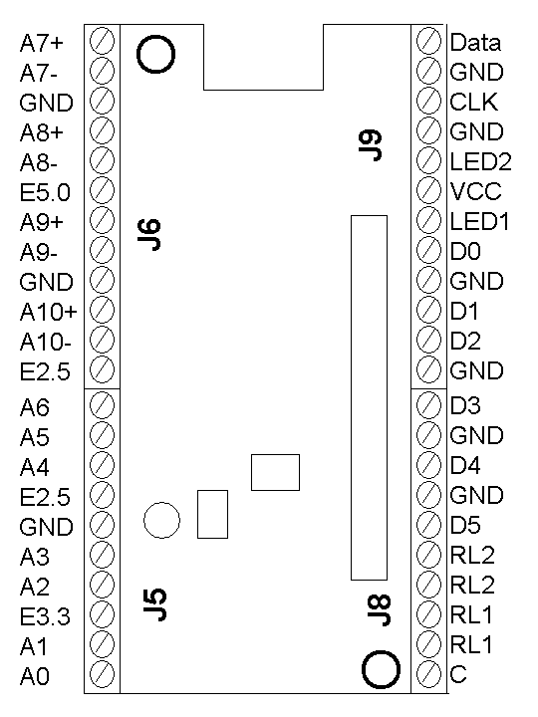
TOP VIEW

Note that these channels are shared with differential channels A11-A13 and both of them cannot be used at the same time.

Differential Analog Channels

Channels A11-A13 can be used for differential signals. Dynamic range and conversion formula is the same as single ended channels.

Differential Precision Analog Channels

Channels A7-A10 are precision differential channels. They have a sensor front end with gain of 100. Dynamic range of these channels is ±12.5mV. The offset is cancelled by measurement of the constant offset and writing it to the E2PROM for software cancellation. The result of the ADC can be converted to voltage (in mv) knowing that Voltage = 12.5 (ADC_READING /2048 -1)
Draft – Aug 2003

Digital Channels

Channels D0-D5 are Digital channels that can be used for digital input or output. They can be used for counting external phenomena, triggering based on external events or for actuating external signal.

The result of these channels can be saved to the E2PROM for totalizing sensors to avoid losing count in case of power reset. These channels can be protected against switch bouncing. When they set as input they have internal pull-up resistance so that they can be plugged to switch (close-open) sensors.

Counter Channel

This channel is appropriate for high-speed counting or frequency measurement. It has a Schmitt triggered front end.
Draft – Aug 2003

MDA300CA

CENS

Internal Channels

There is an internal sensor for temperature and humidity. This can be used for monitoring the health of the system. It can also be used for “cold junction compensation” in thermocouple measurement applications. The Voltage of the device also can be read using the Mica2’s internal monitor to have lifetime information.

Relay Channels

There are two relay channels that can be used for actuation of external phenomena. Both relays are optical solid state for maximum isolation and minimum power consumption. One relay is normally open and the other one is normally closed type.

External Sensors Excitation

There are three excitation of 5.0V, 3.3V, and 2.5V available for exciting external sensors. They can be used for turning on active external sensors or they can be used in half bridge or full bridge sensors such as strain gauge, force or pressure measurement.

LEDs

LED signals are brought out for applications that use motes inside enclosures and want to bring the LEDs to the case.

Power Supply (Vcc)

It can be used for external Battery attachment.

SOFTWARE ARCHITECTURE

Architecture

The software driver is written in nesC under tinyOs-1.x. There is only one component (SamplerC.nc) that user needs to include and that component abstracts all components of the MDA300A underneath.

The Sample interface (provided by SamplerC.nc) lets the application to call all the channels periodically (or one-shot) with necessary parameters. Application will continuously receives the corresponding event based on the time interval setting. It will receive the event only once in the case of ONE_SHOT an in the case of digital or counter channels it receives the event asynchronously if EVENT parameter has been set. On call for the sample a record number is returned that can be used for reconfiguration or retaking of that sampling. Note that multiple calls in different intervals can be used for one channel.

Digital channels can be set to output and the corresponding channels can be set to high, low or toggle. Relay channels are output by default and can be set

If sampling of different records collides on a shared resource like ADC the underlying software holds the sampling until the shared resource is free.

Sampling of internal temperature and humidity channels faster than on second interval may lead to internal sensor self heating and is not recommended.

The data that returns in the event is the raw value of ADC in case of ANALOG channels. It is the counter value in the case of COUNTER and DIGITAL channels. It is battery voltage in mili-volt in VOLTAGE channel, is humidity in 0-100% ranges in HUMIDITY channel and temperature in 0.1 Fahrenheit resolutions in TEMPRATURE channel.

Sampler leaves all underneath hardware in sleep when no sampling in progress. All external interrupts including digital and counter channels are active at that time.
Draft – Aug 2003

MDA300CA

CENS
Sample.nc Interface
Sampling Channels Synchronously or Asynchronously
command int8_t⁵ getSample(uint8_t channel¹,uint8_t channelType²,uint16_t interval³,uint8_t param⁴);
event result_t dataReady(uint8_t channel¹,uint8_t channelType²,uint16_t data⁶);
command result_t reTask(int8_t record⁵,uint16_t interval³);
command result_t reParam(int8_t record⁵,uint16_t param⁴);
command result_t stop(int8_t record⁵);
Digital Outputs
command result_t set_digital_output(uint8_t channel⁷);
command result_t High(uint8_t channel⁸);
command result_t Low(uint8_t channel⁹);
command result_t Toggle(uint8_t channel⁸);
1 it can be 0-13 in case of ANALOG; 0-6 in case of DIGITAL and it is irrelevant in case of COUNTER, VOLTAGE, TEMPRATURE and
HUMIDITY.
2 it can be ANALOG, DIGITAL, COUNTER, TEMPRATURE, HUMIDITY or VOLTAGE.
3 Interval in the order of 0.1 second. It can also be set to ONE_SHOT.
4 parameters that are described in the following tables.
5 The record number that getSample returns for later operations like reTasking or reParametring or stopping that record.
6 raw data from ADC or Counters.
7 channels 0-6.
8 channels 0-6, NORMALLY_OPEN_RELAY, NORMALLY_CLOSE_RELAY

Channel Parameters; ANALOG*
SAMPLER_DEFAULT | No Excitation, No Averaging, Sample Immediately
AVERAGE_FOUR | Return the result average of four sample
AVERAGE_EIGHT | Return the result average of eight sample
AVERAGE_SIXTEEN | Return the result average of sixteen sample
EXCITATION_25 | Turn 2.5V excitation before sampling
EXCITATION_33 | Turn 3.3V excitation before sampling
EXCITATION_50 | Turn 5.0V excitation before sampling
EXCITATION_ALWAYS_ON | Leave excitation always ON. Default is only ON before sampling of the specified channels.
DELAY_BEFORE_MEASUREMENT | After turning excitation ON insert delay before sampling. Default is immediate sampling. This is specifically important in capacitive sensors.  Delay is fixed and it is equal to 50ms.
* Channels 0-13

Channel Parameters; DIGITAL*
SAMPLER_DEFAULT | No Excitation, Action based on rising edge, Synchronously based on the interval
RISING_EDGE** | Action based on rising edge
FALLING_EDGE** | Action based on falling edge
EVENT | The event fired asynchronously at the edge, interval is irrelevant
EEPROM_TOTALIZER | Keeps the last reading in EPROM. Continue at power ON from last reading. Always update EEPROM.
EXCITATION_33 | Turn 3.3V excitation ON (always)
EXCITATION_50 | Turn 5.0V excitation ON (always)
RESET_ZERO_AFTER_READ | Reset variable to zero for measurement of frequency. Default is accumulative.
DEBOUNCER | Turn on de-bouncer filter
*Channels 0-6
** if both RISING_EDGE and FALLING_EDGE action happens on both edge.

Channel Parameters; COUNTER*
SAMPLER_DEFAULT | No Excitation, Action based on rising edge, Synchronously based on the interval
RISING_EDGE** | Action based on rising edge
FALLING_EDGE** | Action based on falling edge
EVENT | The event fired asynchronously at the edge , interval is irrelevant
EEPROM_TOTALIZER | Keeps the last reading in EPROM. Continue at power ON from last reading. Always update EEPROM.
EXCITATION_33 | Turn 3.3V excitation ON (always)
EXCITATION_50 | Turn 5.0V excitation ON (always)
RESET_ZERO_AFTER_READ | Reset variable to zero for measurement of frequency. Default is accumulative.
*Channel is irrelevant
** if both RISING_EDGE and FALLING_EDGE action happens on both edge.

Channel Parameters; VOLTAGE, TEMPRATURE, HUMIDITY*
SAMPLER_DEFAULT | No effect
*Channel is irrelevant

Timing Diagram and Parameters
MDA300CA

CENS
ADC sampling time increases with AVERAGE_FOUR option to 3.29ms and the effective throughput is reduced to 304Hz.

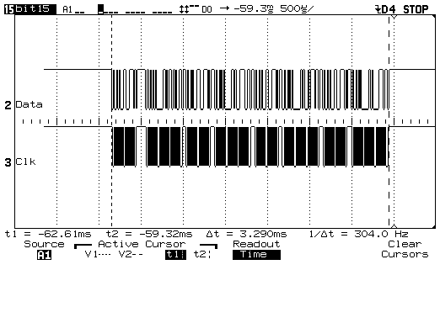
Draft – Aug 2003

ADC sampling time increases with AVERAGE_SIXTEEN option to 13.84ms and the effective throughput is reduced to 72.25Hz.

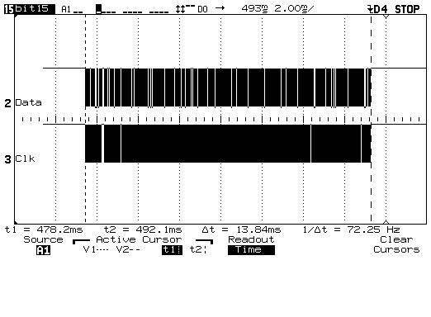
The delay time between stability of excitation and start of sampling is 22.8μSec in no load condition. If the sensor is not stable by that time, then the option DELAY_BEFORE_MEASURMENT should be called for the sensor to be stable. This is specially may be important in the case of capacitive sensors.

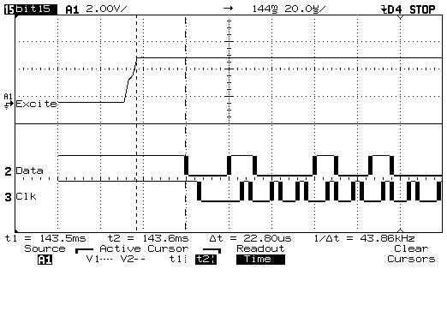
ADC sampling time is 782μSec and the effective throughput is 1.279KHz. I2C Clock is 80KHz.

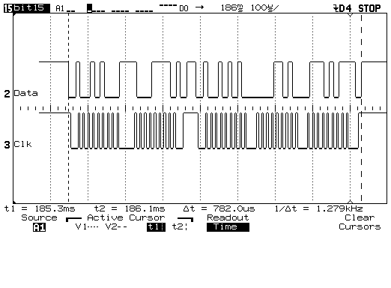

DELAY_BEFORE_MEASUREMENT turns excitation immediately but delays sampling 50ms so that the sensor gets stable. This has effect on the maximum sampling throughput, which will be reduced to 20Hz.

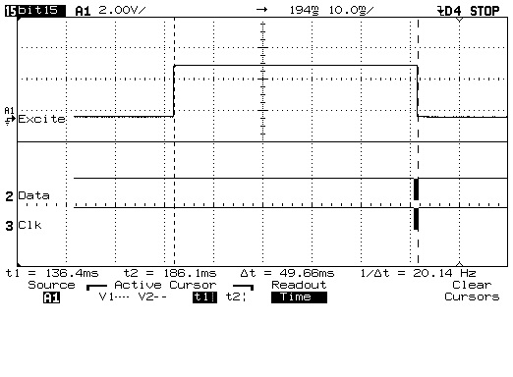

Delay of Digital line is 362μSec. This picture shows the time from the edge of the input to the end of reading of the status of digital lines.

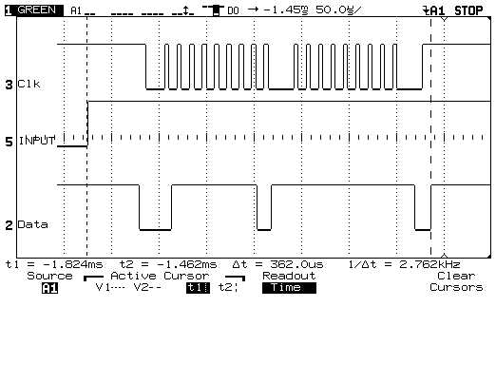
Draft – Aug 2003

MDA300CA

CENS
Delay of Counter line is 16.7μSec.

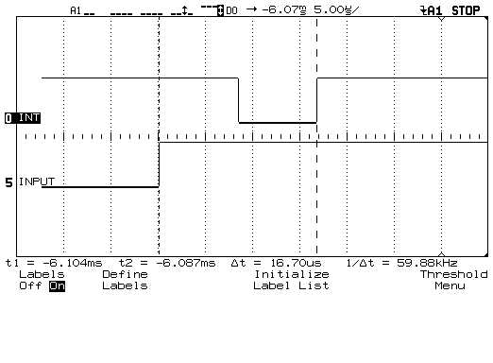
Example Application
Measurement of External temperature (air, soil, water) using NTC or PTC thermistor:
NTC is “Negative Coefficient” and PTC is “positive Coefficient” temperature sensor. They are very precise and are widely used in industry. They are used as below:
Excitation R_{fix}
GND 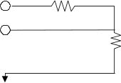

Sensor* | THERMISTOR 10K OHM NTC From “BC Components” part number “2322 640 55103”
Rfix** | 13K0.1%
Excitation | 2.5V
Sample Code*** | record = call Sample.getSample(1,ANALOG,600,EXCITATION_25);
Conversion**** | result = (int)(0.5 + 10 * (110.2149 - 1.138253e-1 * adc + 7.509040e-5* adc * adc - 3.188276e-8* adc* adc * adc + 7.069376e-12* adc * adc * adc * adc - 6.502949e-16* adc *adc *adc * adc * adc));
*It can be purchased from digikey, www.digikey.com ; BC1489-ND
**13K 0.1% resistors from Mouser Electronics, www.mouser.com part 66-RC55-D-13K
***In the sample code channel one called each 60 second as example and it can be any of the channels 0-6.
****This polynomial gives less than 0.1°C error over -25 to 60 results in tenths of a degree.

Sensor | Water and Soil Temperature Sensors probe 108 from Campbell Scientific, http://www.campbellsci.com/
Rfix | None, internal inside the sensor.
Excitation* | 5.0V
Sample Code** | record = call Sample.getSample(1,ANALOG,600,EXCITATION_25);
Conversion | To be determined
*5.0V excitation gives 125mV range which can be resolved to 125mV/0.6mV or 0.48%. Note to turn off channels not to let channels be always on to avoid self heating which may lead to calibration error in measurement.
**In the sample code channel one called as example and it can be any of the channels 0-6.
***For air temperature a sun shield needed for maximum accuracy.
Single Ended Analog Channel
R_{sense}

Draft – Aug 2003

MDA300CA

CENS

Measurement of Humidity:
Humidity sensors are usually capacitive sensor.
Excitation R_{fix}
GND 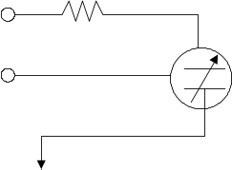

Sensor* | HumiRel HM1500; immersion OK, with NTC temperature compensation
Rfix** | 10Ω
Excitation | 3.3V
Sample Code*** | record = call Sample.getSample(1,ANALOG,600,EXCITATION_33 | DELAY_BEFORE_MEASUREMENT | AVERAGE_FOUR);
Conversion**** | result= (int) (( -3.9559e-6*adc * adc + 6.1797e-2*res-67.681) +0.5);
*can be purchased from Digikey, www.digikey.com ; HM1500-ND
**Only in beta release of the board to avoid oscillation of excitation with capacitive loads. It can be purchased from Digikey,
www.digikey.com ; 10.0XBK-ND
***In the sample code channel one called as example and it can be any of the channels 0-6. Delay before excitation is necessary in driving capacitive loads for sensor stability.
****in 0-100% humidity

Single Ended Analog channel
Measurement of Soil Moisture:
Soil Moisture sensors are usually capacitive sensor. EC-10 and EC-20 are particularly good at measurement of soil moisture in wet conditions. In dry conditions needs carefull calibration for specific soil type. Also in the presence of the contamination may need extra calibration. Consult manufacturer for further information.

Excitation R_{fix}
GND

Sensor | Decagon Echo ECHO10 and EC-20; http://www.decagon.com/
Rfix* | 10Ω
Excitation | 2.5V
Sample Code** | record = call Sample.getSample(1,ANALOG,600,EXCITATION_33 | DELAY_BEFORE_MEASUREMENT | AVERAGE_FOUR);
ECHO-10 Conversion*** | conv= ((float)adc) *2.5 /4096;  result = (int)(100*(0.000936 * (conv * 1000) - 0.376) + 0.5);
ECHO-20 Conversion*** | conv= ((float)adc) *2.5 /4096;  result = (int)(100*(0.000695 * (conv * 1000) - 0.29) + 0.5);
*Only in beta release of the board to avoid oscillation of excitation with capacitive loads. It can be purchased from Digikey,
www.digikey.com ; 10.0XBK-ND
**In the sample code channel one called, as example and it can be any of the channels 0-6. Delay before excitation is necessary in driving capacitive loads for sensor stability.
*** Result is volumetric % water content. According to Manual Theta = 0.000936*mVout - 0.376 where Theta is the volumetric water content fraction (1=100%)
Single Ended Analog channel

Leaf Wetness:
Leaf wetness sensors are resistive sensors that change their resistance based on the wetness they experience. The end result is usually a discrete value between 0-10 (Or 0-15 depending on the model).

Excitation R_{fix}
GND

Sensor | Leaf wetness from Davis Weather; http://www.davisnet.com/weather
Rfix** | 510K0.1%
Excitation | 2.5V
Sample Code*** | record = call Sample.getSample(1,ANALOG,600,EXCITATION_25);
Conversion**** | conv= ((float)adc) *2.5 /4096;  result = (int)((10*(conv-1.66)/(0.51-1.66))+0.5);  result = result > 10 ? 10 : result < 0 ? 0 : result;
* The output is resistance to ground >1Meg dry, <130K wet So Dry is >1.66V, Wet is <0.51V
** It can be purchased from Digikey, www.digikey.com ; P510KBBCT-ND
***In the sample code channel one called each 60 second as example and it can be any of the channels 0-6.
Draft – Aug 2003

MDA300CA

CENS
Rain Gauge:
Rain gauges are usually ON/OFF connections. Each connection represents certain amount of rain. The accumulative value represents total amount of rain sensor visited since installation. Digital inputs have internal pull-up resistor and the sensor can be directly connected to a digital channel.
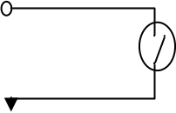

Sensor | Rain Collector from Davis Weather; http://www.davisnet.com/weather
Sample Code* | record = call Sample.getSample(1,DIGITAL,3000,EEPROM_TOTALIZER);
Rain Sensor from Davis** | result = dig;
*In the sample code channel one called, as example and it can be any of the channels 0-5.
** In some rain sensor DEBOUNCER may be needed for some rain sensors.
***Dig is the result of the event. It can be used directly and it is hundred times rainfall per inch
Motion Detector:
Motion detector can be turned ON using one of the excitations and expect event to happen when they observe a moving object. Motion detectors usually have Normally-Open or Normally-Closed output.

Sensor | Any Motion detector with 5V supply.
Sample Code* | record = call Sample.getSample(1,DIGITAL,3000, EVENT | EXCITATION_50);
Motion Detector | result = dig;
*In the sample code channel one called, as example and it can be any of the channels 0-5. RISING_EDGE or FALLING_EDGE can be set depending on the sensor. The event happens asynchronously (sampling time is irrelevant) and the application can do the action accordingly.
Excitation
Digital Input
Excitation
Digital Input
Digital Input

Draft – Aug 2003

MDA300CA

CENS
Wind Speed (Average and Gust) and Wind Direction:
Wind speed sensor anemometer is measuring number of wind speed pulses per second and translates them into gust wind and average wind speed. Wind direction measures a rotational potentiometer resistance and converts that value to an offset from north.

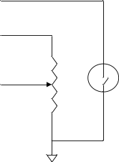

Sensor | Wind Speed and Direction Sensors, 034B set from Campbell Scientific, http://www.campbellsci.com/  OR  Wind Speed and Direction Sensors from Davis Weather , http://www.davisnet.com/weather
Excitation | 2.5V
Sample Code* | record = call Sample.getSample(1,ANALOG,600,EXCITATION_25);  record = call Sample.getSample(1,COUNTER,20, RESET_ZERO_AFTER_READ);
Conversion  Davis-Set | // KPH = freq*3.62 We count for 30 seconds (1/10 KPH)  // KPH = freq*2*1.810 We count for 2 seconds (KPH)  // Linear voltage to angle. 0V = North. 4 degree dead zone  gust = (int)((float)counter * 1.81 + 0.5);  wind = (int)((float)counter * 3.62/3 + 0.5);  direction = (int)((float)adc*356.0/4096+0.5);
Conversion  Campbell Scientific | // KPH = freq*2.879 We count for 30 seconds (1/10 KPH)  // KPH = freq*2*1.4395 We count for 2 seconds  // Linear V to Angle, 1/2 excitation.  gust = (int)((float)val*1.4395 + 0.5);  wind = (int)((float)val*2.879/3 + 0.5);  direction = (int)((float)val*356.0/2048+0.5);
*In the sample code analog channel one called each 60 second as example and it can be any of the channels 0-6 and counter channel is called for 2 second for gust wind and it is averaged for 30 second for wind speed. The addition of the values that are read in the 2 second interval for 15 times to measure the 30Second periode should be done in the application software.
GND

Wind Speed

Excitation

Wind Direction

Pressure:
Pressure can be measured with any analog pressure sensor. Example of that is MPXA6115A from Motorola.

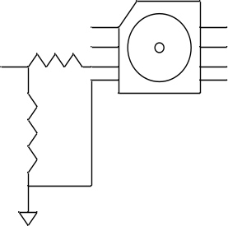

Sensor | MPXA6115A from Motorola
Rd* | 270K,1%
Excitation | 2.5V
Sample Code** | record = call Sample.getSample(1,ANALOG,600,EXCITATION_50 | DELAY_BEFORE_MEASUREMENT);
Conversion | // ADC is 1/2 chip Vout Result is in mBar/10  // Sensor output: PmBar = (Vo/Vs)*1111.11+105.555  result = (int)(((float)adc/4096)*11111.1 + 1055.55 + 0.5);
* It can be purchased from Digikey, http://www.digikey.com/ , P270KBBCT-ND
**In the sample code analog channel one called each 60 second as example and it can be any of the channels 0-6.

Single Ended Analog channel

EX
GND
Rd
Rd
Draft – Aug 2003

MDA300CA

CENS
Radiation Sensors:
Radiation sensors are very important for environmental studies. They mainly include Quantum Sensors for measure PAR in the 400 to 700 nm waveband and are available in terrestrial and underwater configurations. LI-COR Pyranometer Sensors measure solar radiation received from a whole hemisphere. They are suitable for measuring global sun plus sky radiation. LI-COR's Photometric Sensors measure illumination in terms of lux (1 footcandle = 10.764 lux). This is radiation as the human eye sees it. They all can be connected to the board using a shunt resistance. Rhunt resitance should be very precise for maximum accuracy. In addition each sensor has a separate calibration factor that is shipped with that from the company. All these radiation sensors can be purchased from Campbell Scientific and LI-COR.

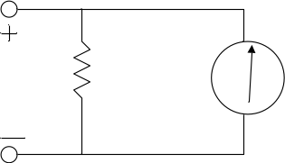

Sensor | LI-190SA Quantum Sensor, LI-200SA Pyranometers, LI-210SA Photometric Sensor
R_{shunt}* | Rshunt = 182Ω, 0.1%
Sample Code** | record = call Sample.getSample(7,ANALOG,600,EXCITATION_50 | AVERAGE_EIGHT);
Conversion*** | //Calibration Coefficient from factory  CC = 12.28 // in (µA/1000µmol s⁻¹m⁻²)  I = adc * 6.1 / Rshunt // current (µA)  L = 1000* I / CC // Light Intensity (µmol s⁻¹m⁻²)
* 182Ω 0.1% resistors from Mouser Electronics, www.mouser.com part 66-RC55-D-182
**In the sample code analog channel seven called each 60 second as example and it can be any of the channels 7-10.
***Note that calibration coefficient depends on individual sensor and is shipped via sensor.
Other Sensors:

List of other sensors will be added soon. This includes thermocouple, IR temperature sensor, thermopile, Strain gauge Bridge, force.

R_{shunt}
Precision
Differential
Analog
Channels

Draft – Aug 2003

MDA300CA

CENS
DIMENTIONS:

0.545”
1.880”
0.282”

2.255”
PACKAGING:

Packaging component are for connection of main Mica board to the MDA300CA and the enclosure are as below:

Screws | * Note1 | Qty. 2
Nuts | * Note1 | Qty. 1
Spacers | * Note1 | Qty. 2
Enclosure | * Note1 | Qty. 1
Battery | * Note1 | Qty. 1
*consult with manufacturer at Xbow (http://www.xbow.com).
0.4”
2D0.125”
All Dimensions in Inch
Contact information:

Purchasing: sales@xbow.com
Technical Information: “Mohammad Rahimi” mhr@cens.ucla.edu
Environmental Sensing Information: “Mike Wimbrow” mike.wimbrow@jamesreserve.edu

Web Information: http://www.cens.ucla.edu/~mhr/daq/

Source Code: http://cvs.cens.ucla.edu/viewcvs/viewcvs.cgi/tos-contrib/sensorIB/
Instruction at http://cvs.cens.ucla.edu/
Source Code: http://sourceforge.net/projects/tinyos/

