Computers graphics – Final project

I apologize in advance if the colors are weird, I am colorblind. All the project is written in pyopengl using opengl 3.1.7

To run the code, simply run `python main.py` (you may need to install requirements by running `pip install -r requirements.txt`)

This 3D scene renders a cow in a land with trees, lamps and rocks. The lamps are metallics and illuminate the surrounding.

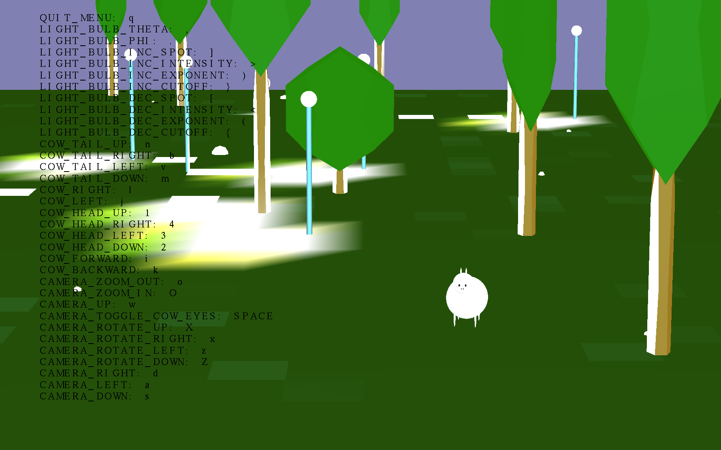

Every material is defined in the materials.py file and used when needed, we won’t go over it as it is trivial.

**Every object is defined in its own class in the objs/ directory and drawn by the draw() method, let’s go over them:**

**1. The land** is composed of a lot of small quads, the size and the accuracy are controlled by parameters. The normal of every small squad is randomized a bit to add texture to the land.

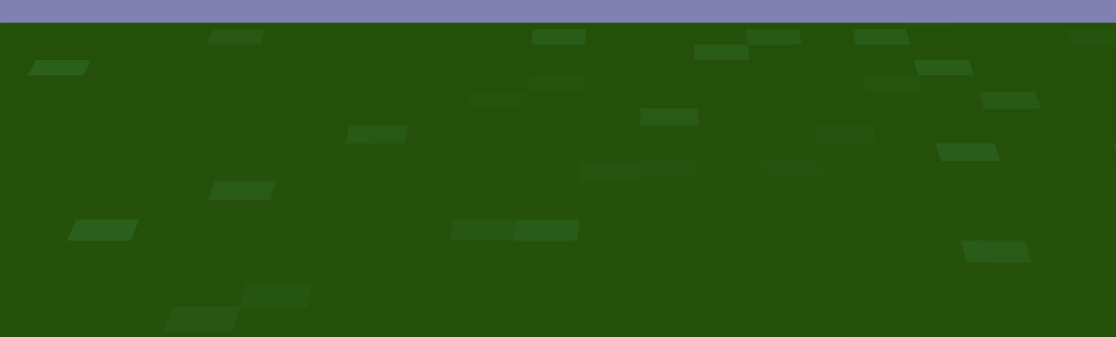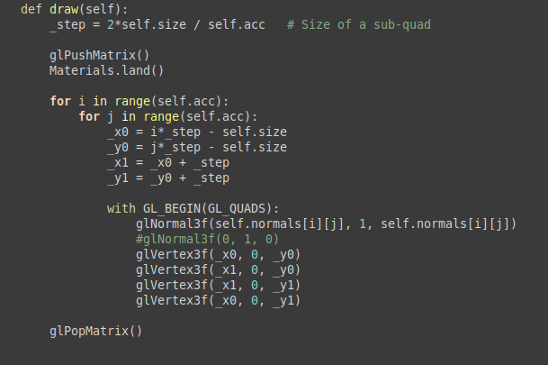

**2. The cow** is white, it is composed of ellipses and circles, has two eyes, a nose, legs, ears and a tail. She can move his head and tails up left right and down and can move and look in every direction, all her physical attributes can be configured with parameters, the cow is relatively generic and will adapt to attribute changes. Periodically she moves her tail to look alive, she really love the small land she lives in.

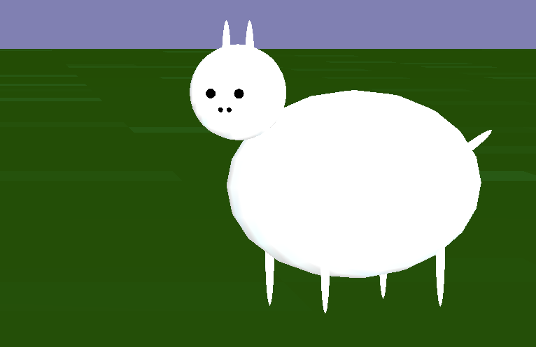

**3.** In this land, there are a lot of **trees**, and the cow loves them, their size and place are randomized and their total number is a parameter. The trees look good, but they are actually only composed of two dodecahedrons, one for the trunk and one for the leaves.

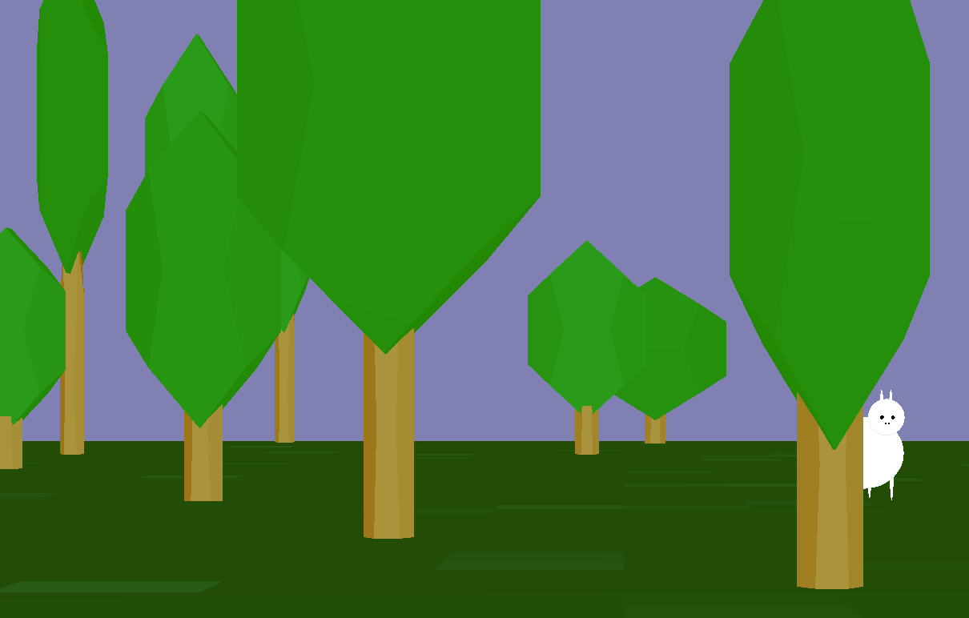

**4.** To make it more realistic, some **rocks** were thrown on the land, here again they are dodecahedrons randomly scaled and rotated.

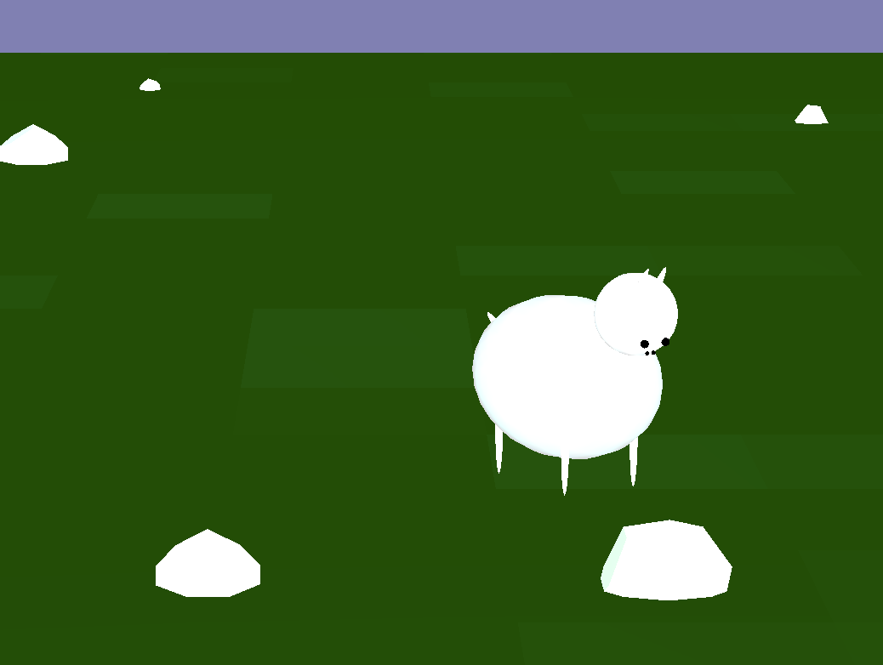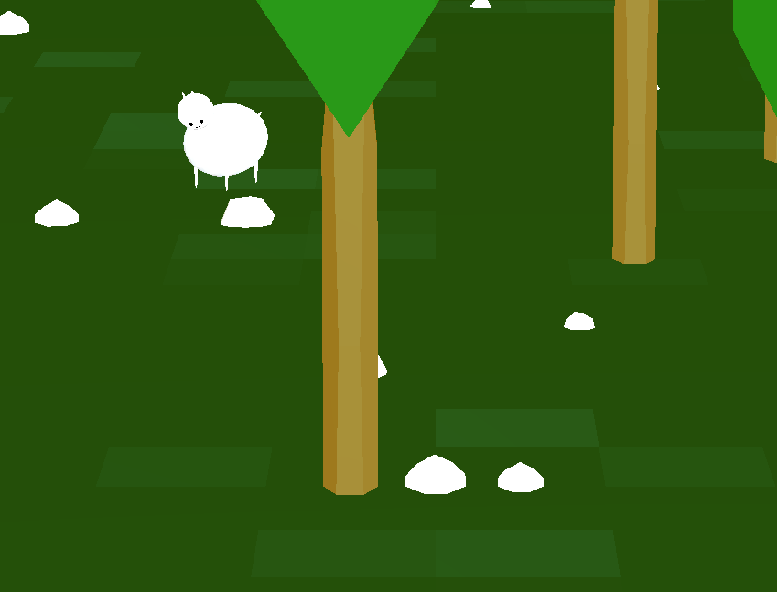

**5**. Finally, to add a bit of light, **light bulbs** can be found on the land, their position and size are randomized but for simplicity they all illuminate with the same lighting properties. The texture of the body is metallic and the bulb is just a white sphere. They illuminate around them with properties that can be controlled by the user. Of course they fully work with solar energy.

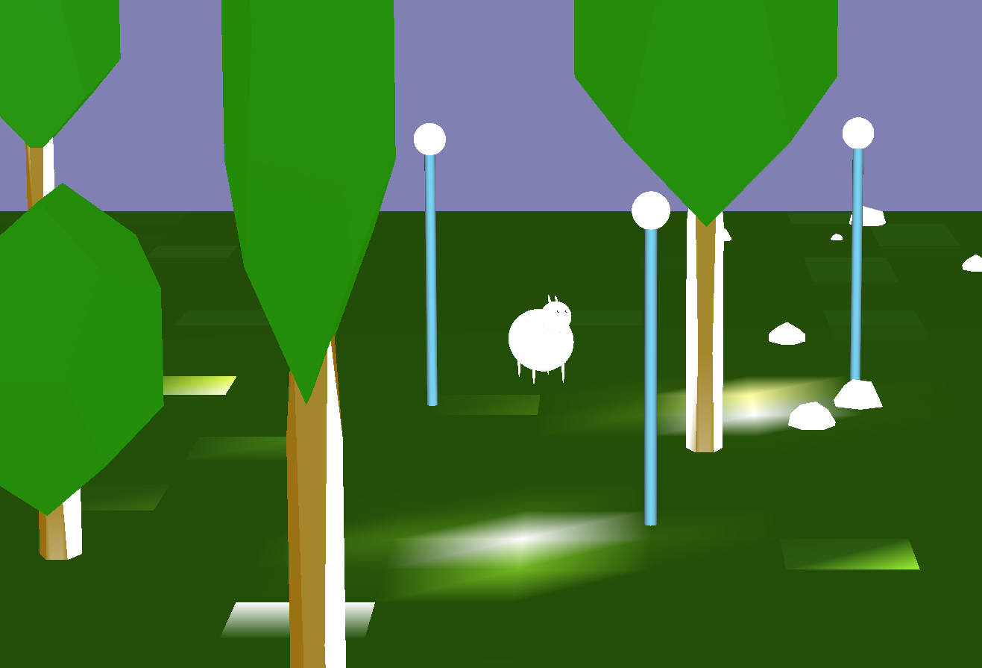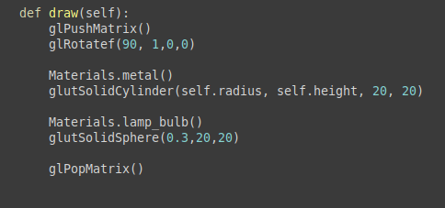

A lot of controls are given to the user, he can move almost all the body parts of the cow, move the camera in every axis and zoom in/out, control the properties of the light bulbs (exponent spot, cutoff, direction and intensity) and of course move the cow in the land. There is no collision detection.

The user can also switch to cow-POV mode and see through the cow eyes, this is done by keeping the cow position and angle as object attributes and calculate the right eye position and reference position to pass to gluLookAt function

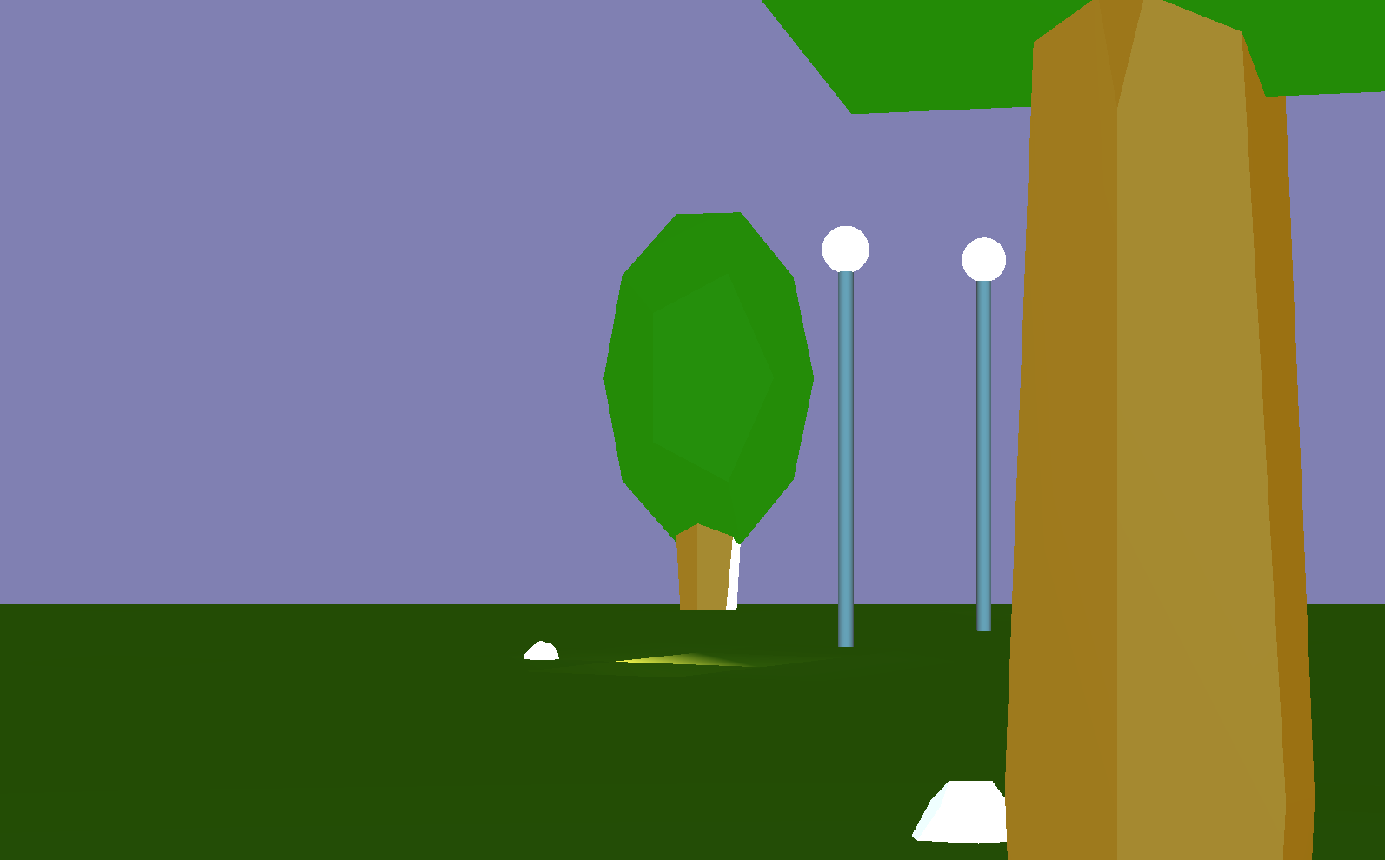

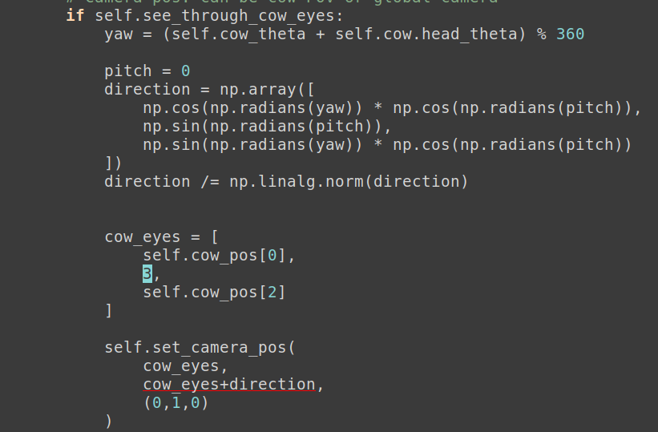

Otherwise the camera position is simulated using basic transformations, the position and the angle of the camera are also hold as object attributes

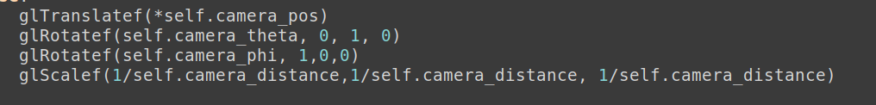

With a right click, the user can open a menu and display a menu with all the commands available, or adjust the intensity of the bulbs and ambient light. At night the cow is scared, but thanks to the light bulbs she feels good.

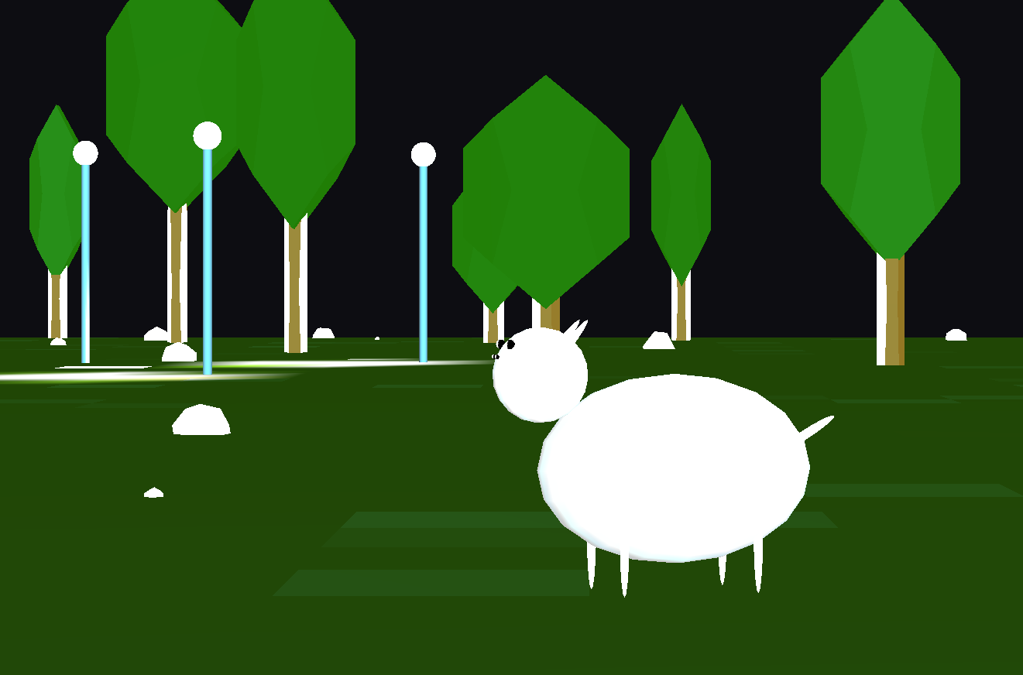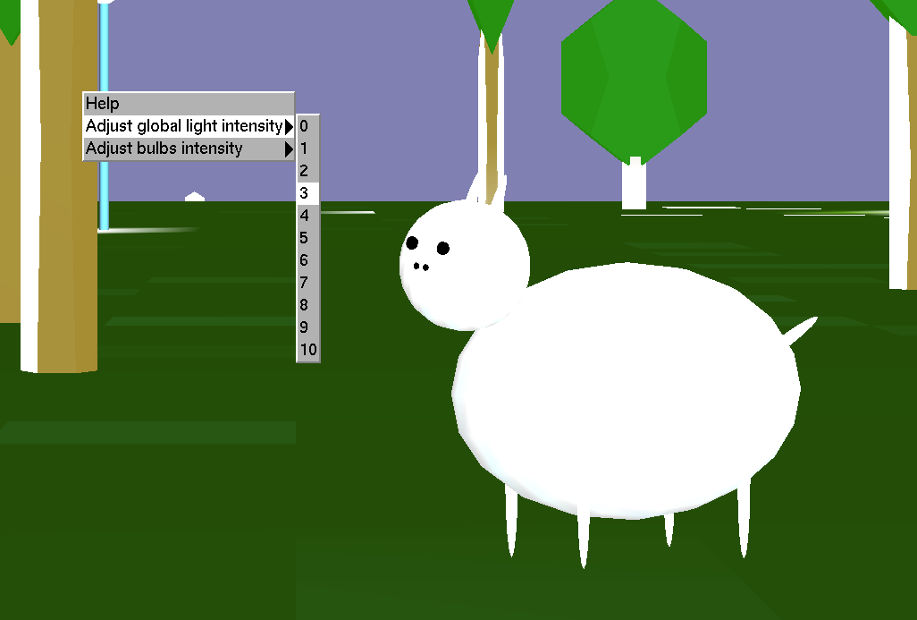

This is the end of the presentation, the code should be clean and documented and thus understandable. I really liked doing this project and the whole course, probably the best one in my degree, thanks a lot for everything !