Northwind Outdoor Ltd. — Conceptual Architecture

1. Architecture Overview
The proposed Northwind infrastructure will provide a centrally managed Linux-based environment supporting business users, administrators, shared data, hosted applications and core infrastructure services.
The architecture will separate business-facing services from the foundational infrastructure required to operate them. Shared capabilities including identity, networking, compute, storage, monitoring, logging, backup, time synchronisation, security, patch management and administration will support the delivery and operation of business services.
The conceptual architecture is designed around the following objectives:
- provide secure and consistent access to business services;
- centralise administration where appropriate;
- protect and segregate business information;
- provide observable and auditable infrastructure;
- support recovery from operational errors and infrastructure failures;
- enable controlled software and configuration changes;
- provide sufficient scalability for foreseeable growth;
- minimise unnecessary technical complexity;
- maintain interoperability with existing Northwind services.
The architecture remains technology-agnostic at this stage. Product, platform and protocol selection will be addressed through later HLD design decisions and subsequently detailed within the LLD.

2. Conceptual Architecture Layers
I would model the Northwind environment using five logical layers.

Layer 1 — Users and Administrative Access
This represents the people and administrative functions consuming the infrastructure.
It includes:
- office-based employees;
- remote employees;
- authorised Linux/system administrators;
- approved business/application users;
- administrative and operational support activities.
Users interact with services through controlled network access and authenticated identities.
Administrators additionally require secure management paths allowing them to configure, maintain, troubleshoot and recover infrastructure without granting unnecessary privileges.
The conceptual distinction between business-user access and administrative access should be retained throughout later design stages.

Layer 2 — Connectivity and Access Services
This layer provides the communications foundation through which users, administrators and systems reach each other.
Primary capabilities:

CAP-009 — Network Connectivity & Core Network Services

CAP-008 — Remote Access
The layer is responsible conceptually for:
- communication between systems;
- access to infrastructure and business services;
- service discovery and name resolution;
- network configuration services;
- connectivity between logical infrastructure areas;
- controlled external/remote connectivity;
- appropriate restriction of unauthorised network access.
Remote access is treated separately from ordinary network connectivity because it introduces additional security and administration requirements.
This layer becomes one of the foundational elements of the architecture because many other capabilities depend upon reliable connectivity.

Layer 3 — Shared Infrastructure Services
This layer contains services consumed by multiple other capabilities.
The most significant are:

Identity & Access Management — CAP-001
Provides central management of identities, roles and access throughout the user lifecycle.
It will provide identity context to services such as:
- File & Data Services;
- Remote Access;
- Application Hosting;
- Systems Administration;
- Security controls.
The architecture must also consider recovery access should central IAM become unavailable, because our dependency analysis identified a potential circular relationship between IAM and administration.

Time Synchronisation — CAP-014
Provides a consistent infrastructure time reference.
It supports:
- authentication;
- logging;
- monitoring;
- scheduled operations;
- incident investigation;
- security analysis.
Although comparatively small as a visible service, the dependency analysis suggests that time synchronisation is a foundational shared service with potentially broad failure impact.

Service Integration / Interoperability — CAP-011
Allows new infrastructure to exchange information and operate alongside required existing Northwind business services.
It should remain sufficiently flexible to support integration without forcing unnecessary replacement of existing services.

Layer 4 — Business and Infrastructure Service Delivery
This is where capabilities directly supporting Northwind's users and business workloads reside.

File & Data Services — CAP-003
Provides authorised storage, organisation and sharing of business information.
Conceptually it consumes:
- Network Connectivity;
- Storage;
- Compute;
- Identity & Access Management;
- Logging/Audit.
File & Data Services will enforce business-data segregation and authorised access while remaining recoverable through the Backup & Recovery capability.

Application Hosting — CAP-010
Provides an environment for Northwind business applications and infrastructure-hosted services.
Applications consume appropriate:
- Compute;
- Network;
- Storage;
- Identity;
- Time;
- Security;
- Monitoring.
Specific dependencies may differ between individual applications and will therefore be refined later during HLD/LLD.

Reporting — CAP-012
Consumes information generated by capabilities such as:
- Monitoring;
- Logging;
- Asset & Configuration Management.
Its purpose is to transform operational information into useful reporting for capacity, service health, growth and infrastructure decision-making.

Layer 5 — Infrastructure Resource Foundation
This is the foundation on which hosted services execute and retain data.

Compute Provisioning / Hosting — CAP-015
Provides processing resources and execution environments for Northwind infrastructure and business workloads.
Conceptually this includes the ability to:
- provide workloads with CPU and memory;
- host operating environments;
- create and manage compute resources;
- expand resources as requirements grow.
No virtualisation platform or physical/server model is selected yet.

Storage Provisioning & Management — CAP-004
Provides persistent storage required by:
- File & Data Services;
- Backup & Recovery;
- hosted applications;
- identity services;
- other infrastructure workloads.
Storage must support appropriate capacity, accessibility, administration and recovery requirements.
Again, no storage technology is selected at this conceptual stage.

3. Cross-Cutting Operational and Control Capabilities
Some capabilities do not sit cleanly within one vertical layer.
Instead, they operate across the architecture.
This is particularly important for Northwind.

Security — CAP-017
Security should span the complete architecture rather than appear as a single perimeter component.
Security controls may apply across:
- identities;
- users;
- administrative access;
- hosts;
- network paths;
- business data;
- applications;
- remote access;
- software lifecycle;
- monitoring/logging.
This reflects our Defence in Depth and Least Privilege design principles.

Monitoring & Alerting — CAP-006
Monitoring provides operational visibility across:
- compute;
- storage;
- network;
- applications;
- business/infrastructure services.
Its role is to detect:
- availability issues;
- service failures;
- resource constraints;
- abnormal conditions;
- threshold breaches.
Monitoring feeds operational response and reporting.

Logging & Audit — CAP-005
Logging provides evidence of important:
- system activity;
- administrative activity;
- authentication events;
- application/service events;
- security events.
Central correlation requires consistent time synchronisation.
Logging supports:
- troubleshooting;
- auditability;
- incident investigation;
- security analysis.

Backup & Recovery — CAP-007
Backup and recovery protects important data, configuration and service state across relevant architectural layers.
It supports recovery from:
- data loss;
- configuration error;
- failed changes;
- infrastructure failure;
- software failure;
- operational mistakes.
Recovery dependencies must be designed carefully so that the infrastructure required to perform a recovery does not depend entirely on the failed service being recovered.

Software & Patch Management — CAP-013
Patch and software lifecycle processes span hosted workloads and infrastructure services.
They must support:
- controlled update deployment;
- appropriate testing;
- evidence of change;
- recovery/rollback where required;
- consistent administration.

Automation & Scheduled Operations — CAP-002
Automation supports repeatable operations across the environment.
Potential uses include:
- scheduled maintenance;
- administrative housekeeping;
- provisioning;
- backup execution;
- reporting;
- bulk changes.
Automation should only replace a manual process once the operation and its failure/recovery behaviour are understood.

Systems Administration & Management — CAP-016
Administrative capability spans almost every managed component.
Rather than representing twenty separate administrator-to-service relationships in the conceptual model, it should be considered a cross-cutting management plane.
Administrators require controlled access to:
- compute;
- storage;
- networking;
- identity;
- hosted applications;
- file services;
- monitoring;
- logging;
- backup;
- patch management.
Administrative access must remain authenticated, least-privileged and auditable.

Asset & Configuration Management — CAP-018
Provides the authoritative operational record of Northwind technology assets and their:
- ownership;
- status;
- lifecycle;
- relevant configuration information.
The v1 architecture does not require a dedicated asset-management platform.
The capability can initially be delivered through structured records and later expanded if business or operational complexity justifies it.

4. Conceptual Architecture Model
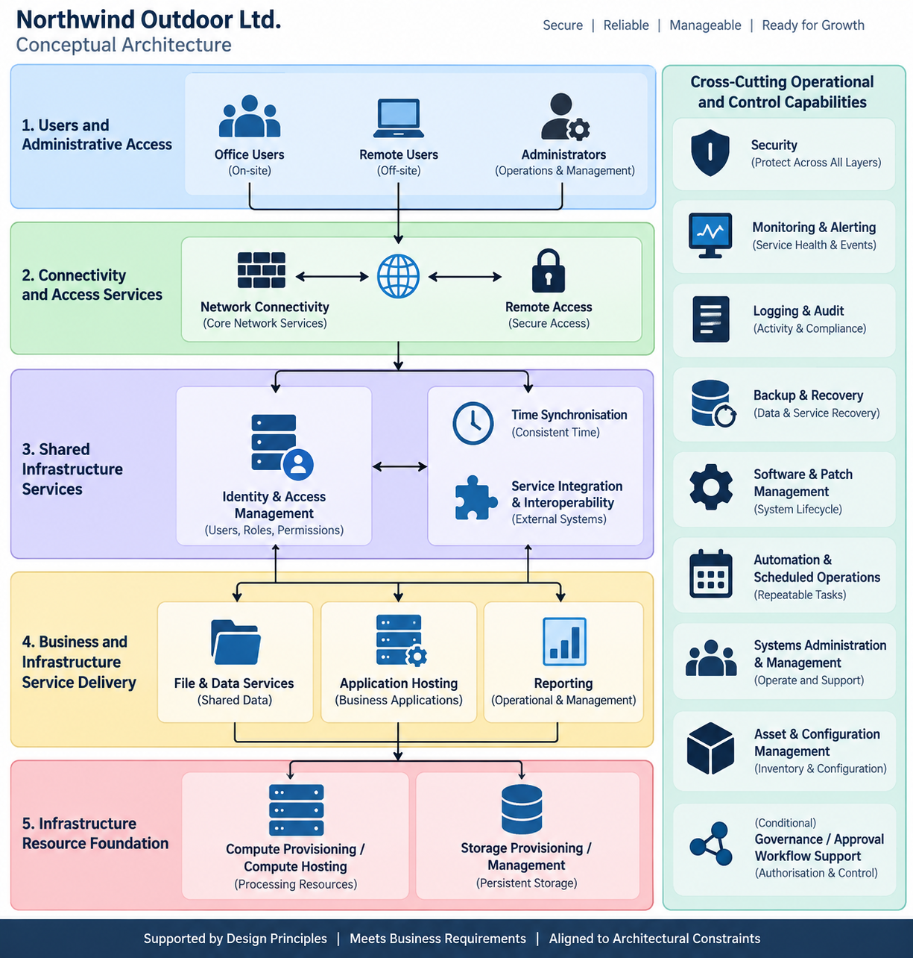

5. Key Architectural Relationships
Our dependency work exposes several relationships that should influence the architecture.
Network as a foundational service
Many capabilities require network connectivity.
Failure of core connectivity may therefore affect:
- IAM;
- File Services;
- Remote Access;
- Application Hosting;
- monitoring;
- integrations;
- patching;
- administration.
Network resilience and recovery will consequently require explicit consideration later.
Compute and Storage as infrastructure foundations
Compute provides execution resources.
Storage provides persistence.
Keeping them conceptually separate prevents us from accidentally assuming that every workload, storage service or application must share the same platform.
Identity as a shared control plane
IAM is not merely another application.
It controls access to several other capabilities.
Its failure therefore creates potentially broad effects.
The conceptual architecture must account for:
- authentication dependency;
- authorised administrative access;
- recovery access if central IAM fails.
Time as a hidden foundational dependency
Time Synchronisation appears simple but supports multiple high-value functions.
Its importance is disproportionate to its apparent complexity.
That should influence later resilience and monitoring decisions.
Monitoring and Logging are different
The conceptual architecture should retain their distinction.
Monitoring asks:
Is the infrastructure operating correctly?
Logging/Audit asks:
What happened?
They interact but solve different operational problems.
Backup is not simply storage
Backup & Recovery uses Storage, but the capability also includes:
- controlled backup processes;
- recovery procedures;
- validation;
- restoration.
This is important because Northwind's requirement is not merely “retain copies of data”; it is restore services successfully when required.

6. Logical Separation Without Premature Physical Separation
One particularly important architectural statement should go into the HLD:
Conceptual separation does not automatically require physical separation.
For example, we might show:
- IAM;
- Monitoring;
- Logging;
- Backup;
- Application Hosting
as separate conceptual components.
That does not yet mean Northwind needs five physical servers.
They could later be deployed across virtual machines, shared infrastructure, dedicated systems, or other appropriate execution environments depending on security, resilience, performance and maintainability requirements.
This prevents the HLD from accidentally becoming an LLD.

7. Management Plane vs Service Plane
I think one particularly useful concept for Northwind is to distinguish:
Service Plane
Provides services to users and applications:
- IAM authentication;
- File Services;
- Application Hosting;
- Network services;
- Remote Access.
Management Plane
Allows administrators to operate those services:
- Systems Administration;
- Monitoring;
- Logging;
- Patch Management;
- Automation;
- Asset Management;
- Backup administration.
This distinction will become very useful later when we design administrative network access and privilege boundaries.
It also connects nicely with your existing networking knowledge: you're already familiar with the conceptual difference between traffic used to provide a service and traffic used to manage infrastructure.

8. Key Architectural Risks / Questions Carried Forward
The conceptual architecture also leaves several deliberate questions for later HLD work.
These include:
Resilience: Which foundational services warrant redundancy, and where can Northwind accept an SPOF with documented recovery?
IAM recovery: How can administrators recover central identity services if normal administration itself relies upon IAM?
Backup dependency: What infrastructure must remain available to perform restores during a wider outage?
Network dependency: Which services need to remain usable during partial network failure?
Storage architecture: Which workloads require shared versus locally attached storage?
Application hosting: What level of workload isolation is appropriate?
Remote access: How will external users and administrators reach required resources without unnecessarily exposing internal services?
Monitoring/logging: How centralised should operational visibility become in v1?
Security: Which controls belong in existing capabilities versus dedicated security mechanisms?
Interoperability: Which existing Northwind/M365 or other external business services must the new environment integrate with?
These are exactly the questions that should drive the upcoming architecture options and HLD diagrams.

