Design Question
What network segments are required for the first Northwind implementation, and why does each one exist?

1. Decision Summary
Northwind v1 will implement a segmented network architecture based on security trust boundaries and communication requirements, rather than separating systems solely according to technical function.
Five primary security zones are proposed:
Zone | Purpose
USER | Employee endpoints and normal business activity
SERVER | Internal infrastructure and business services
MGMT | Privileged infrastructure administration
PERIPHERAL | Printers and other lower-trust embedded/peripheral devices
EXTERNAL / UNTRUSTED | Internet/WAN and networks outside the Northwind trust boundary
Traffic between trusted internal zones will be controlled through firewall policy using a default-deny, explicitly permitted model.
Access will be permitted according to documented business and administrative requirements rather than allowing unrestricted communication between network segments.
A dedicated bastion/jump host (JUMP01) will provide the controlled administrative path into the Management Zone.
Detailed VLAN IDs, IP addressing, firewall ports, DHCP scopes and individual network flows are intentionally deferred until the relevant server roles and service requirements have been established.

2. Design Principles
Several principles were established during the design discussion.
2.1 Segmentation represents trust boundaries
Network segments should not be created simply because systems perform different functions.
A separate network is justified where systems have materially different:
- security characteristics;
- exposure requirements;
- administrative requirements;
- communication requirements;
- patching or lifecycle characteristics;
- compromise impact.
This avoids unnecessary VLAN proliferation while ensuring meaningful security boundaries exist.

2.2 Inter-zone communication follows least privilege
Placement within a network zone does not automatically grant unrestricted access to another zone.
Traffic crossing security boundaries should be explicitly permitted according to the required:
Source → Destination → Service
For example:
USER → DNS01 → DNS ALLOW
USER → FILE01 → SMB ALLOW
USER → APP01 → HTTPS ALLOW

USER → DNS01 → SSH DENY
USER → FILE01 → SSH DENY
USER → SERVER → Other DENY
The final rules will depend upon the services implemented during later LLD and implementation activities.

2.3 Service consumption and service administration are separate
Normal users require access to business services but do not require administrative access to the infrastructure providing those services.
For example:
USER → FILE01 → SMB
represents consumption of the file service.
Administrative access follows a separate trusted path:
Authorised Admin
↓
JUMP01
↓
Management / Administrative Access
↓
FILE01
This separation reduces unnecessary exposure of administrative interfaces and protocols.

3. Proposed Security Zones
3.1 USER Zone
Purpose
The USER Zone provides network connectivity for normal Northwind employee endpoints and day-to-day business activity.
Expected systems
Examples include:
- office desktops;
- employee laptops;
- managed staff wireless clients;
- authorised administrator workstations when performing normal user activities.
Printers are deliberately excluded and placed within the separate Peripheral Zone.
Rationale
Employee endpoints represent a different trust class from Northwind infrastructure.
User devices regularly interact with:
- email;
- web browsers;
- downloaded files;
- external websites;
- user-supplied data;
- potentially removable media.
They therefore represent a comparatively exposed part of the environment.
Separating user endpoints from servers and management infrastructure limits the potential impact of a compromised workstation and supports defence-in-depth.
USER systems will only be permitted to access specific infrastructure services required for business operation.
Remote users
Northwind requires remote and office users to receive a broadly consistent service experience.
The logical access available to remote workers should therefore align with appropriate USER services. However, whether VPN clients are placed directly into the USER Zone or into a dedicated remote-access network with equivalent permitted access is deferred for later design.

4. SERVER Zone
Purpose
The SERVER Zone contains internal infrastructure and business services consumed by Northwind systems and employees.
Potential systems/services
Examples may include:
- DNS;
- DHCP;
- NTP/time services;
- identity services;
- file services;
- logging services;
- internal application services;
- other Linux infrastructure introduced during v1.
The exact server estate will be determined under subsequent LLD-01 questions.
Rationale
Servers have different security and operational requirements from employee endpoints.
Separating servers from USER systems allows Northwind to control precisely which services users may consume without exposing unnecessary server services or administrative interfaces.
For example, an employee may require:
USER → FILE01 → SMB
but should not therefore receive:
USER → FILE01 → SSH
The firewall boundary between USER and SERVER provides a mechanism for enforcing this distinction.
Application segmentation
Application servers will not automatically receive dedicated network segments.
Additional segmentation should only be introduced where an application has materially different exposure, sensitivity or communication requirements.
For example, a future architecture containing an Internet-facing web server, application backend and sensitive database could justify additional security zones.
No such requirement has currently been established for Northwind v1.

5. MGMT — Management Zone
Purpose
The Management Zone provides a trusted network path for privileged administration of Northwind infrastructure.
It is not limited to management of network equipment.
Management encompasses administrative control of infrastructure such as:
- Linux servers;
- Proxmox;
- firewall infrastructure;
- routers/switches;
- infrastructure management interfaces;
- monitoring administration;
- other privileged infrastructure interfaces.
Rationale
Administrative traffic has a fundamentally different trust requirement from ordinary business traffic.
Separating management access reduces the number of systems capable of directly accessing privileged interfaces and provides a clearer boundary for:
- access control;
- administrative logging;
- auditing;
- monitoring;
- privileged access management.
Administrative access model
Northwind will use a dedicated bastion/jump host (JUMP01) as the primary administrative entry point.
Conceptually:
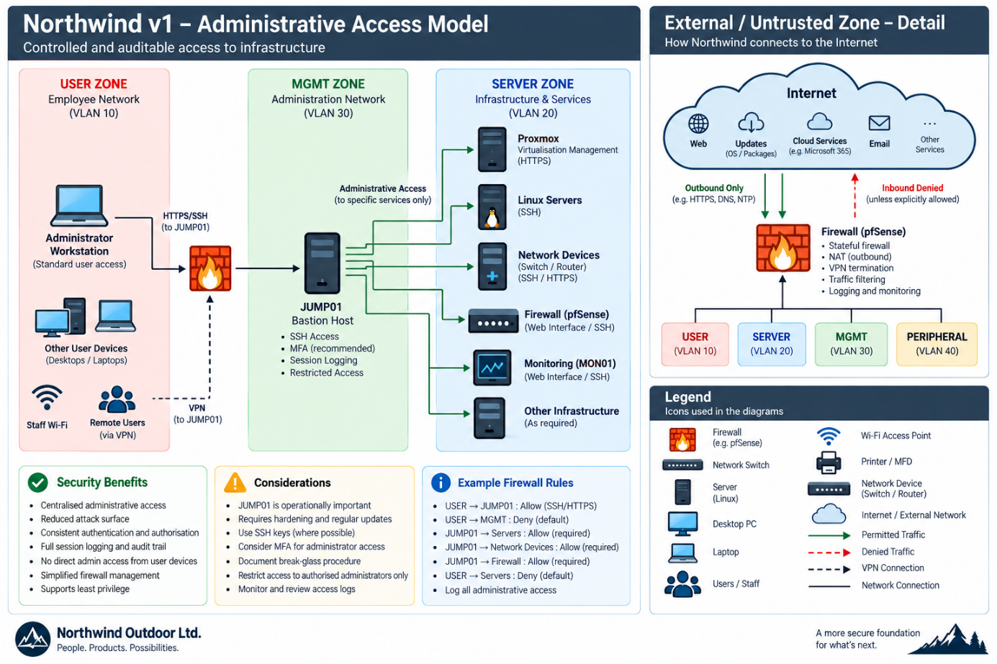
Ordinary USER systems will not receive general access to MGMT.
Only authorised administrators will be permitted to reach JUMP01, and administrative connections to infrastructure will subsequently originate through the controlled management path.
Why a bastion was selected
Three approaches were considered:
- dual-homed/trunk-connected administrator workstations;
- direct administrative access from selected USER workstations;
- a dedicated bastion/jump host.
Dual-homed administrator workstations were technically feasible but would connect an endpoint performing normal user activities directly to the trusted management environment. Compromise of that endpoint could therefore weaken the management security boundary.
Direct firewall exceptions from administrator workstations would be simpler but would require multiple endpoints to hold privileged network access.
The bastion model was selected because it centralises the administrative trust boundary and provides a controlled location for applying:
- authentication controls;
- SSH security;
- access restrictions;
- administrative logging;
- auditing;
- hardening.
Although this introduces additional initial configuration, it should provide a simpler and more consistent administrative access model as the environment develops.
Availability consideration
JUMP01 becomes operationally important because failure of the bastion could prevent normal administrative access.
Northwind's existing recovery-based resilience approach means a redundant bastion is not currently required for v1.
A documented break-glass/recovery procedure should instead be developed to allow infrastructure administration when the normal bastion path is unavailable.

6. PERIPHERAL Zone
Purpose
The Peripheral Zone isolates network-connected printers and potentially other embedded peripheral devices from managed employee endpoints and infrastructure.
Initial systems
The initial implementation is expected primarily to contain:
- network printers;
- multifunction printers/scanners.
Other embedded devices may be evaluated for placement here if introduced later.
Rationale
Printers represent a different security class from managed employee workstations.
Such devices may have:
- vendor-specific operating systems/firmware;
- different patching mechanisms;
- long operational lifetimes;
- continuous network availability;
- limited endpoint security capabilities;
- limited host-level monitoring capabilities;
- embedded web-management services;
- protocols such as IPP, SNMP or SMB;
- stored or cached business information.
A compromised user workstation could potentially attack a vulnerable printer and establish an additional foothold within the network.
Conversely, a compromised printer should not have unrestricted ability to initiate connections toward employee workstations or infrastructure.
Segmentation therefore compensates partially for the reduced endpoint control available on embedded devices.
Communication principle
Employees should be able to use printers without giving printers unrestricted access to employee systems.
Conceptually:
USER → PRINTER Required printing services ALLOW
PRINTER → USER Unsolicited traffic DENY
PRINTER → SERVER Default DENY
PRINTER → MGMT Default DENY
MGMT → PRINTER Approved administration ALLOW
PRINTER → INTERNET Restrict/justify DENY/ALLOW as required
Specific exceptions may be required.
For example, multifunction devices could legitimately require access to:
- DNS;
- NTP;
- mail relay;
- approved file services.
Such flows should be individually justified rather than providing general SERVER access.

7. EXTERNAL / UNTRUSTED Zone
Purpose
The External/Untrusted Zone represents networks outside Northwind's trusted internal environment, principally the Internet/WAN side of the firewall.
Rationale
Internal Northwind systems may require outbound Internet connectivity for legitimate purposes such as:
- operating-system updates;
- package repositories;
- external business services;
- software downloads;
- time or other approved external services.
The requirement for an internal server to initiate an outbound connection does not imply that external systems should be permitted to initiate connections toward that server.
Stateful firewalling and associated network controls will enforce this boundary.
Future public services
If Northwind later introduces Internet-facing applications or APIs, those systems should not automatically be placed within the internal SERVER Zone.
Such requirements may justify introduction of a dedicated DMZ or equivalent security zone.
No current v1 requirement justifies implementing a DMZ, so this is deferred.

8. Monitoring Considerations
Monitoring traffic and management traffic should not automatically be treated as equivalent.
A monitoring system may need to query infrastructure such as:
MON01 → FILE01
MON01 → DNS01
MON01 → Proxmox
MON01 → Firewall
These represent monitoring/observability flows.
An administrator accessing the MON01 administrative interface represents privileged management access.
The eventual placement of monitoring infrastructure and its permitted flows should therefore be determined according to its actual communication requirements rather than assuming all monitoring systems belong within MGMT.

9. Backup Network Consideration
A dedicated backup network was considered during the discussion.
Potential advantages could include:
- isolation of backup traffic;
- reduced contention with production traffic;
- tighter control of systems permitted to communicate with backup infrastructure;
- additional protection of recovery infrastructure.
However, a dedicated backup network also introduces:
- additional VLANs/subnets;
- additional interfaces;
- routing requirements;
- firewall policy;
- operational complexity.
The relatively small scale of Northwind v1 does not currently provide sufficient justification for a dedicated backup network.
The requirement should be reconsidered during detailed design of the Backup & Recovery capability.
Status: Deferred design consideration.

10. Application Network Consideration
Dedicated application VLANs were also considered.
The design decision is that systems will not be segmented simply because they perform different technical functions.
Additional application security zones should be introduced only where different:
- exposure;
- sensitivity;
- data classification;
- communication requirements;
- security requirements
create a genuine trust boundary.
Northwind v1 therefore retains a general SERVER Zone unless subsequent application design identifies a requirement for further separation.
Status: Deferred unless justified by application design.

11. Conceptual v1 Network Architecture
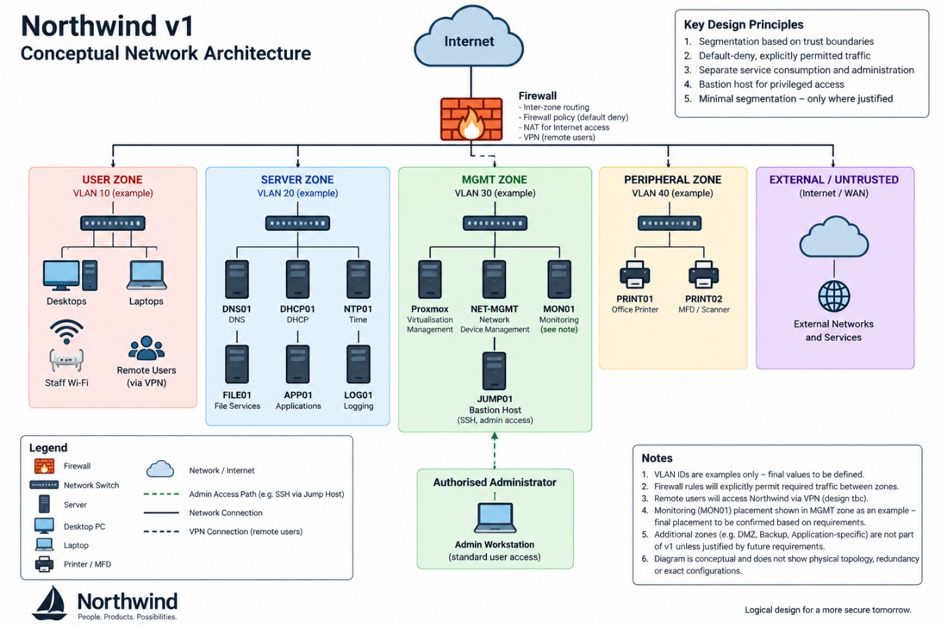
The diagram is conceptual only and does not yet represent physical switching, VLAN IDs, routing interfaces or exact firewall flows.

12. Security Policy Principle
The following principle will govern later firewall design:
Inter-zone communication will follow a default-deny, explicitly permitted model based upon documented business, service and administrative requirements.
Firewall permissions should ultimately be defined according to:
Source → Destination → Required Service → Business/Technical Justification
Creation of separate VLANs without corresponding access-control policy is not considered sufficient segmentation.

13. Key Risks and Mitigations
Risk | Mitigation / Design Response
Compromised USER endpoint attempts lateral movement | Separate USER from infrastructure and explicitly permit required SERVER services
Administrative interfaces exposed to ordinary endpoints | Dedicated MGMT trust boundary and bastion-based administration
Compromise of administrator workstation provides direct MGMT access | Administrator workstation does not require direct membership of MGMT
Bastion failure prevents normal administration | Recovery-based resilience plus documented break-glass procedure
Compromised printer used as persistent internal foothold | Dedicated PERIPHERAL trust zone and restricted inter-zone communication
Excessive VLAN complexity | Additional zones introduced only where a genuine trust/exposure difference exists
Public service compromises internal SERVER systems | Future public services trigger consideration of DMZ architecture
Firewall rules become overly permissive | Default-deny model with individually justified flows
Segmentation prevents legitimate infrastructure communication | Required flows documented and validated during detailed service design

14. Deferred Detailed Design
The following items are intentionally not decided under LLD-01-Q02:
- VLAN IDs;
- IPv4/IPv6 addressing;
- subnet sizes;
- default gateways;
- DHCP scopes;
- DNS configuration;
- physical switch-port configuration;
- trunk/access-port assignments;
- detailed firewall rules;
- exact protocol/port matrix;
- VPN client network placement;
- monitoring-server network placement;
- backup network design;
- DMZ design;
- application-specific segmentation.
These decisions depend upon the server estate, service architecture and subsequent LLD work.

15. Implementation and Learning Implications
The design creates practical implementation work directly relevant to the Northwind project and Linux administration objectives, including:
- Linux network configuration;
- SSH administration;
- bastion-host configuration;
- SSH key management;
- user/group administration;
- sudo configuration;
- Linux host firewalling;
- service exposure and port identification;
- routing and network troubleshooting;
- logging and auditing;
- SELinux considerations;
- network service configuration;
- firewall policy testing;
- troubleshooting cross-zone connectivity.
It also allows existing networking knowledge to be applied to Linux systems administration rather than treating the two disciplines independently.

16. Decision
Accepted for Northwind v1 conceptual network design.
Northwind v1 will use the following security zones:
USER / SERVER / MGMT / PERIPHERAL / EXTERNAL-UNTRUSTED
Privileged infrastructure administration will use a bastion/jump-host model, while communication between security zones will use default-deny with explicitly permitted service flows.
Additional segmentation—including DMZ, backup and application-specific networks—will only be introduced when supported by a defined business, security or technical requirement.

