LLD-01-004 — Initial Server & VM Estate
Question
What should the initial Northwind v1 server estate look like—not exact sizing yet, but server roles?

1. Decision Summary
Northwind v1 will initially use a deliberately small server estate consisting of one physical Proxmox hypervisor and five RHEL 10 virtual machines.
The proposed estate is:
Hostname | Platform | Primary Role
HYP01 | Proxmox VE / Physical Host | Compute / Virtualisation
JUMP01 | RHEL 10 VM | Bastion / Administrative Access
CORE01 | RHEL 10 VM | DNS, DHCP and NTP
FILE01 | RHEL 10 VM | File & Data Services
OPS01 | RHEL 10 VM | Central Logging, Monitoring & Alerting
BACKUP01 | RHEL 10 VM | Backup & Recovery
The design deliberately avoids creating a dedicated VM for every HLD capability.
Capabilities may instead be:
- implemented through a dedicated server;
- consolidated with compatible services;
- distributed across multiple systems;
- provided by existing network/hypervisor infrastructure;
- deferred until a specific workload requires them.
This approach reduces unnecessary VM sprawl while retaining meaningful security, operational and recovery boundaries.
Exact CPU, memory, storage and network-interface sizing is outside the scope of this question and will be determined during subsequent detailed design.

2. Design Principle — Capability Does Not Equal Server
The HLD defines capabilities Northwind requires but does not prescribe the number of servers required to implement them.
For example:
CAP-003 File & Data Services
↓
FILE01
represents a capability where a dedicated workload is justified.
However:
CAP-017 Security
↓
SELinux + firewalld + SSH + permissions
+ segmentation + hardening + patching
represents a cross-cutting capability rather than a requirement for a dedicated SEC01 server.
The server estate has therefore been designed by asking:
Does this capability require a dedicated operating-system instance, or can it be delivered more appropriately through existing infrastructure, consolidation, distributed controls or operational processes?
Every additional VM creates operational overhead because it must be:
- patched;
- hardened;
- monitored;
- backed up;
- documented;
- administered;
- recovered;
- capacity-managed;
- troubleshot.
A dedicated VM therefore requires sufficient technical, security or operational justification.

3. HYP01 — Compute / Virtualisation
Role
HYP01 will provide the physical compute platform hosting the Northwind v1 virtual server estate.
The selected virtualisation platform is Proxmox VE, in accordance with the existing virtualisation design decision.
Functions
HYP01 will provide:
- virtual machine hosting;
- virtual CPU and memory allocation;
- VM virtual disks;
- virtual networking integration;
- VM lifecycle management;
- VM console access;
- infrastructure snapshots where appropriate;
- the foundation for future VM expansion.
Rationale
The hypervisor represents a unique infrastructure and failure domain.
Failure of HYP01 can result in loss of all hosted Northwind VMs.
It therefore requires:
- restricted administrative access;
- minimal unnecessary software;
- independent patching and lifecycle management;
- appropriate backup/recovery procedures;
- monitoring;
- controlled management-network access.
HYP01 is a physical host and is not itself part of the VM count.
Northwind v1 accepts the single-hypervisor dependency under the existing recovery-based resilience strategy.
High-availability hypervisor clustering remains outside v1 scope.

4. JUMP01 — Bastion / Administrative Access
Role
JUMP01 will provide the controlled administrative entry point for privileged infrastructure administration.
Functions
Expected functions include:
- administrative SSH access;
- controlled access into the Management Zone;
- administrative authentication;
- privileged Linux administration;
- administrative activity logging;
- future integration with stronger authentication controls where required.
Rationale
Northwind administrators should not require unrestricted direct administrative connectivity from normal USER endpoints into the infrastructure environment.
The administrative path will instead follow the model established under LLD-01-002:
Administrator
↓
USER Zone
↓
Firewall Policy
↓
JUMP01
↓
Management Path
↓
Northwind Infrastructure
A dedicated bastion reduces the number of endpoints requiring privileged network access and provides a central point for administrative access controls and auditing.
Because compromise of the bastion could provide significant infrastructure access, unrelated business services will not be hosted on JUMP01.
Failure of JUMP01 may prevent normal administrative access; therefore a documented break-glass/recovery procedure will eventually be required.

5. CORE01 — Core Linux Network Services
Role
CORE01 will provide the principal Linux-hosted core network services required by Northwind v1.
Services
Initial services will include:
- DNS;
- DHCP;
- NTP/time synchronisation.
Rationale
These services are lightweight foundational infrastructure functions with broadly similar operational requirements.
Consolidating them onto CORE01:
- reduces unnecessary VM sprawl;
- provides a clear location for Linux core network services;
- separates foundational network services from business data and recovery infrastructure;
- provides practical administration and troubleshooting experience with Linux network services.
Northwind accepts that consolidation creates a shared failure domain.
Failure of CORE01 could simultaneously affect:
- name resolution;
- allocation/renewal of DHCP leases;
- time synchronisation.
This risk is considered acceptable for v1 under the recovery-based resilience model.
Existing DHCP leases and local system clocks will not immediately cease functioning if CORE01 becomes unavailable, although prolonged failure may cause increasing operational impact.
DNS availability may have a more immediate impact and should therefore be monitored closely.

6. DHCP Design Consideration
DHCP could alternatively be provided by the perimeter/network infrastructure.
For an organisation of Northwind's current size, this could provide a simpler architecture.
However, Linux-hosted DHCP has been selected for v1 because:
- it remains technically appropriate for the environment;
- it centralises selected Linux core services;
- it provides practical administration and troubleshooting experience;
- it allows interaction between Linux systems administration and existing network-routing/segmentation knowledge.
This is recognised as a project-specific design consideration rather than a claim that dedicated Linux DHCP is universally preferable.
Multi-VLAN DHCP
CORE01 is expected to reside within the SERVER Zone while providing DHCP services to other network segments.
DHCP broadcasts do not normally cross Layer-3 boundaries.
The network infrastructure will therefore require DHCP relay functionality for applicable VLANs.
Conceptually:
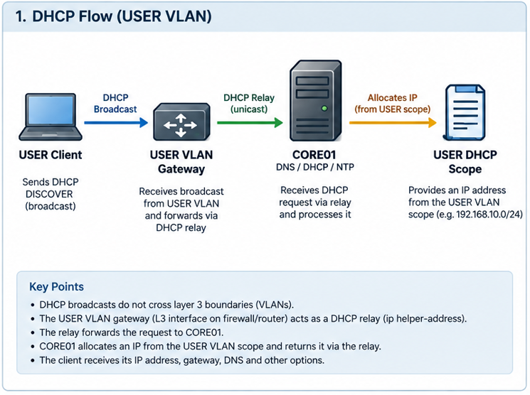
This allows a single CORE01 DHCP service to provide addressing for multiple network segments while maintaining the segmentation established under LLD-01-002.
Server and management infrastructure may use static addressing or reservations where appropriate.
Detailed scopes, addressing and relay configuration are deferred to network detailed design.

7. FILE01 — File & Data Services
Role
FILE01 will provide centralised Northwind business file and data services.
Expected functions
These may include:
- departmental file shares;
- shared business data;
- access-controlled directories;
- departmental data segregation;
- filesystem permissions;
- ACLs;
- storage quotas where required;
- business data storage.
Rationale
File services justify a dedicated VM because they have distinct:
- storage requirements;
- permission requirements;
- backup requirements;
- recovery requirements;
- performance characteristics;
- capacity-growth requirements;
- business impact.
Failure or compromise of file services should not automatically affect core network services, logging, monitoring or backup infrastructure.
The dedicated VM also allows file storage to scale independently from other infrastructure workloads.

8. FILE01 Storage Model
A dedicated STOR01 storage server will not be deployed in v1.
Instead, storage capability will initially be implemented through a combination of:
- Proxmox virtual storage;
- dedicated virtual disks presented to FILE01;
- RHEL storage management;
- LVM;
- XFS;
- persistent filesystem configuration;
- capacity management.
Conceptually:
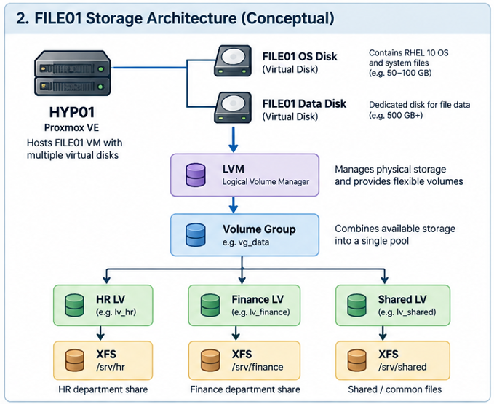

This allows Northwind to implement CAP-004 Storage Provisioning & Management without introducing an unnecessary dedicated network-storage dependency.
A dedicated storage server may be reconsidered if future requirements introduce:
- shared storage between multiple servers;
- clustered applications;
- specialised storage requirements;
- substantially increased capacity;
- workloads requiring independent network storage.

9. OPS01 — Logging, Monitoring & Alerting
Role
OPS01 will provide centralised operational visibility for the Northwind v1 environment.
Functions
Initial functions will include:
- centralised log collection;
- log retention;
- infrastructure monitoring;
- service-health monitoring;
- capacity/utilisation monitoring;
- alerting;
- operational reporting where appropriate.
Consolidation Decision
Central logging and monitoring were initially considered as separate LOG01 and MON01 servers.
There are legitimate reasons for separating these functions.
Dedicated systems would provide:
- stronger failure-domain separation;
- improved forensic isolation;
- independent scaling;
- independent storage/retention policies;
- reduced likelihood that monitoring compromise affects central logs;
- reduced likelihood that logging failure affects monitoring.
However, Northwind v1 is expected to have:
- a small server estate;
- relatively low log volume;
- limited analytics requirements;
- no initial SIEM requirement;
- limited monitoring integrations;
- no large application estate.
Maintaining two independent RHEL VMs would therefore introduce additional:
- patching;
- monitoring;
- backup requirements;
- firewall policy;
- documentation;
- operating-system administration.
For v1, the operational simplicity gained through consolidation is considered proportionate to the additional shared failure risk.
Logging and monitoring will therefore initially coexist on OPS01.

10. OPS01 Future Separation Trigger
The decision to consolidate logging and monitoring should be reviewed if Northwind introduces:
- significantly increased log volume;
- additional servers/applications;
- SIEM functionality;
- security analytics;
- stricter audit requirements;
- stronger forensic-isolation requirements;
- performance contention;
- significantly increased monitoring integrations;
- different log-retention requirements;
- increased regulatory/compliance requirements.
A future architecture may therefore evolve from:
OPS01
├── Logging
├── Monitoring
└── Alerting
to:
Operations
|
+------+------+
| |
LOG01 MON01
Logging/Audit Monitoring
The separation should be driven by an identified requirement rather than implemented pre-emptively.

11. BACKUP01 — Backup & Recovery
Role
BACKUP01 will provide centralised backup and recovery services for Northwind infrastructure.
Functions
Expected functions include:
- server backup coordination;
- configuration backup;
- business-data backup;
- retention management;
- recovery operations;
- backup validation;
- support for recovery testing.
The exact backup architecture remains subject to the detailed CAP-007 design.
Rationale
Backup infrastructure represents a distinct security and recovery trust boundary.
Production workloads should not possess unrestricted access capable of modifying or deleting the backup copies intended to recover those workloads.
Hosting unrelated services on BACKUP01 would increase the risk that compromise of another workload could affect Northwind's recovery capability.
The server therefore remains dedicated.
This directly supports Northwind's recovery-based resilience strategy.

12. Capabilities Without Dedicated VMs
Several Northwind capabilities remain within v1 but do not require dedicated servers.
CAP-001 — Identity & Access Management
No IAM01 will initially be deployed.
Centralised identity has previously been deferred for v1.
Identity and access management will initially use RHEL mechanisms including:
- local users;
- local groups;
- UGO/RWX permissions;
- ACLs where appropriate;
- sudo;
- documented joiner/leaver administration.
Centralised identity may be introduced through a future requirement/change.

CAP-002 — Automation & Scheduled Operations
No AUTO01 will initially be deployed.
Automation will initially use:
- shell scripts;
- cron where appropriate;
- systemd timers;
- documented repeatable administrative procedures.
Centralised configuration-management tooling such as Ansible remains a future enhancement after manual administration and scripting practices have been established.

CAP-004 — Storage Provisioning & Management
No STOR01 will initially be deployed.
Storage will be implemented through:
- Proxmox storage;
- VM virtual disks;
- RHEL LVM;
- XFS;
- filesystem/mount management;
- capacity-management processes.

CAP-008 — Remote Access
No dedicated VPN01 is currently required.
Remote-access termination is expected to be provided through perimeter/network security infrastructure.
A dedicated VPN server should only be introduced if later technical or security requirements justify it.

CAP-010 — Application Hosting
No APP01 will initially be deployed.
HYP01 provides the compute capability necessary to host future applications, but Northwind does not currently have a sufficiently defined application workload requiring a dedicated application VM.
Application infrastructure will be introduced when an actual application requirement exists.

CAP-013 — Software & Patch Management
No PATCH01 will initially be deployed.
RHEL systems will initially use approved package repositories and standard RHEL package-management functionality.
Patch management will consist of both technical mechanisms and operational governance, including:
- update identification;
- testing;
- approval;
- installation;
- validation;
- reporting.
Centralised repository/content-management infrastructure may be introduced if future scale or governance requirements justify it.

CAP-017 — Security
No generic SEC01 will be deployed.
Security is a cross-cutting capability implemented through controls including:
- network segmentation;
- firewall policy;
- SELinux;
- host firewalling;
- SSH security;
- authentication;
- sudo;
- permissions;
- patching;
- logging;
- monitoring;
- backup protection;
- system hardening.
Dedicated security infrastructure should only be introduced when a specific workload exists—for example vulnerability scanning, SIEM or specialised threat-detection services.

13. Capability-to-Infrastructure Mapping
The current conceptual mapping is:
Capability | Initial Implementation
CAP-001 Identity & Access Management | Distributed RHEL local identity/access controls
CAP-002 Automation & Scheduled Operations | Distributed scripts, cron/systemd timers
CAP-003 File & Data Services | FILE01
CAP-004 Storage Provisioning/Management | HYP01 + RHEL LVM/XFS
CAP-005 Logging & Audit | OPS01
CAP-006 Monitoring & Alerting | OPS01
CAP-007 Backup & Recovery | BACKUP01
CAP-008 Remote Access | Perimeter/network infrastructure
CAP-009 Network Connectivity & Core Services | Network infrastructure + CORE01
CAP-010 Application Hosting | Compute capability available on HYP01; workload deferred
CAP-011 Integration / Interoperability | Implemented as required by individual services
CAP-012 Reporting | Primarily OPS01 and operational processes
CAP-013 Software & Patch Management | RHEL/DNF + update governance
CAP-014 Time Synchronisation | CORE01
CAP-015 Compute Provisioning / Hosting | HYP01
CAP-016 Systems Administration & Management | JUMP01 + distributed administration
CAP-017 Security | Cross-cutting technical and operational controls
This mapping should remain traceable through the RTM and subsequent LLD documents.

14. Initial Conceptual Estate
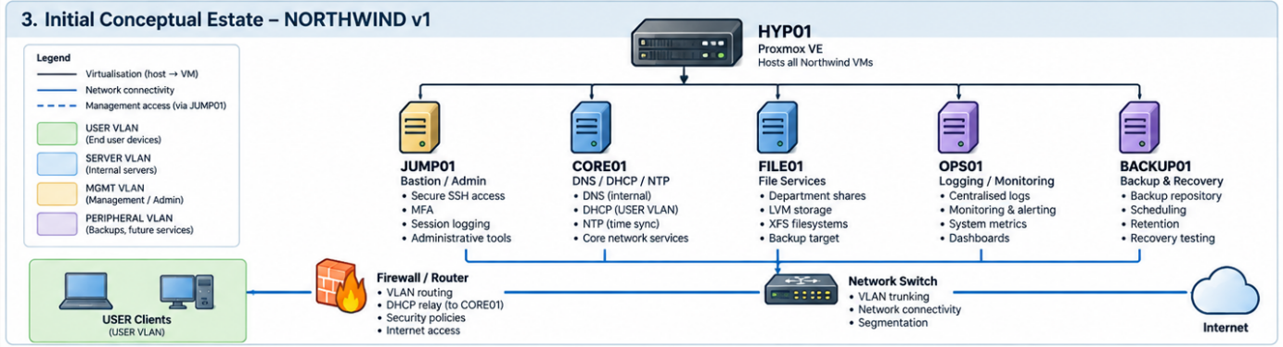
The diagram represents logical workload placement only.
Network-zone placement and communication paths remain governed by LLD-01-002.

15. Rejected / Deferred Initial Hosts
Proposed Host | Disposition | Reason
IAM01 | Deferred | Centralised IAM not required for v1
AUTO01 | Deferred | Automation initially distributed through scripts/timers
STOR01 | Not required | Storage delivered through Proxmox + RHEL LVM/XFS
LOG01 | Consolidated | Logging incorporated into OPS01
MON01 | Consolidated | Monitoring incorporated into OPS01
VPN01 | Not required initially | Remote access expected from perimeter infrastructure
APP01 | Deferred | No defined application workload yet
PATCH01 | Not required initially | RHEL package management + governance sufficient for current scale
SEC01 | Not required | Security is currently cross-cutting rather than a standalone workload
These decisions should be reconsidered when future requirements materially change the environment.

16. Design Trade-Offs Accepted
Northwind v1 deliberately accepts several consolidation-related risks.
CORE01
DNS, DHCP and NTP share a failure domain.
This is accepted because the services are lightweight and the environment uses recovery-based resilience.
OPS01
Logging and monitoring share a failure and compromise domain.
This is accepted because the current environment is small and does not justify two independently maintained systems.
HYP01
All VMs currently depend upon a single physical hypervisor.
This is accepted under the existing decision to use recovery-based resilience rather than implementing artificial high availability.
These are known and documented design trade-offs, not accidental architecture limitations.

17. Deferred Detailed Design
LLD-01-004 intentionally does not define:
- vCPU allocations;
- memory allocations;
- virtual disk sizes;
- physical storage sizes;
- detailed LVM layouts;
- filesystem sizes;
- VLAN IDs;
- IP addresses;
- NIC quantities;
- exact software packages;
- DNS implementation;
- DHCP implementation;
- NTP implementation;
- file-sharing protocols;
- monitoring platform;
- logging platform;
- backup software;
- backup retention;
- firewall ports;
- detailed inter-server network flows.
These decisions belong to subsequent infrastructure and service-specific detailed designs.

18. Relationship to LLD-01-005
LLD-01-004 defines what infrastructure should exist.
It does not yet define the order in which that infrastructure must be implemented.
The next question will therefore determine dependencies and build sequencing:
Which components must exist before we can build anything else?
This will establish the initial implementation sequence and identify bootstrap dependencies such as compute, networking, administrative access and core services.

19. Decision
Accepted as the proposed Northwind v1 initial server estate.
Northwind will begin with:
Physical infrastructure
- HYP01 — Proxmox virtualisation/compute host
RHEL 10 virtual infrastructure
- JUMP01 — Bastion and privileged administration
- CORE01 — DNS, DHCP and NTP
- FILE01 — File and data services
- OPS01 — Logging, monitoring and alerting
- BACKUP01 — Backup and recovery
The estate will remain intentionally small.
Additional servers will be introduced only where new requirements, workload growth, security boundaries, scaling requirements or operational constraints provide sufficient justification.
This design provides Northwind with the required initial infrastructure capabilities while avoiding unnecessary server proliferation and preserving a clear path for future expansion.

