EVIDENCIA, METODOS SOBRE PRODUCTO
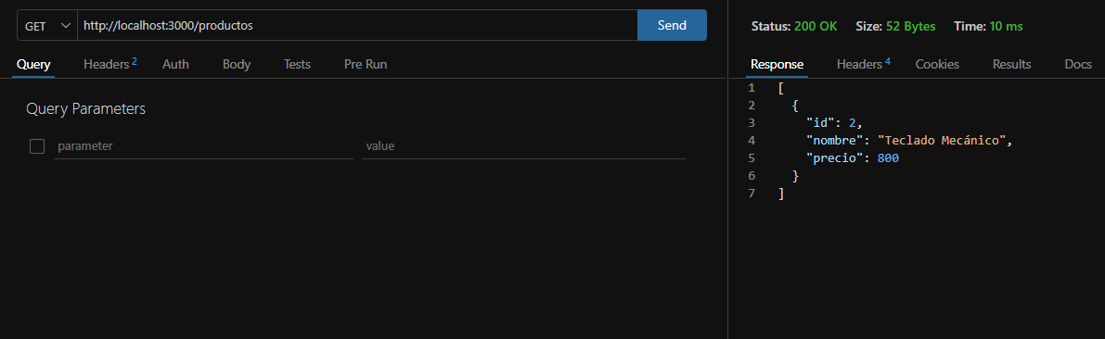
GET

GET BY ID
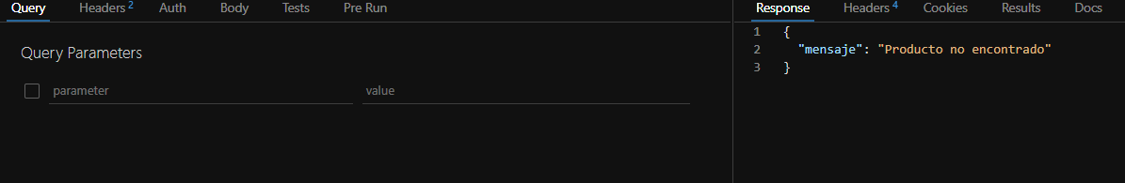

POST
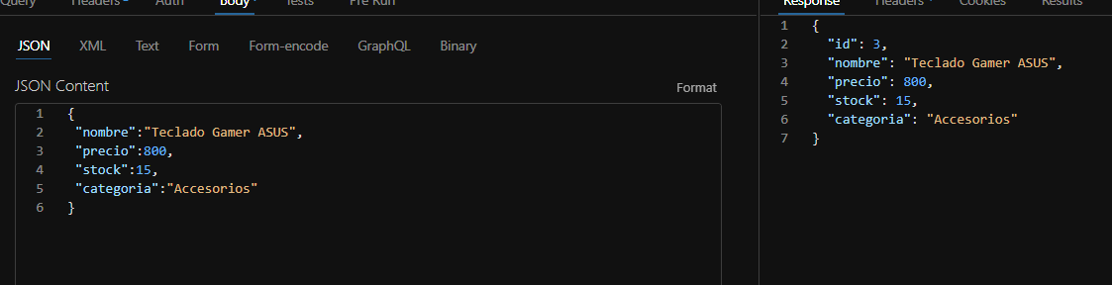
PUT
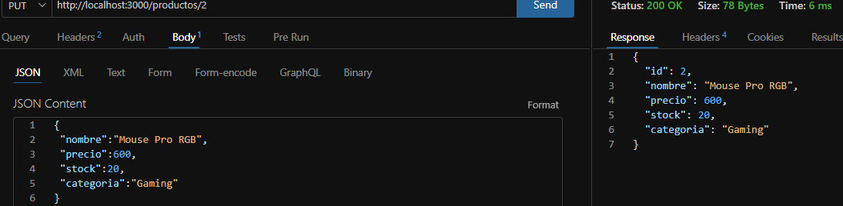

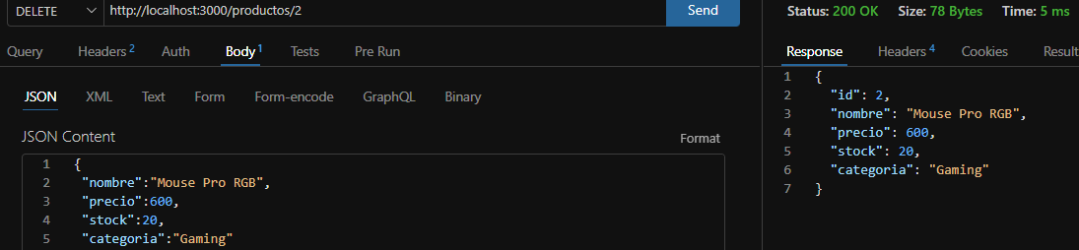
DELETE

EVIDENCIA METODOS SOBRE CLIENTE

GET
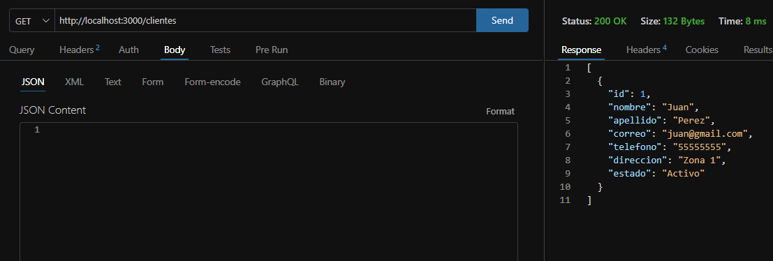

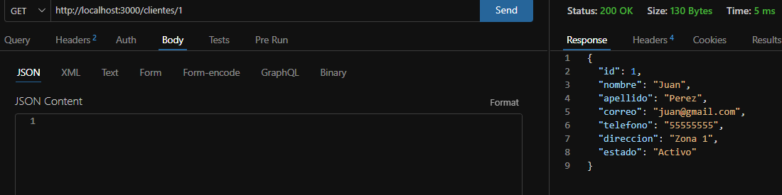
GET BY ID

POST
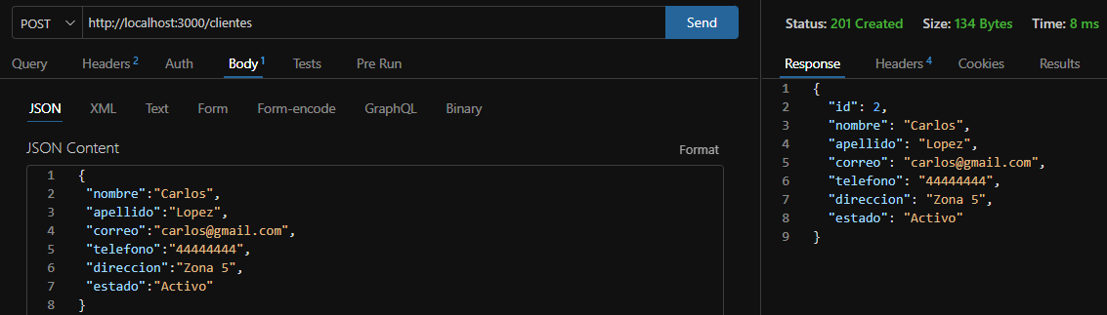

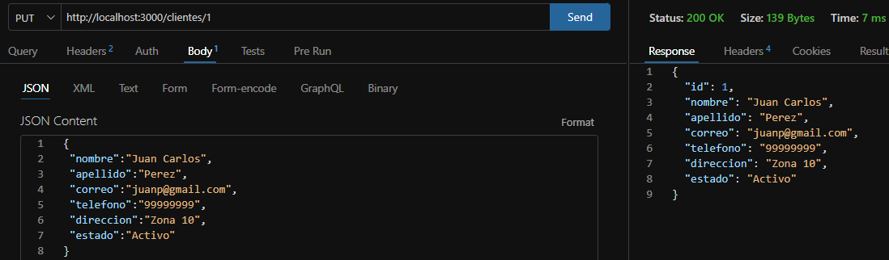
PUT

DELETE
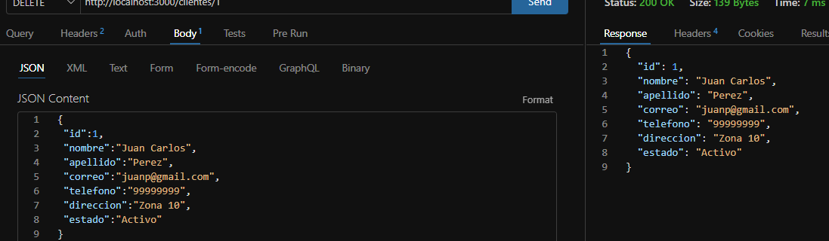

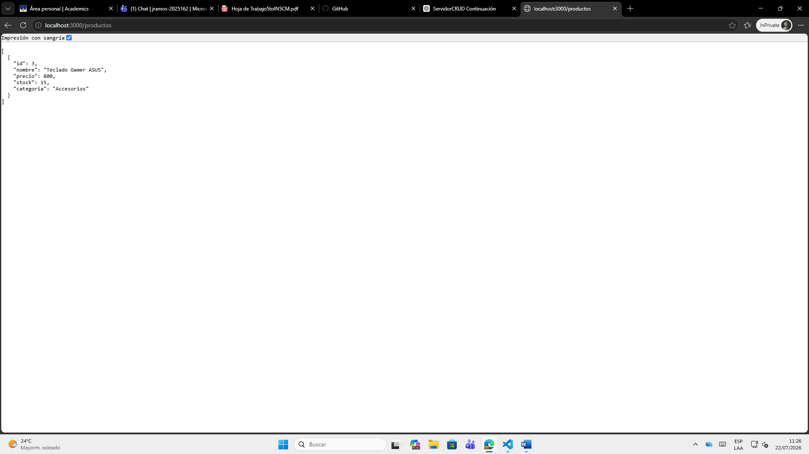
PRUEBAS DESDE NAVEGADOR

