**Recognizing and Expressing Affect**

Presentation Summary

Part 1 **Research status of emotion expression recognition**

1.1 Facial expression recognition.

1.2 feature extraction

Part 2 **Markov, D-S theory**

2.1 Markov model

There is probability of changing emotion status in Markov model, so in this emotion model, there are 27 (i,j ) and they construct 27 dimensional Probability matrix .

=

(i,j ) is the probability of status to status. Additionally, there is a relationship among them:

We can conclude that if there are m emotions and there will be m dimensional emotional space, and for every emotion there are n levels, which means that there will be emotion status. Regard l=, we can find that:

= and

2.2 Dempster-Shafer evidence theory

The D-S evidence theory is based on the theory of non-empty finite fields Θ. Θ is called frame of discernment or FOD, which represent a finite number of system states {θ1, θ2, ⋯, θn}, the system state assumes that Hi is a subset of Θ, an element of FOD's power set P(Θ).

D-S combination formula:

k=

For multiple basic probability assignment functions, there is a rule:

m(A)=

The combined probability value after combination is

m(A) = , A

k=

Combine emotional space model with D-S evidence theory. This model will capture outer simulation by sensor, and then D-S theory will be applied into it for combining outside emotion information, which finally will promote the transfer of emotion status and reach a new state of emotion.

Part 3 **Models（Application of Markov, D-S theory）**

**Discrete Affective Space Model**

1. Construct a three-dimensional model based on fear, anger and happy, and any emotional status will match a certain point on the 3-dimensional space.

2. Define happy as a, anger as b, fear as c, so, there are a, b, c

3. Set that every basic emotion only have three intensity.

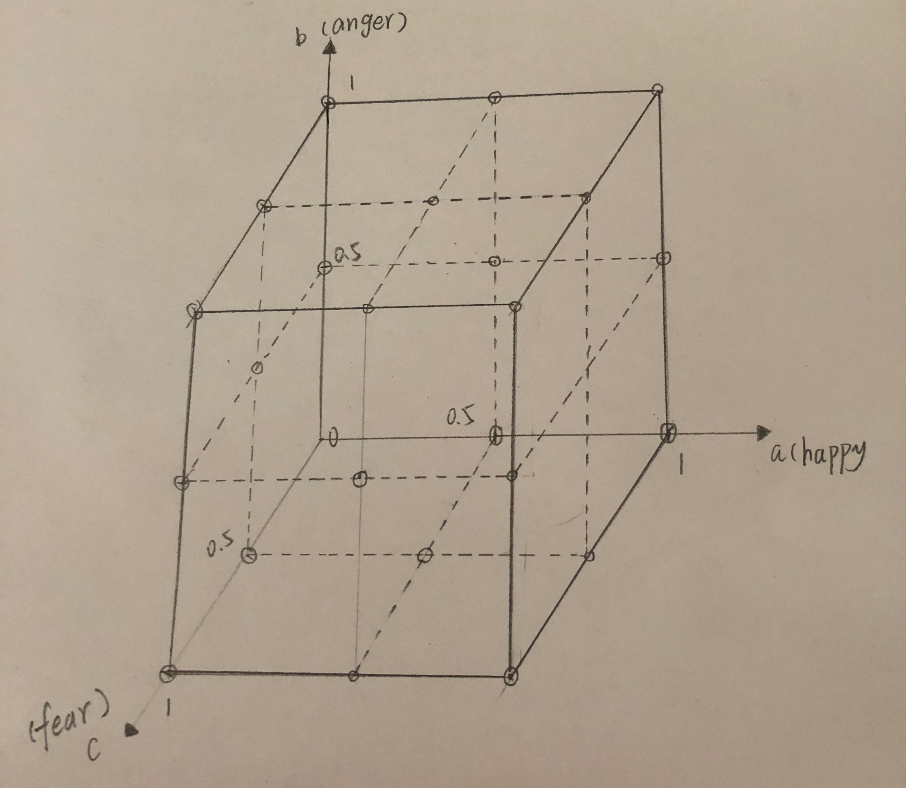

S = the strength of simulation from outside environment

P = basic credibility

Emotional Information Processing Flow

Fig. 1. emotional space model

Fig. 1. emotional space model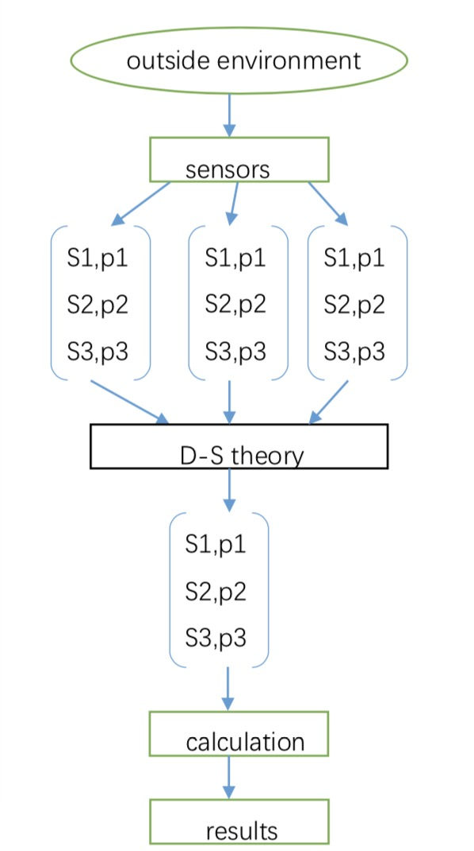

Fig. 2. Emotional Information Processing Flow

4. Combine emotional space model with d-s evidence theory.

5. This model will capture outer simulation by sensor, and then D-S theory will be applied into it for combining outside emotion information, which finally will promote the transfer of emotion status and reach a new state of emotion.