How to connect your WSL in github using SSH so you don’t have to enter you username and key everytime you push a changes.

1. Create a ssh key if you don’t have one: 
2. Add ssh key to ssh agent:



1. Add your ssh to github:

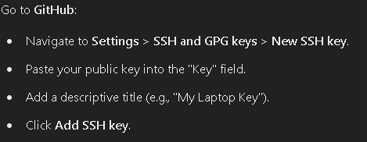

1. Test your ssh connection:

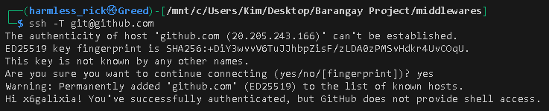

1. Update your github remote url:

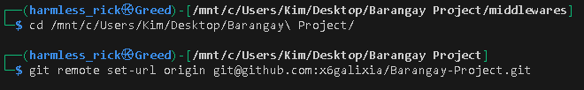

CONGRATS YOU CAN NOW PUSH YOUR CHANGES ONTO YOUR GITHUB WITHOUT BEING ASK FOR USERNAME AND PASSWORD.