BREAK

Stack: Flask 3, Python 3.13, openpyxl, matplotlib, openai SDK, python-pptx, playwright
Model: DeepSeek V4 (deepseek-chat default), one verdict call + optional follow-up
Cost: around $0.0001 per analysis. Follow-up question around $0.00013
Port: 127.0.0.1:1006 (loopback only, CSRF double-submit cookie, single-flight semaphore)
Tests: 352 across all 6 days; 73 for Day 6.1

Walk-through (all 18 frames)
Each frame is captioned and explained. Frames marked KEEP are the recommended six attachments; the rest are deep-dive frames for a thread or a follow-up post.
01. Empty home . KEEP
Cold start. Big BREAK wordmark with the E in purple and a magenta slash. Vertical day rail on the left. Editorial masthead with VOL / ISSUE / DEEPSEEK metadata.
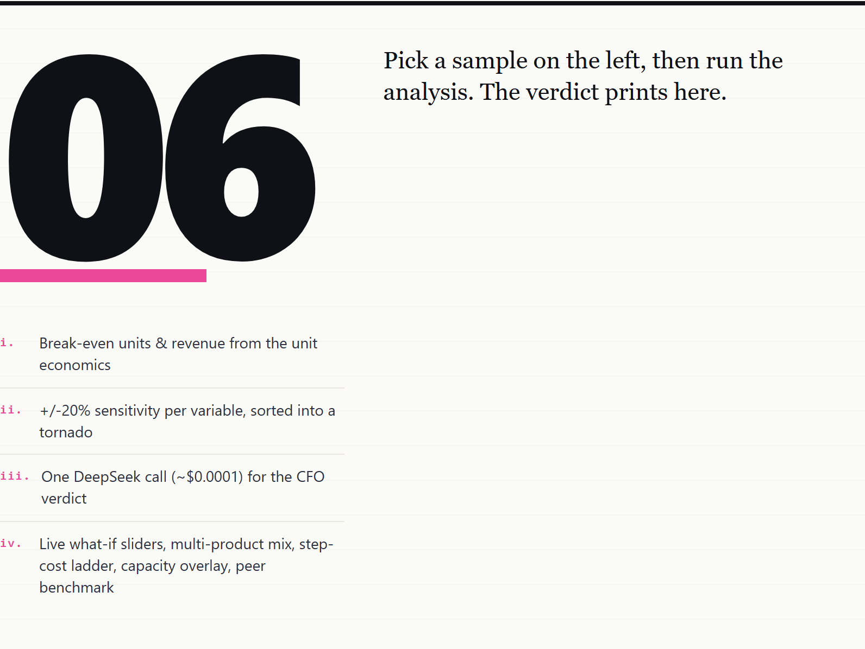
First load. The hero numeral '06' sits in the canvas as a magazine pull-numeral with a magenta underline. The lede on the right is an ordered list of what shows here after a run: break-even units and revenue, sensitivity, AI verdict, what-if sliders, multi-product, step-cost, capacity, peer benchmark.
02. Masthead
Editorial header. Wordmark, VOL / ISSUE / DEEPSEEK metadata, COST.VOLUME.PROFIT strap.
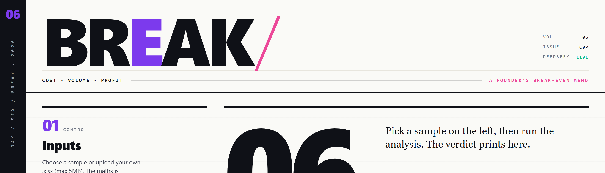
The masthead is two rows. Top row: huge BREAK wordmark on the left, three meta lines on the right (VOL 06, ISSUE CVP, DEEPSEEK LIVE/NO KEY). Bottom row: a thin strap with the 'COST . VOLUME . PROFIT' tag on the left and 'A FOUNDER'S BREAK-EVEN MEMO' on the right, separated by a hairline rule.
03. Hero KPI . KEEP
The break-even number, three stat tiles, optional cash-basis toggle, peer benchmark band.
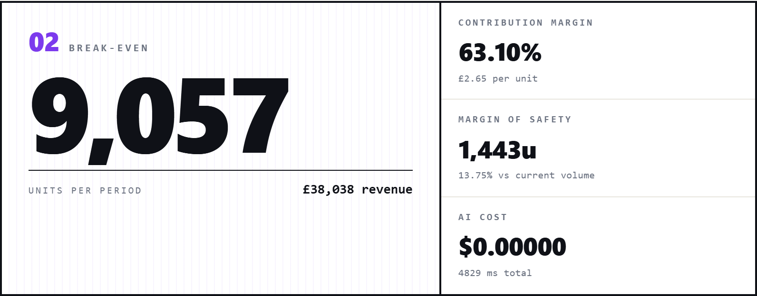
The brew & bites cafe sample. Break-even at 9,057 units per period (revenue GBP 38,038). CM ratio 63.10% with the peer benchmark band underneath showing where 63.10% sits inside the 62 to 72% typical cafe range (in_range, green pos pill). Margin of safety 1,443 units (13.75% above current volume of 10,500). AI cost $0.00000 because skip_ai was on for the screenshot.
04. Capacity card
REACHABLE pill plus headroom percent. Optional metadata.capacity_units.
The cafe has a stated capacity of 18,000 transactions per period. BE at 9,057u sits 49.7% below the ceiling, so the pill is green and the card is calm. If BE were above capacity, the pill would flip to red 'NOT REACHABLE' and the chart would draw the dashed magenta capacity line ahead of the BE marker.
05. Covenant card
OK / BREACH pill plus buffer percent vs current revenue.
The bank covenant is a minimum revenue of GBP 42,000 per period. Current revenue (10,500 units * GBP 4.20) is GBP 44,100, so the buffer is +5%. The card sits green. A negative buffer flips the pill to red 'COVENANT BREACH' so the founder knows the loan terms would trip before any P&L damage.
06. Break-even profile . KEEP
Inline SVG. Revenue line (purple), total cost line (ink), fixed cost reference (grey dashed), profit/loss zones (soft green/red), BE marker (magenta) plus optional dashed capacity line.
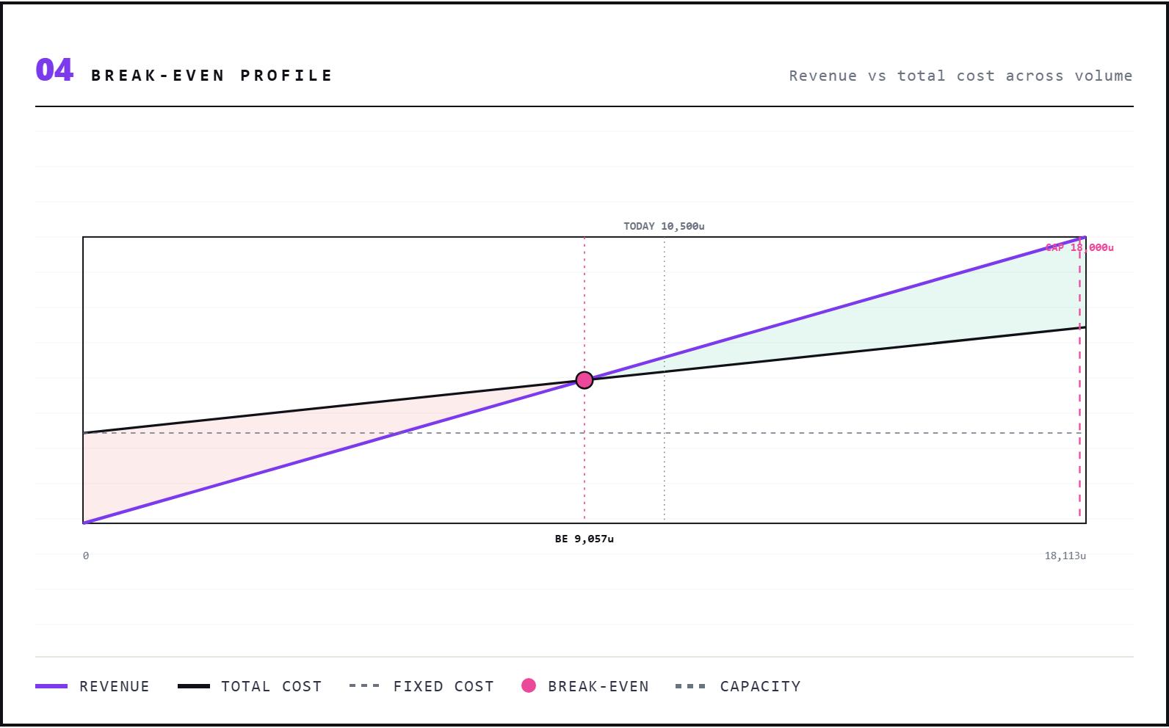
The classic break-even chart, redrawn client-side from the JSON payload so the live UI never needs a server round-trip when sliders move. The polygon fills mark the loss triangle (lower left) and the profit wedge (upper right). The magenta dot at the BE point is outlined in ink for legibility against the soft fills. A small 'BE 9,057u' label sits below the dot on the volume axis.
07. Live what-if sliders
Four sliders (price, vc, fixed, volume) with delta-vs-base hints on four KPIs.
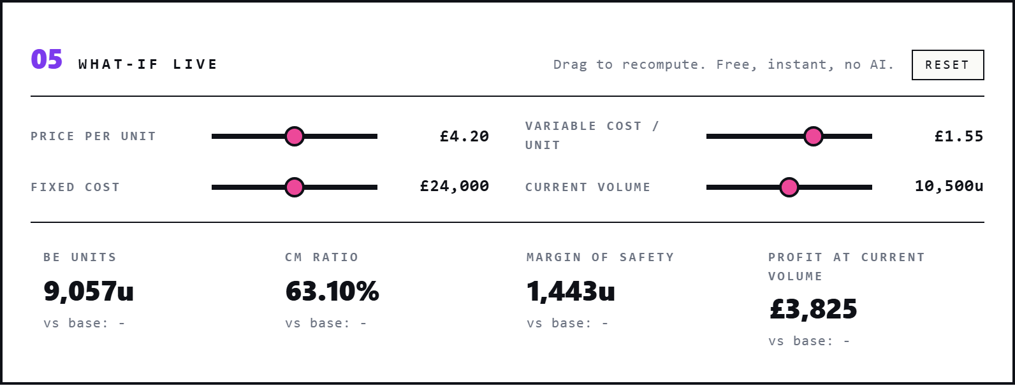
The fastest way to build intuition. Drag 'Price per unit' down by 10p and the BE jumps; drag 'Variable cost' down by 5p and it falls. Each KPI tile shows the 'vs base' delta in tabular monospace, coloured red when the change is adverse (BE rises, profit falls) and green when favourable. No server round-trip; pure JS.
08. Target profit calculator
Three independent modes: profit-from-volume, volume-from-target-profit, price-from-target-margin.
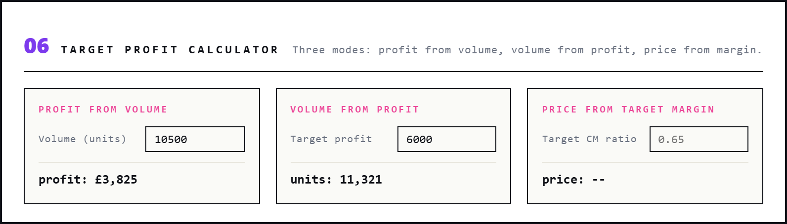
The inverse of the break-even calculation. Type a volume, see the profit. Type a target profit, see the volume needed. Type a target CM ratio, see the price you would have to charge given today's variable cost. Useful when the founder is sketching pricing on the back of a napkin.
09. Compare three prices
Same fixed and vc, three price points side by side. BE / CM ratio / MoS for each.
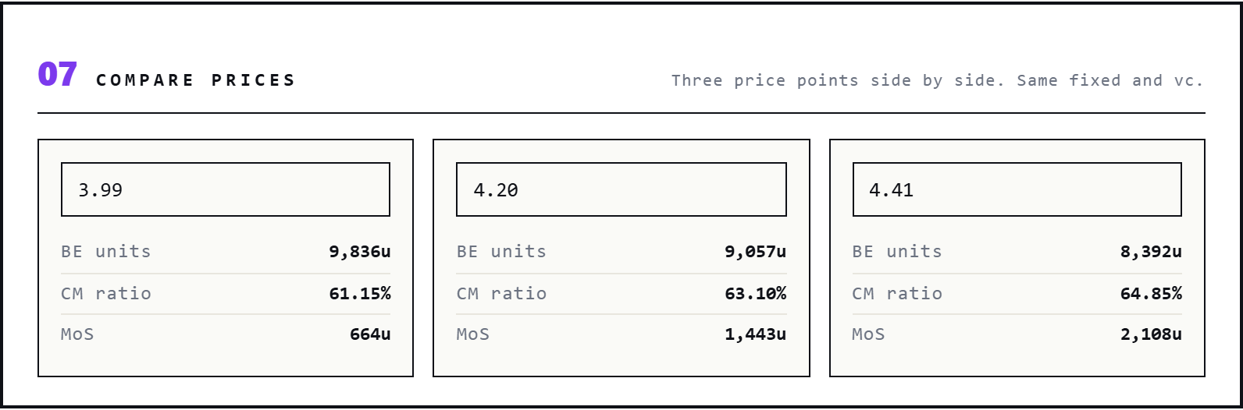
Pre-populated at -5% / 0% / +5% of the headline price. The trade-off is visible at a glance: drop price 5p and the cafe needs 779 more cups to break even; raise it 5p and BE drops by 665 cups. Built for the back-pocket pricing meeting.
10. Multi-product mix . KEEP
Weighted CM and per-product BE allocation. Three live mix sliders.
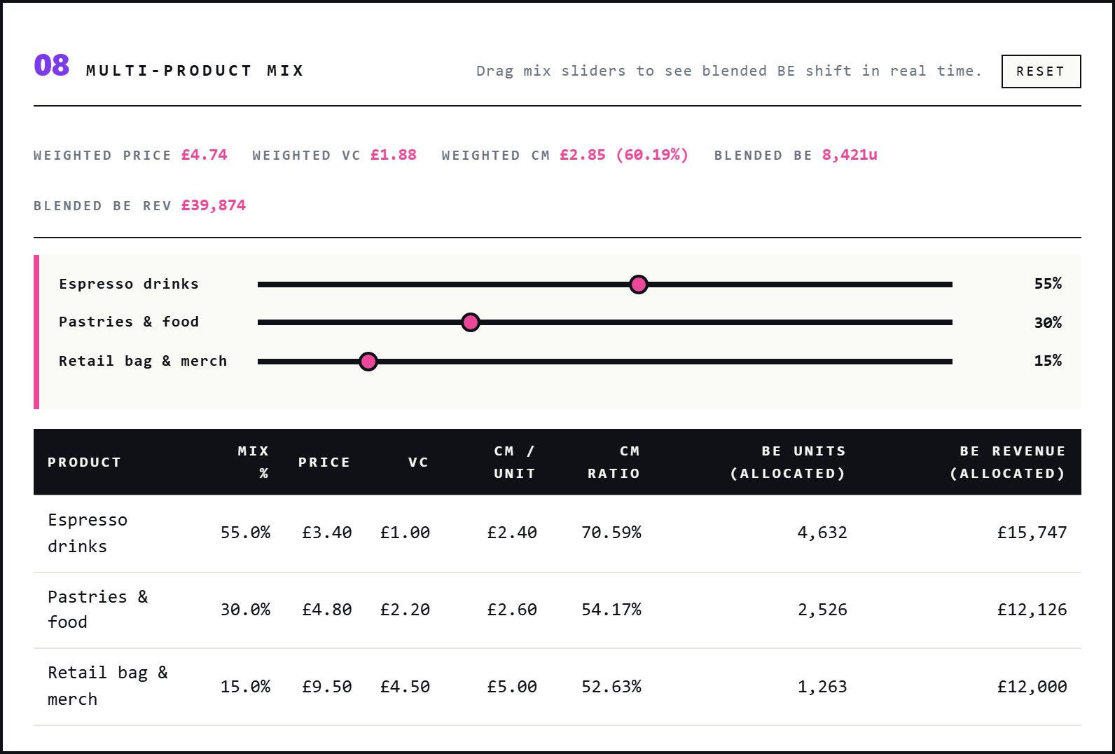
Real businesses sell more than one SKU. The brew & bites cafe sells espresso drinks (55% mix, 70.59% CM ratio), pastries & food (30%, 54.17%), and retail bag & merch (15%, 52.63%). Weighted CM lands at GBP 2.85 per transaction (60.19%). Drag any slider; the blended BE moves in real time and the per-product allocation updates. If the slider sum drifts off 100%, the card auto-normalises with a magenta warning line.
11. Step-cost ladder
BE recomputes inside each fixed-cost segment.
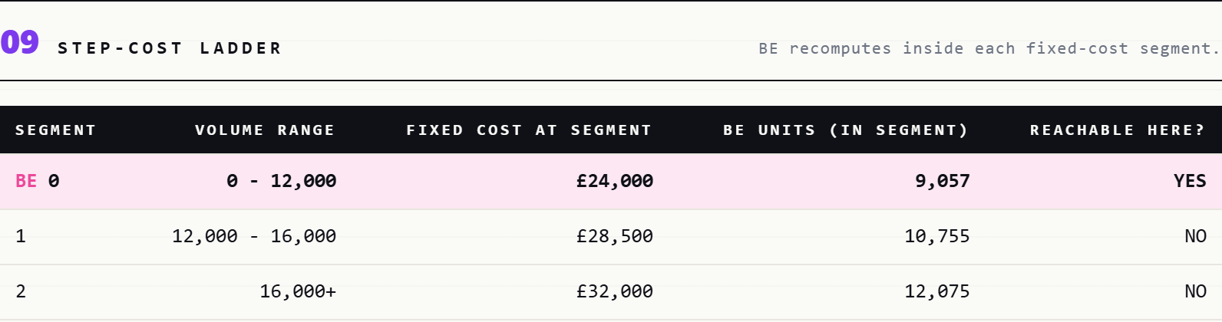
Fixed cost is not smooth. The cafe needs a second barista at 12,000 transactions (adds GBP 4,500 of fixed) and a baker at 16,000 (adds another GBP 3,500). The ladder shows three segments: baseline (GBP 24,000 fixed, BE 9,057u, REACHABLE inside the 0-12k range), step 1 (GBP 28,500, BE 10,755u, but that is above the 12-16k range so unreachable here), step 2 (GBP 32,000, BE 12,075u). The 'BE' marker sits next to the first reachable segment.
12. Sensitivity grid
+/-20% / +/-10% / 0% on price, variable cost, fixed cost.
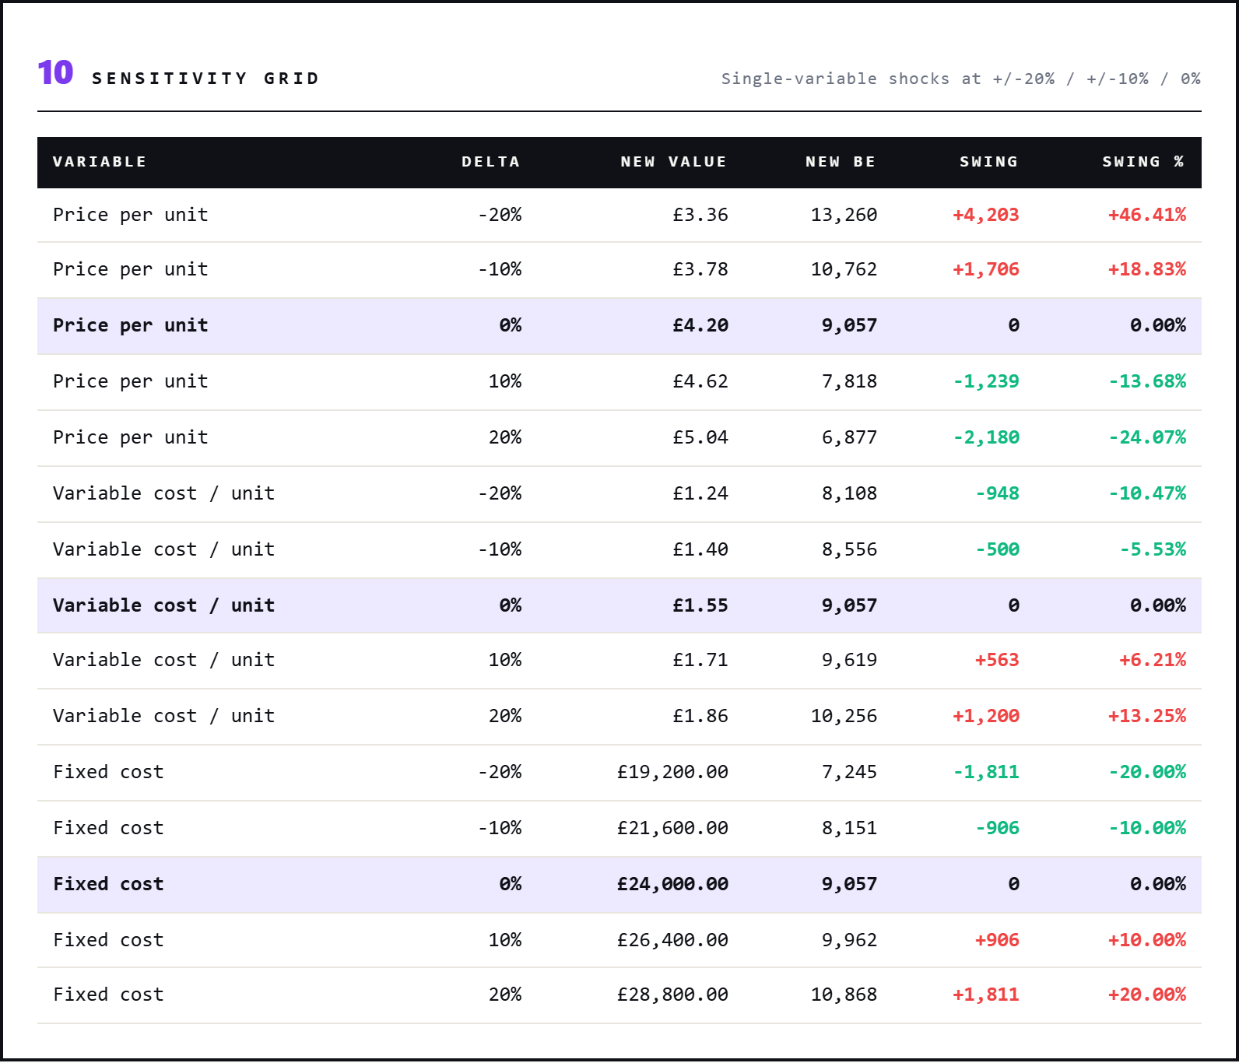
Ink header, baseline (0%) rows highlighted in soft purple, swing values coloured red (BE rises) / green (BE falls). Price is the dominant lever in this sample: a 10% price cut raises BE by 17.98% (1,541 units), far more than equivalent shocks to vc or fixed. The +/-10% rows feed the tornado chart in the Excel and PDF exports.
13. 2D heatmap
BE units across price (rows) and variable cost (cols). Soft green = low BE, magenta = high BE.
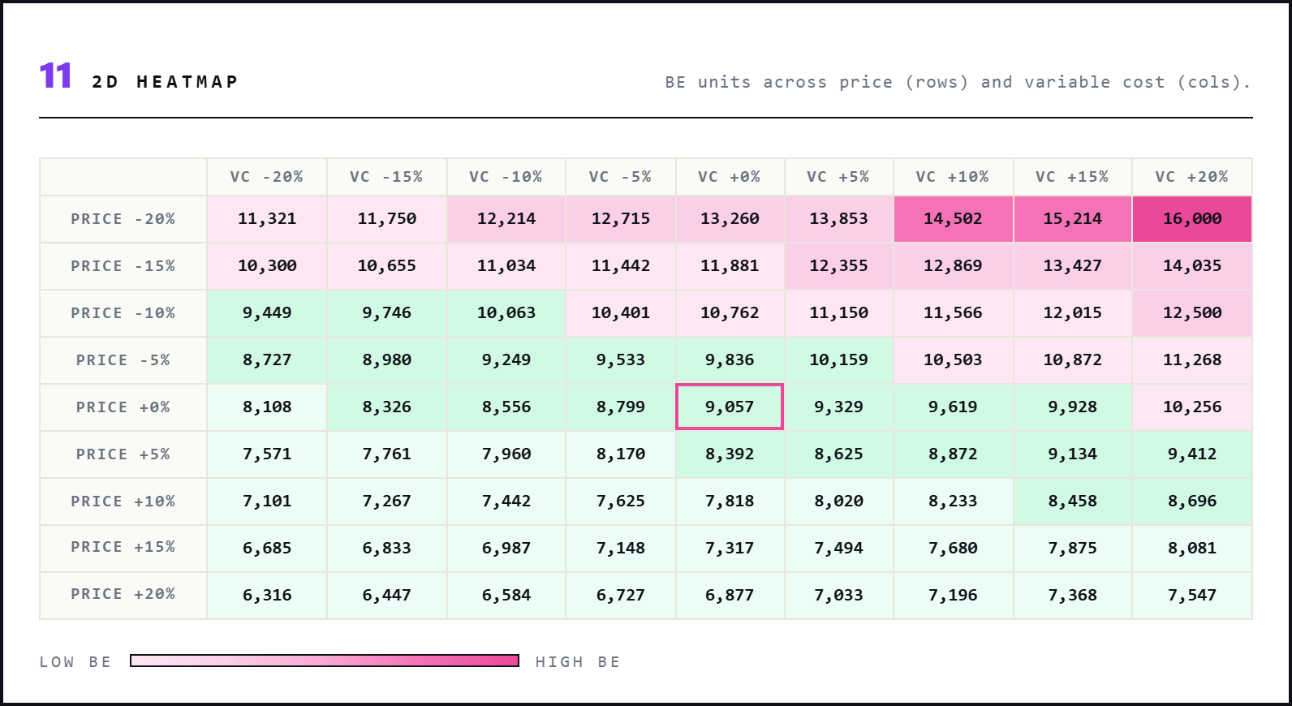
The joint surface that the single-variable sensitivity hides. The baseline cell (price 0%, vc 0%) is outlined in magenta and equals 9,057. Top-right corner (price -20%, vc +20%) is the worst case at 16,000 units. Bottom-left (price +20%, vc -20%) is the best at 6,316. Useful when the founder is negotiating both supplier prices and pricing simultaneously.
14. Monte Carlo . KEEP
4,000 triangular shocks on price, vc, fixed. P5 / median / P95 bands plus 24-bin histogram.
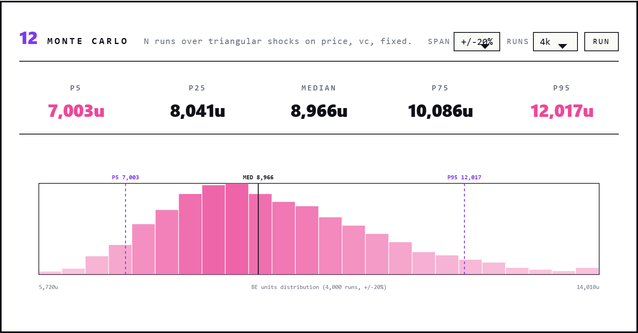
The right-skewed distribution typical of CVP under symmetric input shocks: thin price means BE is more sensitive to downward price moves than upward ones. Median 8,966 units. P5 7,003, P95 12,017 — a wide range that quantifies the founder's actual risk. Tunable to +/-10% / +/-20% / +/-30% span and 2k / 4k / 10k runs. Seed-stable, so a re-run with the same seed reproduces the histogram exactly.
15. Time-phased BE . KEEP
Cumulative BE crossing on a planned volume curve.
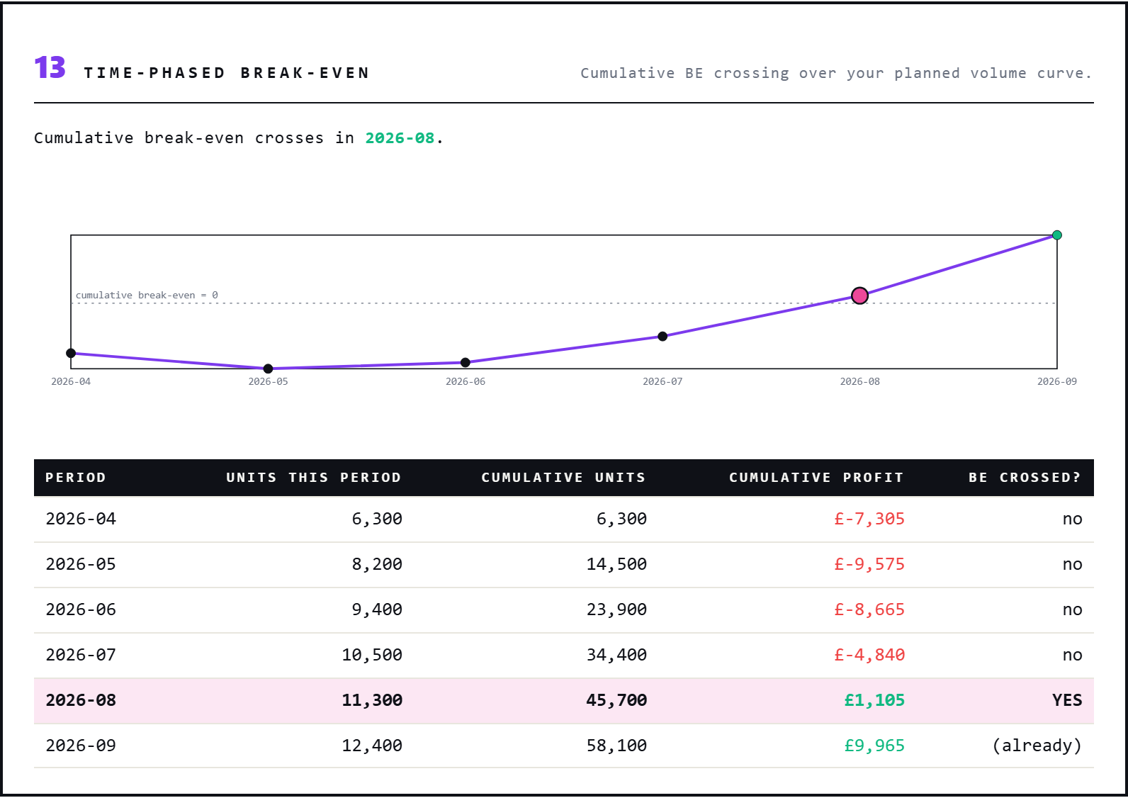
When a 'volume_curve' sheet is present, the tool walks the periods and accumulates units while fixed recurs each period. The cafe's planned ramp goes 6,300 to 12,400 over six months. Cumulative profit dips to -GBP 9,575 in May before climbing back. The first period where cumulative profit crosses zero is 2026-08 (GBP 1,105). 2026-09 sits in the green at GBP 9,965. The polyline marks the crossing month with a magenta dot.
16. Show-the-working panel
Eight formulas with substituted values for audit and teaching.
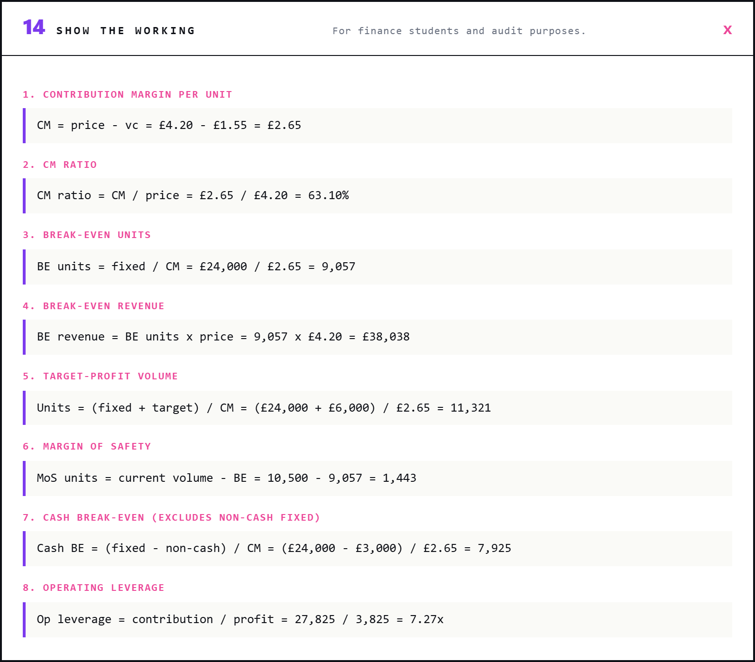
Collapsible card. CM = price - vc = GBP 4.20 - GBP 1.55 = GBP 2.65. CM ratio = CM / price = GBP 2.65 / GBP 4.20 = 63.10%. BE units = fixed / CM = GBP 24,000 / GBP 2.65 = 9,057. Then BE revenue, target-profit volume, MoS, cash BE, operating leverage. Every formula has the live numbers substituted in. Useful when an accountant wants to audit the maths or a finance student wants to learn it.
17. Export bar
XLSX, CSV, PDF, PPTX. Embedded chart PNGs, currency-aware formatting.
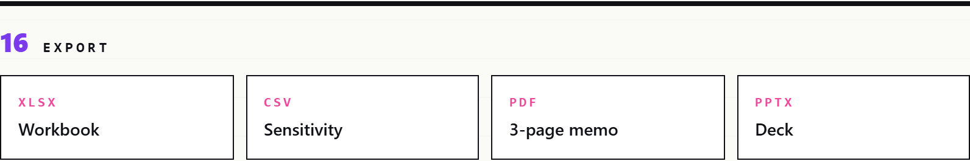
All four exports are generated from the same AnalysisResult. The XLSX has Summary, Inputs, and Sensitivity sheets with embedded break-even chart and tornado PNGs. The PDF is a 3-page A4 memo (cover + chart + sensitivity & verdict). The PPTX is a 3-slide deck. The CSV is the flat sensitivity grid encoded utf-8-sig so Excel auto-detects UTF-8.
18. AI verdict + follow-up . KEEP
Serif pull-quote with magenta left rail. One DeepSeek call, one optional follow-up.
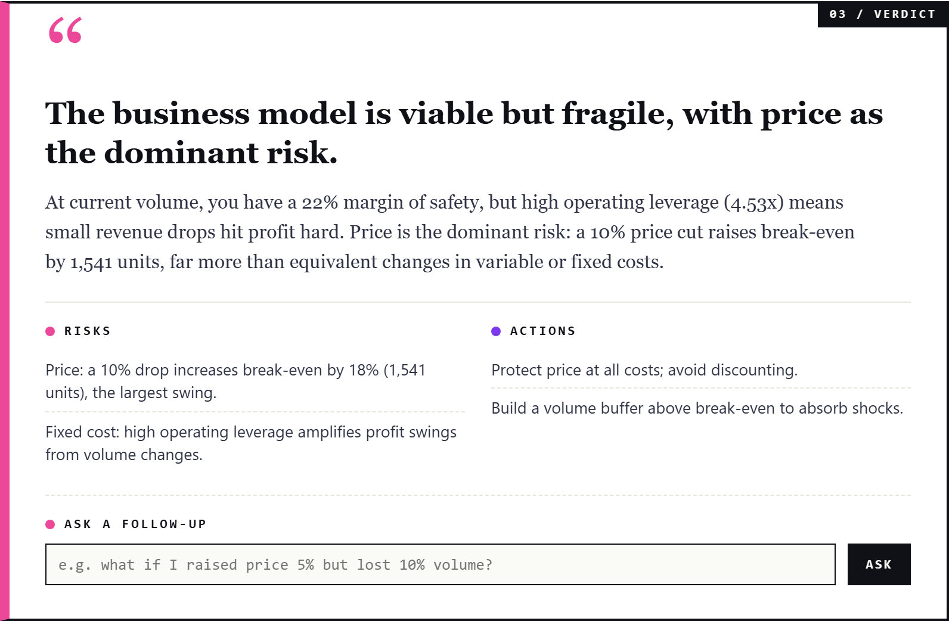
Coffee shop sample. Verdict: 'The business model is viable but fragile, with price as the dominant risk.' Body: 'At current volume, you have a 22% margin of safety, but high operating leverage (4.53x) means small revenue drops hit profit hard. Price is the dominant risk: a 10% price cut raises break-even by 1,541 units, far more than equivalent changes in variable or fixed costs.' Risks (magenta dot) and Actions (purple dot) follow. The 'Ask a follow-up' box on the same card answers free-text questions for around $0.00013.
How it works
The Tool:
Pure-Python deterministic core. cvp_schema.py parses the workbook into typed dataclasses (CVPMetadata, CVPInputs, Product, StepCost, VolumePoint). cvp_maths.py is pure functions: headline_stats, sensitivity_table, tornado, multi_product_stats, step_cost_be, time_phased_be, heatmap_grid, operating_leverage_at. monte_carlo.py runs 4,000 triangular shocks with a stable seed. benchmarks.py is a curated dictionary of 10 industries with CM-ratio bands. The pipeline (pipeline.py) orchestrates: parse, do the maths, optionally call DeepSeek, return one AnalysisResult that the writers and front-end serialise from.
AI Verdict + Follow-up:
One DeepSeek V4 call per analysis. The system prompt instructs a CFO voice, two to three sentences, do-not-restate the inputs. The user prompt is a pre-summarised digest: company, period, currency, unit economics, headline stats, sensitivity per variable, dominant lever. JSON mode returns headline + summary + risks + actions in a strict shape. The follow-up endpoint reads the cached run, builds a 4-line summary plus the question, and asks for a 2 to 3 sentence answer. Content-hash cache stores parsed payloads so identical inputs never pay twice. Cost guardrail of $0.05 per run via DAY06_MAX_COST_USD.
Live What-If, Mix Sliders, Heatmap, URL state:
All client-side. The break-even maths is one division, so the JS recomputes it on every slider tick without hitting the server. The mix-shift sliders auto-normalise to 100% with a magenta warning line if the user drags the sum off. The 2D heatmap is a 9x9 grid coloured with a green-to-magenta scale; the baseline cell is outlined in magenta. URL state encodes price/vc/fixed/volume/target/currency into the querystring on every successful run, so a 'SHARE URL' button copies a self-contained link to the clipboard. Print stylesheet hides the controls and turns the page into a clean memo.
Excel & Exports:
openpyxl writes a 3-sheet workbook (Summary, Inputs, Sensitivity) with embedded break-even chart and tornado PNGs (rendered by matplotlib, Agg backend). Currency-aware formatting (GBP / USD / EUR / fallback). The CSV is utf-8-sig encoded so Excel auto-detects. python-pptx writes a 3-slide deck (cover / chart / sensitivity + verdict). matplotlib.backends.backend_pdf writes a 3-page A4 PDF memo. Filenames include a slugified company + period + timestamp.
Limitations addressed
Day 6 originally shipped with an honest limitations list. Most of it is now in the build (hence the .1 release). Each item below was a 'we don't do this yet' in the first README; the description is what shipped in 6.1.
- Multi-product weighted CM. Card 10 reads a 'products' sheet, computes weighted price/vc/CM, blended BE, and per-product BE allocation. Three live mix-shift sliders let the founder shift mix and watch BE recompute live, with auto-normalisation.
- Step-cost behaviour. Card 11 reads a 'step_costs' sheet, walks the ladder of fixed-cost thresholds, recomputes BE inside each segment, and highlights the first reachable BE.
- Time-phased BE. Card 15 reads a 'volume_curve' sheet, accumulates units while fixed recurs, finds the first period where cumulative profit crosses zero. Polyline plus per-period table.
- Capacity constraints. metadata.capacity_units. REACHABLE / NOT REACHABLE pill plus a magenta dashed capacity line on the chart. Buffer percent shows headroom.
- Stochastic sensitivity (Monte Carlo). Card 14. 4,000 triangular shocks on three inputs, P5 / P25 / median / P75 / P95, 24-bin histogram, tunable span (10/20/30%) and runs (2k/4k/10k). Seed-stable.
- Bank covenants overlay. metadata.covenant_min_revenue. OK / BREACH pill plus buffer percent vs current revenue.
- Industry benchmark overlay. metadata.industry. Peer CM range band under the contribution-margin tile, with above / in_range / below classification across 10 industries.
- Save / name / re-open scenarios. Save button, named runs in the dock, click to re-open. Server-side label persists in run cache.
- Compare two runs. Pick two saved runs in the dock, click Compare, see deltas across 9 metrics in a table.
- AI free-text follow-up. Ask-a-follow-up box on the verdict card. Around $0.00013 per question on deepseek-chat.
- 2D sensitivity heatmap. Card 13. 9x9 grid, green-to-magenta scale, baseline outlined.
- Live what-if sliders. Card 7. Four sliders that recompute four KPIs (BE, CM ratio, MoS, profit at current volume) with delta-vs-base hints.
- Inverse target-profit calculator. Card 8. Three modes: profit-from-volume, volume-from-profit, price-from-target-margin.
- Compare-three pricing. Card 9. Three price inputs, three result columns side by side.
- Shareable URL + print. Inputs encoded as querystring; SHARE URL copies to clipboard. Print stylesheet hides controls and turns the page into a clean memo.
- Show-the-working panel. Card 16. Eight formulas with live substituted values for audit / teaching.
Limitations still standing
These are the gaps a real CFO would still flag. Calling them out honestly is part of the build; pretending the tool is more than it is loses trust.
- Currency conversion / FX layer. The tool reads whatever currency is in metadata and formats accordingly; cross-currency consolidation is post-30 (Day 19 territory).
- Real distribution fitting from historical data. Monte Carlo here uses triangular shocks centred on the inputs; a richer build would fit Beta, log-normal, or empirical distributions per variable from the user's own history.
- Bank-feed integration. The MVP is upload-only. Pulling unit economics from Xero / QuickBooks / Stripe via OAuth is post-30 territory.
- Multi-entity consolidation. One company per workbook. Real treasuries need consolidation, intercompany, and per-bank-account modelling.
- Counterparty payment terms. No debtor-by-debtor receipts forecast. The MVP treats receipts as a flat line per category. Day 10 (AP ageing) is the natural feed for this.
- UK tax auto-generation. VAT quarterly, PAYE monthly, corp tax annual. The MVP requires explicit tax rows; auto-generation needs a P&L-feed contract.
Post-30 expansion
- Bank-feed integration (Xero / QuickBooks / Stripe).
- Currency conversion + multi-entity consolidation.
- Empirical distribution fitting from past months instead of triangular shocks.
- Counterparty payment-term overlay (debtor ageing-aware receipts) - feeds from Day 10.
- UK tax auto-generation from a P&L (VAT / PAYE / corp tax).

