Budget vs Actual Tracker

Stack: Flask 3, Python 3.12, openpyxl, python-pptx, anthropic SDK
Model: Claude Haiku 4.5 (default), Sonnet 4.6 / Opus 4.7 selectable
Cost: around $0.004 per analysis on Haiku 4.5
Port: 127.0.0.1:1003 (loopback only, no auth)
Tests: around 35 across variance, schema, writers, no-dash guard

Walk-through
Five frames, in order. Empty home, single-period sample, drill-through, multi-period sample, multi-period charts. Attach to the LinkedIn post in the same order.

1. Empty home
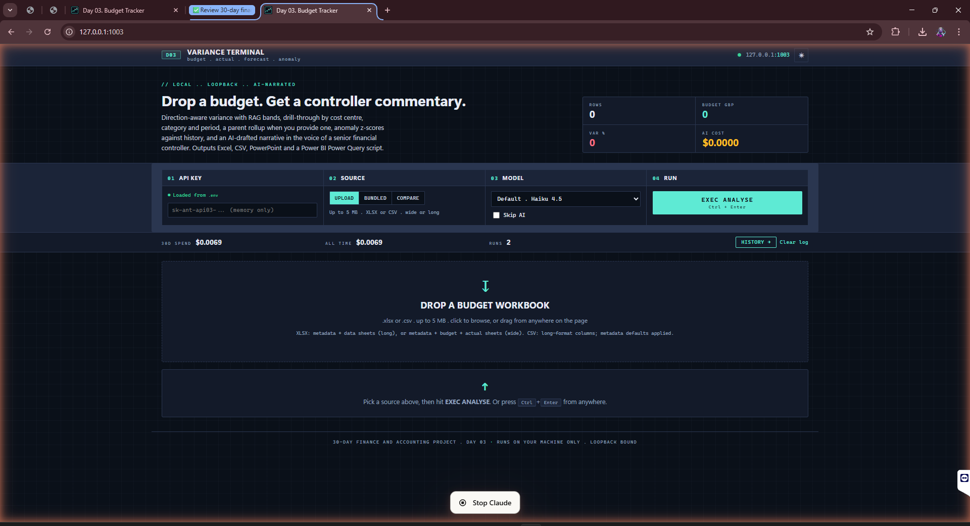
Cold start. Drop zone front and centre, sample picker on the right.
First load. Hero ribbon empty because no run has happened yet. Drop zone gets the largest slice of the canvas because that is the single thing the user is here to do. Three bundled samples on the right give a one-click route in. Status pill at the bottom shows the API key is wired and the last run cost. Slate, cyan and rose terminal palette. Different shape to Day 2 on purpose.

2. Sample Co Ltd: commentary plus pivots
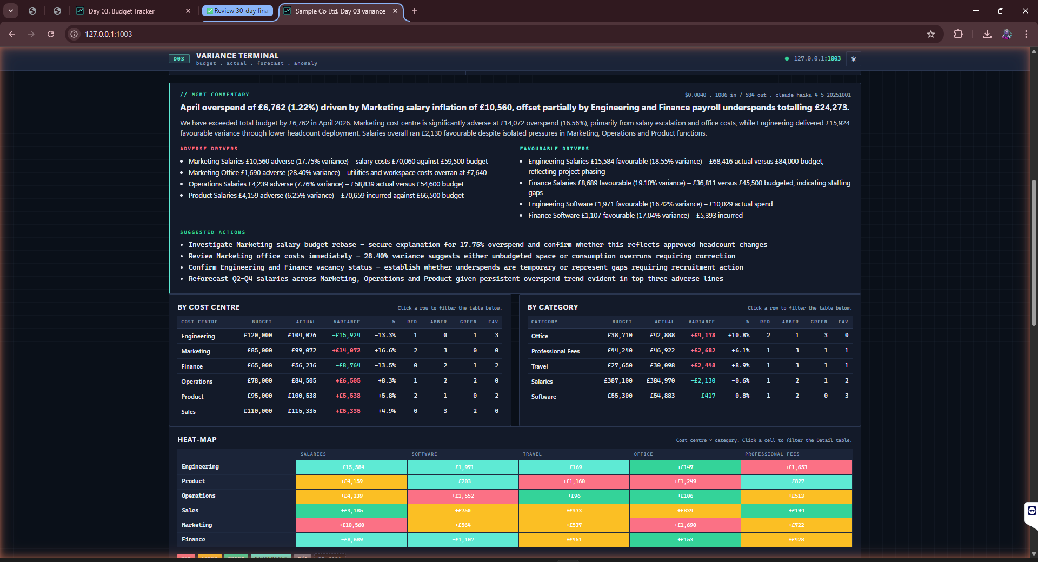
Single-period sample. Commentary card at top, three pivot rollups underneath, heat-map below.
Click Sample Co Ltd. Two and a half seconds later the screen is full. AI commentary card at top: headline banner with the total variance figure in GBP, a controller-voiced summary paragraph, adverse drivers and favourable drivers in two columns, an actions checklist. Every figure traces back to a row in the digest the model saw. Below the commentary, three pivots: by cost centre, by category, by RAG bucket. Click any row to add a filter pill on the Detail grid further down. Click again to clear it.

3. Heat-map and Detail grid with filter pills
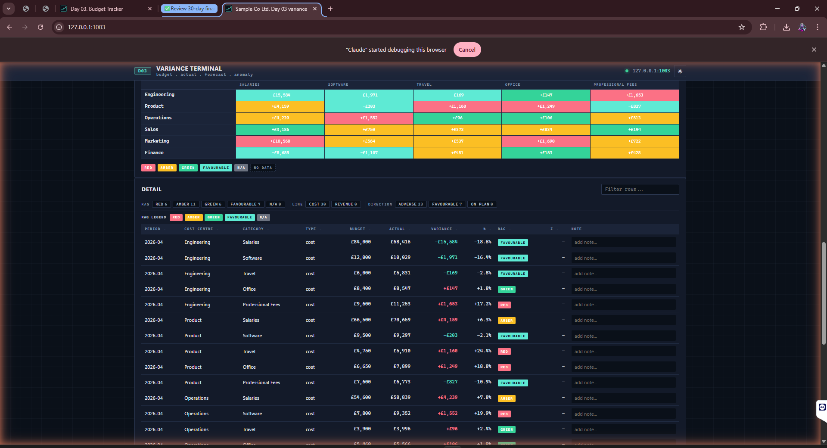
Cost centre by category heat-map sits above the Detail grid. Filter pills show the current selection.
Heat-map is the visual triage layer. Cost centre on one axis, category on the other, cell colour driven by RAG. A red cell means a row that needs attention; a blue cell means a favourable variance big enough to be worth a sentence in the commentary too. Detail grid below: every variance row, sortable on every column, search box that filters across all string columns at once. Notes column on the right is editable inline. Type a one-liner against a row, hit tab, it persists into the next export.

4. Quarterly: commentary plus parent rollups
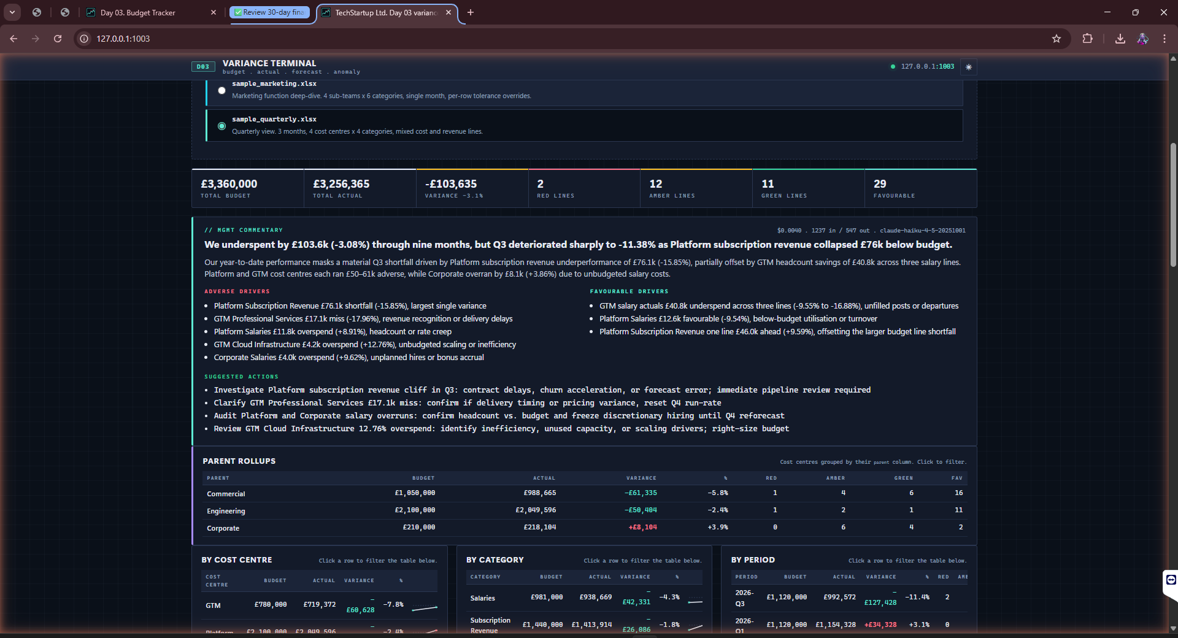
TechStartup Quarterly. Headline KPIs across the top, commentary, then parent rollups grouped by parent column.
Switching to the quarterly sample changes the shape of the analysis. Three periods (Q1, Q2, Q3) and a mix of cost and revenue lines mean the commentary now talks about a trajectory, not a single month. Parent rollups: a Commercial parent that expands into GTM and Customer Success child rows, an Engineering parent that expands into Platform. Same caret-and-click interaction as Excel grouped rows. Totals roll up correctly; RAG on the parent row is the worst RAG of any child. The model picks the deceleration up: revenue ahead in Q1 slipping by Q3 while costs hold steady, and writes the action item I want a controller to see.

5. Quarterly pivots, sparklines, heat-map
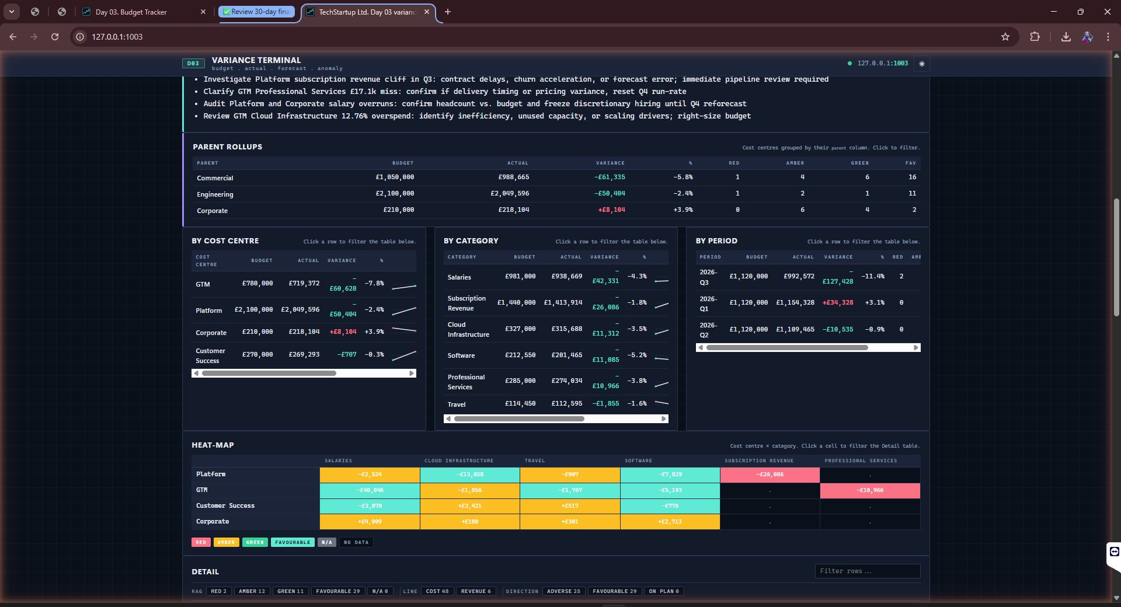
Multi-period pivots gain a sparkline column. Heat-map gains a period dimension.
With more than one period, every pivot row gets a tiny SVG sparkline of variance over time. The shape jumps out faster than a number sequence ever does: a flat green line, a stepped red one, a u-shape that means a one-off. The heat-map gains a period dimension too, small multiples, one mini heat-map per period, sat next to each other. Everything from this view exports: the Excel workbook has a By Period sheet, the PowerPoint deck has the trend slide, the Power BI M script returns the period column ready to slice.

How it works
The Tracker:
Drop zone front and centre, three bundled samples on the right. Hero ribbon up top counts periods, total variance, red lines, adverse percentage, and the actual API spend on the last run. Samples ship in the repo: Sample Co Ltd (single month, six cost centres, all cost lines), Acme Marketing (single month with per-row tolerance overrides on event travel because conferences make the fixed 5% band useless), and TechStartup Quarterly (three periods, mix of cost and revenue lines). UI sits on a slate, cyan and rose terminal palette. Sharp 2-3px corners, single sans stack. Different shape to Day 2 on purpose.
AI Commentary:
Pre-summarised pipe-delimited digest of headline numbers, top-5 adverse drivers, top-5 favourable drivers and the three rollups. About 60% token saving over JSON. System prompt cached. Output is strict JSON with headline, summary, adverse drivers, favourable drivers and actions. Voice tuned to a senior controller writing the board pack commentary. About $0.004 per run on Claude Haiku 4.5.
The quarterly sample is the showcase: revenue ahead of plan in Q1 slipping by Q3 while costs hold steady, and the model picks the deceleration up and writes the action item I want a controller to see. Errors get scrubbed of paths and keys before the UI sees them; on failure the rest of the analysis still runs and a stub card explains what broke.
Excel Output:
Six sheets single-period, seven multi-period. Summary with an embedded BarChart, By Cost Centre, By Category, By Period when applicable, Detail with autofilter and inline notes, Commentary styled for the deck, and Inputs echoed back for reproducibility. RAG fills on the rag column of every sheet. GBP currency formatting throughout. Native autofilter is the drill-through tool. Drops straight into a month-end pack.
Power BI Script:
One-click Power Query M generator. Paste it into Power BI Desktop's blank query editor and you get the same long-format table the app uses, ready to model. Skips the import wizard. A binary .pbix would need the Power BI SDK and a .NET runtime which is out of scope for a 1MB Flask app, so the script is the path.
Comparison and History:
Last 100 runs persisted to JSONL, FIFO eviction. Pick any prior run from the history modal, click Compare, and you get a row-level diff with highlighted RAG transitions, a comparison Excel workbook with conditional formatting, and a flat CSV. Z-score flags rows that are more than 2 sigma off the running mean variance for the same cost centre and category. Hover the icon for the explanation.
PowerPoint and JSON:
Three-slide deck on demand: title, KPI tiles plus headline narrative, drivers and actions. Same palette as the web UI, drops straight into a board pack. JSON snapshot exports the raw analysis result for anyone wanting to feed it into a downstream tool.

Limitations
Built in a day. Some are deliberate scope cuts; some are post-30 work. Documented honestly.
- GBP only in the MVP. Non-GBP metadata is rejected with a clear remediation message. Multi-currency is on the post-30 list.
- Period labels are opaque strings. April-26, 2026-04 and Q1 26 all work; they sort by first-seen order. No date parsing, no auto-fill for missing months.
- AI commentary is a draft. The fallback when the API errors is a stub card with the error reason; the rest of the analysis still runs. Treat it as a starting point, not the final wording.
- Power BI export is a Power Query script, not a .pbix file. A binary report would need the Power BI SDK and a .NET runtime which is out of scope for a 1MB Flask app.
- Run history caps at 100 with FIFO eviction. The JSONL store is fine for a single user; a finance team would want a shared store, which is post-30.
- Single-flight on /api/analyse. A slow run blocks a second click. The UI shows a spinner and disables the button while running so it isn't a practical issue with one user.
- XLSX in only on the canonical path. CSV is supported as a convenience but the canonical shape is a workbook with a metadata sheet plus either a long data sheet or budget plus actual sheets.
Bottom line
A controller's day-3 commentary used to be a thirty-minute spreadsheet job followed by another thirty minutes of writing. With this app it's two clicks plus an editorial pass on the AI paragraph. The tool earns its half cent of API spend by giving the controller back an hour every month-end.
Day 4 tomorrow.

