The Liquidity Ledger

Stack: Flask 3, Python 3.13, openpyxl, matplotlib, openai SDK
Model: DeepSeek V4 (deepseek-chat default)
Cost: around $0.0004 per analysis. Days 1 to 3 sat at around $0.002 to $0.005 on Claude Haiku 4.5
Port: 127.0.0.1:1004 (loopback only)
Tests: 42 across schema, maths, scenario, chart, writers, no-dash

Walk-through (all seven frames)
Each frame is captioned and explained. Frames marked LinkedIn are the recommended five attachments; the others are supporting evidence for the docx readers.
01. Empty home . LinkedIn
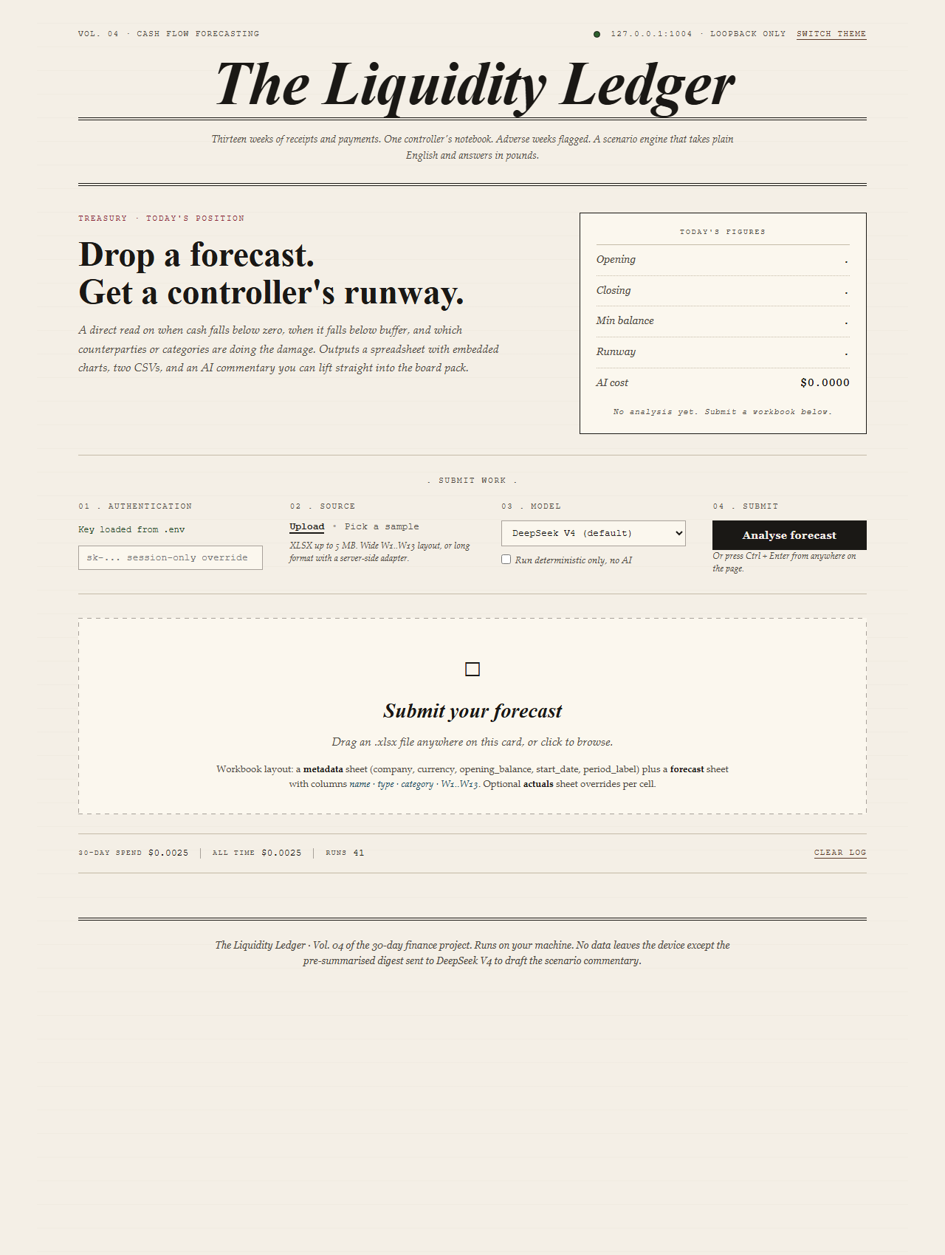
Cold start. Cream paper masthead, italic Didot title, four-card 'Submit work' desk.
First load. Hero KPI panel empty because no run has happened yet. Below the lede, the desk: 01 Authentication, 02 Source, 03 Model, 04 Submit. Different aesthetic to Day 3 on purpose.
02. Bundled samples
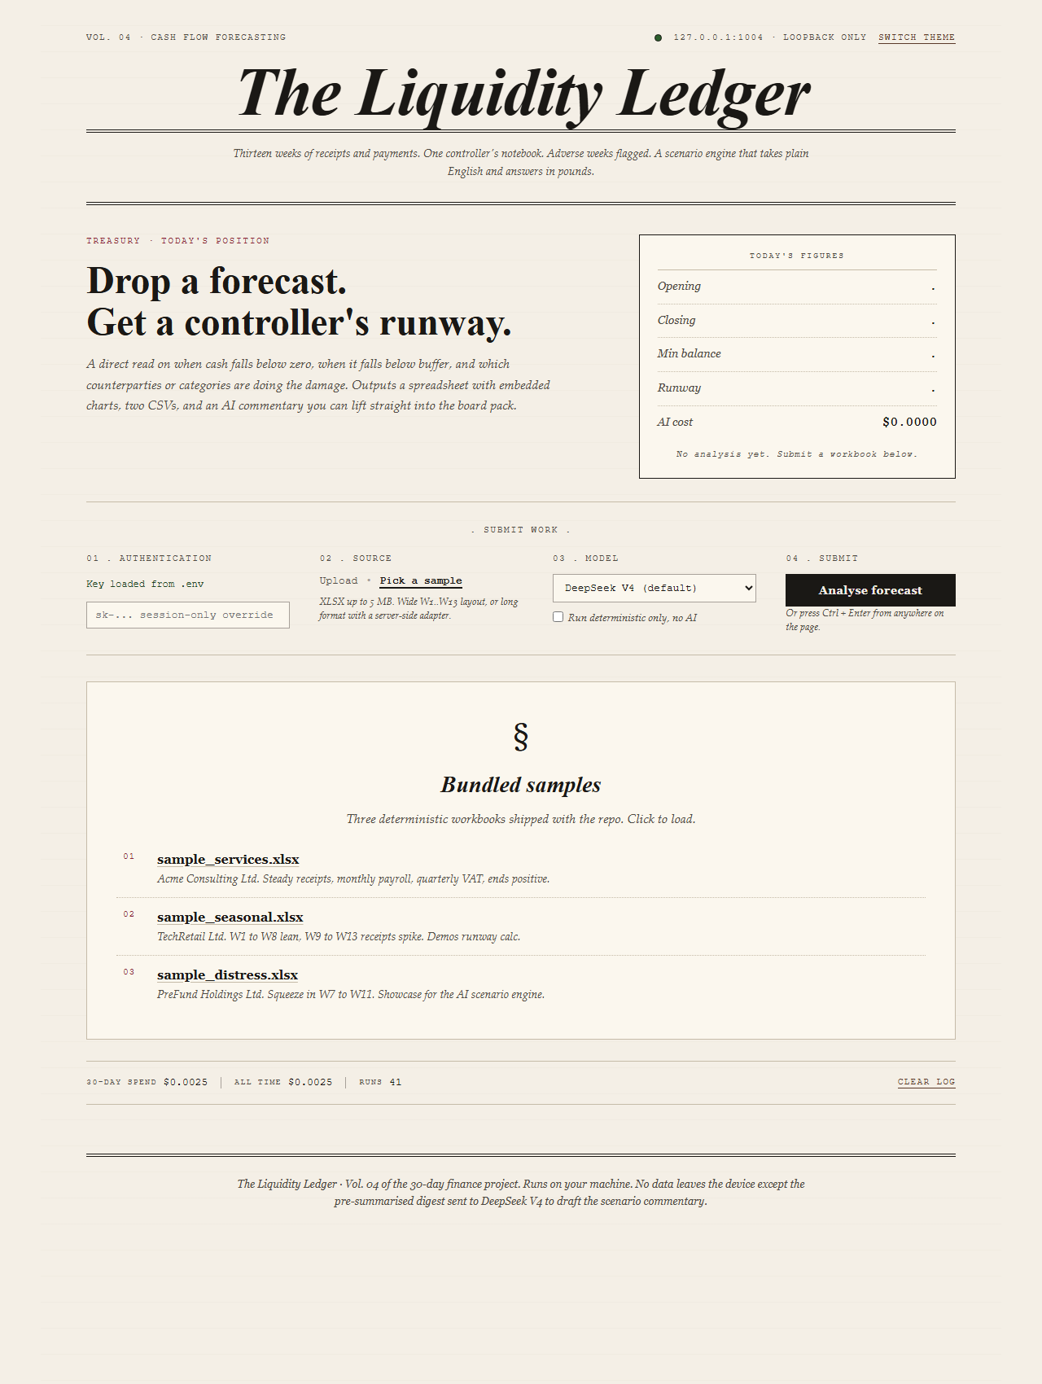
Three deterministic workbooks shipped in the repo. Numbered article list under the desk.
Click 'Pick a sample' in the Source field. The bundled samples card unfolds with three workbooks: Acme Consulting, TechRetail Quarterly, PreFund Holdings. Cost log strip at the bottom shows the running spend across runs.
03. Base run, AI commentary . LinkedIn
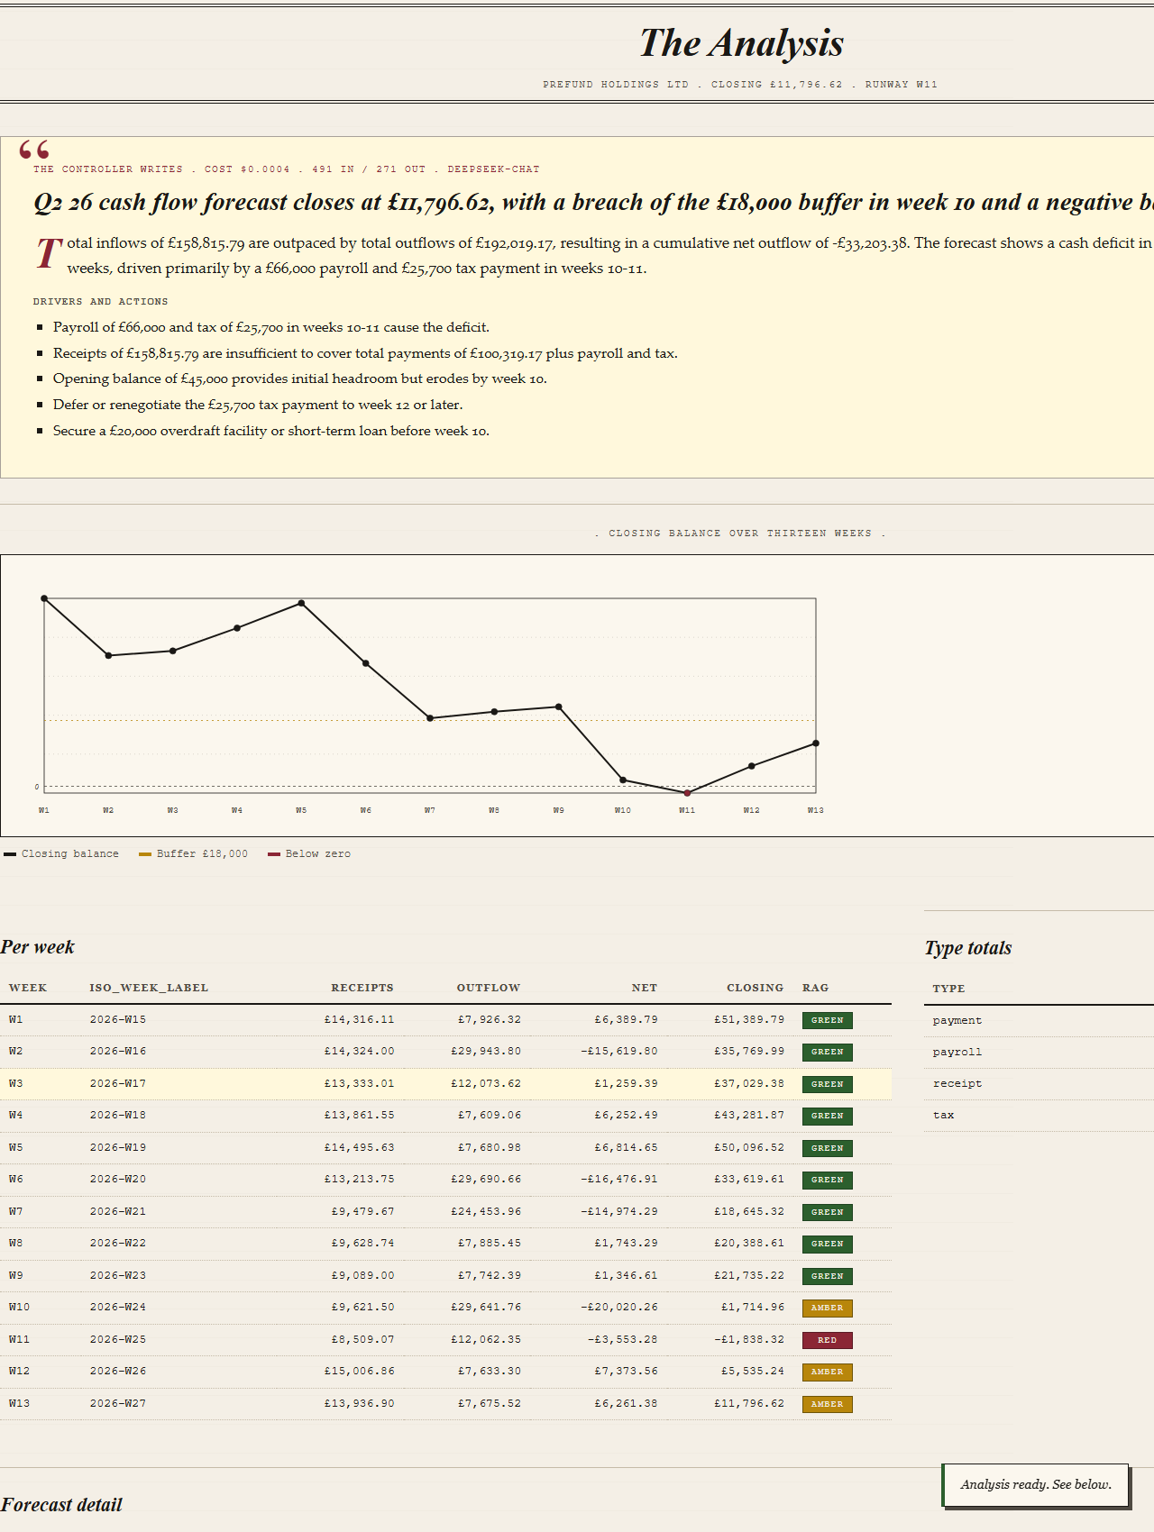
PreFund Holdings Ltd. Controller commentary, closing balance chart, per-week table.
Click the distress sample. Two and a half seconds later 'The Analysis' banner sits at the top, the AI commentary card carries the controller-voice headline + summary + drivers + actions, and the chart and table render below. Cost: $0.0004 for the analysis (491 in / 271 out, deepseek-chat). The runway lands at W11.
04. Closing balance chart and per-week ledger
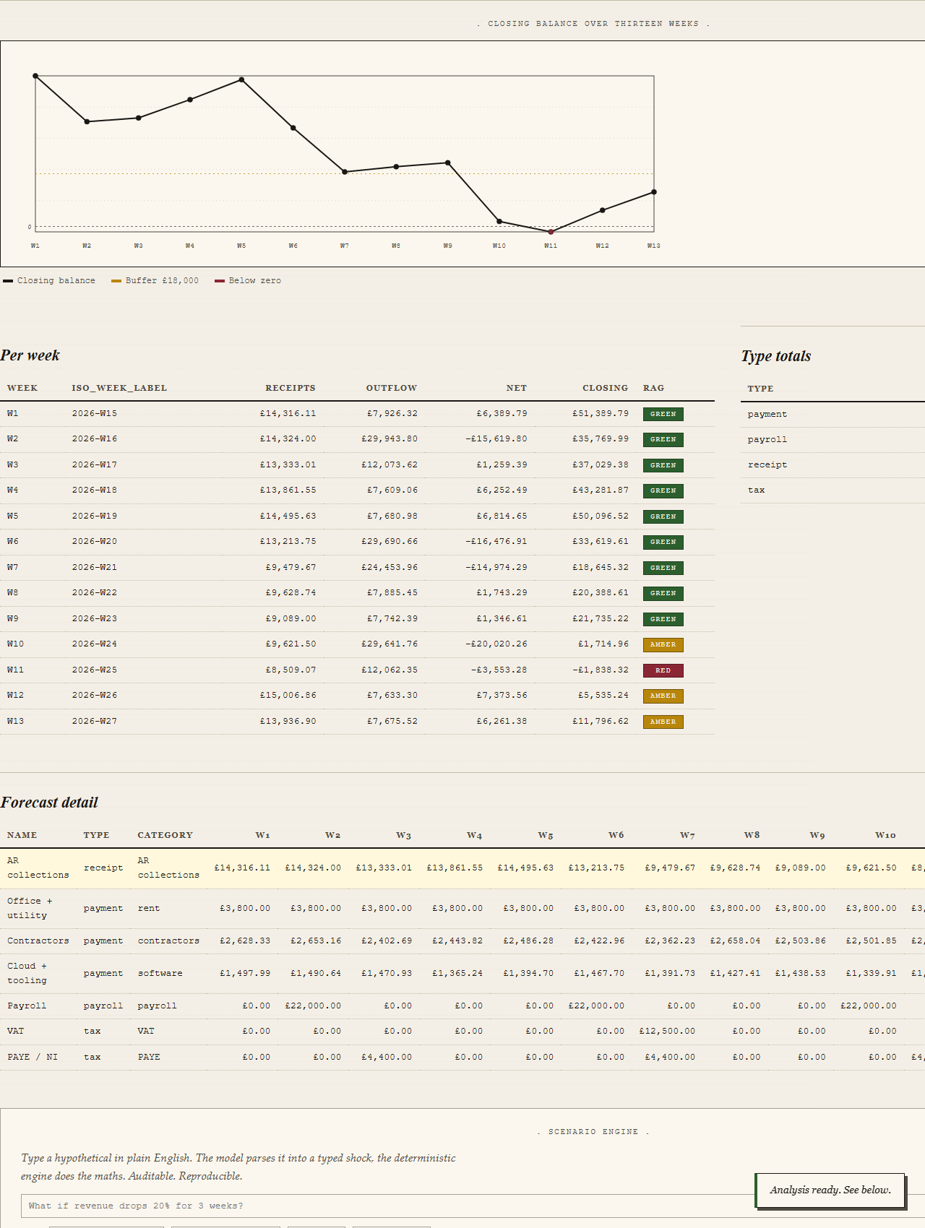
Inline SVG balance line. Ledger-style table with double-rule headers and dotted rows.
Inline SVG with theme-aware colours. Faint dashed reference lines mark zero and the buffer breach. The table sits in Courier figures, ledger-style, with RAG fills running forest green, mustard, burgundy.
05. Forecast detail (W1..W13 wide grid) . LinkedIn
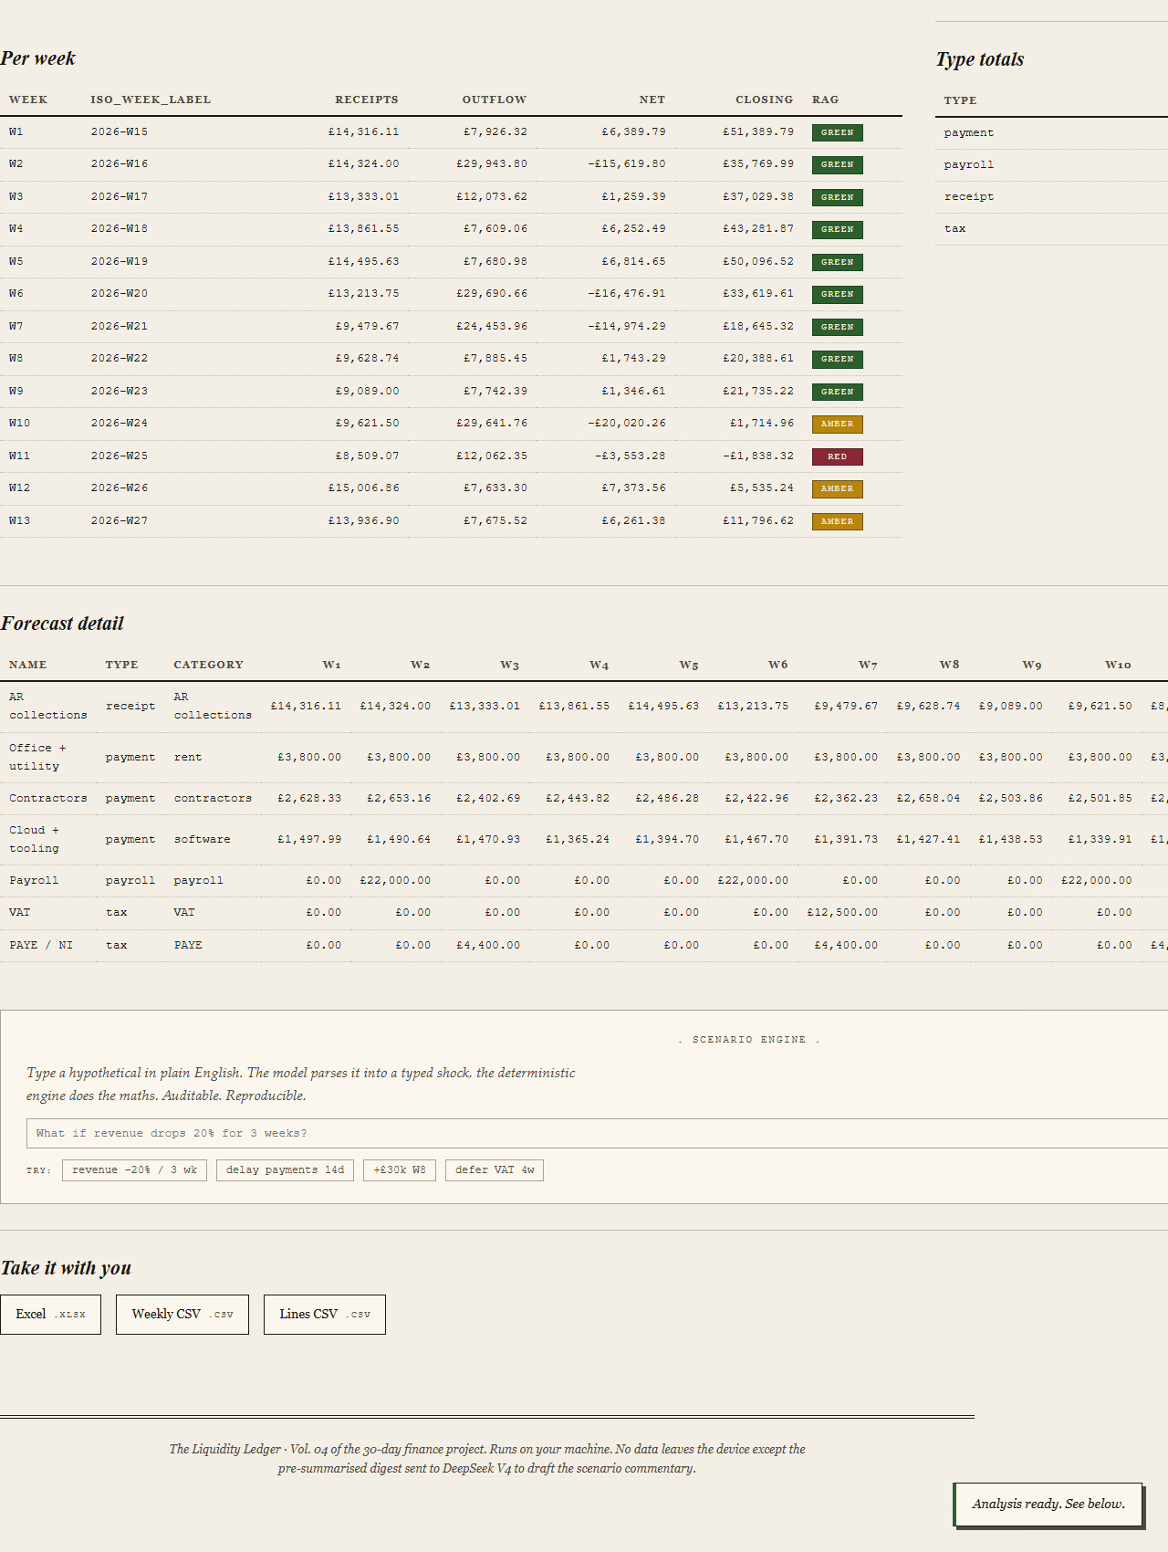
One row per cashflow line, one column per week, totals on the right.
This is what a treasurer would normally edit in Excel. The app renders it back so you can confirm what was parsed and spot any line you forgot. Source column on the right labels each row as forecast, actual, scenario or hybrid.
06. Scenario engine . LinkedIn
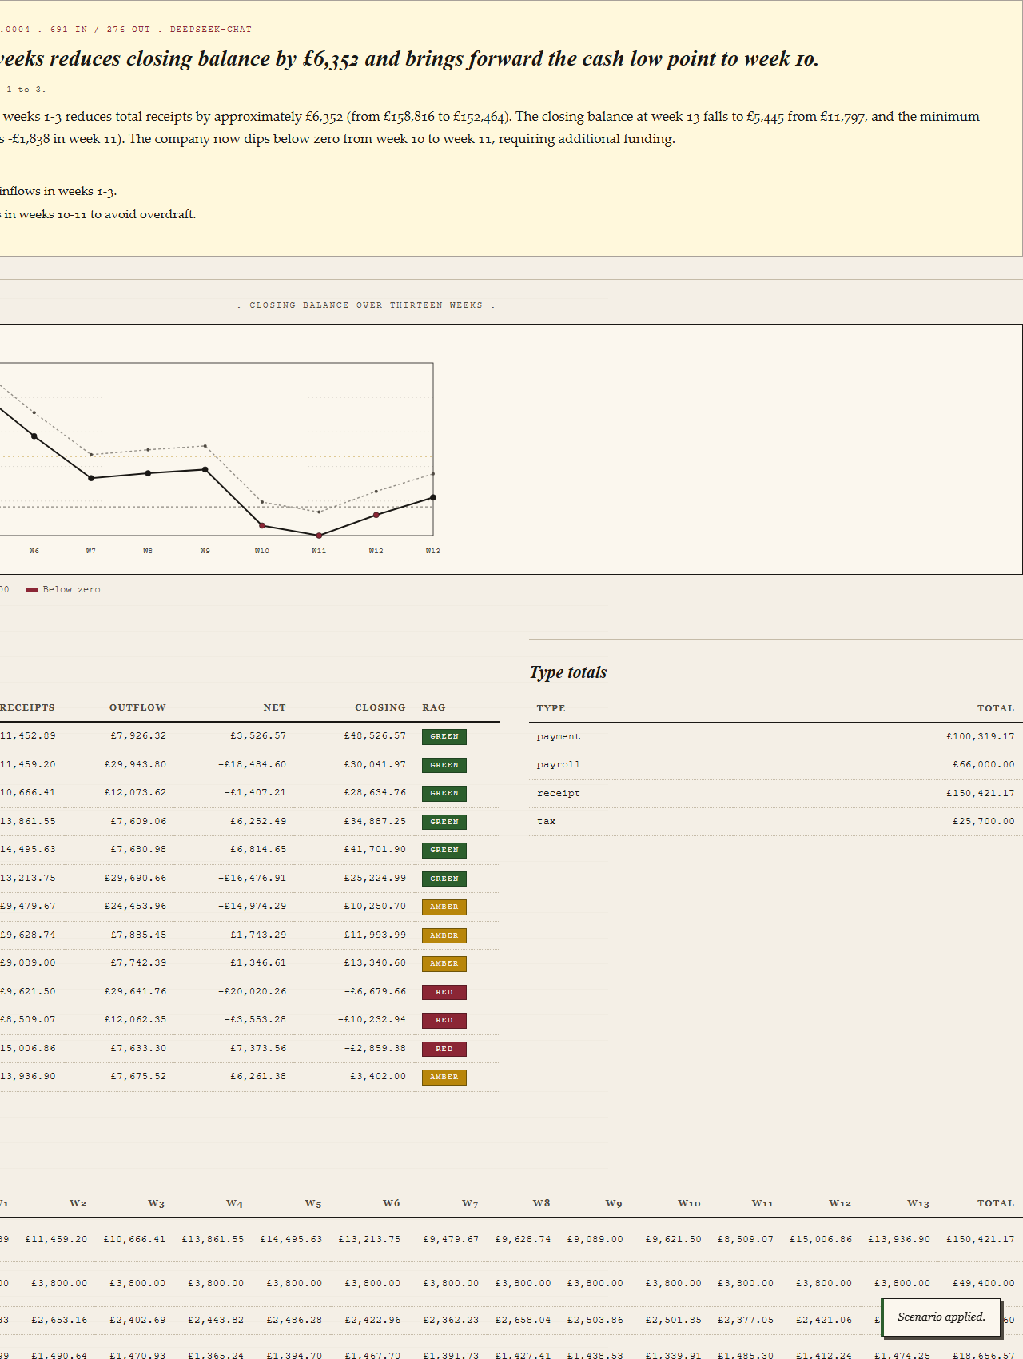
'What if revenue drops 20% for 3 weeks?' parsed into a typed shock and applied.
DeepSeek parses the free-text prompt into a typed Shock (revenue_pct, magnitude -0.20, weeks 1 to 3) and the deterministic engine recomputes. Two series on the chart now: dashed grey for base, solid ink for scenario. Per-week table flips colour at W10 and W11 as the bands shift. The AI commentary refreshes with a scenario-aware byline ('The controller on this scenario').
07. Downloads . LinkedIn
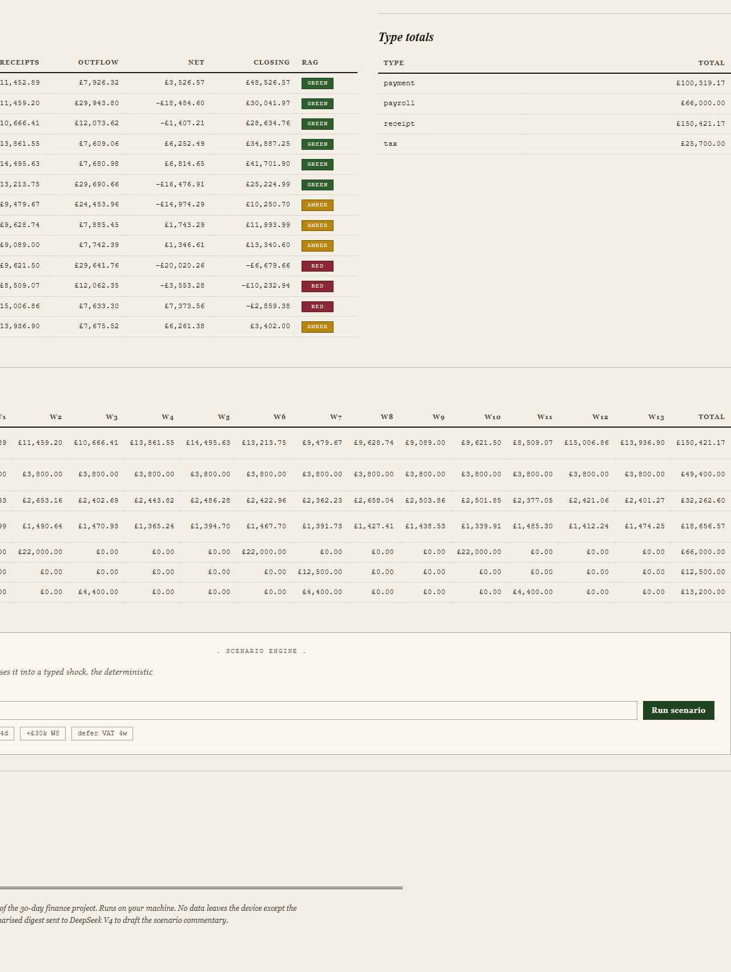
Excel, weekly CSV, lines CSV. Cost log strip at the bottom.
Three downloads per run. Excel ships Summary, Forecast, Weekly, Scenario (only after a scenario), Commentary (only after a scenario), and Inputs sheets. CSVs are utf-8-sig. The colophon at the bottom restates the privacy promise.

Cost: DeepSeek V4 vs Claude Haiku 4.5
Day 4 is the first project in the sprint to lean on DeepSeek instead of Claude. The reason is cost. On a JSON-shaped finance workload the switch is roughly 10x to 20x cheaper, with no noticeable quality drop on the structured commentary task. Concrete observation from this build: the distress sample scored a $0.000474 commentary on DeepSeek V4 (491 in / 271 out tokens). The same call on Claude Haiku 4.5 lands around $0.0024, so the switch saves about 80% on every analysis.
Model | Claude Haiku 4.5 | DeepSeek V4 (deepseek-chat)
Input price (per 1M) | $1.00 | $0.27 miss / $0.07 hit
Output price (per 1M) | $5.00 | $1.10
Per-call cost (observed) | around $0.002 to $0.005 | around $0.0001 to $0.0005
Cost per 1,000 analyses | around $2 to $5 | around $0.10 to $0.50
Cost per 100,000 analyses | around $200 to $500 | around $10 to $50
Quality on this task | Excellent | Materially equivalent for short JSON output
Caching | Explicit ephemeral hint | Automatic prefix cache

Strategic implication: at a fifth of a US cent per analysis, AI narration is no longer a feature to gate or skip. It runs on every base analysis automatically, the same way you'd never gate computing the closing balance.
Limitations
Built in a day. Some are deliberate scope cuts; some are post-30 work. Documented honestly so a reader knows what they're picking up.
- GBP only in the MVP. Non-GBP metadata is rejected with a clear remediation message.
- Period labels are opaque strings. April-26, 2026-04 and Q1 26 all work; they sort by first-seen order. No date parsing.
- AI commentary is a draft. The fallback when the API errors is a stub card with the error reason; the rest of the analysis still runs.
- Power BI integration not yet wired (Day 3 had it). Could be added post-30 by reusing day-03's Power Query M generator.
- Run history caps at 100 with FIFO eviction.
- Scenario taxonomy covers six shock types. M&A, hiring waves and capex spread are not yet supported.
- Bank feed integration via open banking API is post-30, called out in the brief as the natural next step.
Bottom line
A controller's 13-week cash plan used to be a spreadsheet job followed by a writing job. With this app it's a drop (or a sample click) plus an editorial pass on the AI paragraph. The DeepSeek migration is what makes the AI commentary feel like a system feature instead of a premium upsell. The tool earns its fraction of a cent of API spend many times over by giving the controller back an hour every week.

