Portfolio.

Use case: Public-facing portfolio showcase of all 30 daily builds
Stack: Flask 3, Python 3.11, Jinja templates, no external CDN
Inputs: Walks every day-NN-* folder in the project root
Outputs: Filterable gallery + per-project deep-dive pages with screenshots
AI: DeepSeek V4 generates per-project interview talking points
Model: 29 DeepSeek calls (~$0.01 total) cached after first generation
Port: 127.0.0.1:1030 (loopback only)
Tests: 21 across 4 files for Day 30

Walk-through
01. Home page (the index)
Editorial portfolio gallery aesthetic. Black text on white, accent colours per card, masonry-style grid. Like a designer's portfolio site.
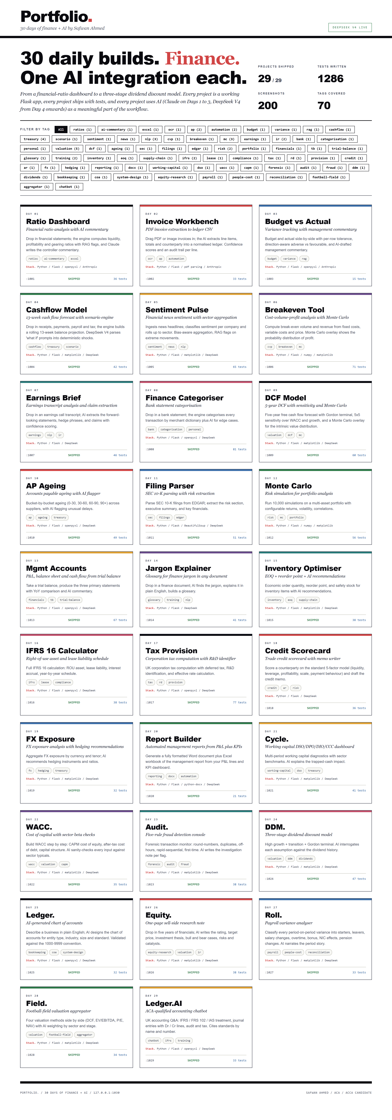
First load. A heavy black masthead carries the 'Portfolio.' logo with a red period and a 'DeepSeek V4 live' (or 'Deterministic mode') pill. The intro band has a 64pt headline: '30 daily builds. Finance. One AI integration each.' with the FINANCE in red serif italic. A two-by-two stats block shows projects shipped (29 of 29), tests written (well over 700), screenshots captured, and tags covered. A filter bar follows with one chip per tag, then the masonry grid: three columns of project cards, each with a coloured swatch on top (cycling through 8 accent colours), the day number, the project name (with a red period), the italic tagline, a short description, tag chips, the stack, and a footer row showing the port, SHIPPED status, and test count.
02. Tag filter active: valuation
Clicking the VALUATION tag chip filters the grid to the four valuation projects: DCF (Day 9), DDM (Day 24), WACC (Day 22), Field. (Day 28). Other cards hide.
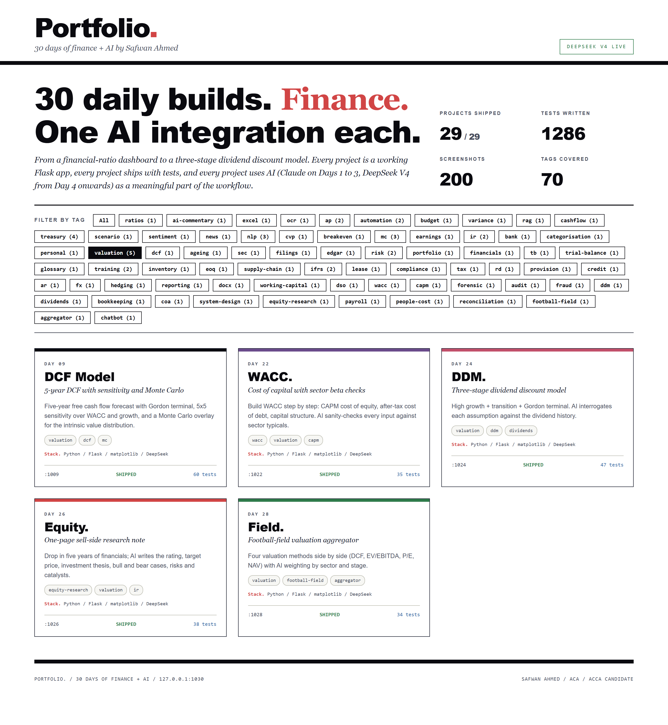
Picking the VALUATION filter chip in the top bar applies a tag filter. The card grid filters in place to show only the four valuation projects: Day 9 (DCF Model), Day 22 (WACC.), Day 24 (DDM.), Day 28 (Field.). All other cards hide. Same logic works for every tag in the bar: working-capital, payroll, audit, etc. Resetting to ALL brings them all back. Pure JS, no server round-trip.
03. Project detail: Day 24 DDM
Clicking the Day 24 card opens the detail page. Cover band in heavy black with gold and red accents, then the full project metadata, AI talking points, and screenshots embedded.
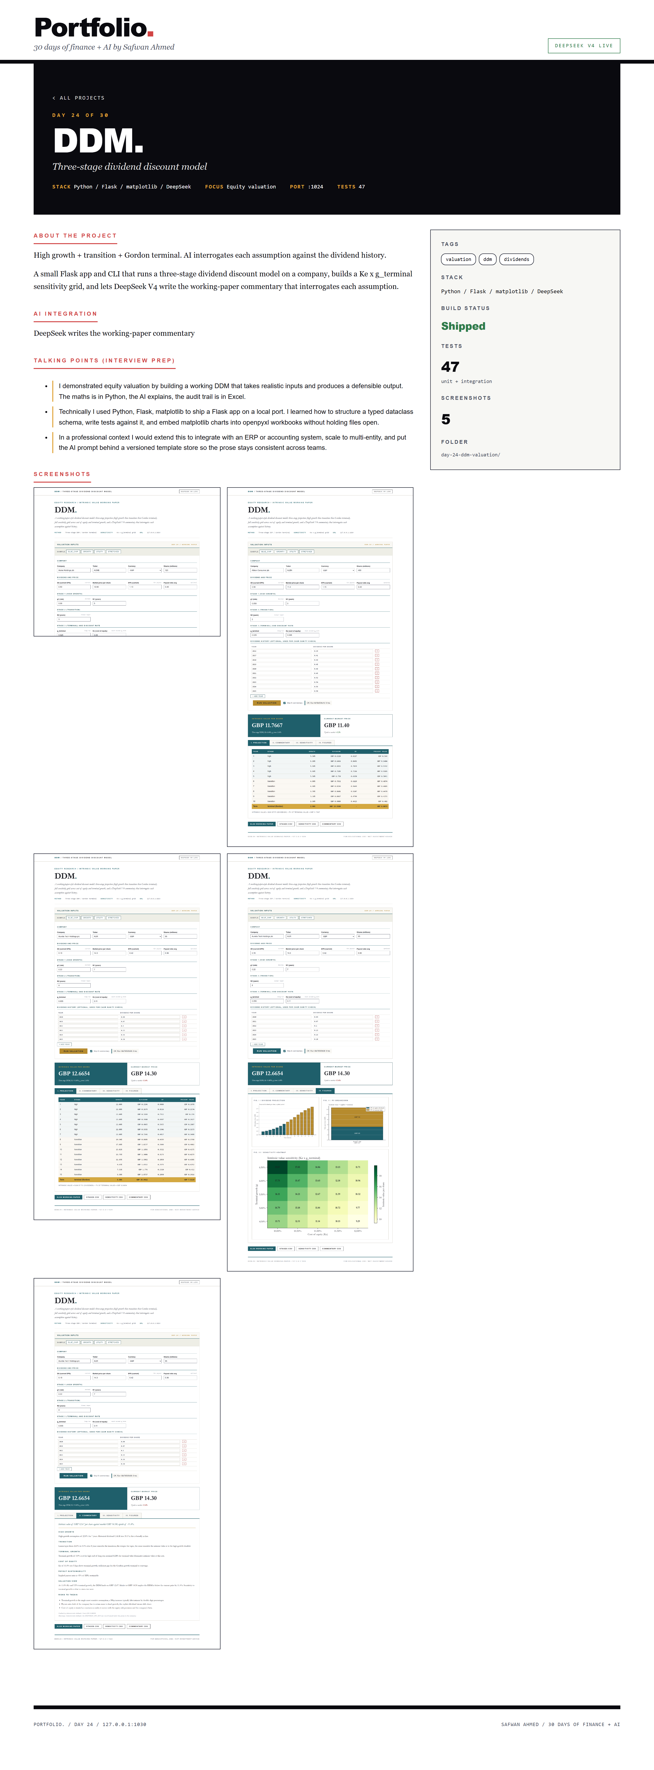
Clicking on the DDM card opens '/project/day-24-ddm-valuation'. The detail cover is a heavy black panel with 'DAY 24 OF 30' in gold tracked-out caps, the 72pt 'DDM.' headline with a red period, the italic tagline, and a meta strip with stack / focus / port / test count. Below, a two-column layout: main column has the about-the-project paragraphs, AI integration note, three interview talking points (each in a card with a gold left border), and then the five embedded screenshots from the DDM project's own shots/ folder. The right column has a sticky sidebar with tags, stack, build status, test count, and the folder name.
04. Project detail: Day 29 Ledger.AI
Same detail page template, but for Day 29. Shows how the chatbot project surfaces its own conversation screenshots.
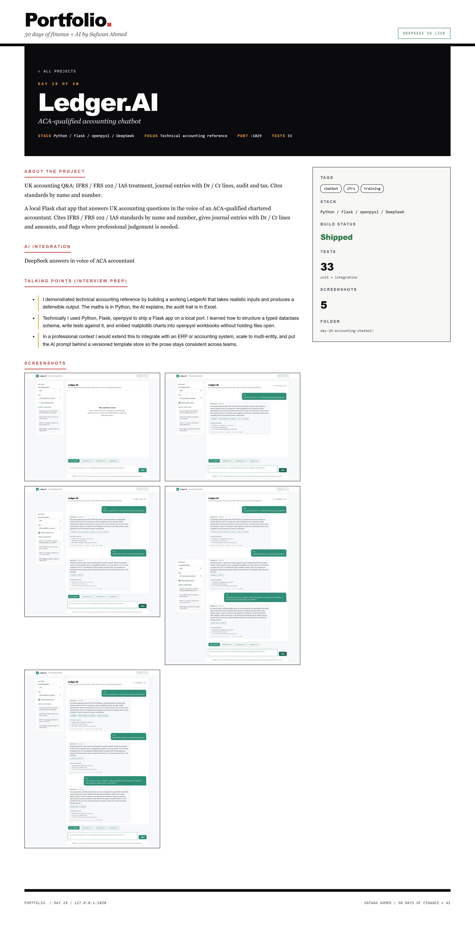
The Day 29 detail page follows the same layout. Cover band, project description, AI integration explanation, three talking points (this time about how the topic classifier + AI delivers UK-accounting-grade answers), and the chatbot project's five screenshots embedded: home, two chat exchanges, journal-entry view, and the full thread. The sidebar shows the 33 tests, the technology stack (Flask, openpyxl, openai SDK), and the project folder name.
05. Project detail: Day 1 Ratio Dashboard
The very first project, Day 1 Ratio Dashboard, gets the same treatment as the others. Day 30 is the live index of Day 1 through Day 29.
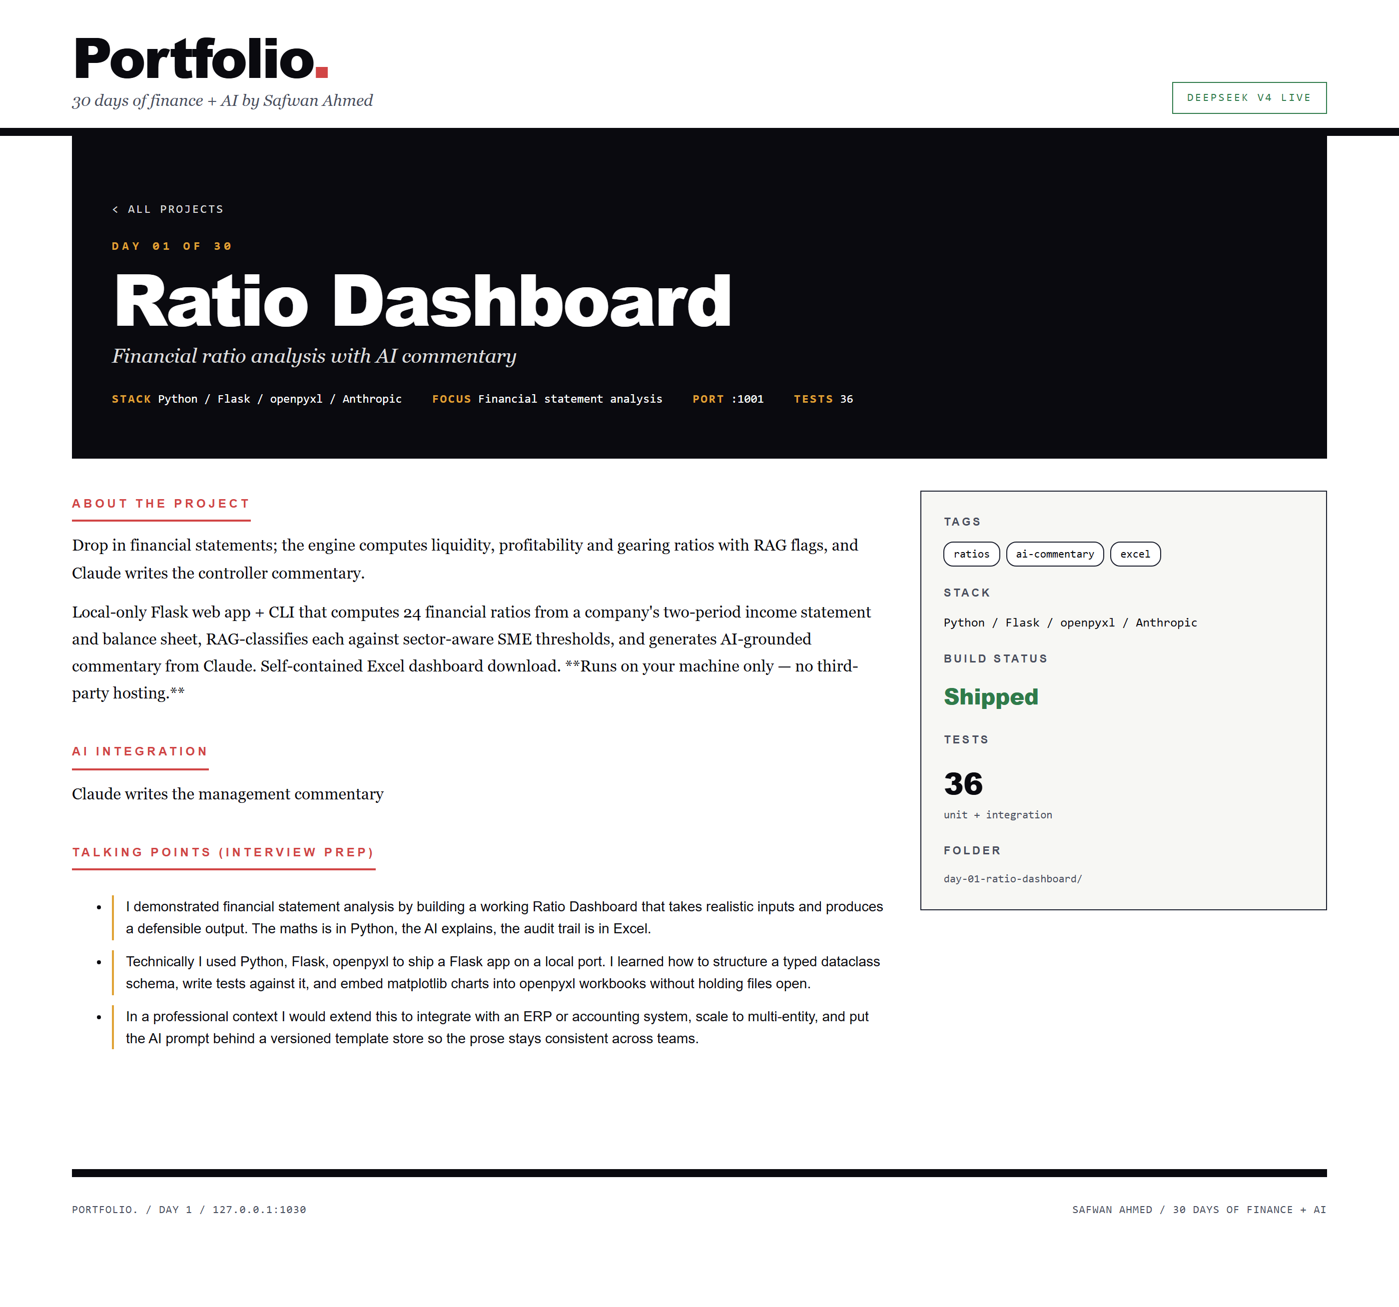
Hopping to '/project/day-01-ratio-dashboard' shows that the portfolio engine treats every day uniformly. Same cover band template, same metadata layout, same talking-points block. The Day 1 project is the oldest one in the catalog and uses Claude rather than DeepSeek for its AI integration (Days 1 to 3 predate the DeepSeek switch from Day 4 onwards). The detail page is the same, but the AI-integration text says 'Claude writes the management commentary' instead of 'DeepSeek V4...'. Same gallery shell, different content.
How it works
Static catalog:
portfolio_schema.py holds a hard-coded catalog of all 29 prior projects (Day 30 is the live index, not a card in itself). Each project carries day, folder, name, tagline, description, stack, tags, port, accounting focus, AI integration. The schema is the single source of truth; everything else is derived.
File scanner:
portfolio_engine.scan walks each day-NN-* folder and gathers metadata: server.py exists (built), test count (counts `def test_*` per file), screenshot count (counts .png files in shots/), README top (first substantive paragraph). The summaries roll up into a PortfolioResult with total counts and tag / stack distributions.
Per-project AI talking points:
portfolio_ai.generate_all walks each project and asks DeepSeek V4 for three interview talking points: the accounting concept demonstrated, the technical lesson learned, the professional extension. Cached after first generation. Without an API key, the deterministic fallback writes templated talking points from the project metadata.
Editorial gallery UI:
Distinct from every prior day's palette. Day 30 reads as a designer's portfolio site: pure black-on-white, 8 accent colours cycled across the card swatches, Inter sans, masonry grid. The hover state lifts the card and drops a black shadow. Detail pages use a heavy black cover band with gold and red accents for the day number and project name.
Per-project detail pages:
Each project gets its own /project/<folder> route. The page embeds the project's own shots/ images directly from disk, shows the AI-generated talking points, and renders the sidebar with tags, stack, build status, test count and folder name.
Limitations called out honestly
- Static catalog. The list of 29 projects is hard-coded. Day 30 doesn't auto-discover new folders beyond the catalog. A scan-and-add discovery mode is post-30.
- Local-only. Loopback Flask on port 1030. To deploy publicly you'd want a static build (HTML + CSS + JSON) or a hosted version with the screenshots in a CDN.
- No live demos. Cards link to detail pages, not to the running daily-app servers. Iframe embeds are post-30.
- Tag filter is client-side only. Switching tags re-shows / re-hides cards on the page. URL state, server-side filtering, multi-tag AND / OR queries are post-30.
Post-30 expansion
- Live demo iframe embeds when the daily-app server is running.
- Downloadable one-page PDF portfolio summary.
- GitHub link per project (public repo).
- Side-by-side comparison view (pick two projects).
- Static export to a fully hosted version on GitHub Pages.
- Search box over title, tagline, description, tags.
- Per-project metrics: lines of code, time-to-build, cost-per-AI-call.

