零、需求

积分等级CRUD列表和表单

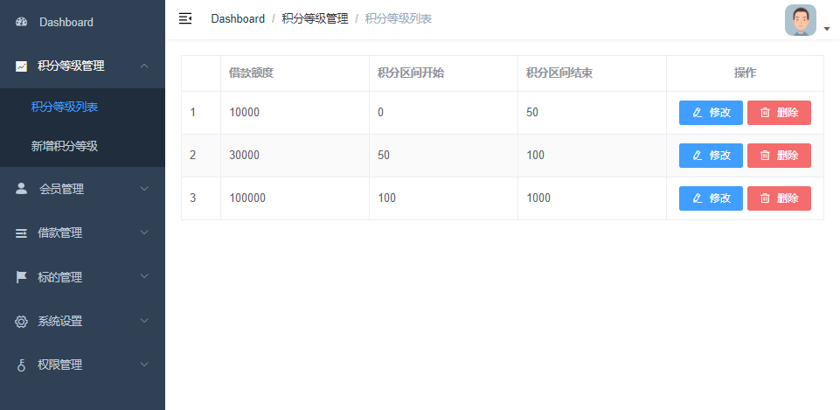

表单

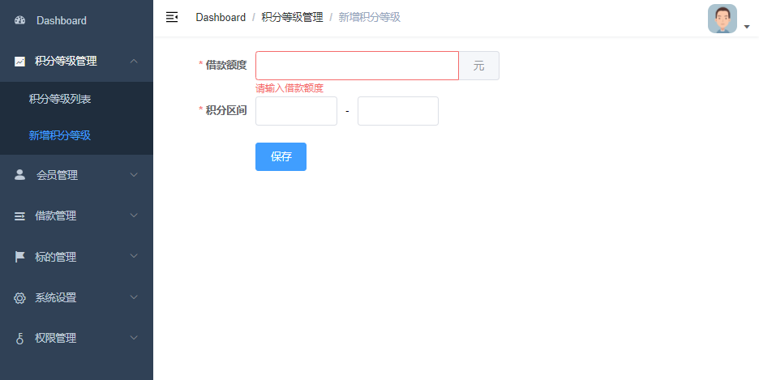

一、创建父工程finance

最普通的maven工程即可

1、创建SpringBoot项目

Group：com.gsm
Artifact：finance

2、删除src目录

3、配置SpringBoot版本

<parent>
<groupId>org.springframework.boot</groupId>
<artifactId>spring-boot-starter-parent</artifactId>
<version>2.3.4.RELEASE</version>
</parent>

4、配置pom依赖版本号

<properties>
<java.version>1.8</java.version>
<spring-cloud-alibaba.version>2.2.2.RELEASE</spring-cloud-alibaba.version>
<spring-cloud.version>Hoxton.SR8</spring-cloud.version>
<mybatis-plus.version>3.4.1</mybatis-plus.version>
<velocity.version>2.0</velocity.version>
<swagger.version>2.9.2</swagger.version>
<swagger-bootstrap-ui.version>1.9.2</swagger-bootstrap-ui.version>
<commons-lang3.version>3.9</commons-lang3.version>
<commons-fileupload.version>1.3.1</commons-fileupload.version>
<commons-io.version>2.6</commons-io.version>
<alibaba.easyexcel.version>2.1.1</alibaba.easyexcel.version>
<apache.xmlbeans.version>3.1.0</apache.xmlbeans.version>
<fastjson.version>1.2.28</fastjson.version>
<gson.version>2.8.2</gson.version>
<json.version>20170516</json.version>
<aliyun-java-sdk-core.version>4.3.3</aliyun-java-sdk-core.version>
<aliyun-sdk-oss.version>3.10.2</aliyun-sdk-oss.version>
<jodatime.version>2.10.1</jodatime.version>
<jwt.version>0.7.0</jwt.version>
<httpclient.version>4.5.1</httpclient.version>
</properties>

5、配置pom依赖

<dependencyManagement>
<dependencies>
<!--Spring Cloud-->
<dependency>
<groupId>org.springframework.cloud</groupId>
<artifactId>spring-cloud-dependencies</artifactId>
<version>${spring-cloud.version}</version>
<type>pom</type>
<scope>import</scope>
</dependency>

<!--Spring Cloud Alibaba-->
<dependency>
<groupId>com.alibaba.cloud</groupId>
<artifactId>spring-cloud-alibaba-dependencies</artifactId>
<version>${spring-cloud-alibaba.version}</version>
<type>pom</type>
<scope>import</scope>
</dependency>

<!--mybatis-plus-->
<dependency>
<groupId>com.baomidou</groupId>
<artifactId>mybatis-plus-boot-starter</artifactId>
<version>${mybatis-plus.version}</version>
</dependency>
<!--mybatis-plus 代码生成器-->
<dependency>
<groupId>com.baomidou</groupId>
<artifactId>mybatis-plus-generator</artifactId>
<version>${mybatis-plus.version}</version>
</dependency>
<!-- Mybatis Plus 代码生成器模板引擎, -->
<dependency>
<groupId>org.apache.velocity</groupId>
<artifactId>velocity-engine-core</artifactId>
<version>${velocity.version}</version>
</dependency>

<!--swagger-->
<dependency>
<groupId>io.springfox</groupId>
<artifactId>springfox-swagger2</artifactId>
<version>${swagger.version}</version>
</dependency>
<!--swagger ui-->
<dependency>
<groupId>io.springfox</groupId>
<artifactId>springfox-swagger-ui</artifactId>
<version>${swagger.version}</version>
</dependency>
<!--swagger-bootstrap-ui-->
<dependency>
<groupId>com.github.xiaoymin</groupId>
<artifactId>swagger-bootstrap-ui</artifactId>
<version>${swagger-bootstrap-ui.version}</version>
</dependency>

<!--commons-lang3-->
<dependency>
<groupId>org.apache.commons</groupId>
<artifactId>commons-lang3</artifactId>
<version>${commons-lang3.version}</version>
</dependency>

<!--文件上传-->
<dependency>
<groupId>commons-fileupload</groupId>
<artifactId>commons-fileupload</artifactId>
<version>${commons-fileupload.version}</version>
</dependency>

<!--commons-io-->
<dependency>
<groupId>commons-io</groupId>
<artifactId>commons-io</artifactId>
<version>${commons-io.version}</version>
</dependency>

<!--excel解析-->
<dependency>
<groupId>com.alibaba</groupId>
<artifactId>easyexcel</artifactId>
<version>${alibaba.easyexcel.version}</version>
</dependency>
<!--excel解析依赖-->
<dependency>
<groupId>org.apache.xmlbeans</groupId>
<artifactId>xmlbeans</artifactId>
<version>${apache.xmlbeans.version}</version>
</dependency>

<!--json-->
<dependency>
<groupId>com.alibaba</groupId>
<artifactId>fastjson</artifactId>
<version>${fastjson.version}</version>
</dependency>
<dependency>
<groupId>org.json</groupId>
<artifactId>json</artifactId>
<version>${json.version}</version>
</dependency>
<dependency>
<groupId>com.google.code.gson</groupId>
<artifactId>gson</artifactId>
<version>${gson.version}</version>
</dependency>

<!--阿里云SDK远程调用-->
<dependency>
<groupId>com.aliyun</groupId>
<artifactId>aliyun-java-sdk-core</artifactId>
<version>${aliyun-java-sdk-core.version}</version>
</dependency>

<!--阿里云文件管理-->
<dependency>
<groupId>com.aliyun.oss</groupId>
<artifactId>aliyun-sdk-oss</artifactId>
<version>${aliyun-sdk-oss.version}</version>
</dependency>

<!--日期时间工具-->
<dependency>
<groupId>joda-time</groupId>
<artifactId>joda-time</artifactId>
<version>${jodatime.version}</version>
</dependency>

<!--jwt工具-->
<dependency>
<groupId>io.jsonwebtoken</groupId>
<artifactId>jjwt</artifactId>
<version>${jwt.version}</version>
</dependency>

<!--httpclient-->
<dependency>
<groupId>org.apache.httpcomponents</groupId>
<artifactId>httpclient</artifactId>
<version>${httpclient.version}</version>
</dependency>

</dependencies>
</dependencyManagement>

<dependencies>
<dependency>
<groupId>org.springframework.boot</groupId>
<artifactId>spring-boot-starter-test</artifactId>
<scope>test</scope>
</dependency>
</dependencies>

需要理解dependencyManagement和dependencies的区别

二、创建模块finance-common
1、创建Maven模块

在finance下创建普通maven模块

Group：com.gsm
Artifact：finance-common

注意名字中的中划线

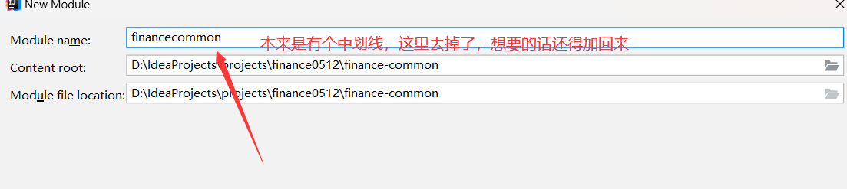

2、配置pom

<dependencies>

<dependency>
<groupId>org.springframework.boot</groupId>
<artifactId>spring-boot-starter-web</artifactId>
</dependency>

<!--lombok用来简化实体类：需要安装lombok插件-->
<dependency>
<groupId>org.projectlombok</groupId>
<artifactId>lombok</artifactId>
</dependency>

</dependencies>

三、创建模块service-base
1、创建Maven模块

在finance下创建普通maven模块
Group：com.gsm
Artifact：service-base

2、配置pom
注意：依赖finance-common

<dependencies>
<dependency>
<groupId>com.gsm</groupId>
<artifactId>finance-common</artifactId>
<version>1.0-SNAPSHOT</version>
</dependency>
<!--swagger-->
<dependency>
<groupId>io.springfox</groupId>
<artifactId>springfox-swagger2</artifactId>
</dependency>
<!--swagger ui-->
<dependency>
<groupId>io.springfox</groupId>
<artifactId>springfox-swagger-ui</artifactId>
</dependency>
</dependencies>

特别注意 <version>1.0-SNAPSHOT</version> 这里到底是1.0-SNAPSHOT ， 还是0.01-？

四、创建模块service-core
1、创建Maven模块

在finance下创建普通maven模块

Group：com.gsm
Artifact：service-core

2、配置pom

注意：依赖service-base

<dependencies>

<dependency>
<groupId>com.gsm</groupId>
<artifactId>service-base</artifactId>
<version>1.0-SNAPSHOT</version>
</dependency>

<!--mysql-->
<dependency>
<groupId>mysql</groupId>
<artifactId>mysql-connector-java</artifactId>
</dependency>

<!--mybatis-plus-->
<dependency>
<groupId>com.baomidou</groupId>
<artifactId>mybatis-plus-boot-starter</artifactId>
</dependency>
<!--mybatis-plus 代码生成器-->
<dependency>
<groupId>com.baomidou</groupId>
<artifactId>mybatis-plus-generator</artifactId>
</dependency>
<!-- Mybatis Plus 代码生成器模板引擎, -->
<dependency>
<groupId>org.apache.velocity</groupId>
<artifactId>velocity-engine-core</artifactId>
</dependency>
</dependencies>

特别注意 <version>1.0-SNAPSHOT</version> 这里到底是1.0-SNAPSHOT ， 还是0.01-？

五、代码生成器
1、创建数据库

创建数据库finance_core
并执行sql脚本初始化数据结构和数据

2、创建代码生成器

代码生成器开始时候执行一次，建立到哪个工程都可以，我们这里建立到service-core工程。

在test目录中创建测试用例，并执行

首先在test目录创建package com.gsm.finance.core
然后再在com.gsm.finance.core 下新建class

package com.gsm.finance.core;

import com.baomidou.mybatisplus.annotation.DbType;
import com.baomidou.mybatisplus.annotation.IdType;
import com.baomidou.mybatisplus.generator.AutoGenerator;
import com.baomidou.mybatisplus.generator.config.DataSourceConfig;
import com.baomidou.mybatisplus.generator.config.GlobalConfig;
import com.baomidou.mybatisplus.generator.config.PackageConfig;
import com.baomidou.mybatisplus.generator.config.StrategyConfig;
import com.baomidou.mybatisplus.generator.config.rules.NamingStrategy;
import org.junit.Test;

public class CodeGenerator {

@Test
public void genCode() {

// 1、创建代码生成器
AutoGenerator mpg = new AutoGenerator();

// 2、全局配置
GlobalConfig gc = new GlobalConfig();
String projectPath = System.getProperty("user.dir");
gc.setOutputDir(projectPath + "/src/main/java");
gc.setAuthor("gsm");
gc.setOpen(false); //生成后是否打开资源管理器
gc.setServiceName("%sService"); //去掉Service接口的首字母I %s占位符 名字
gc.setIdType(IdType.AUTO); //主键策略
gc.setSwagger2(true);//开启Swagger2模式 之前已经加上了Swagger2依赖
mpg.setGlobalConfig(gc);

// 3、数据源配置
DataSourceConfig dsc = new DataSourceConfig();
dsc.setUrl("jdbc:mysql://localhost:3306/finance_core?serverTimezone=GMT%2B8&characterEncoding=utf-8");
dsc.setDriverName("com.mysql.cj.jdbc.Driver");
dsc.setUsername("root");
dsc.setPassword("root");
dsc.setDbType(DbType.MYSQL);
mpg.setDataSource(dsc);

// 4、包配置
PackageConfig pc = new PackageConfig();
pc.setParent("com.gsm.finance.core");
pc.setEntity("pojo.entity"); //此对象与数据库表结构一一对应，通过 DAO 层向上传输数据源对象。
// ... 类似可以修改Controller、Service、mapper、xml等的路径 不修改就用默认的名字
mpg.setPackageInfo(pc);

// 5、策略配置
StrategyConfig strategy = new StrategyConfig();

strategy.setNaming(NamingStrategy.underline_to_camel);//数据库表映射到实体的命名策略

strategy.setColumnNaming(NamingStrategy.underline_to_camel);//数据库表字段映射到实体的命名策略
strategy.setEntityLombokModel(true); // lombok
strategy.setLogicDeleteFieldName("is_deleted");//逻辑删除字段名
strategy.setEntityBooleanColumnRemoveIsPrefix(true);//去掉布尔值的is_前缀（确保tinyint(1)）
strategy.setRestControllerStyle(true); //restful api风格控制器 返回json

mpg.setStrategy(strategy);

// 6、执行
mpg.execute();
}
}

启动自动生成

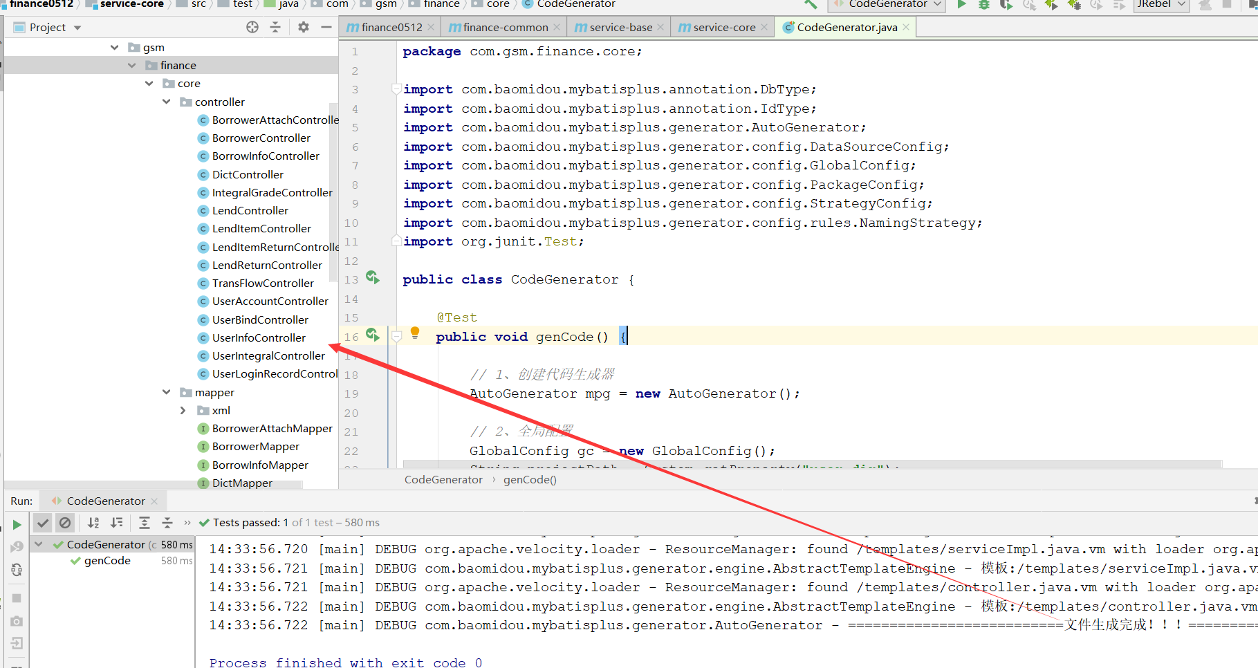

实体数据层、dao层、service、controller层都生成了

六、启动应用程序

首先在resources文件夹下建立配置文件 application.yml

补充：常见的配置文件有3种，properties 、 xml 、 yml

1、创建application.yml

server:
port: 8110 # 服务端口

spring:
profiles:
active: dev # 环境设置
application:
name: service-core # 服务名
datasource: # mysql数据库连接
type: com.zaxxer.hikari.HikariDataSource
driver-class-name: com.mysql.cj.jdbc.Driver
url: jdbc:mysql://localhost:3306/finance_core?serverTimezone=GMT%2B8&characterEncoding=utf-8
username: root
password: 123456

mybatis-plus: #mybatis
configuration:
log-impl: org.apache.ibatis.logging.stdout.StdOutImpl
mapper-locations: classpath:com/gsm/finance/core/mapper/xml/*.xml

2、创建SpringBoot配置文件

在service-core中创建com.gsm.finance.core.config包，创建MybatisPlusConfig类

package com.gsm.finance.core.config;

@Configuration
@MapperScan("com.gsm.finance.core.mapper")
@EnableTransactionManagement //事务处理
public class MybatisPlusConfig {

@Bean
public MybatisPlusInterceptor mybatisPlusInterceptor() {
MybatisPlusInterceptor interceptor = new MybatisPlusInterceptor();
interceptor.addInnerInterceptor(new PaginationInnerInterceptor(DbType.MYSQL));//分页
return interceptor;
}
}

3、创建SpringBoot启动类

注意：扫描com.gsm.finance

package com.gsm.finance.core;

@SpringBootApplication
@ComponentScan({"com.gsm.finance"})
public class ServiceCoreApplication {

public static void main(String[] args) {
SpringApplication.run(ServiceCoreApplication.class, args);
}
}

4、运行启动类

查看控制台8110端口是否成功启动

