一、积分等级列表接口
1、编写积分等级管理接口

在controller中添加admin包，添加AdminIntegralGradeController类

package com.gsm.finance.core.controller.admin;

@CrossOrigin
@RestController
@RequestMapping("/admin/core/integralGrade")
public class AdminIntegralGradeController {

@Resource
private IntegralGradeService integralGradeService;

@GetMapping("/list")
public List<IntegralGrade> list(){
return integralGradeService.list();
}
}

2、测试
重启服务，访问： http://localhost:8110/admin/core/integralGrade/list 查看结果json数据

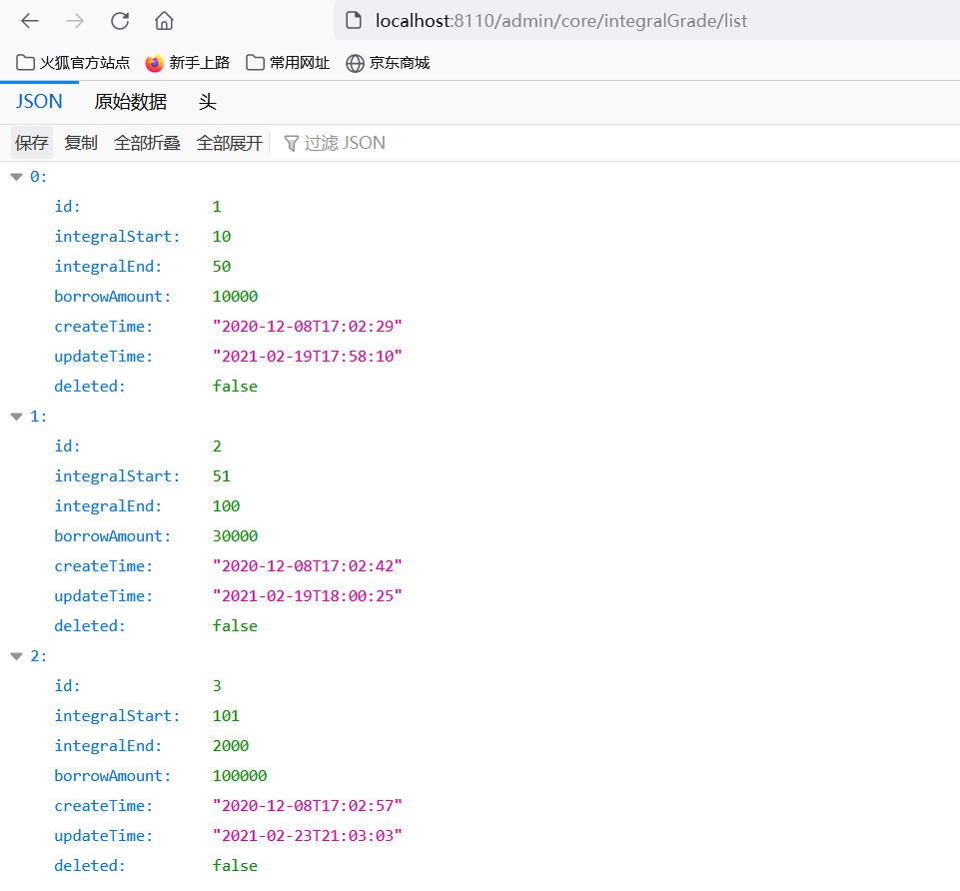

二、逻辑删除接口
1、添加删除方法

AdminIntegralGradeController添加removeById方法

@DeleteMapping("/remove/{id}")
public boolean removeById(@PathVariable Long id){
return integralGradeService.removeById(id);
}

2、使用postman测试删除

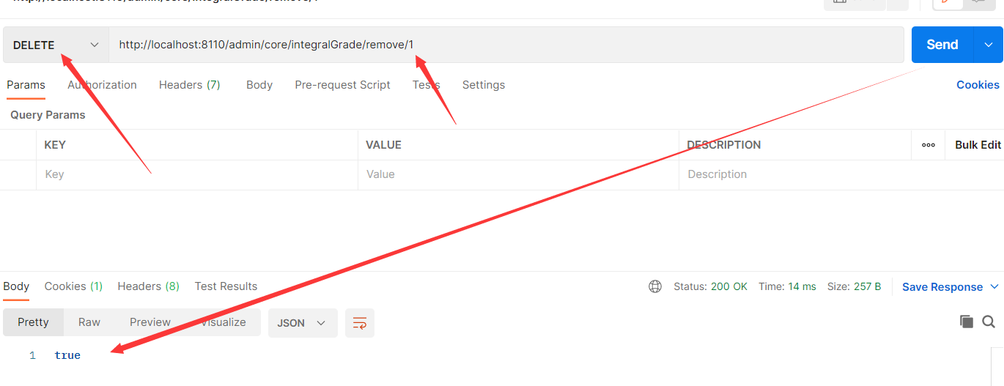

三、配置Swagger2
1、Swagger2配置文件

在service-base 工程中
新建com.gsm.finance.base.config ， 包下新建Swagger2Config

package com.gsm.finance.base.config;

import com.google.common.base.Predicates;
import org.springframework.context.annotation.Bean;
import org.springframework.context.annotation.Configuration;
import springfox.documentation.builders.ApiInfoBuilder;
import springfox.documentation.builders.PathSelectors;
import springfox.documentation.service.ApiInfo;
import springfox.documentation.service.Contact;
import springfox.documentation.spi.DocumentationType;
import springfox.documentation.spring.web.plugins.Docket;
import springfox.documentation.swagger2.annotations.EnableSwagger2;

@Configuration
@EnableSwagger2
public class Swagger2Config {

@Bean
public Docket adminApiConfig(){

return new Docket(DocumentationType.SWAGGER_2);

}

}

2、查看Swagger文档

重启服务器查看接口文档：http://localhost:8110/swagger-ui.html

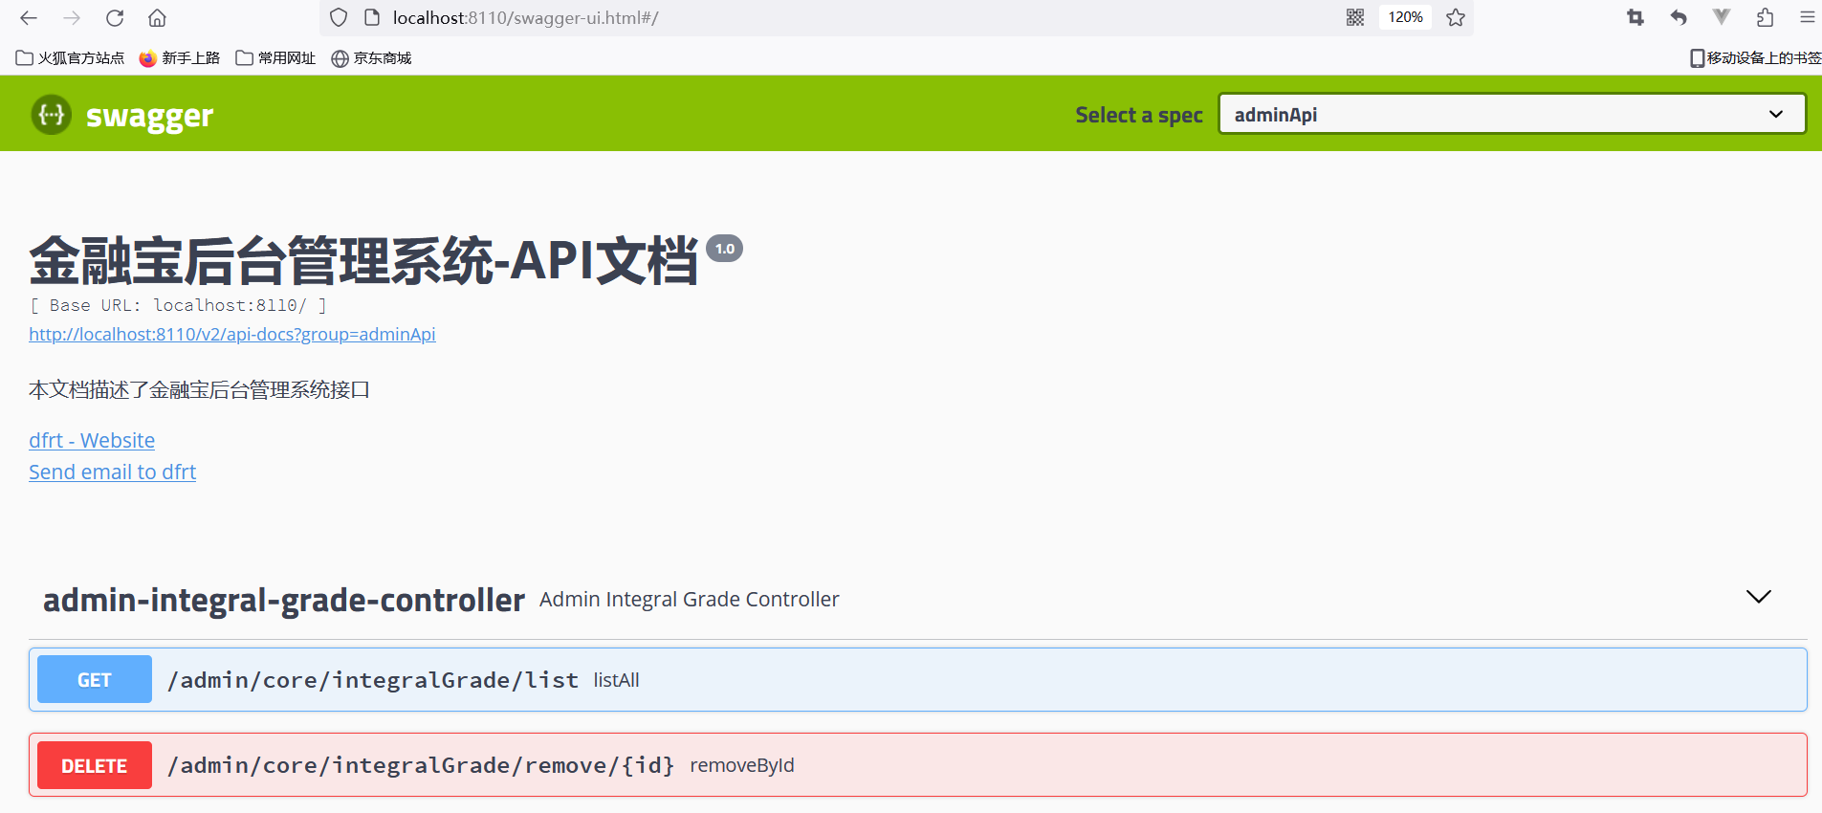

3、常见注解

实体类注解：entity的实体类中可以添加一些自定义设置，例如：

@ApiModelProperty(value = "创建时间", example = "2019-01-01 8:00:00")
private LocalDateTime createTime;

@ApiModelProperty(value = "更新时间", example = "2019-01-01 8:00:00")
private LocalDateTime updateTime;

controller注解：

定义在类上

@Api(tags = "积分等级管理")

定义在方法上

@ApiOperation("积分等级列表")

@ApiOperation(value = "根据id删除积分等级", notes = "逻辑删除")

定义在参数上

@ApiParam(value = "数据id", required = true, example = "100")

再次 查看网页

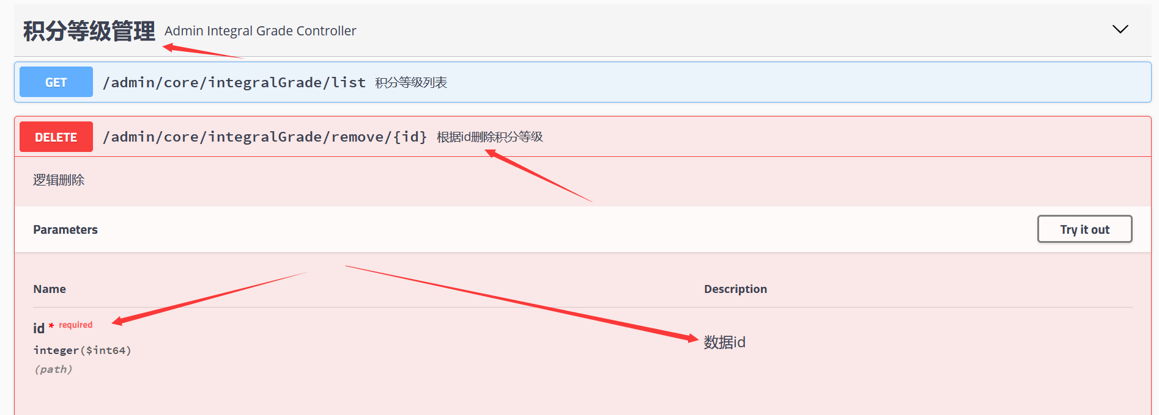

4、接口分组配置

package com.gsm.finance.base.config;

import com.google.common.base.Predicates;
import org.springframework.context.annotation.Bean;
import org.springframework.context.annotation.Configuration;
import springfox.documentation.builders.ApiInfoBuilder;
import springfox.documentation.builders.PathSelectors;
import springfox.documentation.service.ApiInfo;
import springfox.documentation.service.Contact;
import springfox.documentation.spi.DocumentationType;
import springfox.documentation.spring.web.plugins.Docket;
import springfox.documentation.swagger2.annotations.EnableSwagger2;

@Configuration
@EnableSwagger2
public class Swagger2Config {

@Bean
public Docket adminApiConfig(){

return new Docket(DocumentationType.SWAGGER_2)
.groupName("adminApi") //接口分组显示
.apiInfo(adminApiInfo())
.select()
//只显示admin路径下的接口
.paths(Predicates.and(PathSelectors.regex("/admin/.*")))
.build();

}

@Bean
public Docket webApiConfig(){

return new Docket(DocumentationType.SWAGGER_2)
.groupName("webApi") //接口分组显示
.apiInfo(adminApiInfo())
.select()
//只显示api路径下的接口
.paths(Predicates.and(PathSelectors.regex("/api/.*")))
.build();

}

private ApiInfo adminApiInfo(){

return new ApiInfoBuilder()
.title("金融宝后台管理系统-API文档")
.description("本文档描述了金融宝后台管理系统接口")
.version("1.0")
.contact(new Contact("gsm", "https://www.easthome.com/", "3567455033@qq.com"))
.build();
}
}

效果
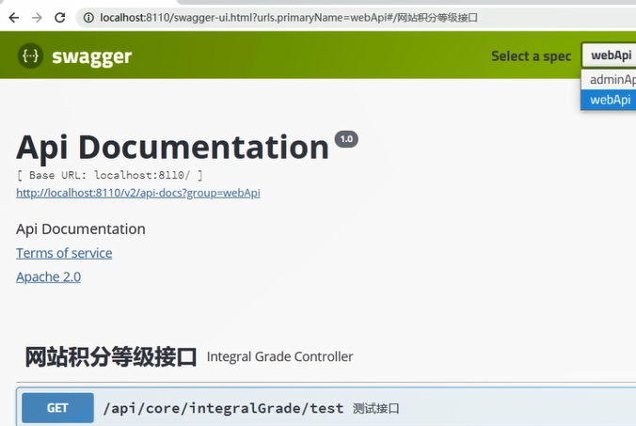

5、文档描述信息

package com.gsm.finance.base.config;

import com.google.common.base.Predicates;
import org.springframework.context.annotation.Bean;
import org.springframework.context.annotation.Configuration;
import springfox.documentation.builders.ApiInfoBuilder;
import springfox.documentation.builders.PathSelectors;
import springfox.documentation.service.ApiInfo;
import springfox.documentation.service.Contact;
import springfox.documentation.spi.DocumentationType;
import springfox.documentation.spring.web.plugins.Docket;
import springfox.documentation.swagger2.annotations.EnableSwagger2;

@Configuration
@EnableSwagger2
public class Swagger2Config {

@Bean
public Docket adminApiConfig(){

return new Docket(DocumentationType.SWAGGER_2)
.groupName("adminApi") //接口分组显示
.apiInfo(adminApiInfo())
.select()
//只显示admin路径下的接口
.paths(Predicates.and(PathSelectors.regex("/admin/.*")))
.build();

}

@Bean
public Docket webApiConfig(){

return new Docket(DocumentationType.SWAGGER_2)
.groupName("webApi") //接口分组显示
.apiInfo(adminApiInfo())
.select()
//只显示api路径下的接口
.paths(Predicates.and(PathSelectors.regex("/api/.*")))
.build();

}

private ApiInfo adminApiInfo(){

return new ApiInfoBuilder()
.title("金融宝后台管理系统-API文档")
.description("本文档描述了金融宝后台管理系统接口")
.version("1.0")
.contact(new Contact("gsm", "https://www.easthome.com/", "3567455033@qq.com"))
.build();
}
}

效果截图

