**MEETING NOTE**

**2017/03/08 Nova meeting**

implement before meeting:

try every ckpt for every model

test data in :

**/dataset/Nova**

PQ_0007

PQ_V4

PQ_V11

test_3

.mat for directly SR is saved in :

XXXXX_d

**2017/03/14 Nova meeting**

implement before meeting:

deconv_x4_big : deeper model just like the ESPCN paper

deconv_x4_we : edge punished model

after meeting:

1. SSIM vs PSNR
2. Ringing
3. try VDSR to solve Ringing

**2017/04/12 lab meeting**

implement before meeting:

model

sub-pixel

no residual

residual

scale

x2 x4

feat.

L1 norm, not MSE

loss = sum for all pixels ( abs(gt - output) )

L1 norm then L2 norm

trained on CG

Mix loss function

after meeting:

1. calculate the SSIM on the ringing image
2. implement the Mix loss function
3. find the ringing @ natural image

**2017/05/07 lab meeting**

~~fix the~~ **~~color bias~~** ~~problem:~~

~~1.~~

~~add~~ **~~manga109~~** ~~pic into the~~ **~~LapSR dataset (in peter' PC @ spider2)~~**

~~2.~~

~~regenerate the dataset .mat files by changing the RGB 2 YCbCr formula~~ **~~without using API~~**

~~3.~~

~~change the YCbCr 2 RGB formula in python with the formula corresponding to the step 2~~

~~4.~~

~~train the Model~~

1. ~~DN with gamma, beta~~
2. ~~without DN, but with L1 regular~~

~~replace our result pictures in the slides of~~ **~~0507 Novatek Progress Report~~** ~~with color bias fixed ones (LAPCG_d)~~

~~higer lr~~

~~test on Set5 Set14~~

~~regenerate the test .mat~~

**2017/05/23 Nova meeting**

**To do :**

**七月底:**

**The best one in the whole candidate models + ….**

**1. gradient loss 跑結果圖 @ natural image**

**2. more layers**

**3. float16**

**-> 跑結果圖 (RGB image & gradient map)**

**fine tune on CG**

**more layers - ongoing**

**edge detection and do less sharpness - ongoing**

**global/ local var. - ongoing**

**~~CG image contrast suppression - done, useless~~**

**ESPCN on pure CG**

**收尾 (demo on film)**

**check:**

**~~low vs high contrast uniformity - done, useless~~**

**~~different direction uniformity~~**

**~~rotate pattern~~**

**pattern:7, 18, 43, 44**

*~~DN (no gamma and beta) + L1 on LAPSR_more_manga and show the performance~~*

*comment: 整體效果變好但是某些極端case(e.q. 白底黑字)會劣化(更多噪點)*

~~跑圖 (original -> 2 by SR -> compared with IBS, SRCNN, FSRCNN)~~

**Other issue:**

**~~OL_Lunch_x4_GT in 35manga109 <-> LAPCG~~**

**~~302003.png in LAPSR <-> Set5~~**

~~PSNR formula difference http://forum.slime.com.tw/thread102222.html~~

**Question:**

1. **In normalization, gamma and beta is shared by all neurons or belonging to one neuron?**
   1. **Ans : in DN, shared by all neurons.**
2. 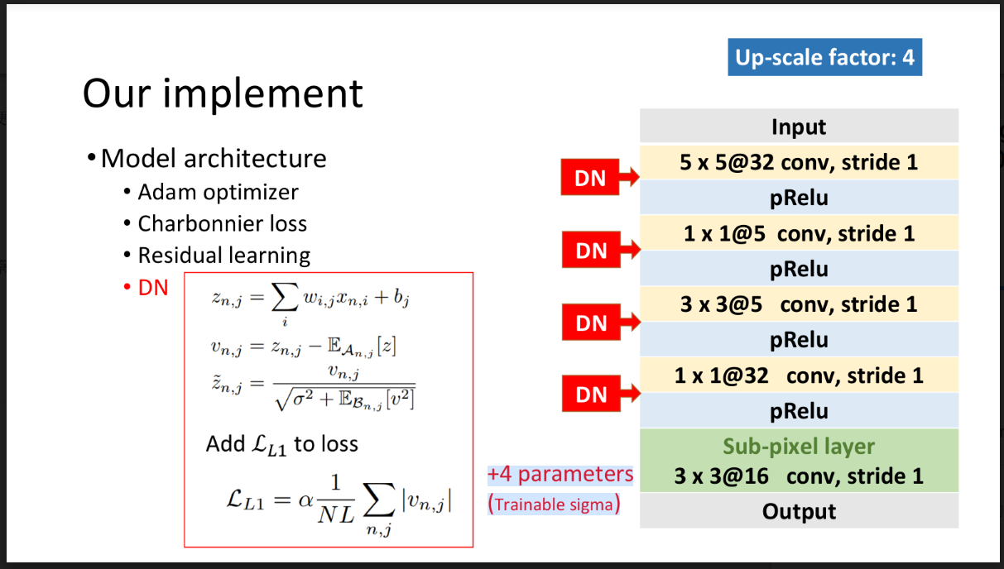 **~~trainable sigma is ?~~** 
   1. **~~Ans: Just the sigma in the denominator!~~**
3. **how to do DN at inference time?**
   1. **Ans: Just do in a single image.**
4. 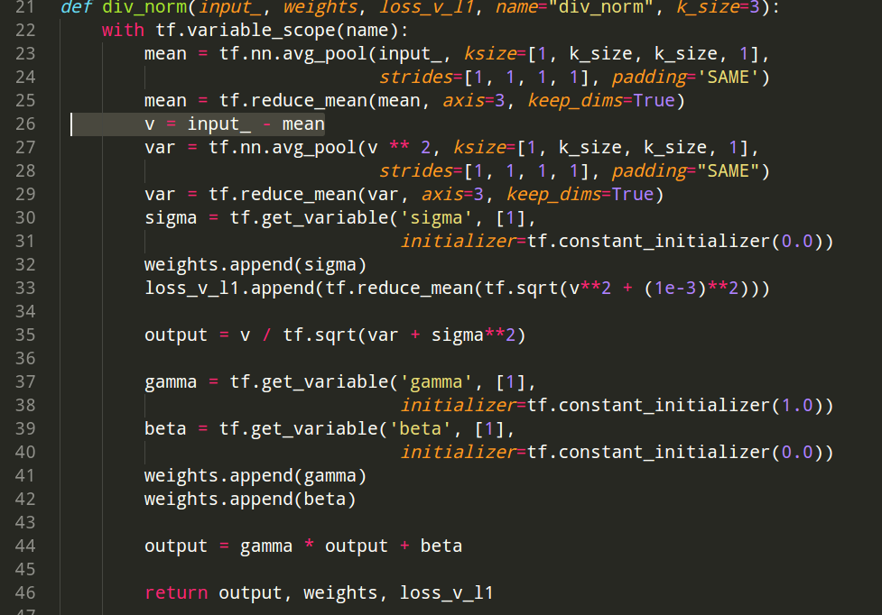**(in MODEL_div_l1.py) line 26 really does the divisive normalization?**
5. **Is more CG images in the training set really help the performance? (on perceptron)**

* **In the case a. , NO**

6. tensorboard loss visual problem (launch logs @ AI)

7. feature maps montage

8. tensor actual values

**data Detail:**

|  |  |  |  |  |
| --- | --- | --- | --- | --- |
| Dataset | # of raw images | # of .mat in x2 | # of .mat in x4 | # of .mat/3 in x4 |
| 21manga109 | 21 |  | 88704 | 29568 |
| 35manga109 | 35 |  | 546840 | 182280 |
| LAPSR (stride = 9) | 390 |  | **723192** | **241064** |
| LAPSR_stride_17 (stride = 17) |  | 234168 | 78056 |
| **collected dataset** |  |  |  |  |
| **LAPSR_manga**  (LAPSR + 21manga109) | ***411*** |  | ***813912*** | ***271304*** |
| **LAPSR_more_manga**  (LAPSR + 35manga109) | ***425*** |  | ***1270032*** | ***423344*** |

**model Detail:**

|  |  |  |  |  |  |  |
| --- | --- | --- | --- | --- | --- | --- |
| **DN** | Y | **gamma, beta** | Y | **L1 regular** | Y | a. |
| N |  |
| N | Y | c.  (Guan) |
| N |  |
| N | **L1 regular** | Y | b. |  |  |
| N | d. |  |  |

|  |
| --- |
| **Setting** |
| **start training** |
| **python {train_scipt}** |
| **restart training** |
| ex:  *epoch_130.ckpt-1632784.meta* in checkpoint folder  **python {train_scipt} --model_path epoch_130.ckpt-1632784** |
| **hyper** |
| IN_IMG_SIZE = (17, 17)  OUT_IMG_SIZE = (17 * SCALE_FACTOR, 17 * SCALE_FACTOR)  BATCH_SIZE = 128  MOMENTUM = 0.9  USE_ADAM_OPT = True  BASE_LR = **2e-4**  LR_RATE = 0.02  LR_STEP_SIZE = 300 |

1. **DN with gamma, beta, l1** 
   1. pyhton : TEST_div_l1
   2. ckpt : xSCALE_div_l1_gamma_beta_plus_manga
2. **without DN, but with L1 regular**
   1. pyhton : TEST_div_l1_no_DN
   2. ckpt : xSCALE_div_l1_no_DN_plus_manga
3. **DN without gamma, beta; but with l1**
   1. pyhton :
      1. TRAIN_div_l1_original + MODEL_div_l1_original
      2. TEST_div_l1_original
   2. ckpt :
      1. xSCALE_div_l1_original_plus_(more_)manga
      2. xSCALE_div_l1_original (trained on LAPSR_stride_17)
      3. x4_div_l1_adam_1(trained on wrong YCbCr LAPSR_stride_17) by Guan
4. **no DN + no L1**
   1. pyhton :
      1. TEST_no_DN_no_l1 + MODEL_div_l1_no_DN_no_l1 (MODEL_no_DN_no_l1)
   2. ckpt : xSCALE_no_DN_no_L1_plus_(more)_manga
5. **DN without gamma, beta; but with l1 + gradient loss**
   1. pyhton :
      1. TRAIN_div_l1_original_grad + MODEL_div_l1_original
   2. ckpt : xSCALE_div_l1_original_{lamda_value}grad_plus_more_manga

1. **DN without gamma, beta; but with l1 + Deeper model**

i. pyhton :

1. TRAIN_div_l1_original_deeper + MODEL_div_l1_original_deeper

ii. ckpt :

1. x%d_div_l1_original_deeper_plus_manga

1. **DN without gamma, beta; but with l1 + gradient loss + Deeper model**

i. pyhton :

1. TRAIN_div_l1_original_grad_deeper + MODEL_div_l1_original_deeper

ii. ckpt :

1. x%d_div_l1_original_grad_deeper_plus_manga

**h. DN without gamma, beta; but with l1 + total_var_loss**

i. pyhton :

1. TRAIN_div_l1_original_total_var + MODEL_div_l1_original

ii. ckpt :

1. x%d_div_l1_original_%.2ftv_ON_{training_data_set}

**i. DN without gamma, beta; but with l1 + edge_modulation**

i. pyhton :

1. TRAIN_div_l1_original_edge_ver2 + MODEL_div_l1_original

ii. ckpt :

1. x%d_div_l1_original_%.2fedge_ON_{training_data_set}

|  |  |  |  |  |  |  |  |  |  |  |  |  |  |  |
| --- | --- | --- | --- | --- | --- | --- | --- | --- | --- | --- | --- | --- | --- | --- |
| sub-pixel  +  residual | | train | | cal. PSNR | | | | visual | | | | | | |
| **LAPSR_manga** | | Set5 | | Set14 | | LAPCG_d | nova_d | testForValidation_d | nova0.25_d | LAPCG_plus_  tFV_d |  |  |
| to epoch 300 | to epoch 500 | to epoch 300 | to epoch 500 | to epoch 300 | to epoch 500 |  |  |  |  |  |  |  |
| a. | x2 |  |  |  |  |  |  |  |  |  |  |  |  |  |
| x4 | v, ha | v, ha | x | bic: **28.43**  SR: 30.54  (stop increasing @ epoch 190) | x | bic: **26.10**  SR: 27.64  (stop increasing @ epoch 120) | vo, ha, epoch 500 |  | vo, ha, epoch 190 |  |  |  |  |
| b. | x2 |  |  |  |  |  |  |  |  |  |  |  |  |  |
| x4 | v, ha | v, ha | x | bic: **28.43**  SR: 30.34  (stop increasing @ epoch 120) | x | bic: **26.10**  SR: 27.47  (stop increasing @ epoch 190) | vo, ha, epoch 450 |  |  |  |  |  |  |
| c.-1  (div_l1_original_plus_manga) | x2 | -,ha |  | bic: **33.69**  SR: 36.96  (stop increasing @ epoch 170) |  | bic: **30.34**  SR: 32.64  (stop increasing @ epoch 130) |  |  | -,no, epoch 180 |  |  |  |  |  |
| x4 | v, ha | v, ha | x | bic: **28.43**  SR: 30.60  (stop increasing @ epoch 220) | x | bic: **26.10**  SR: 27.64  (stop increasing @ epoch 180) |  | v, no, epoch 230 | vo, ha, epoch 220 | v, no, epoch 230 |  |  |  |
| c.-2  (div_l1_original) | x2 |  |  |  |  |  |  |  |  |  |  |  |  |  |
| x4 | v, ha | v, ha  (train on LAPSR_stride_17 only) | x | bic: **28.43**  SR: 30.52  (stop increasing @ epoch 330) | x | bic: **26.10**  SR: 27.61  (stop increasing @ epoch 330) |  |  |  |  |  |  |  |
| d. | x2 |  |  |  |  |  |  |  |  |  |  |  |  |  |
| x4 | v, ha | x | bic: **28.43**  SR: 30.38  (stop increasing @ epoch 190) | x | bic: **26.10**  SR: 27.52  (stop increasing @ epoch 220) | x | vo, ha, epoch 200 |  |  |  |  |  |  |
| f. | x2 | -,ha |  |  |  | bic: **30.34**  SR: 32.78  (stop increasing @ epoch 190) |  |  |  |  |  |  |  |  |
| g. | x2 | -,ha |  |  |  |  |  |  |  |  |  |  |  |  |

|  |  |  |  |  |  |  |  |  |  |  |  |  |  |  |
| --- | --- | --- | --- | --- | --- | --- | --- | --- | --- | --- | --- | --- | --- | --- |
| sub-pixel  +  residual | |  | train | | cal. PSNR | | | | visual | | | | | |
| **LAPSR_more_manga** | | Set5 | | Set14 | | nova_d | LAPCG_plus_tFV_d | Set5_d | Set14_d | nova0.25_d | testForValidation_d |
| to epoch 300 | to epoch 500 | to epoch 300 | to epoch 500 | to epoch 300 | to epoch 500 |  |  |  |  |  |  |
| a. | x2 |  |  |  |  |  |  |  |  |  |  |  |  |  |
| x4 |  | v, ha | v, ha | x | bic: **28.43**  SR: 30.59  (stop increasing @ epoch 180) | x | bic: **26.10**  SR: 27.67  (stop increasing @ epoch 170) |  |  |  |  |  | vo, ha, epoch 170 |
| c.-1 | x2 |  |  |  |  |  |  |  |  |  |  |  |  |  |
| x4 |  | v, ha | v, ha | x | bic: **28.43**  SR: 30.54  (stop increasing @ epoch 120) | x | bic: **26.10**  SR: 27.63  (stop increasing @ epoch 170) |  |  |  |  |  | vo, ha, epoch 200 |
| d. | x2 |  |  |  |  |  |  |  |  |  |  |  |  |  |
| x4 |  | v, ha | x | bic: **28.43**  SR: 30.47  (stop increasing @ epoch 160) | x | bic: **26.10**  SR: 27.62  (stop increasing @ epoch 140) | x |  |  |  |  |  |  |
|  | | lambda |  | | | | | | | | | | |  |
| e. | x2 |  |  |  |  |  |  |  |  |  |  |  |  |  |
| x4 | 0.75 | v, ha | x | bic: **28.43**  SR: 30.51  (stop increasing @ epoch 150) | x | bic: **26.10**  SR: 27.63  (stop increasing @ epoch 120) | x |  | v, no, epoch 200 |  |  |  |  |
| 0.5 | -, ha(to epoch 240) | x | bic: **28.43**  SR: 30.52  (stop increasing @ epoch 110) | x | bic: **26.10**  SR: 27.64  (stop increasing @ epoch 100) | x |  | v, no, epoch 200 |  |  | v, no, epoch 150 |  |
| 0.25 | -, ha(to epoch 240) | x | bic: **28.43**  SR: 30.52  (stop increasing @ epoch 110) | x | bic: **26.10**  SR: 27.63  (stop increasing @ epoch 120) | x |  | v, no, epoch 200 |  |  |  |  |

**STATUS**

~

stopped (not finish)

-

processing

v

done

vo

done and the data is transferred to my pc

**LOCATION**

ha

hank AI server

me

my pc

no

no

**TO DO**

**no residual**

**L1**

|  |  |  |  |  |  |  |  |  |  |  |  |  |
| --- | --- | --- | --- | --- | --- | --- | --- | --- | --- | --- | --- | --- |
| sub-pixel | train | | | cal. PSNR | | | visual | | | | | |
| 91G100 | | | Set5 | | | nova_d | | | testForValidation_d | | |
| to epoch 300 | to epoch 500 | to epoch 700( with L2 loss) | to epoch 300 | to epoch 500 | to epoch 700( with L2 loss) | to epoch 300 | to epoch 500 | to epoch 700( with L2 loss) | to epoch 300 | to epoch 500 | to epoch 700( with L2 loss) |
| x2 | vo, AI | vo, AI | vo, AI(hank2) | vo |  | ~, AI | vo |  |  | vo | vo, AI | vo, AI |
| x4 | vo, AI | vo, PC | v, AI(hank) | vo |  |  | vo |  |  | vo | vo, me | vo, AI |

**MSE**

|  |  |  |
| --- | --- | --- |
|  | visual | |
| sub-pixel | validation_d | nova_d |
| x2 | vo | vo |
| x4 | vo | vo |

**residual**

**L1, trian on 91G100**

|  |  |  |  |  |  |  |  |  |
| --- | --- | --- | --- | --- | --- | --- | --- | --- |
| sub-pixel | train | | cal. PSNR | | visual | | | |
| 91G100 | | Set5 | | nova_d | | testForValidation_d | |
| to epoch 300 | to epoch 500 | to epoch 300 | to epoch 500 | to epoch 300 | to epoch 500 | to epoch 300 | to epoch 500 |
| x2 | vo, PC |  |  |  |  |  |  |  |
| x4 | vo, PC |  |  |  |  |  | vo,PC |  |

**L1, trian on CG**

|  |  |  |  |  |  |  |  |  |
| --- | --- | --- | --- | --- | --- | --- | --- | --- |
| sub-pixel | train | | cal. PSNR | | visual | | | |
| Nova_CG | | Set5 | | nova_d | | testForValidation_d | |
| to epoch 300 | to epoch 500 | to epoch 300 | to epoch 500 | to epoch 300 | to epoch 500 | to epoch 300 | to epoch 500 |
| x2 | -, me |  |  |  |  |  |  |  |
| x4 |  |  |  |  |  |  |  |  |

**SSIM**

|  |  |  |  |  |  |  |  |  |
| --- | --- | --- | --- | --- | --- | --- | --- | --- |
| sub-pixel | train | | cal. PSNR | | visual | | | |
| 91G100 | | Set5 | | nova_d | | testForValidation_d | |
| to epoch 300 | to epoch 500 | to epoch 300 | to epoch 500 | to epoch 300 | to epoch 500 | to epoch 300 | to epoch 500 |
| x2 | ~o  (3 epoch), me |  |  |  |  |  |  |  |
| x4 |  |  |  |  |  |  |  |  |

**Mix ( MS-SSIM + L1)**

|  |  |  |  |  |  |  |  |  |
| --- | --- | --- | --- | --- | --- | --- | --- | --- |
| sub-pixel | train | | cal. PSNR | | visual | | | |
| 91G100 | | Set5 | | nova_d | | testForValidation_d | |
| to epoch 300 | to epoch 500 | to epoch 300 | to epoch 500 | to epoch 300 | to epoch 500 | to epoch 300 | to epoch 500 |
| x2 | ~o  (25 epoch), me |  |  |  |  |  |  |  |
| x4 |  |  |  |  |  |  |  |  |

**pc**

**peter pc**

**AI**

**server, peter account**

**me**

**my pc**

**~**

**not finish**

**-**

**processing**

**v**

**done**

**vo**

**done and transferred to my pc**

**result**

**table**

dataset

train

91G100

test

Set5

visual

testForValidation_d

Nova

|  |  |  |  |
| --- | --- | --- | --- |
| PSNR | sub-pixel, x2 | | |
| bicubic | L1 | MSE |
| no residual | - | best, epochs 290 | best, epochs 220 |
| 33.69158847816106 | 36.16 | 36.5 |

|  |  |  |  |
| --- | --- | --- | --- |
| PSNR | sub-pixel, x4 | | |
| bicubic | L1 | MSE |
| no residual | - | best, epochs 290 | best, epochs 240 |
| 28.43633544780433 | 29.73 | 30.24 |

**SUPPLEMENT**

**Model**

**scale : x2 x3 x4**

|  |  |  |
| --- | --- | --- |
|  | **sub-pixel** | **deconv** |
| **residual** |  |  |
| **no residual** |  |  |

number of model = 2 * 2 * 3 = 12

**Code**

**peteryu PC IP : 140.114.28.179 -p 7735**

1 GTX 1070

**residual**

/SR/spider

**peteryu server IP : 140.114.28.200 -p 7735**

4 GTX 1080

**no residual**

/Disk1/peteryu/FSRCNN_our

**2017/03/08**

try every ckpt for every model

test data in

**/dataset/Nova**

PQ_0007

PQ_V4

PQ_V11

test_3

.mat for directly SR is saved in :

XXXXX_d

ckpt :

x2

|  |  |  |
| --- | --- | --- |
|  | sub-pixel | deconv |
| residual | fsrcnn_sub_x2  不小心覆蓋掉原本psnr資料夾裡的ckpt = = |  |
| no residual |  |  |

x3

|  |  |  |
| --- | --- | --- |
|  | sub-pixel | deconv |
| residual |  |  |
| no residual |  |  |

x4

|  |  |  |
| --- | --- | --- |
|  | sub-pixel | deconv |
| residual |  |  |
| no residual |  |  |