Praveen Doluweera

Task 4: ARM Assembly Programming

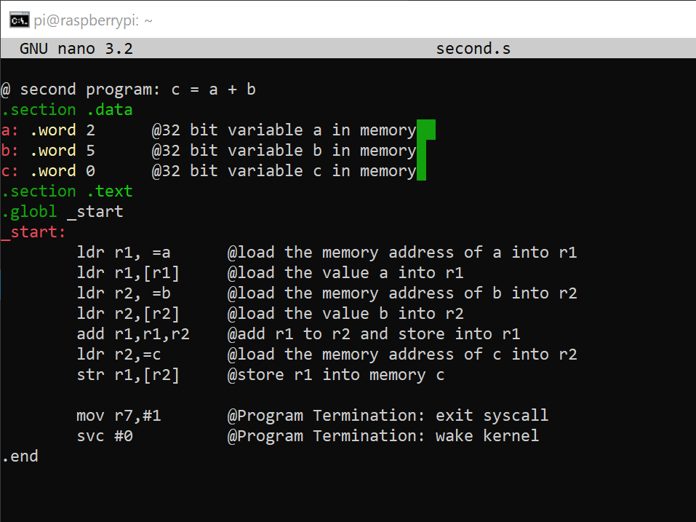

*Figure 1 – Creation of the second file and the program*

First you create the second file using the nano command. This file doesn’t produce an output. I then went to debug and check the registers as shown in Figure 2.

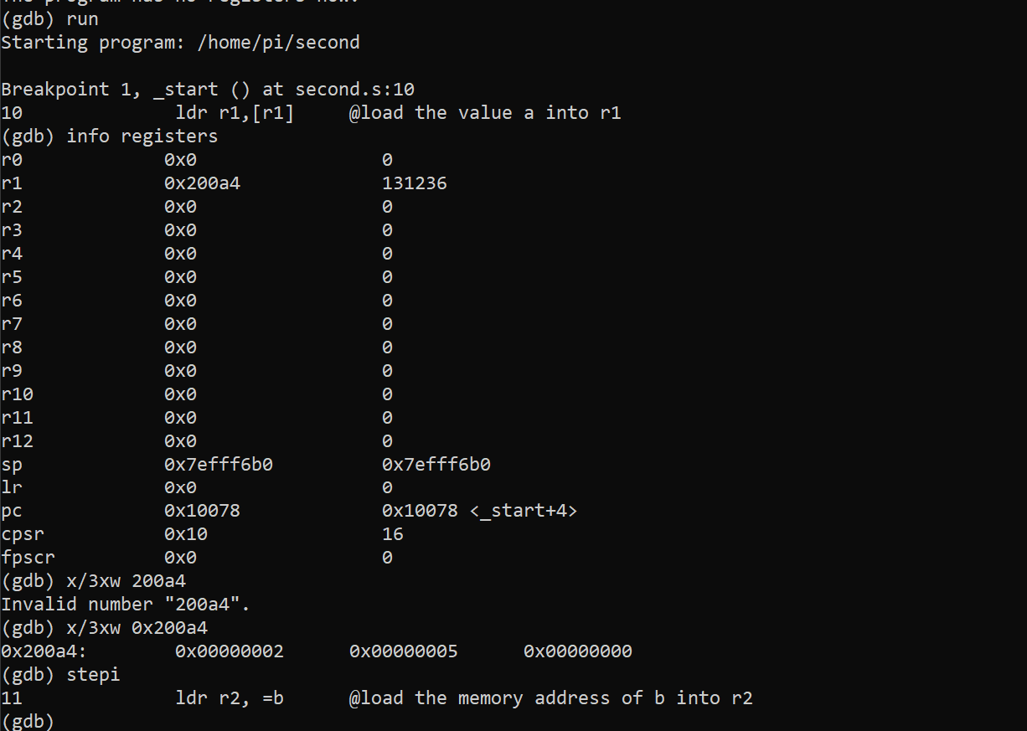

*Figure 2 – Debugging the code*

A breakpoint was set at line 10 and the “x/nfs address” command was used to examine the memory content.

Part B

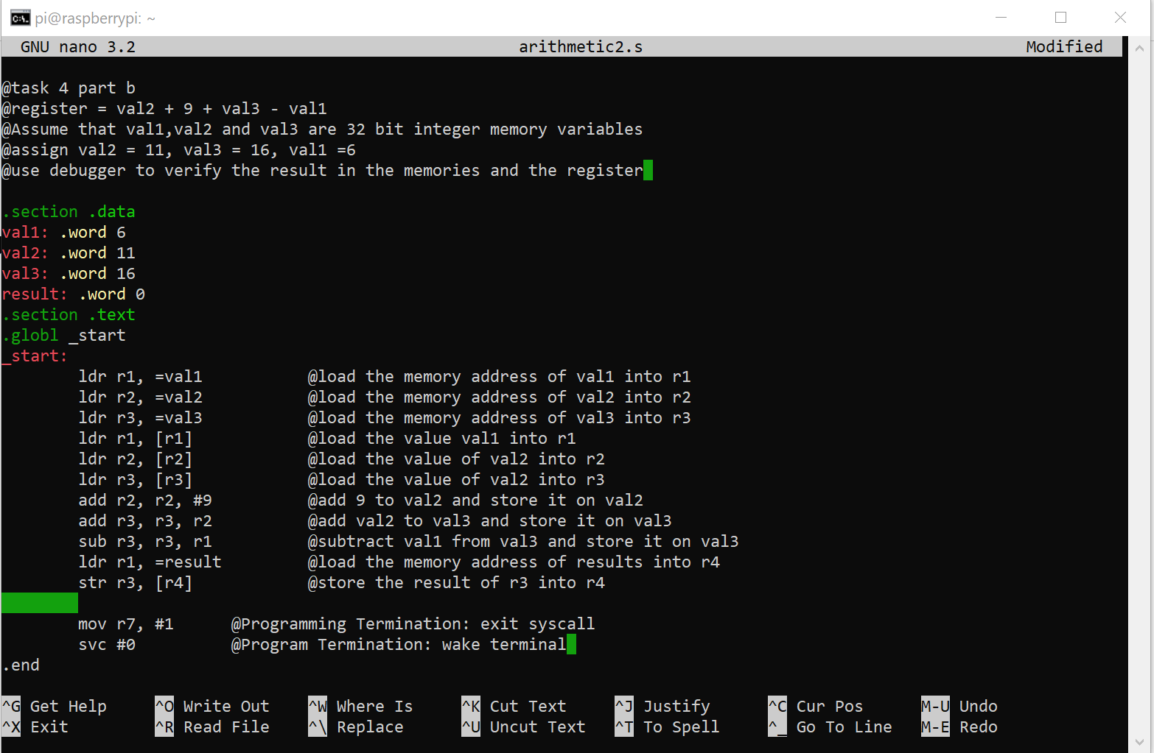

*Figure 3 – the arithmetic2.s program*

Just like in part a, there is no output. Then debugging was done on the program.

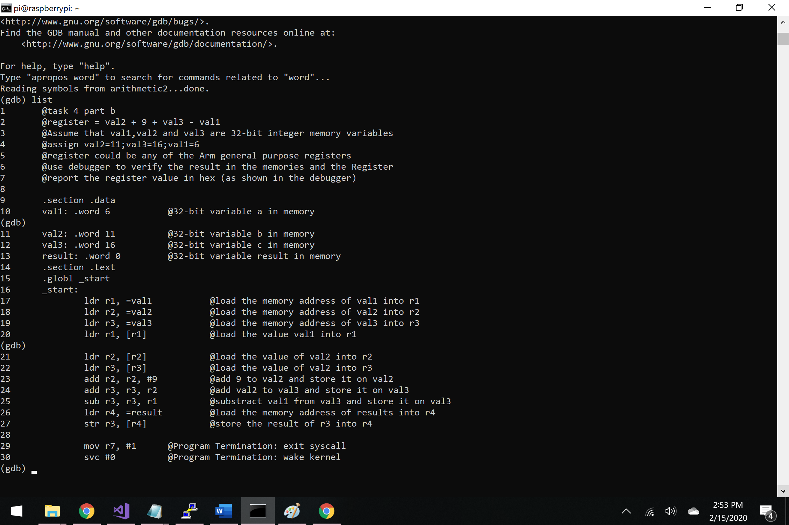

*Figure 4 – Debugging arithmetic2 program*

A breakpoint is set at line 17 and then the info registers command was used to show the address of the registers.

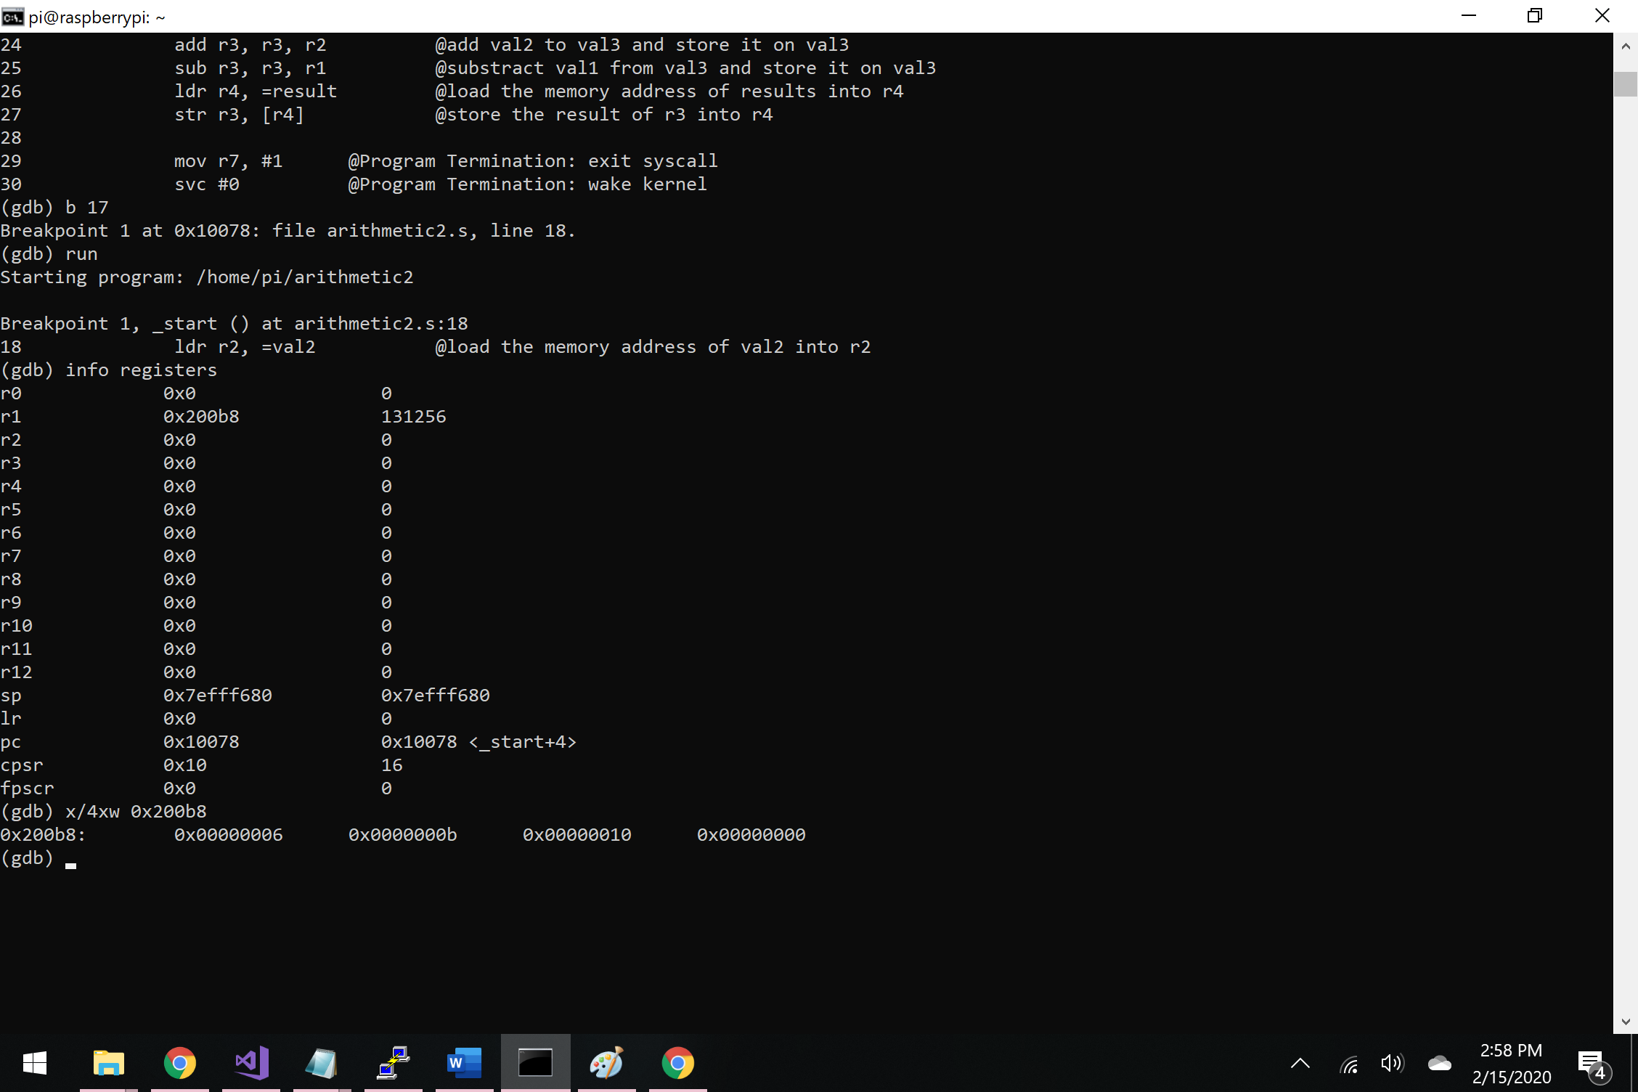

*Figure 5 – debugging*

The stepi command was used to go through to see the changes in the program. The final memory location is shown by typing in commands to see the memory as shown in figure 6 below.

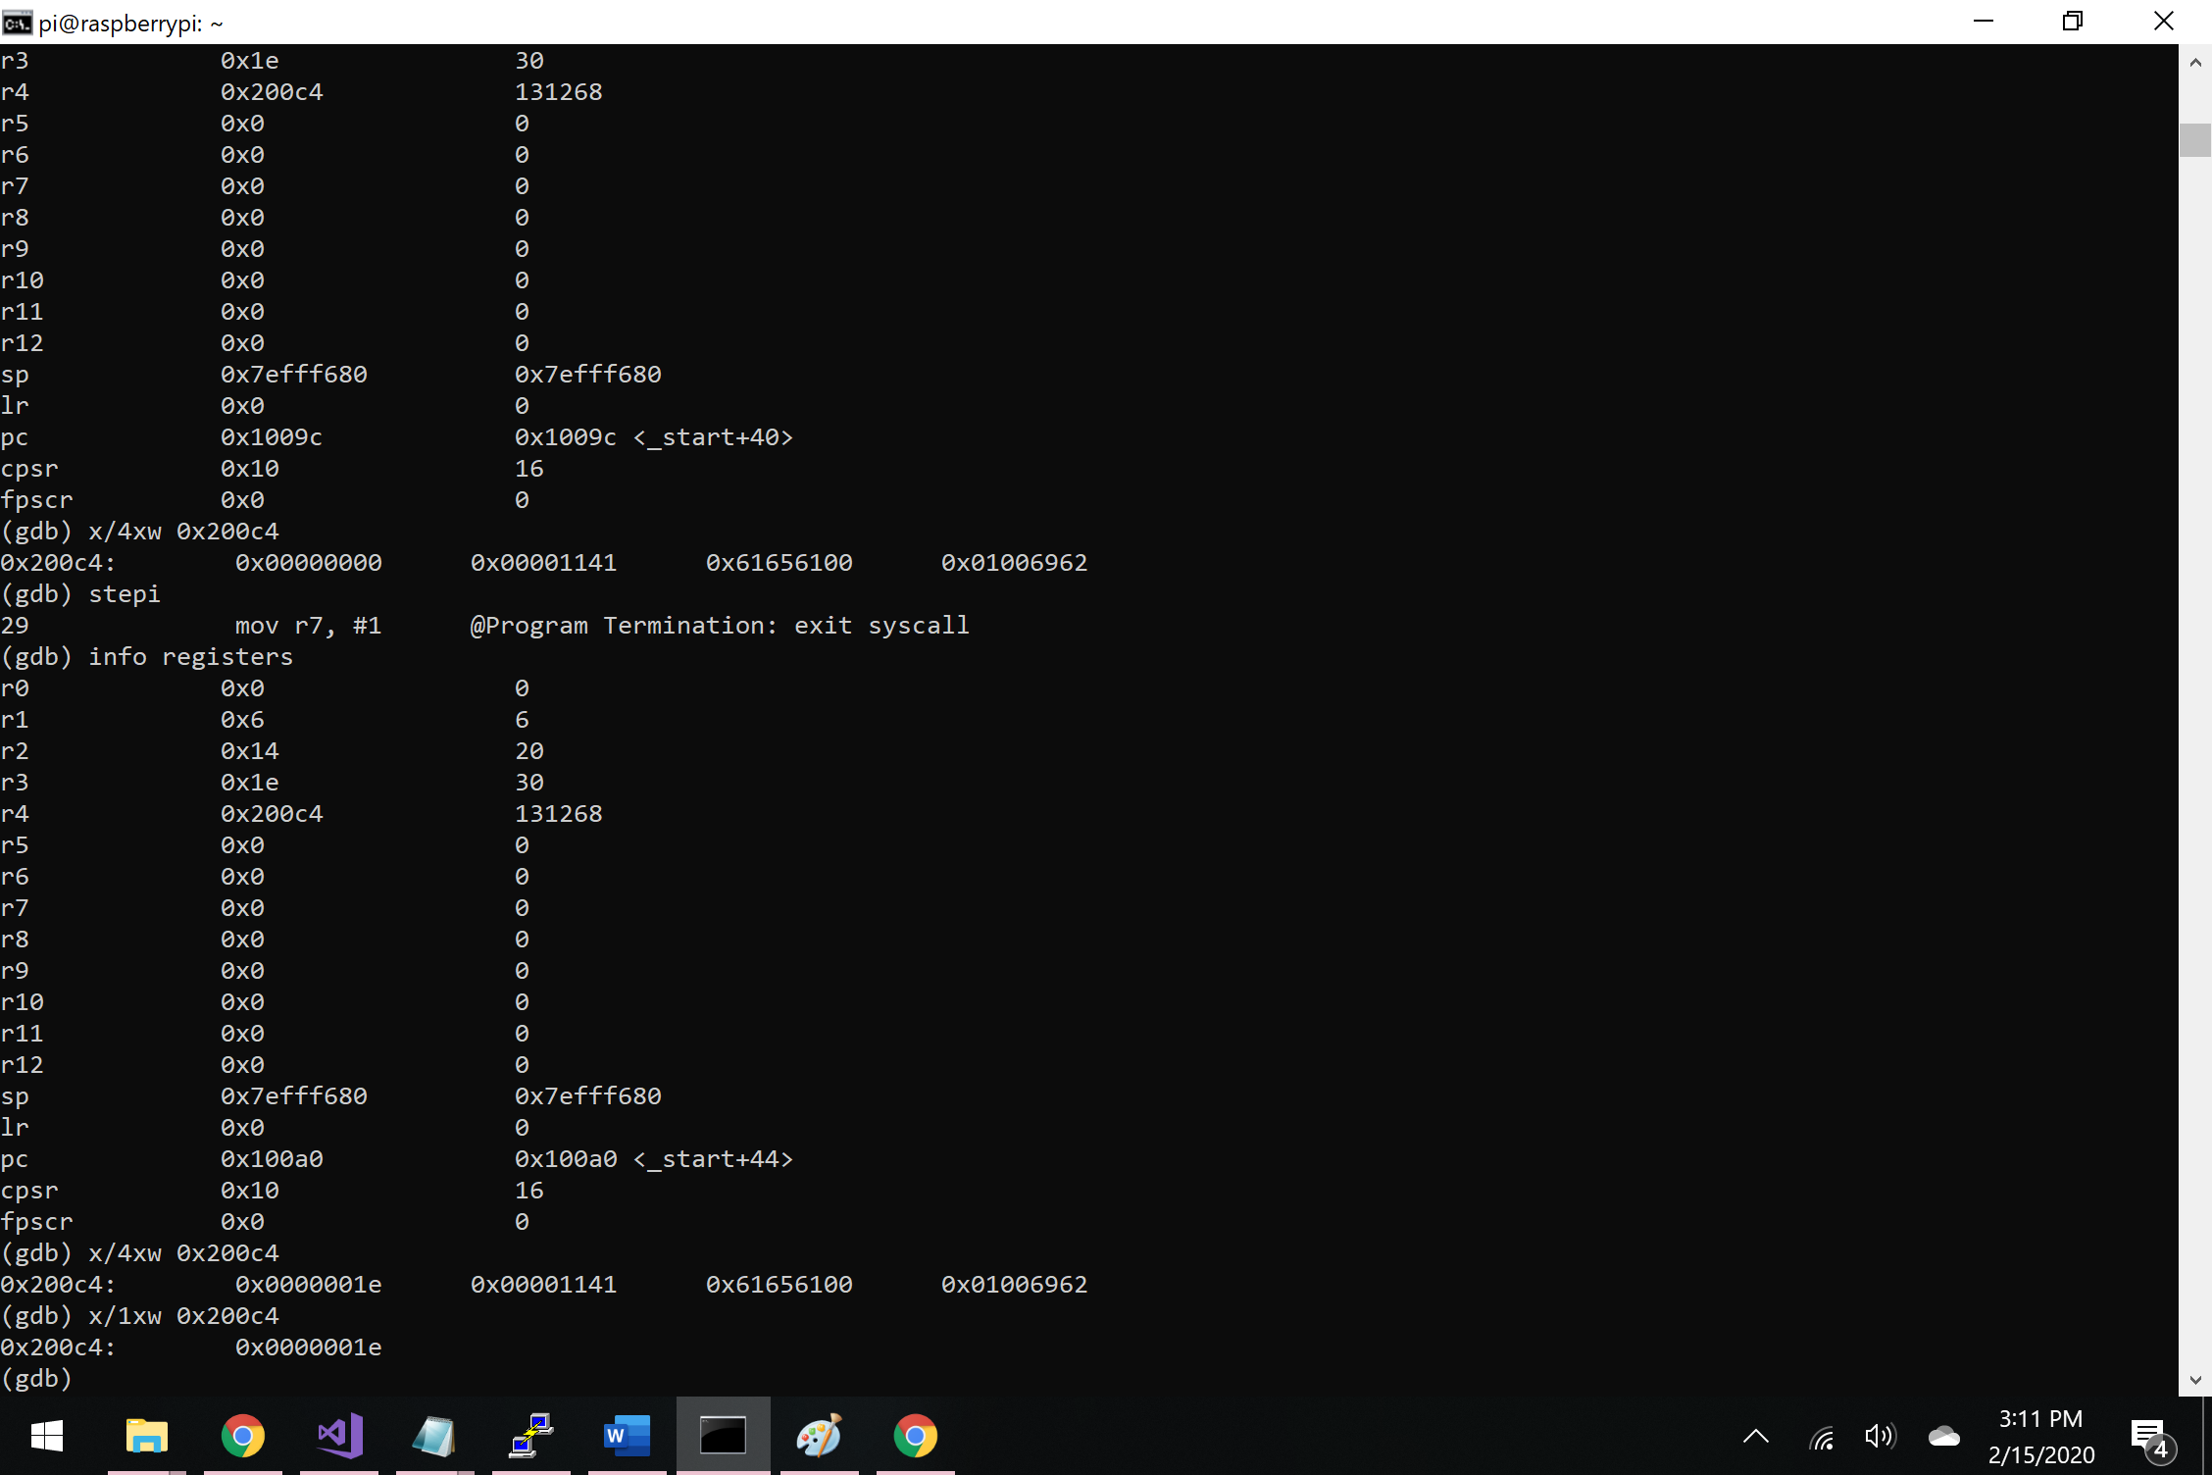

*Figure 6 – Final memory values*