Praveen Doluweera

Part 1

The original code in the instructions gave an error message because the correct keyword is not shalfword it is .hword. The updated code is shown below in Figure 1

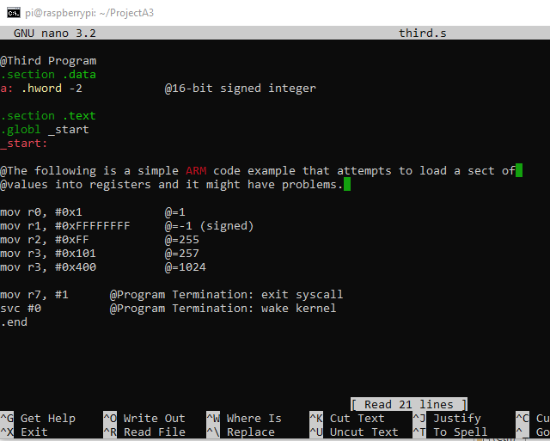

*Figure 1*

The code was then assembled and linked and ran as it was supposed to. It was then debugged using gdb as shown in Figure 2 and 3 below.

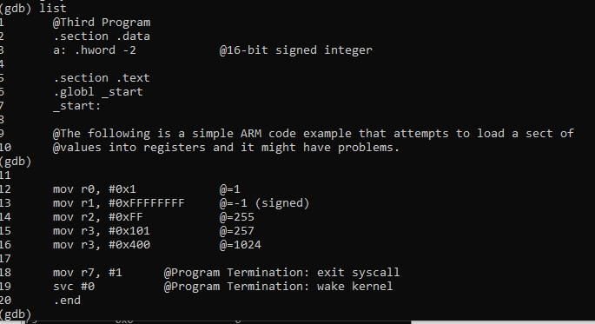

*Figure 2*

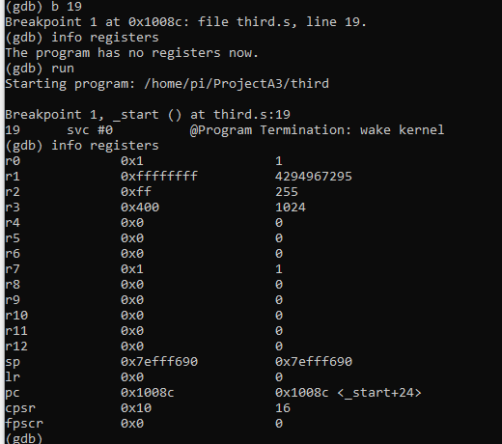

*Figure 3*

As you can see, the registers hold the values that they are expected to as shown in the comment of the original code.

Part 2

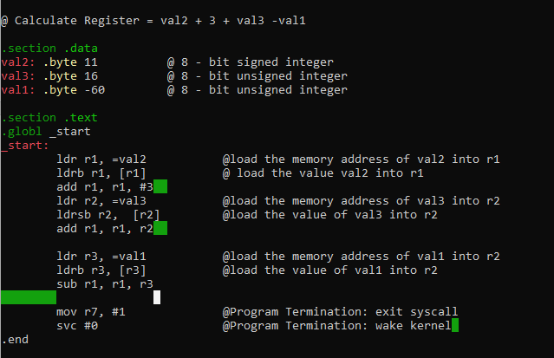

*Figure 4*

Figure 4 shows the code for the arithmetic expression val2+3+vale-val1

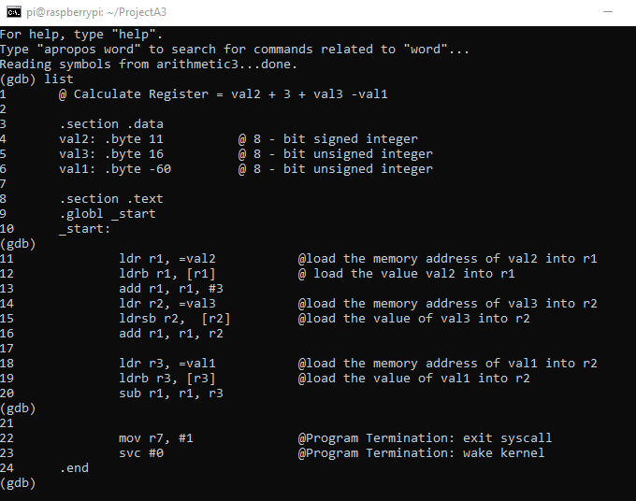

*Figure 5*

In figure 5 you can see that I am using gdb to debug my program.

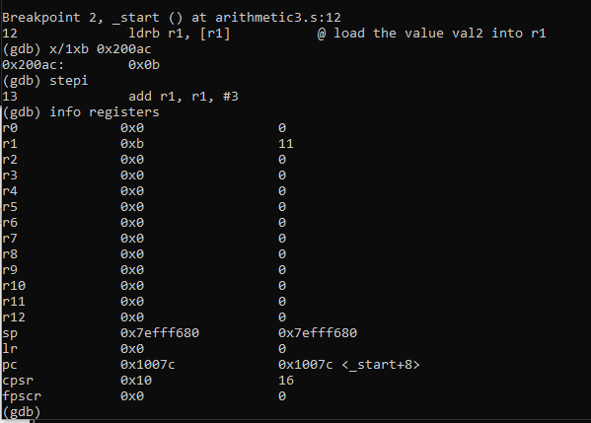

*Figure 6*

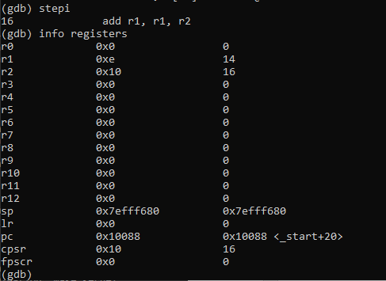

*Figure 7*

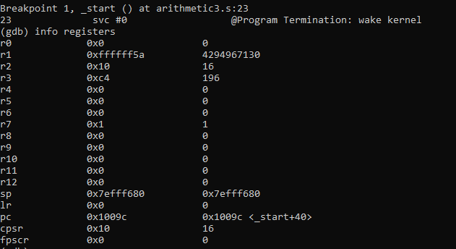

*Figure 8*

In figures 6 and 7 I step through the program to check if the correct values are loaded onto the registers.

In figure 8, you can see that the value in r1 which is expected to be 90 or 5A is FFFFFFF5A which is not correct. This is because in the original code val1 is declared as an unsigned integer alongside all of the others. The ldrb command was used instead of ldrsb. This means that two’s complement was done on the number which give the value 1111111 00111100 which in turn gives the value FFFFFFFF5A which is shown.

**

*Figure 9*

If in the original arithmetic3.s program, val 1 was declared as a sign value, the correct answer of 5A=90 would be shown in register r1.