First I enabled ssh on my raspberry pi so I was able to run commands from my computer. I then followed the instructions and created the first program

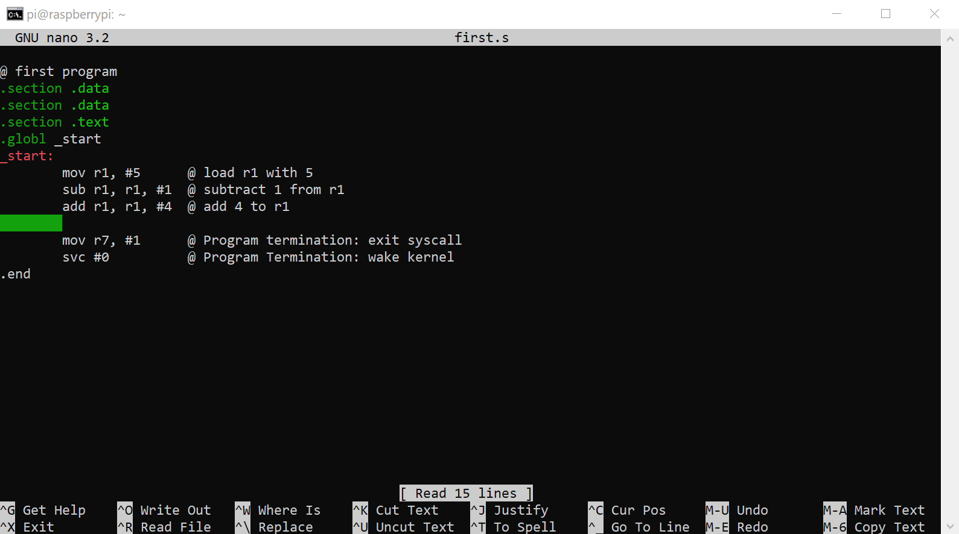

*Figure 1: Creating the first program (first.s)*

I noticed that this didn’t have an output when I ran it which is expected because there was nothing that was asked to be printed. I also saw how the debugger is opened and used

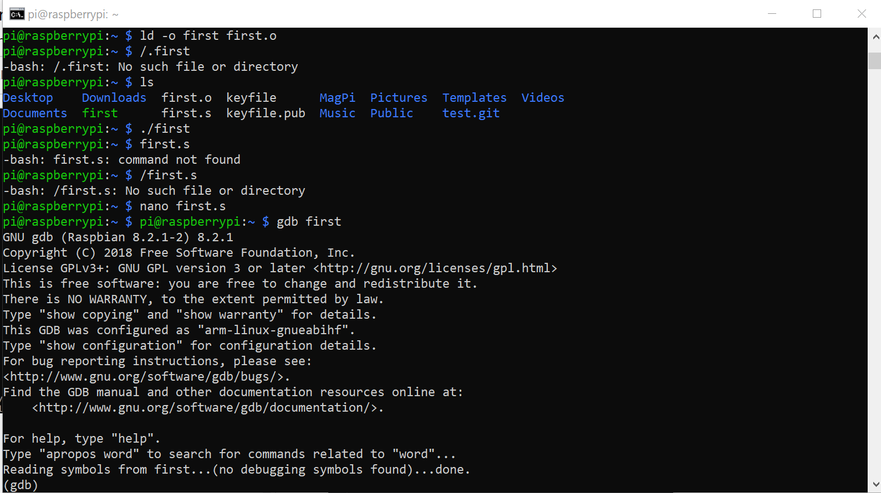

*Figure 2: Seeing the first file doesn’t run and showing the debugger*

Next a new file was created called arithmetic1 in which a certain mathematical operation was carried out.

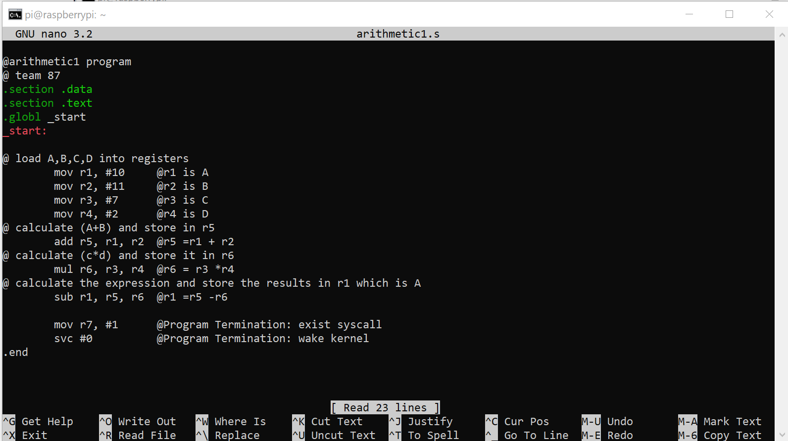

*Figure 3: The contents of the arithmetic1 program*

Then the debugger was used to create breakpoints and show the operations taking place on each line.

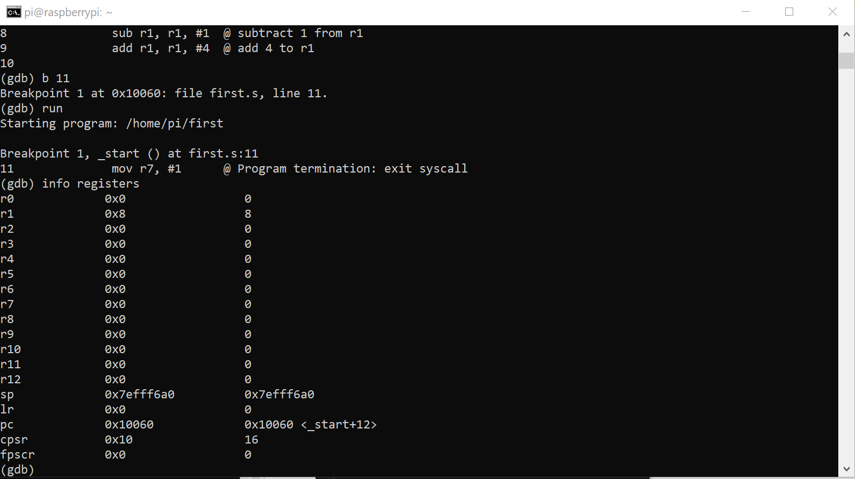

*Figure 4: Breakpoint 1 Registers*

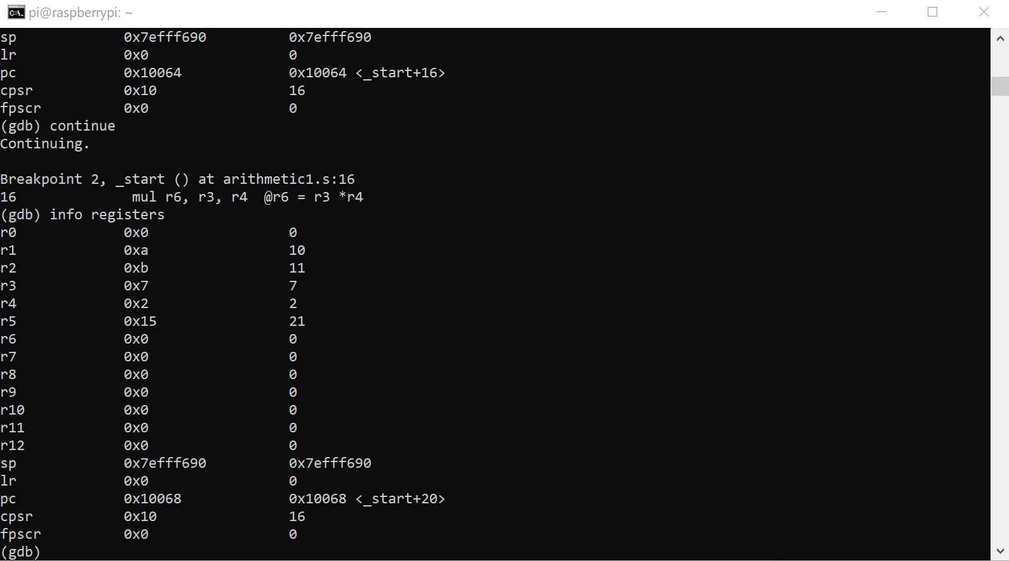

*Figure 5: Breakpoint 2 Registers*

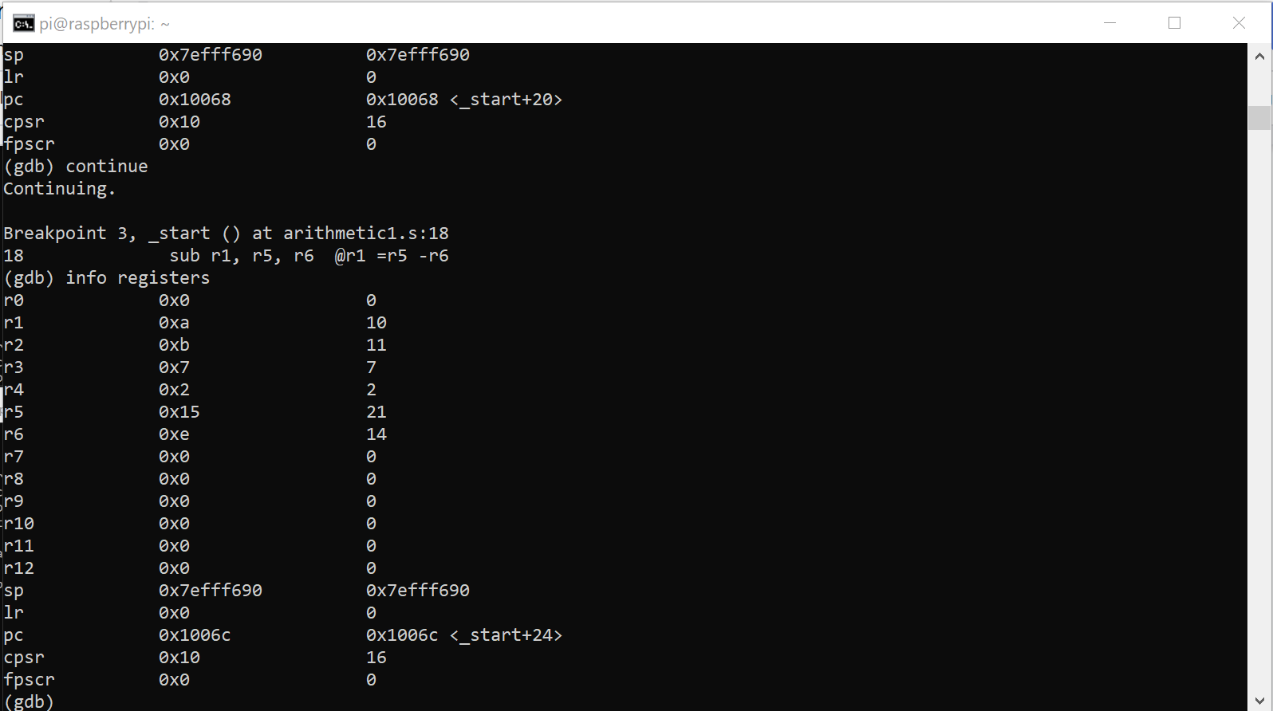

*Figure 6: Breakpoint 3 registers*

As you can see, the final answer to the problem of 7 is written on to r1 and is shown below in figure 7

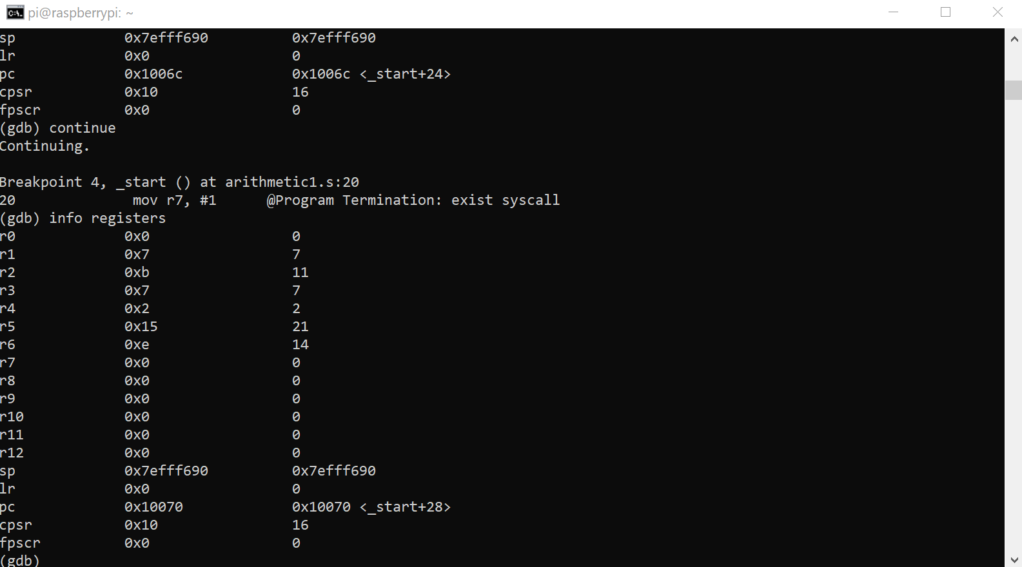

*Figure 7: The register values for breakpoint 4*