Lab Taks-5

Question-1
Create an animation using two box that will move in the opposite direction.
Graph Plot (Picture)-
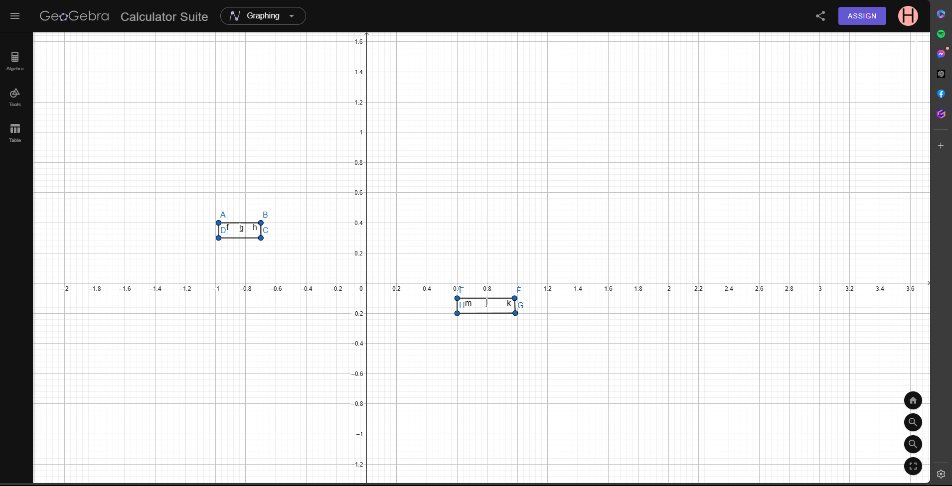
Code-
#include <iostream>
#include<GL/gl.h>
#include <GL/glut.h>
using namespace std;

float _move = 0.0f;
float move2 = 1.0f;
void drawScene() {
glClear(GL_COLOR_BUFFER_BIT);
glColor3d(1, 0, 0);
glLoadIdentity(); //Reset the drawing perspective
glMatrixMode(GL_MODELVIEW);

glPushMatrix();
glTranslatef(_move, 0.0f, 0.0f);
glBegin(GL_QUADS);
glVertex2f(-0.98, 0.4);
glVertex2f(-0.7, 0.4);
glVertex2f(-0.7, 0.3);
glVertex2f(-0.98, 0.3);
glEnd();
glPopMatrix();

glPushMatrix();
glTranslatef(move2, 0.0f, 0.0f);
glBegin(GL_QUADS);
glColor3d(1, 1.0, 0);
glVertex2f(0.6, -0.1);
glVertex2f(0.98, -0.1);
glVertex2f(0.9849819163916, -0.1984922916182);
glVertex2f(0.6, -0.2);
glEnd();
glPopMatrix();
glutSwapBuffers();
}

void update(int value) {

_move += .02;
if (_move > 1.89)
{
_move = -1.0;
}

move2 -= .02;
if (move2 < -1.89)
{
move2 = 1.0;
}
glutPostRedisplay();
glutTimerFunc(20, update, 0);
}

int main(int argc, char** argv) {
glutInit(&argc, argv);
glutInitDisplayMode(GLUT_DOUBLE | GLUT_RGB);
glutInitWindowSize(800, 800);
glutCreateWindow("Transformation");
glutDisplayFunc(drawScene);
gluOrtho2D(-2, 2, -2, 2);
glutTimerFunc(20, update, 0);
glutMainLoop();
return 0;
}

Output Screenshot (Full Screen)-
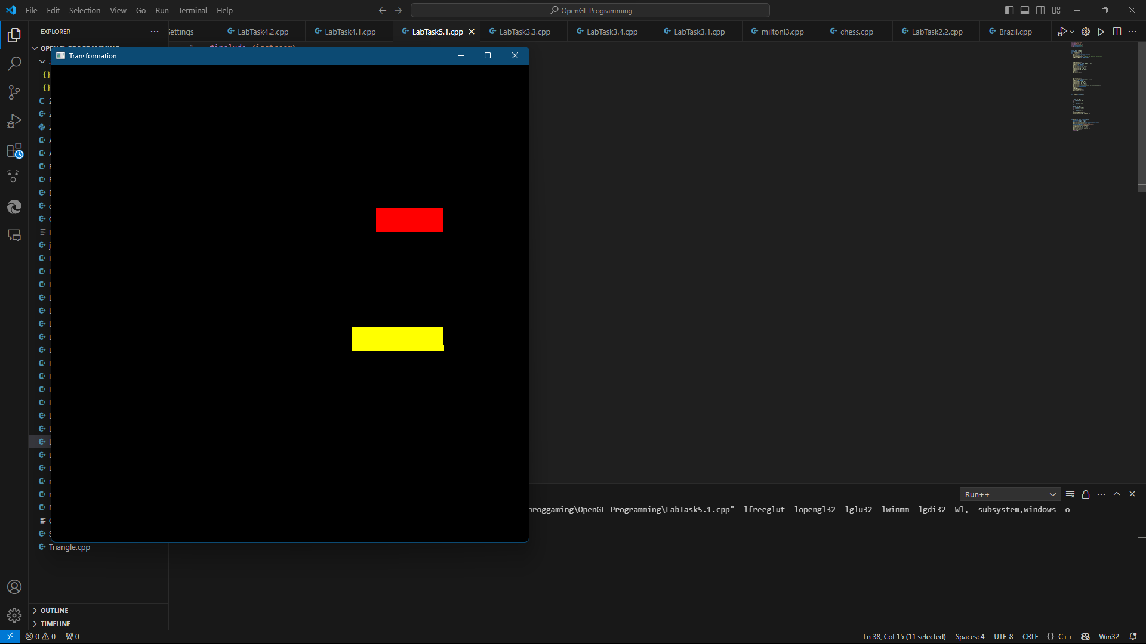

Question-2
Design a car which will have rotating wheels.

Graph Plot (Picture)-
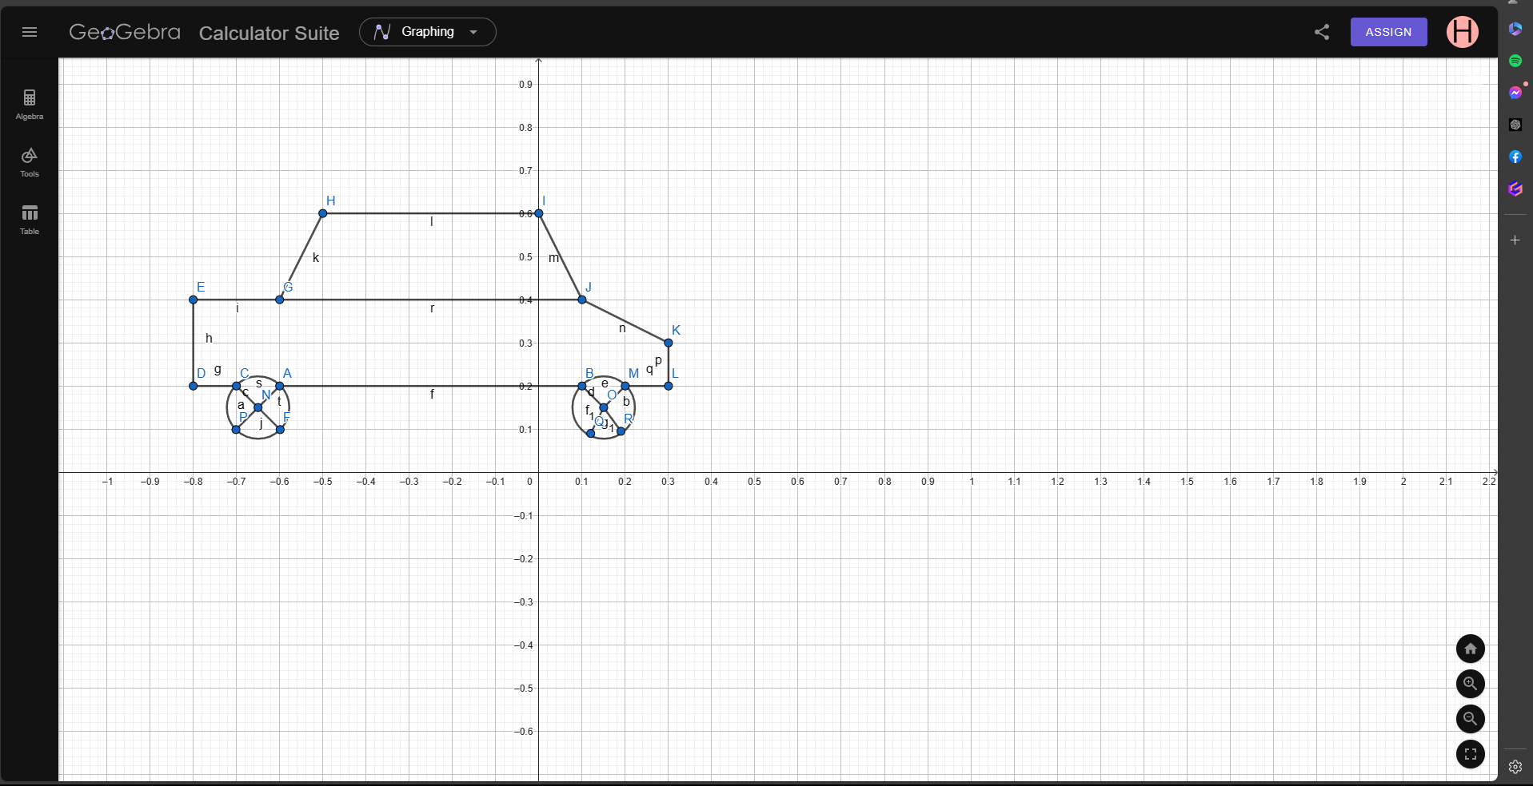
Code-

#include <iostream>
#include<GL/gl.h>
#include <GL/glut.h>
#include <windows.h>
#include<math.h>
using namespace std;

float _move = 0.0f;
float _move2 = 0.0f;

float _angle1 = 0.0f;
void drawScene() {
glClear(GL_COLOR_BUFFER_BIT);

glLoadIdentity(); //Reset the drawing perspective
glMatrixMode(GL_MODELVIEW);

//car
glPushMatrix();

glBegin(GL_QUADS);
glColor3d(1, 1.0, 1.0);
glVertex2f(-0.6, 0.4);
glVertex2f(0.1, 0.4);
glVertex2f(0, 0.6);
glVertex2f(-0.5, 0.6);
glEnd();
glPopMatrix();
glPushMatrix();

glBegin(GL_POLYGON);
glColor3d(1, 0, 0);
glVertex2f(-0.8, 0.2);
glVertex2f(0.3, 0.2);
glVertex2f(0.3, 0.3);
glVertex2f(0.1, 0.4);
glVertex2f(-0.6, 0.4);
glVertex2f(-0.8, 0.4);

glVertex2f(-0.8, 0.2);

glEnd();
glPopMatrix();

//circle

// Circle at the left wheel
glPushMatrix();
glTranslatef(-0.65f, 0.15f, 0.0f); // Translate to the bottom-left point of the circle
glRotatef(_angle1, 0.0f, 0.0f, 1.0f); // Rotate around the bottom-left point
glTranslatef(0.65f, -0.15f, 0.0f); // Translate back to the original position
// Draw the circle
glBegin(GL_POLYGON);
float xOffa = -0.65;
float yOffa = 0.15;
for (int i = 0; i < 300; i++)
{
glColor3f(1.0f, 1.0f, 1.0f);
float pi = 3.1416;
float a = (i * 2 * pi) / 300;
float r = 0.07234394566543254;
float x = r * cos(a) + xOffa;
float y = r * sin(a) + yOffa;
glVertex2f(x, y);
}
glEnd();

glBegin(GL_LINES);
glColor3f(1.0f, 0.0f, 0.0f); // Red
glVertex2f(-0.6, 0.2); // x, y
glVertex2f(-0.65, 0.15);
glVertex2f(-0.6, 0.1); // x, y
glVertex2f(-0.65, 0.15);// x, y
glVertex2f(-0.7, 0.2); // x, y
glVertex2f(-0.65, 0.15);
glVertex2f(-0.7, 0.1); // x, y
glVertex2f(-0.65, 0.15);
// x, y
glEnd();
glPopMatrix();

// Circle at the right wheel
glPushMatrix();
glTranslatef(0.15f, 0.15f, 0.0f); // Translate to the bottom-right point of the circle
glRotatef(_angle1, 0.0f, 0.0f, 1.0f); // Rotate around the bottom-right point
glTranslatef(-0.15f, -0.15f, 0.0f); // Translate back to the original position
// Draw the circle
glBegin(GL_POLYGON);
float xOffa2 = 0.15;
float yOffa2 = 0.15;
for (int i = 0; i < 300; i++)
{
glColor3f(1.0f, 1.0f, 1.0f);
float pi = 3.1416;
float a = (i * 2 * pi) / 300;
float r = 0.07234394566543254;
float x = r * cos(a) + xOffa2;
float y = r * sin(a) + yOffa2;
glVertex2f(x, y);
}
glEnd();
glBegin(GL_LINES);
glColor3f(1.0f, 0.0f, 0.0f); // Red
glVertex2f(0.2, 0.2); // x, y
glVertex2f(0.15, 0.15);
glVertex2f(0.1, 0.2); // x, y
glVertex2f(0.15, 0.15);// x, y
glVertex2f(0.19, 0.095); // x, y
glVertex2f(0.15, 0.15);
glVertex2f(0.12, 0.09); // x, y
glVertex2f(0.15, 0.15);
// x, y
glEnd();
glPopMatrix();

glutSwapBuffers();
}

void update(int value) {

_angle1 += 2.0f;
if (_angle1 > 360.0)
{
_angle1 -= 360;
}

glutPostRedisplay();
glutTimerFunc(20, update, 0);

}

int main(int argc, char** argv) {
glutInit(&argc, argv);
glutInitDisplayMode(GLUT_DOUBLE | GLUT_RGB);
glutInitWindowSize(800, 800);
glutCreateWindow("Transformation");
glutDisplayFunc(drawScene);
gluOrtho2D(-2, 2, -2, 2);
glutTimerFunc(20, update, 0);
glutMainLoop();
return 0;
}

Output Screenshot (Full Screen)-

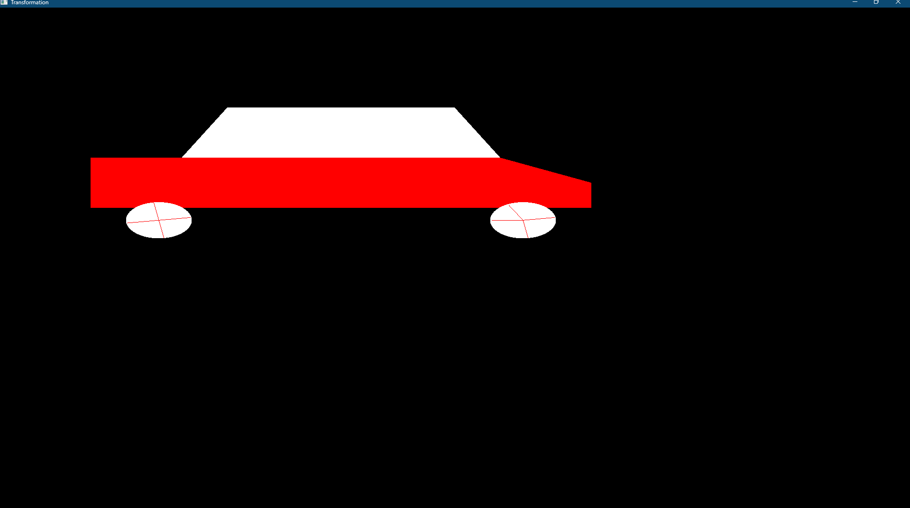

Question-3
Now move your car of question-2 from left to right in a loop.

Graph Plot (Picture)-
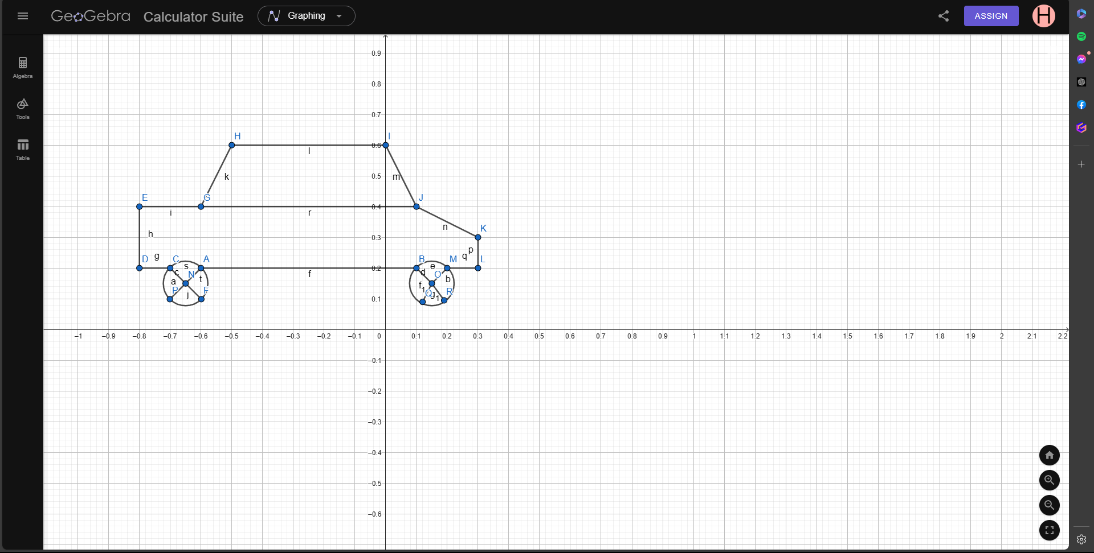
Code-

#include <iostream>
#include<GL/gl.h>
#include <GL/glut.h>
#include <windows.h>
#include<math.h>
using namespace std;

float _move = 0.0f;
float _move2 = 0.0f;

float _angle1 = 0.0f;
void drawScene() {
glClear(GL_COLOR_BUFFER_BIT);

glLoadIdentity(); //Reset the drawing perspective
glMatrixMode(GL_MODELVIEW);

//car
glPushMatrix();
glTranslatef(_move, 0.0f, 0.0f);
glBegin(GL_QUADS);

glColor3d(1, 1.0, 1.0);
glVertex2f(-0.6, 0.4);
glVertex2f(0.1, 0.4);
glVertex2f(0, 0.6);
glVertex2f(-0.5, 0.6);
glEnd();
glPopMatrix();
glPushMatrix();
glTranslatef(_move, 0.0f, 0.0f);
glBegin(GL_POLYGON);
glColor3d(1, 0, 0);
glVertex2f(-0.8, 0.2);
glVertex2f(0.3, 0.2);
glVertex2f(0.3, 0.3);
glVertex2f(0.1, 0.4);
glVertex2f(-0.6, 0.4);
glVertex2f(-0.8, 0.4);

glVertex2f(-0.8, 0.2);

glEnd();
glPopMatrix();

//circle

// Circle at the left wheel
glPushMatrix();
glTranslatef(_move, 0.0f, 0.0f);
glTranslatef(-0.65f, 0.15f, 0.0f); // Translate to the bottom-left point of the circle
glRotatef(_angle1, 0.0f, 0.0f, 1.0f); // Rotate around the bottom-left point
glTranslatef(0.65f, -0.15f, 0.0f); // Translate back to the original position

// Draw the circle
glBegin(GL_POLYGON);
float xOffa = -0.65;
float yOffa = 0.15;
for (int i = 0; i < 300; i++)
{
glColor3f(1.0f, 1.0f, 1.0f);
float pi = 3.1416;
float a = (i * 2 * pi) / 300;
float r = 0.07234394566543254;
float x = r * cos(a) + xOffa;
float y = r * sin(a) + yOffa;
glVertex2f(x, y);
}
glEnd();

glBegin(GL_LINES);
glColor3f(1.0f, 0.0f, 0.0f); // Red
glVertex2f(-0.6, 0.2); // x, y
glVertex2f(-0.65, 0.15);
glVertex2f(-0.6, 0.1); // x, y
glVertex2f(-0.65, 0.15);// x, y
glVertex2f(-0.7, 0.2); // x, y
glVertex2f(-0.65, 0.15);
glVertex2f(-0.7, 0.1); // x, y
glVertex2f(-0.65, 0.15);
// x, y
glEnd();
glPopMatrix();

// Circle at the right wheel
glPushMatrix();
glTranslatef(_move, 0.0f, 0.0f);
glTranslatef(0.15f, 0.15f, 0.0f); // Translate to the bottom-right point of the circle
glRotatef(_angle1, 0.0f, 0.0f, 1.0f); // Rotate around the bottom-right point
glTranslatef(-0.15f, -0.15f, 0.0f); // Translate back to the original position
// Draw the circle
glBegin(GL_POLYGON);
float xOffa2 = 0.15;
float yOffa2 = 0.15;
for (int i = 0; i < 300; i++)
{
glColor3f(1.0f, 1.0f, 1.0f);
float pi = 3.1416;
float a = (i * 2 * pi) / 300;
float r = 0.07234394566543254;
float x = r * cos(a) + xOffa2;
float y = r * sin(a) + yOffa2;
glVertex2f(x, y);
}
glEnd();
glBegin(GL_LINES);
glColor3f(1.0f, 0.0f, 0.0f); // Red
glVertex2f(0.2, 0.2); // x, y
glVertex2f(0.15, 0.15);
glVertex2f(0.1, 0.2); // x, y
glVertex2f(0.15, 0.15);// x, y
glVertex2f(0.19, 0.095); // x, y
glVertex2f(0.15, 0.15);
glVertex2f(0.12, 0.09); // x, y
glVertex2f(0.15, 0.15);
// x, y
glEnd();
glPopMatrix();

glutSwapBuffers();
}

void update(int value) {

_move += .02;
if (_move > 1.89)
{
_move = -1.0;
}
_angle1 += 2.0f;
if (_angle1 > 360.0)
{
_angle1 -= 360;
}

glutPostRedisplay();
glutTimerFunc(20, update, 0);

}

int main(int argc, char** argv) {
glutInit(&argc, argv);
glutInitDisplayMode(GLUT_DOUBLE | GLUT_RGB);
glutInitWindowSize(800, 800);
glutCreateWindow("Transformation");
glutDisplayFunc(drawScene);
gluOrtho2D(-2, 2, -2, 2);
glutTimerFunc(20, update, 0);
glutMainLoop();
return 0;
}

Output Screenshot (Full Screen)-
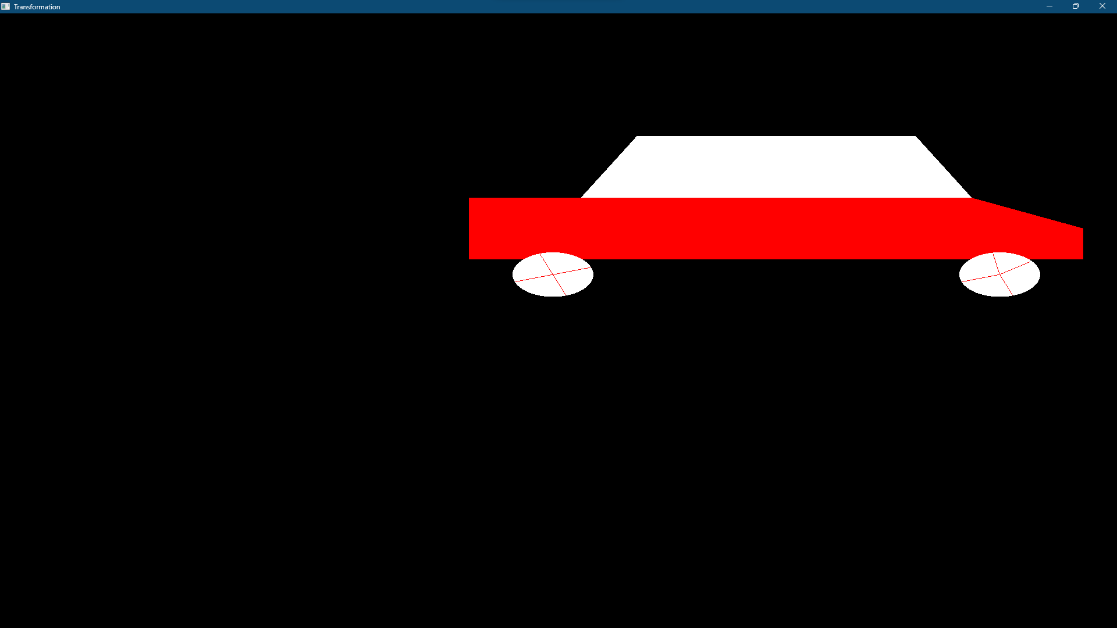

Question-4
Design a windmill with rotating blades

Graph Plot (Picture)-
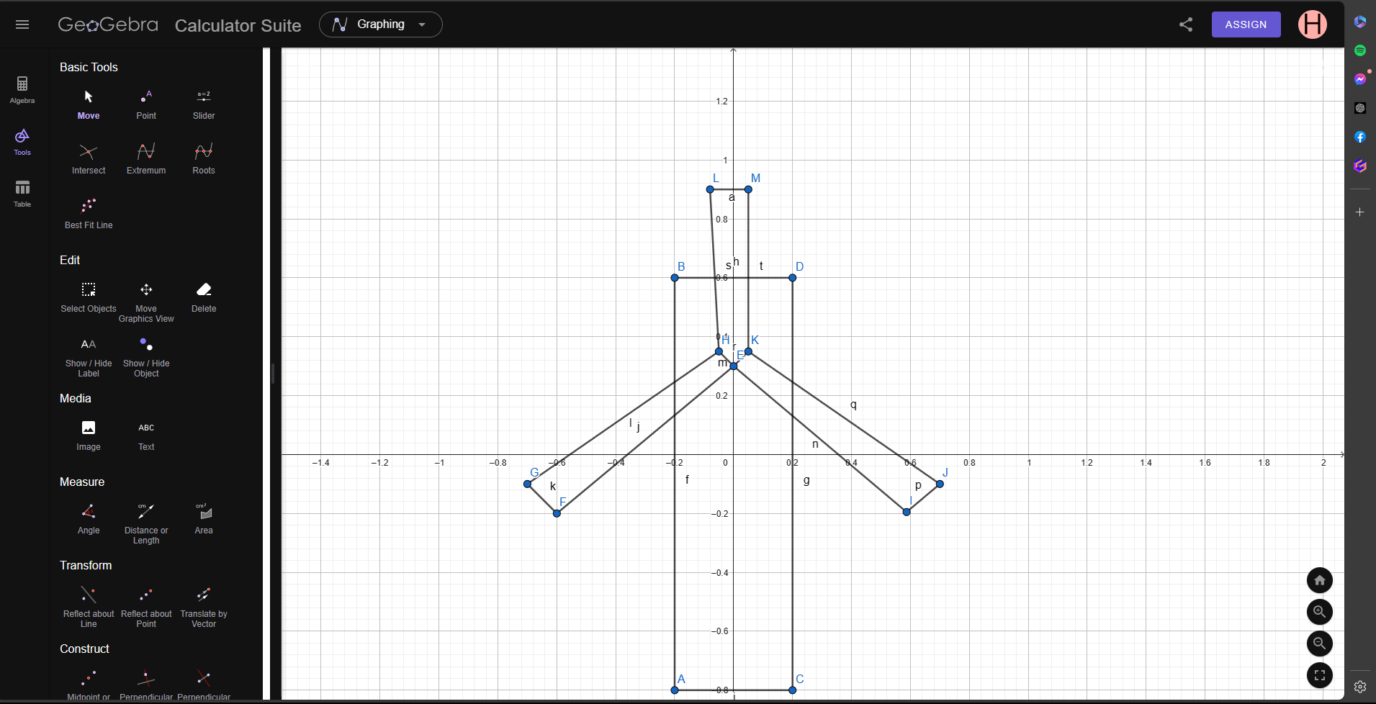

Code-
#include <iostream>
#include<GL/gl.h>
#include <GL/glut.h>
#include <windows.h>
using namespace std;

float _angle1 = 0.0f;
void drawScene() {
glClear(GL_COLOR_BUFFER_BIT);

glLoadIdentity(); //Reset the drawing perspective
glMatrixMode(GL_MODELVIEW);
glPushMatrix();

glBegin(GL_QUADS);
glColor3d(1.0, 1.0, 1.0);
glVertex2f(-0.2, 0.6);
glVertex2f(0.2, 0.6);
glVertex2f(0.2, -0.8);
glVertex2f(-0.2, -0.8);
glEnd();
glPopMatrix();

glPushMatrix();
glTranslatef(0.0f, 0.3f, 0.0f);
glRotatef(_angle1, 0.0f, 0.0f, 1.0f);
glTranslatef(-0.0f, -0.3f, 0.0f);
glColor3d(0, 1.0, 0);
glBegin(GL_QUADS);
glVertex2f(-0.7, -0.1);
glVertex2f(-0.6, -0.2);
glVertex2f(0.0f, 0.3f);
glVertex2f(-0.05, 0.35);
glEnd();
glPopMatrix();

glPushMatrix();
glTranslatef(0.0f, 0.3f, 0.0f);
glRotatef(_angle1, 0.0f, 0.0f, 1.0f);
glTranslatef(-0.0f, -0.3f, 0.0f);
glBegin(GL_QUADS);
glColor3d(0, 1.0, 0);
glVertex2f(0.5870301398619, -0.1951939094097);
glVertex2f(0.7, -0.1);
glVertex2f(0.05, 0.35);
glVertex2f(0.0f, 0.3f);

glEnd();
glPopMatrix();

glPushMatrix();
glTranslatef(0.0f, 0.3f, 0.0f);
glRotatef(_angle1, 0.0f, 0.0f, 1.0f);
glTranslatef(-0.0f, -0.3f, 0.0f);
glBegin(GL_POLYGON);
glColor3d(0, 1.0, 0);
glVertex2f(-0.08, 0.98);
glVertex2f(-0.05, 0.35);
glVertex2f(0.0f, 0.3f);
glVertex2f(0.05, 0.35);
glVertex2f(0.08, 0.98);

glEnd();
glPopMatrix();

glPushMatrix();
glTranslatef(0.0f, 0.3f, 0.0f);
glRotatef(_angle1, 0.0f, 0.0f, 1.0f);
glTranslatef(-0.0f, -0.3f, 0.0f);
glBegin(GL_POLYGON);
glColor3d(1, .0, 0);
glVertex2f(-0.05, 0.35);
glVertex2f(0.05, 0.35);
glVertex2f(0.05, 0.35);

glEnd();
glPopMatrix();

glutSwapBuffers();
}

void update(int value) {

_angle1 += 2.0f;
if (_angle1 > 360.0)
{
_angle1 -= 360;
}
glutPostRedisplay(); //Notify GLUT that the display has changed

glutTimerFunc(20, update, 0); //Notify GLUT to call update again in 25 milliseconds
}

int main(int argc, char** argv) {
glutInit(&argc, argv);
glutInitDisplayMode(GLUT_DOUBLE | GLUT_RGB);
glutInitWindowSize(800, 800);
glutCreateWindow("Transformation");
glutDisplayFunc(drawScene);
glutTimerFunc(20, update, 0); //Add a timer
glutMainLoop();
return 0;
}

Output Screenshot (Full Screen)-

