Lab Taks-6

Question-
Develop an animation that will change the background color of the window after 20ms. Use at least two different colors.

Code-

#include <iostream>
#include <GL/gl.h>
#include <GL/glut.h>
using namespace std;

float c1 = 1.0f;
float c2 = 0.0f;

void drawScene() {
glClearColor(c1, c2, 0.0f, 1.0f);
glClear(GL_COLOR_BUFFER_BIT);
glutSwapBuffers();
}

void update(int value) {
if (c1 == 1.0f && c2 == 0.0f)
{
c1 = 0.0f;
c2 = 1.0f;
}

else
{
c1 = 1.0f;
c2 = 0.0f;
}

glutPostRedisplay();
glutTimerFunc(200, update, 0);
}

int main(int argc, char** argv) {
glutInit(&argc, argv);
glutInitDisplayMode(GLUT_DOUBLE | GLUT_RGB);
glutInitWindowSize(800, 800);
glutCreateWindow("Transformation");
glutDisplayFunc(drawScene);
gluOrtho2D(-2, 2, -2, 2);
glutTimerFunc(20, update, 0);
glutMainLoop();
return 0;
}

Output Screenshot (Full Screen)-
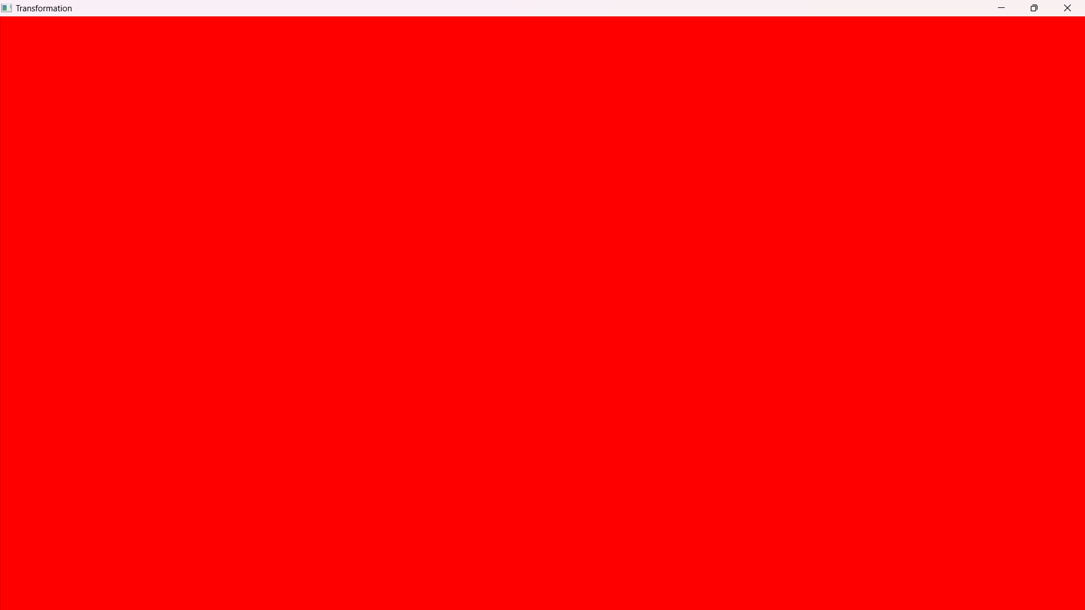

Question-
Develop an animation that will call four objects separately, each after 20 ms.

Code-
#include <iostream>
#include <GL/gl.h>
#include <GL/glut.h>
#include <math.h>

using namespace std;

int objectIndex = 0;
bool separate = true;

void circle(float xOffa, float yOffa, float r)
{
glBegin(GL_POLYGON);

for (int i = 0; i < 300; i++)
{

float pi = 3.1416;
float a = (i * 2 * pi) / 300;

float x = r * cos(a) + xOffa;
float y = r * sin(a) + yOffa;
glVertex2f(x, y);
}
glEnd();
}

void drawScene()
{
glClearColor(0.53f, 0.8f, 0.92f, 1.0f);
glClear(GL_COLOR_BUFFER_BIT);
glLoadIdentity();
glMatrixMode(GL_MODELVIEW);

glBegin(GL_POLYGON);
glColor4f(0.0f, 1.0f, 1.0f, 1.0f);
glVertex2f(-0.8, 0.2);
glVertex2f(-0.8, -0.4);
glVertex2f(0.95, -0.4);
glVertex2f(0.95, 0.2);
glEnd();

if (separate)
{
switch (objectIndex)
{
case 0:
glColor3f(1, 0, 0); // Red
circle(-0.58, -0.1, 0.2);
break;
case 1:
glColor3f(0, 1, 0); // Green
circle(-0.14, -0.1, 0.2);
break;
case 2:
glColor3f(0, 0, 1); // Blue
circle(0.28, -0.1, 0.2);
break;
case 3:
glColor3f(1, 1, 1); // White
circle(0.7, -0.1, 0.2);
break;
default:
break;
}
}
else
{
// Drawing all circles together, each with its own color
glColor3f(1, 0, 0); // Red
circle(-0.58, -0.1, 0.2);

glColor3f(0, 1, 0); // Green
circle(-0.14, -0.1, 0.2);

glColor3f(0, 0, 1); // Blue
circle(0.28, -0.1, 0.2);

glColor3f(1, 1, 1); // White
circle(0.7, -0.1, 0.2);
}

glutSwapBuffers();
}

void update(int value)
{
if (separate)
{
if (objectIndex < 3)
{
objectIndex++;
glutPostRedisplay();
glutTimerFunc(2000, update, 0);
}
else
{
separate = false;
objectIndex = 0;
glutPostRedisplay();
glutTimerFunc(2000, update, 0);
}
}
else
{
objectIndex = 0;
separate = true;
glutPostRedisplay();
glutTimerFunc(2000, update, 0);
}
}

int main(int argc, char** argv)
{
glutInit(&argc, argv);
glutInitDisplayMode(GLUT_DOUBLE | GLUT_RGB);
glutInitWindowSize(800, 800);
glutCreateWindow("Transformation");
glutDisplayFunc(drawScene);
glutTimerFunc(20, update, 0);
glutMainLoop();
return 0;
}

Output Screenshot (Full Screen)-
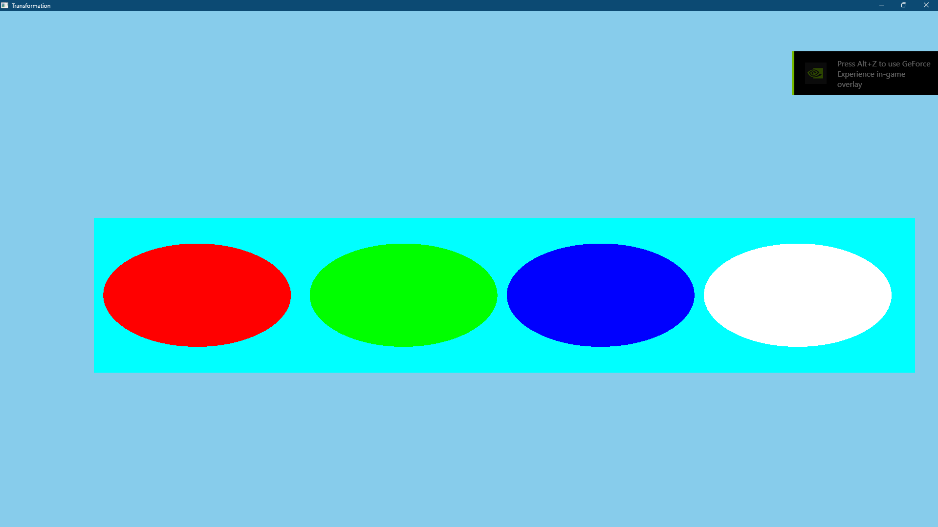

Question-
Develop a code that will have four different objects (keep it simple). The objects will move to the left, right, up and down in a loop.

Code-
#include <iostream>
#include<GL/gl.h>
#include <GL/glut.h>
#include <windows.h>
#include<math.h>
using namespace std;

float _move = 0.0f;
float move2 = 1.0f;
void drawScene() {
glClearColor(0.53, 0.8, 0.92f, 0.0f);
glClear(GL_COLOR_BUFFER_BIT);
glColor3d(1, 0, 0);
glLoadIdentity(); //Reset the drawing perspective
glMatrixMode(GL_MODELVIEW);

glPushMatrix();
glTranslatef(_move, 0.0f, 0.0f);
glBegin(GL_QUADS);
glVertex2f(-0.6, 0.2);
glVertex2f(-0.2, 0.2);
glVertex2f(-0.2, 0);
glVertex2f(-0.6, 0.0);
glEnd();
glPopMatrix();

glPushMatrix();
glTranslatef(move2, 0.0f, 0.0f);
glBegin(GL_QUADS);
glColor3d(1, 1.0, 0);
glVertex2f(0.2, -0.2);
glVertex2f(0.6, -0.2);
glVertex2f(0.6, 0);
glVertex2f(0.2, 0);
glEnd();
glPopMatrix();

//up
glPushMatrix();
glTranslatef(0.0f, _move, 0.0f);
glBegin(GL_QUADS);
glColor3d(0.58, 0.8, 0.7);
glVertex2f(-0.2, -0.2);
glVertex2f(-0.2, -0.6);
glVertex2f(0, -0.6);
glVertex2f(0.0, -0.2);
glEnd();
glPopMatrix();

glPushMatrix();
glTranslatef(0.0f, move2, 0.0f);
glBegin(GL_QUADS);
glColor3d(1, 0.15, 0.9);
glVertex2f(0, 0.6);
glVertex2f(0.2, 0.6);
glVertex2f(0.2, 0.2);
glVertex2f(0.0, 0.2);
glEnd();
glPopMatrix();
glutSwapBuffers();
}

void update(int value) {

_move += .02;
if (_move > 1.89)
{
_move = -1.0;
}

move2 -= .02;
if (move2 < -1.89)
{
move2 = 1.0;
}
glutPostRedisplay();
glutTimerFunc(20, update, 0);
}

int main(int argc, char** argv) {
glutInit(&argc, argv);
glutInitDisplayMode(GLUT_DOUBLE | GLUT_RGB);
glutInitWindowSize(800, 800);
glutCreateWindow("Transformation");
glutDisplayFunc(drawScene);
gluOrtho2D(-2, 2, -2, 2);
glutTimerFunc(20, update, 0);
glutMainLoop();
return 0;
}

Output Screenshot (Full Screen)-
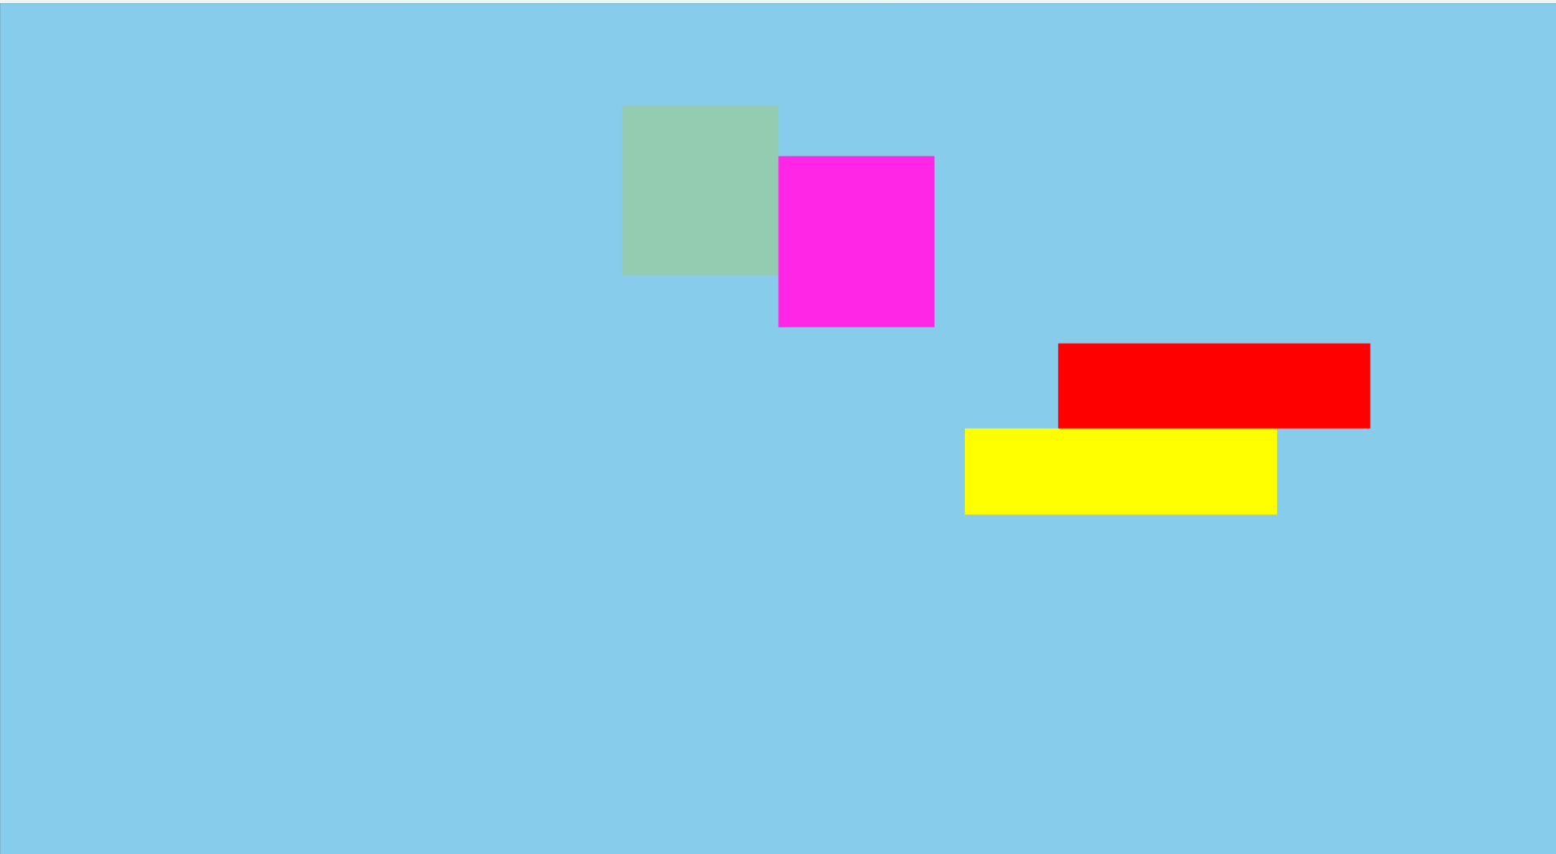

Question-
Develop a code that will have four different objects (keep it simple). Four different keys will be dedicated each objects. The objects will move to the left, right, up and down in a loop as the keys are pressed individually.

Code-

#include <iostream>
#include <GL/gl.h>
#include <GL/glut.h>
using namespace std;

float _move1 = 0.0f;
float _move2 = 0.0f;
void drawScene() {
glutSwapBuffers();
}

void drawScene1() {
glClear(GL_COLOR_BUFFER_BIT);
glColor3d(1, 0, 0);
glLoadIdentity();
glMatrixMode(GL_MODELVIEW);

glPushMatrix();
glTranslatef(_move1, 0.0f, 0.0f);
glBegin(GL_QUADS);
glVertex2f(-0.6, 0.2);
glVertex2f(-0.2, 0.2);
glVertex2f(-0.2, 0);
glVertex2f(-0.6, 0.0);
glEnd();
glPopMatrix();
glutSwapBuffers();
}
void drawScene2() {
glClear(GL_COLOR_BUFFER_BIT);
glColor3d(1, 0, 0);
glLoadIdentity();
glMatrixMode(GL_MODELVIEW);

glPushMatrix();
glTranslatef(_move2, 0.0f, 0.0f);
glBegin(GL_QUADS);
glColor3f(1, 1, 0);
glVertex2f(0.2, -0.2);
glVertex2f(0.6, -0.2);
glVertex2f(0.6, 0);
glVertex2f(0.2, 0);
glEnd();
glPopMatrix();
glutSwapBuffers();

}
void drawScene3() {
glClear(GL_COLOR_BUFFER_BIT);
glColor3d(1, 0, 0);
glLoadIdentity();
glMatrixMode(GL_MODELVIEW);
glPushMatrix();
glTranslatef(0.0, _move1, 0.0f);
glBegin(GL_QUADS);
glColor3f(0, 1, 0);
glVertex2f(-0.2, -0.2);
glVertex2f(-0.2, -0.6);
glVertex2f(0, -0.6);
glVertex2f(0.0, -0.2);
glEnd();
glPopMatrix();
glutSwapBuffers();

}
void drawScene4() {
glClear(GL_COLOR_BUFFER_BIT);
glColor3d(1, 0, 0);
glLoadIdentity();
glMatrixMode(GL_MODELVIEW);

glPushMatrix();
glTranslatef(0.0, _move2, 0.0f);
glBegin(GL_QUADS);
glColor3f(0, 1, 1);
glVertex2f(0, 0.6);
glVertex2f(0.2, 0.6);
glVertex2f(0.2, 0.2);
glVertex2f(0.0, 0.2);
glEnd();
glPopMatrix();

glutSwapBuffers();
}

void update(int value) {
glClearColor(0.53f, 0.8f, 0.92f, 1.0f);
glClear(GL_COLOR_BUFFER_BIT);
_move1 += .02;
_move2 -= .02;
if (_move1 > 1.3)
{
_move1 = -1.5;
}

if (_move2 < -1.5)
{
_move2 = 1.3;
}

glutPostRedisplay();
glutTimerFunc(20, update, 0);
}
void handleKeypress(unsigned char key, int x, int y) {
switch (key) {
case 'd':
glutDisplayFunc(drawScene1);
break;
case 'a':
glutDisplayFunc(drawScene2);
break;
case 'w':
glutDisplayFunc(drawScene3);
break;
case 's':
glutDisplayFunc(drawScene4);
break;

glutPostRedisplay();
}
}

int main(int argc, char** argv) {
glutInit(&argc, argv);
glutInitDisplayMode(GLUT_DOUBLE | GLUT_RGB);
glutInitWindowSize(800, 800);
glutCreateWindow("Transformation");
glutDisplayFunc(drawScene);
gluOrtho2D(-2, 2, -2, 2);
glutKeyboardFunc(handleKeypress);
glutTimerFunc(20, update, 0);
glutMainLoop();
return 0;
}

Output Screenshot (Full Screen)-
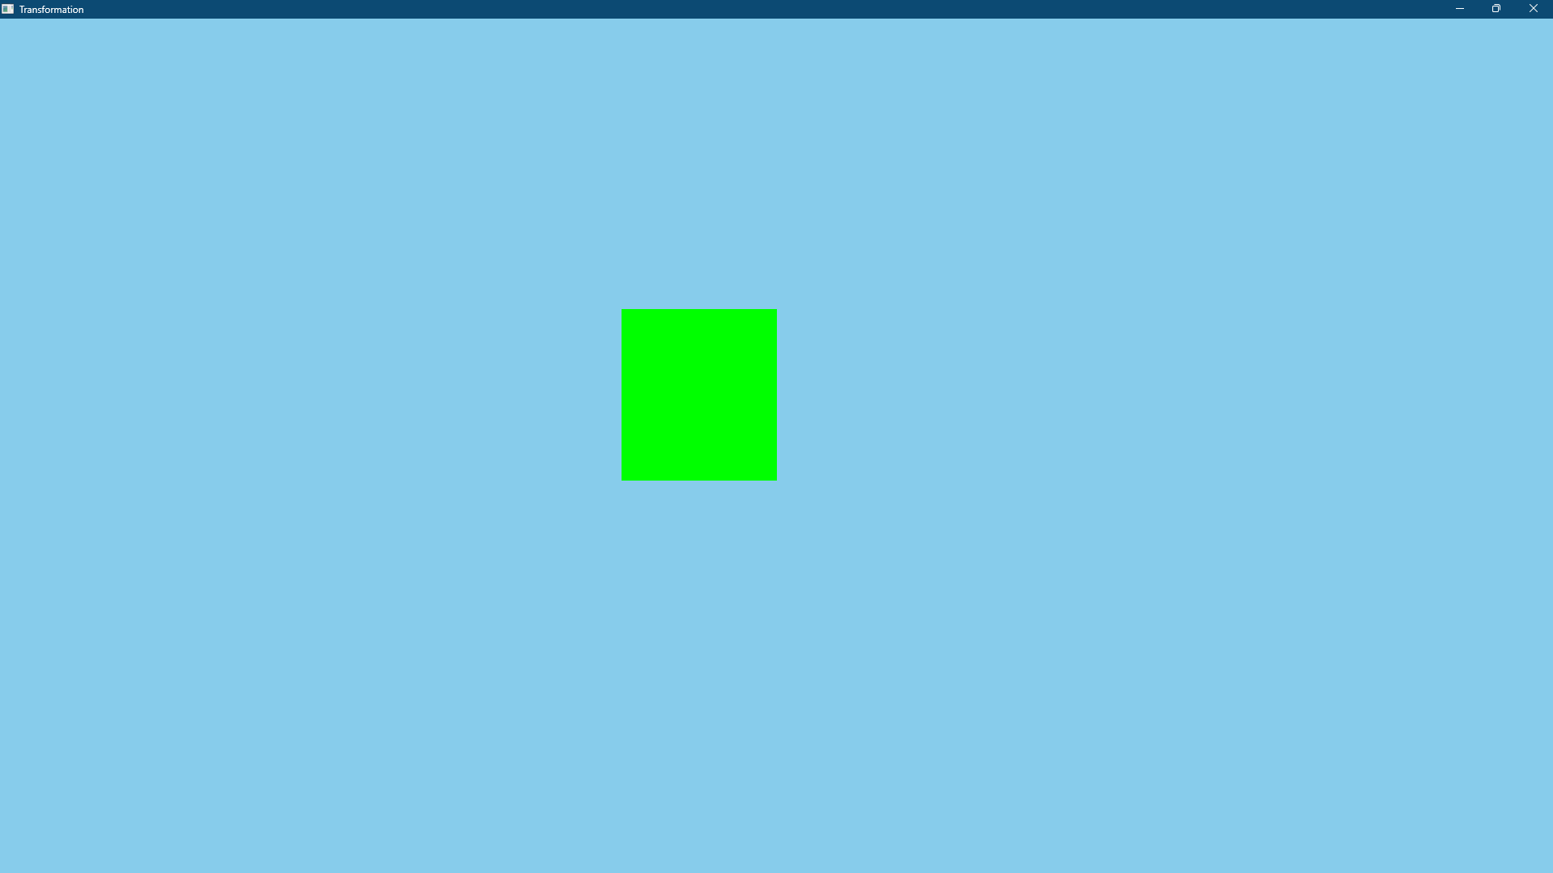

Question-
Develop a code that will have four different objects (keep it simple). Two of the objects will move to the right as the right click is made on the mouse and two of the objects will move to the left as the left key is pressed on the mouse.

Code-

#include<cstdio>

#include <GL/gl.h>
#include <GL/glut.h>

GLfloat position1 = 0.0f;
GLfloat position2 = 0.0f;

void update1(int value) {

position1 -= 0.1f;
if (position1 < -1.0)
position1 = 1.0f;
if (position1 > 1.0)
position1 = -1.0f;

glutPostRedisplay();

glutTimerFunc(100, update1, 0);
}
void update2(int value) {

position2 += 0.1f;

if (position2 < -1.0)
position2 = 1.0f;
if (position2 > 1.0)
position2 = -1.0f;

glutPostRedisplay();

glutTimerFunc(100, update2, 0);
}

void display() {
glClearColor(0.53f, 0.8f, 0.92f, 1.0f);
glClear(GL_COLOR_BUFFER_BIT);

glPushMatrix();
glTranslatef(position2, 0.0f, 0.0f);
glBegin(GL_QUADS);
glColor3f(0.0f, 1.0f, 0.0f);
glVertex2f(-0.3, 0.4);
glVertex2f(-0.3, 0.3);
glVertex2f(0.3, 0.3);
glVertex2f(0.3, 0.4);
glEnd();
glPopMatrix();

glPushMatrix();
glTranslatef(position1, 0.0f, 0.0f);
glBegin(GL_QUADS);
glColor3f(0.0f, 0.0f, 1.0f);
glVertex2f(-0.3, 0.2);
glVertex2f(-0.3, 0.1);
glVertex2f(0.3, 0.1);
glVertex2f(0.3, 0.2);
glEnd();
glPopMatrix();

glPushMatrix();
glTranslatef(position2, 0.0f, 0.0f);
glBegin(GL_QUADS);
glColor3f(0.0f, 1.0f, 0.0f);
glVertex2f(-0.3, -0.1);
glVertex2f(-0.3, -0.2);
glVertex2f(0.3, -0.2);
glVertex2f(0.3, -0.1);
glEnd();
glPopMatrix();

glPushMatrix();
glTranslatef(position1, 0.0f, 0.0f);
glBegin(GL_QUADS);
glColor3f(0.0f, 0.0f, 1.0f);
glVertex2f(-0.3, -0.3);
glVertex2f(0.3, -0.3);
glVertex2f(0.3, -0.4);
glVertex2f(-0.3, -0.4);
glEnd();
glPopMatrix();

glFlush();
}

void handleMouse(int button, int state, int x, int y) {
if (button == GLUT_LEFT_BUTTON)
{
glutTimerFunc(100, update1, 0);
}
if (button == GLUT_RIGHT_BUTTON)
{
glutTimerFunc(100, update2, 0);
}
glutPostRedisplay();
}

int main(int argc, char** argv) {
glutInit(&argc, argv);
glutInitWindowSize(1000, 800);
glutInitWindowPosition(50, 50);
glutCreateWindow("Translation Animation");
glutDisplayFunc(display);
glutMouseFunc(handleMouse);

glutMainLoop();
return 0;
}

Output Screenshot (Full Screen)-

