Lab Practice-7

Question-
Create a simple day and night scenario that will automatically change from day to night

Graph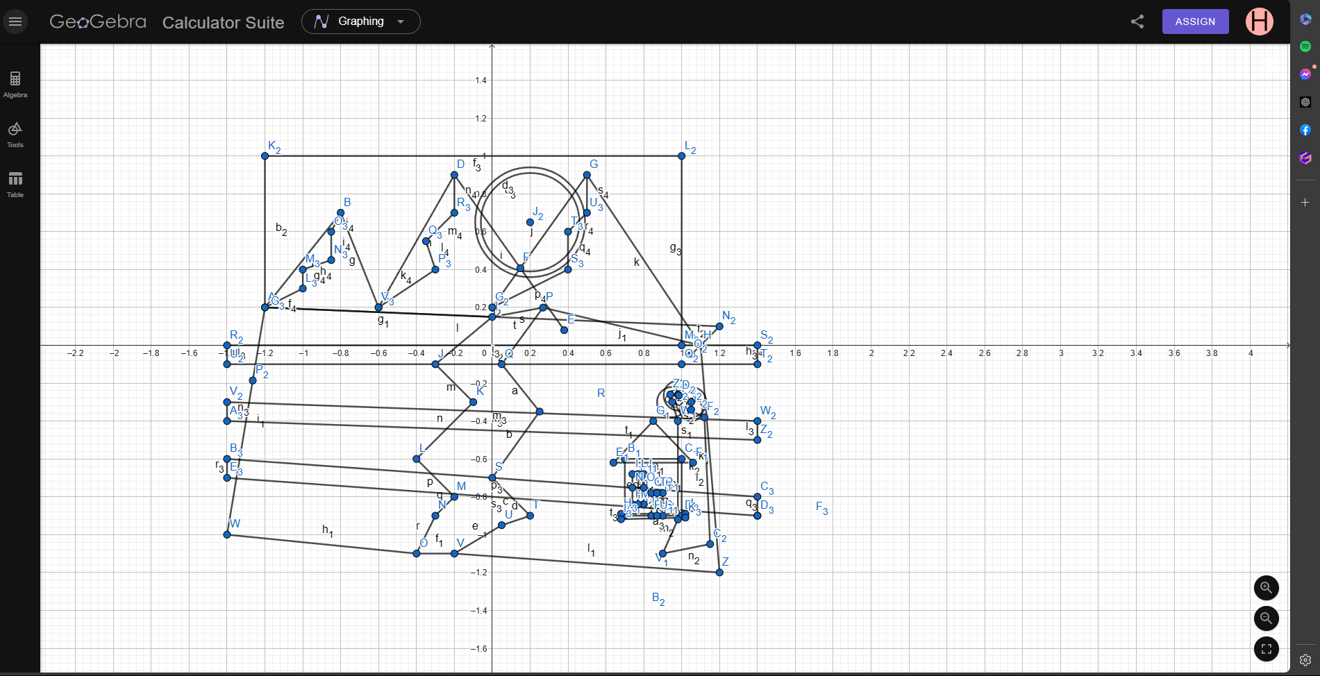

Code-
#include <windows.h>
#include <GL/glut.h>
#include<math.h>
#include <ctime>

#include<iostream>
using namespace std;
int elapsedTime = 0;
const int dayDuration = 2;

void Sky()
{
glBegin(GL_POLYGON);

glColor3f(0x6A / 255.0f, 0x6F / 255.0f, 0xAF / 255.0f);
glVertex2f(-1.2, 1);
glVertex2f(1, 1);

glColor3f(0xC8 / 255.0f, 0xC9 / 255.0f, 0xE5 / 255.0f);
glVertex2f(1.05, -0.05);
glVertex2f(-1.2, 0.2);

glEnd();

glFlush();
}
void rivr()
{
glBegin(GL_POLYGON);

glColor3f(1.0f, 1.0f, 1.0f);
glVertex2f(0, 0.2);
glVertex2f(-0.3, -0.1);
glVertex2f(-0.1, -0.3);
glVertex2f(-0.4, -0.6);
glVertex2f(-0.2, -0.8);
glVertex2f(-0.3, -0.9);
glVertex2f(-0.4, -1.1);
glVertex2f(-0.2, -1.1);
glVertex2f(0.05, -0.95);
glVertex2f(0.2, -0.9);
glVertex2f(0, -0.7);
glVertex2f(0.25, -0.35);
glVertex2f(0.05, -0.1);
glVertex2f(0.2680683815806, 0.1990663142448);
glVertex2f(0, 0.2);

glEnd();

//tree circle

glFlush();
}

void hous()
{
//body
glBegin(GL_POLYGON);

glColor3f(0x99 / 255.0f, 0x69 / 255.0f, 0x43 / 255.0f);

glVertex2f(0.7, -0.6);
glVertex2f(0.7, -0.9);
glVertex2f(1, -0.9);
glVertex2f(1, -0.6);

glEnd();
//head
glBegin(GL_POLYGON);

glColor3f(0xDB / 255.0f, 0xC0 / 255.0f, 0x8B / 255.0f);

glVertex2f(0.64, -0.62);
glVertex2f(1.06, -0.62);
glVertex2f(0.85, -0.4);

glEnd();
//window
glBegin(GL_POLYGON);

glColor3f(0xE5 / 255.0f, 0xF3 / 255.0f, 0xE4 / 255.0f);

glVertex2f(0.74, -0.68);
glVertex2f(0.74, -0.84);
glVertex2f(0.8, -0.84);
glVertex2f(0.8, -0.68);

glEnd();
//door
glBegin(GL_POLYGON);

glColor3f(0xE5 / 255.0f, 0xF3 / 255.0f, 0xE4 / 255.0f);

glVertex2f(0.84, -0.78);
glVertex2f(0.9, -0.78);
glVertex2f(0.9, -0.9);
glVertex2f(0.84, -0.9);

glEnd();

glBegin(GL_POLYGON);

glColor3f(0xE5 / 255.0f, 0xF3 / 255.0f, 0xE4 / 255.0f);

glVertex2f(0.68, -0.89);
glVertex2f(0.6800379059788, -0.9185509677358);
glVertex2f(1.02, -0.91);
glVertex2f(1.02, -0.89);

glEnd();

glFlush();

}
void mud()
{
glBegin(GL_POLYGON);

glColor3f(0.4f, 0.2f, 0.0f);
glVertex2f(-1.2, 0.2);

glColor3f(1.0f, 1.0f, 1.0f);
glVertex2f(1.2, 0.2);

glColor3f(0.6f, 0.4f, 0.2f);
glVertex2f(1.05, -0.05);

glEnd();
glFlush();
}
void tree()
{
//body
glBegin(GL_POLYGON);

glColor3f(0x62 / 255.0f, 0x4B / 255.0f, 0x21 / 255.0f);

glVertex2f(0.9, -1.1);
glVertex2f(1.15, -1.05);
glVertex2f(1.12, -0.38);
glVertex2f(0.95, -0.3);
glVertex2f(0.98, -0.4);

glVertex2f(1, -0.9);

glEnd();

glBegin(GL_POLYGON);
float xOffa = 0.95, f;
float yOffa = -0.3f;
for (int i = 0; i < 300; i++)
{

glColor3f(0x4B / 255.0f, 0x5C / 255.0f, 0x26 / 255.0f);

float pi = 3.1416;
float a = (i * 2 * pi) / 300;
float r = 0.08;
float x = r * cos(a) + xOffa;
float y = r * sin(a) + yOffa;
glVertex2f(x, y);

}

glEnd();

glBegin(GL_POLYGON);
float xOff = 0.985;
float yOff = -0.265f;
for (int i = 0; i < 300; i++)
{

glColor3f(0x4B / 255.0f, 0x5C / 255.0f, 0x26 / 255.0f);

float pi = 3.1416;
float a = (i * 2 * pi) / 300;
float r = 0.08;
float x = r * cos(a) + xOff;
float y = r * sin(a) + yOff;
glVertex2f(x, y);

}

glEnd();
glFlush();
}
void mountain()
{
glBegin(GL_POLYGON);

glColor3f(0.8f, 0.9f, 0.98f);
glVertex2f(-1.2, 0.2);
glColor3f(1.0f, 1.0f, 1.0f);
glVertex2f(-0.8, 0.7);
glVertex2f(-0.6, 0.2);

glEnd();

glBegin(GL_POLYGON);

glColor3f(0.8f, 0.9f, 0.98f);
glVertex2f(-0.6, 0.2);

glColor3f(1.0f, 1.0f, 1.0f);
glVertex2f(-0.2, 0.9);
glVertex2f(0.38, 0.08);

glEnd();

glBegin(GL_POLYGON);

glColor3f(0.8f, 0.9f, 0.98f);
glVertex2f(0, 0.2);

glColor3f(1.0f, 1.0f, 1.0f);
glVertex2f(0.5, 0.9);
glVertex2f(1.1, 0);

glEnd();

glBegin(GL_POLYGON);

glColor3f(0xD3 / 255.0f, 0xED / 255.0f, 0xEE / 255.0f);
glVertex2f(-1.2, 0.2);
glVertex2f(-1, 0.3);
glVertex2f(-1, 0.4);

glColor3f(0xC8 / 255.0f, 0xC9 / 255.0f, 0xE5 / 255.0f);
glVertex2f(-0.85, 0.45);
glVertex2f(-0.85, 0.6);
glVertex2f(-0.8, 0.7);

glEnd();

glBegin(GL_POLYGON);

glColor3f(0xD3 / 255.0f, 0xED / 255.0f, 0xEE / 255.0f);
glVertex2f(-0.6, 0.2);
glVertex2f(-0.2, 0.9);
glVertex2f(-0.2, 0.7);

glColor3f(0xC8 / 255.0f, 0xC9 / 255.0f, 0xE5 / 255.0f);
glVertex2f(-0.35, 0.55);
glVertex2f(-0.3, 0.4);
glVertex2f(-0.6, 0.2);
glEnd();

glBegin(GL_POLYGON);

glColor3f(0xD3 / 255.0f, 0xED / 255.0f, 0xEE / 255.0f);
glVertex2f(0, 0.2);
glVertex2f(0.5, 0.9);
glVertex2f(0.5, 0.7);

glColor3f(0xC8 / 255.0f, 0xC9 / 255.0f, 0xE5 / 255.0f);
glVertex2f(0.4, 0.6);
glVertex2f(0.4, 0.4);
glVertex2f(0, 0.2);
glEnd();
glFlush();
}

void sun()
{

glBegin(GL_POLYGON);
float xOff2 = 0.2;
float yOff2 = 0.65;

for (int i = 0; i < 300; i++) {
// Calculate the fade color from yellow to light white
float fadeFactor = static_cast<float>(i) / 300.0f;
glColor3f((255 - fadeFactor * (255 - 230)) / 255.0f,
(206 - fadeFactor * (206 - 230)) / 255.0f,
(7 - fadeFactor * (7 - 230)) / 255.0f);

float pi = 3.1416;
float a = (i * 2 * pi) / 300;
float r = 0.29;
float x = r * cos(a) + xOff2;
float y = r * sin(a) + yOff2;
glVertex2f(x, y);
}

glEnd();
glFlush();
}
void moonBorder() {
glBegin(GL_LINE_LOOP);
glColor3f(0.0f, 0.0f, 0.0f);

float xOff2 = 0.2;
float yOff2 = 0.65;
float radius = 0.29;

for (int i = 0; i < 300; i++) {
float pi = 3.1416;
float a = (i * 2 * pi) / 300;
float x = radius * cos(a) + xOff2;
float y = radius * sin(a) + yOff2;
glVertex2f(x, y);
}

glEnd();
}
void moon()
{
glBegin(GL_POLYGON);
float xOff2 = 0.2;
float yOff2 = 0.65;

for (int i = 0; i < 300; i++) {

float fadeFactor = static_cast<float>(i) / 300.0f;
glColor3f((0 + fadeFactor * (255 - 0)) / 255.0f,
(0 + fadeFactor * (255 - 0)) / 255.0f,
(0 + fadeFactor * (255 - 0)) / 255.0f);

float pi = 3.1416;
float a = (i * 2 * pi) / 300;
float r = 0.29;
float x = r * cos(a) + xOff2;
float y = r * sin(a) + yOff2;
glVertex2f(x, y);
}

glEnd();

glColor3f(1.0f, 1.0f, 1.0f);
glPointSize(2.0f);
glBegin(GL_POINTS);

for (int i = 0; i < 20; i++) {
float xStar = static_cast<float>(rand()) / static_cast<float>(RAND_MAX) * 2.2 - 1.2;
float yStar = static_cast<float>(rand()) / static_cast<float>(RAND_MAX) * 1.2 - 0.05;

glVertex2f(xStar, yStar);
}

glEnd();
glFlush();
}

void ground()
{
glBegin(GL_POLYGON);

glColor3f(121 / 255.0f, 173 / 255.0f, 98 / 255.0f);

glVertex2f(-1.4, 0);
glVertex2f(-1.4, -0.1);
glVertex2f(1.4, -0.1);
glVertex2f(1.4, 0);

glEnd();

glBegin(GL_POLYGON);

glColor3f(121 / 255.0f, 173 / 255.0f, 98 / 255.0f);

glVertex2f(-1.4, -0.3);
glVertex2f(-1.4, -0.4);
glVertex2f(1.4, -0.5);
glVertex2f(1.4, -0.4);

glEnd();

glBegin(GL_POLYGON);

glColor3f(121 / 255.0f, 173 / 255.0f, 98 / 255.0f);

glVertex2f(-1.4, -0.6);
glVertex2f(-1.4, -0.7);
glVertex2f(1.4, -0.9);
glVertex2f(1.4, -0.8);

glEnd();
glFlush();
}

void nightsky()
{
glBegin(GL_POLYGON);

glColor3f(0.0f, 0.0f, 0.0f);
glVertex2f(-1.2, 1);

glColor3f(0.5f, 0.5f, 0.5f);
glVertex2f(1, 1);

glColor3f(1.0f, 1.0f, 1.0f);
glVertex2f(1.05, -0.05);

glColor3f(0.5f, 0.5f, 0.5f);
glVertex2f(-1.2, 0.2);

glEnd();

glColor3f(1.0f, 1.0f, 1.0f);
glPointSize(2.0f);
glBegin(GL_POINTS);

for (int i = 0; i < 100; i++) {
float x = static_cast<float>(rand()) / static_cast<float>(RAND_MAX) * 2.2 - 1.2;
float y = static_cast<float>(rand()) / static_cast<float>(RAND_MAX) * 1.2 - 0.05;

glVertex2f(x, y);
}

glEnd();

glFlush();
}

int currentScene = 1;

void display() {
glClearColor(0.0f, 0.8f, 0.0f, 1.0f);
glClear(GL_COLOR_BUFFER_BIT);

if (elapsedTime < dayDuration) {

Sky();
sun();
mountain();
ground();
mud();
rivr();
tree();
hous();
}
else {

nightsky();
moon();
moonBorder();
mountain();
ground();
mud();
rivr();
tree();
hous();
}

glutSwapBuffers();
}

void key_callback(unsigned char key, int x, int y) {
if (key == '1' || key == '2') {
currentScene = key - '0';
glutPostRedisplay();
}
}

void timer(int value) {
elapsedTime++;
if (elapsedTime >= dayDuration * 2) {
elapsedTime = 0;
}
glutPostRedisplay();
glutTimerFunc(1000, timer, 0);
}

int main(int argc, char** argv) {
glutInit(&argc, argv);
glutCreateWindow("Press 1 For Day Press 2 For Night");
glutInitWindowSize(800, 600);
glutDisplayFunc(display);
glutKeyboardFunc(key_callback);

// Start the timer
glutTimerFunc(1000, timer, 0);

glutMainLoop();

return 0;
}

Output Screenshot (Full Screen)-
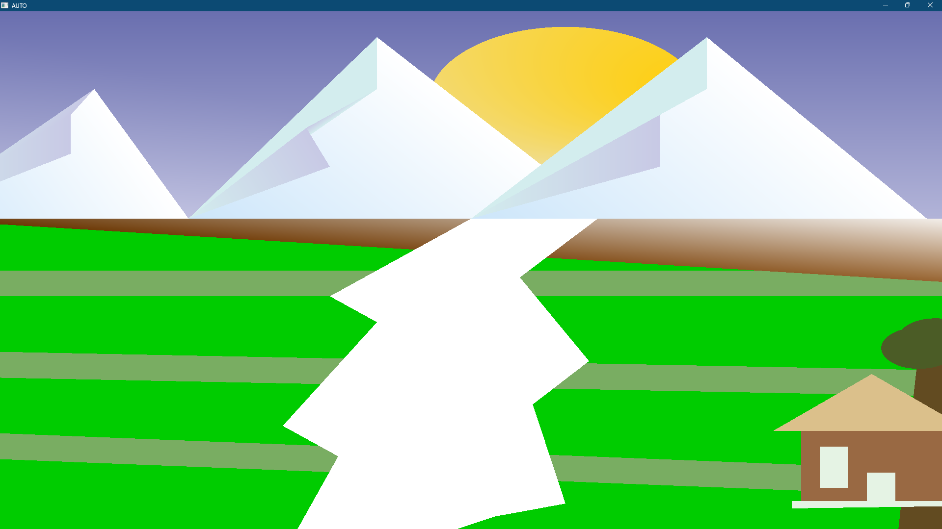
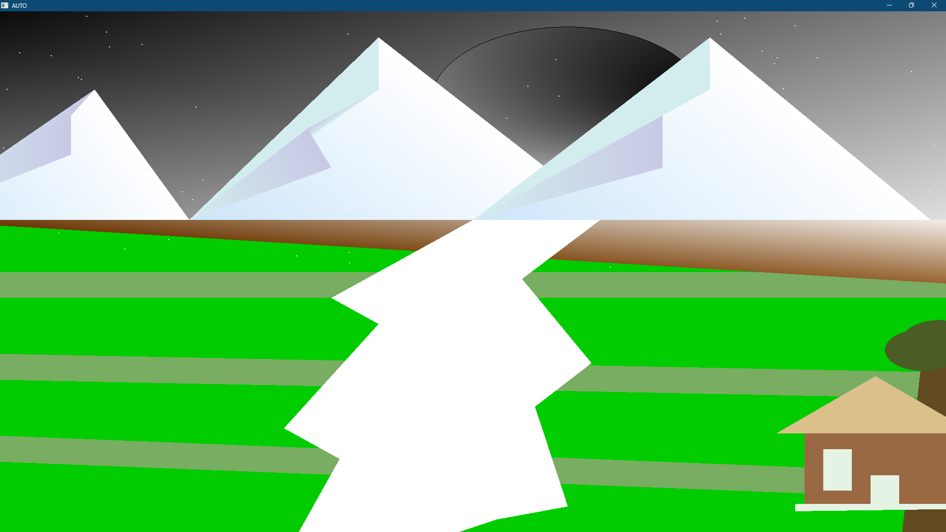

Question-
Create a simple day and night scenario using keyboard interaction. The key ‘D’ or ‘d’ will initiate the day mode and the key ‘N’ or ‘n’ will initiate the night mode.

Graph

Code-
#include <windows.h>
#include <GL/glut.h>
#include<math.h>
#include<iostream>
using namespace std;
void Sky()
{
glBegin(GL_POLYGON);

glColor3f(0x6A / 255.0f, 0x6F / 255.0f, 0xAF / 255.0f);
glVertex2f(-1.2, 1);
glVertex2f(1, 1);

glColor3f(0xC8 / 255.0f, 0xC9 / 255.0f, 0xE5 / 255.0f);
glVertex2f(1.05, -0.05);
glVertex2f(-1.2, 0.2);

glEnd();

glFlush();
}
void rivr()
{
glBegin(GL_POLYGON);

glColor3f(1.0f, 1.0f, 1.0f);
glVertex2f(0, 0.2);
glVertex2f(-0.3, -0.1);
glVertex2f(-0.1, -0.3);
glVertex2f(-0.4, -0.6);
glVertex2f(-0.2, -0.8);
glVertex2f(-0.3, -0.9);
glVertex2f(-0.4, -1.1);
glVertex2f(-0.2, -1.1);
glVertex2f(0.05, -0.95);
glVertex2f(0.2, -0.9);
glVertex2f(0, -0.7);
glVertex2f(0.25, -0.35);
glVertex2f(0.05, -0.1);
glVertex2f(0.2680683815806, 0.1990663142448);
glVertex2f(0, 0.2);

glEnd();

//tree circle

glFlush();
}

void hous()
{
//body
glBegin(GL_POLYGON);

glColor3f(0x99 / 255.0f, 0x69 / 255.0f, 0x43 / 255.0f);

glVertex2f(0.7, -0.6);
glVertex2f(0.7, -0.9);
glVertex2f(1, -0.9);
glVertex2f(1, -0.6);

glEnd();
//head
glBegin(GL_POLYGON);

glColor3f(0xDB / 255.0f, 0xC0 / 255.0f, 0x8B / 255.0f);

glVertex2f(0.64, -0.62);
glVertex2f(1.06, -0.62);
glVertex2f(0.85, -0.4);

glEnd();
//window
glBegin(GL_POLYGON);

glColor3f(0xE5 / 255.0f, 0xF3 / 255.0f, 0xE4 / 255.0f);

glVertex2f(0.74, -0.68);
glVertex2f(0.74, -0.84);
glVertex2f(0.8, -0.84);
glVertex2f(0.8, -0.68);

glEnd();
//door
glBegin(GL_POLYGON);

glColor3f(0xE5 / 255.0f, 0xF3 / 255.0f, 0xE4 / 255.0f);

glVertex2f(0.84, -0.78);
glVertex2f(0.9, -0.78);
glVertex2f(0.9, -0.9);
glVertex2f(0.84, -0.9);

glEnd();

glBegin(GL_POLYGON);

glColor3f(0xE5 / 255.0f, 0xF3 / 255.0f, 0xE4 / 255.0f);

glVertex2f(0.68, -0.89);
glVertex2f(0.6800379059788, -0.9185509677358);
glVertex2f(1.02, -0.91);
glVertex2f(1.02, -0.89);

glEnd();

glFlush();

}
void mud()
{
glBegin(GL_POLYGON);

glColor3f(0.4f, 0.2f, 0.0f);
glVertex2f(-1.2, 0.2);

glColor3f(1.0f, 1.0f, 1.0f);
glVertex2f(1.2, 0.2);

glColor3f(0.6f, 0.4f, 0.2f);
glVertex2f(1.05, -0.05);

glEnd();
glFlush();
}
void tree()
{
//body
glBegin(GL_POLYGON);

glColor3f(0x62 / 255.0f, 0x4B / 255.0f, 0x21 / 255.0f);

glVertex2f(0.9, -1.1);
glVertex2f(1.15, -1.05);
glVertex2f(1.12, -0.38);
glVertex2f(0.95, -0.3);
glVertex2f(0.98, -0.4);

glVertex2f(1, -0.9);

glEnd();

glBegin(GL_POLYGON);
float xOffa = 0.95, f;
float yOffa = -0.3f;
for (int i = 0; i < 300; i++)
{

glColor3f(0x4B / 255.0f, 0x5C / 255.0f, 0x26 / 255.0f);

float pi = 3.1416;
float a = (i * 2 * pi) / 300;
float r = 0.08;
float x = r * cos(a) + xOffa;
float y = r * sin(a) + yOffa;
glVertex2f(x, y);

}

glEnd();

glBegin(GL_POLYGON);
float xOff = 0.985;
float yOff = -0.265f;
for (int i = 0; i < 300; i++)
{

glColor3f(0x4B / 255.0f, 0x5C / 255.0f, 0x26 / 255.0f);

float pi = 3.1416;
float a = (i * 2 * pi) / 300;
float r = 0.08;
float x = r * cos(a) + xOff;
float y = r * sin(a) + yOff;
glVertex2f(x, y);

}

glEnd();
glFlush();
}
void mountain()
{
glBegin(GL_POLYGON);

glColor3f(0.8f, 0.9f, 0.98f);
glVertex2f(-1.2, 0.2);
glColor3f(1.0f, 1.0f, 1.0f);
glVertex2f(-0.8, 0.7);
glVertex2f(-0.6, 0.2);

glEnd();

glBegin(GL_POLYGON);

glColor3f(0.8f, 0.9f, 0.98f);
glVertex2f(-0.6, 0.2);

glColor3f(1.0f, 1.0f, 1.0f);
glVertex2f(-0.2, 0.9);
glVertex2f(0.38, 0.08);

glEnd();

glBegin(GL_POLYGON);

glColor3f(0.8f, 0.9f, 0.98f);
glVertex2f(0, 0.2);

glColor3f(1.0f, 1.0f, 1.0f);
glVertex2f(0.5, 0.9);
glVertex2f(1.1, 0);

glEnd();

glBegin(GL_POLYGON);

glColor3f(0xD3 / 255.0f, 0xED / 255.0f, 0xEE / 255.0f);
glVertex2f(-1.2, 0.2);
glVertex2f(-1, 0.3);
glVertex2f(-1, 0.4);

glColor3f(0xC8 / 255.0f, 0xC9 / 255.0f, 0xE5 / 255.0f);
glVertex2f(-0.85, 0.45);
glVertex2f(-0.85, 0.6);
glVertex2f(-0.8, 0.7);

glEnd();

glBegin(GL_POLYGON);

glColor3f(0xD3 / 255.0f, 0xED / 255.0f, 0xEE / 255.0f);
glVertex2f(-0.6, 0.2);
glVertex2f(-0.2, 0.9);
glVertex2f(-0.2, 0.7);

glColor3f(0xC8 / 255.0f, 0xC9 / 255.0f, 0xE5 / 255.0f);
glVertex2f(-0.35, 0.55);
glVertex2f(-0.3, 0.4);
glVertex2f(-0.6, 0.2);
glEnd();

glBegin(GL_POLYGON);

glColor3f(0xD3 / 255.0f, 0xED / 255.0f, 0xEE / 255.0f);
glVertex2f(0, 0.2);
glVertex2f(0.5, 0.9);
glVertex2f(0.5, 0.7);

glColor3f(0xC8 / 255.0f, 0xC9 / 255.0f, 0xE5 / 255.0f);
glVertex2f(0.4, 0.6);
glVertex2f(0.4, 0.4);
glVertex2f(0, 0.2);
glEnd();
glFlush();
}

void sun()
{

glBegin(GL_POLYGON);
float xOff2 = 0.2;
float yOff2 = 0.65;

for (int i = 0; i < 300; i++) {
// Calculate the fade color from yellow to light white
float fadeFactor = static_cast<float>(i) / 300.0f;
glColor3f((255 - fadeFactor * (255 - 230)) / 255.0f,
(206 - fadeFactor * (206 - 230)) / 255.0f,
(7 - fadeFactor * (7 - 230)) / 255.0f);

float pi = 3.1416;
float a = (i * 2 * pi) / 300;
float r = 0.29;
float x = r * cos(a) + xOff2;
float y = r * sin(a) + yOff2;
glVertex2f(x, y);
}

glEnd();
glFlush();
}
void moonBorder() {
glBegin(GL_LINE_LOOP);
glColor3f(0.0f, 0.0f, 0.0f);

float xOff2 = 0.2;
float yOff2 = 0.65;
float radius = 0.29;

for (int i = 0; i < 300; i++) {
float pi = 3.1416;
float a = (i * 2 * pi) / 300;
float x = radius * cos(a) + xOff2;
float y = radius * sin(a) + yOff2;
glVertex2f(x, y);
}

glEnd();
}
void moon()
{
glBegin(GL_POLYGON);
float xOff2 = 0.2;
float yOff2 = 0.65;

for (int i = 0; i < 300; i++) {

float fadeFactor = static_cast<float>(i) / 300.0f;
glColor3f((0 + fadeFactor * (255 - 0)) / 255.0f,
(0 + fadeFactor * (255 - 0)) / 255.0f,
(0 + fadeFactor * (255 - 0)) / 255.0f);

float pi = 3.1416;
float a = (i * 2 * pi) / 300;
float r = 0.29;
float x = r * cos(a) + xOff2;
float y = r * sin(a) + yOff2;
glVertex2f(x, y);
}

glEnd();

glColor3f(1.0f, 1.0f, 1.0f);
glPointSize(2.0f);
glBegin(GL_POINTS);

for (int i = 0; i < 20; i++) {
float xStar = static_cast<float>(rand()) / static_cast<float>(RAND_MAX) * 2.2 - 1.2;
float yStar = static_cast<float>(rand()) / static_cast<float>(RAND_MAX) * 1.2 - 0.05;

glVertex2f(xStar, yStar);
}

glEnd();
glFlush();
}

void ground()
{
glBegin(GL_POLYGON);

glColor3f(121 / 255.0f, 173 / 255.0f, 98 / 255.0f);

glVertex2f(-1.4, 0);
glVertex2f(-1.4, -0.1);
glVertex2f(1.4, -0.1);
glVertex2f(1.4, 0);

glEnd();

glBegin(GL_POLYGON);

glColor3f(121 / 255.0f, 173 / 255.0f, 98 / 255.0f);

glVertex2f(-1.4, -0.3);
glVertex2f(-1.4, -0.4);
glVertex2f(1.4, -0.5);
glVertex2f(1.4, -0.4);

glEnd();

glBegin(GL_POLYGON);

glColor3f(121 / 255.0f, 173 / 255.0f, 98 / 255.0f);

glVertex2f(-1.4, -0.6);
glVertex2f(-1.4, -0.7);
glVertex2f(1.4, -0.9);
glVertex2f(1.4, -0.8);

glEnd();
glFlush();
}

void nightsky()
{
glBegin(GL_POLYGON);

glColor3f(0.0f, 0.0f, 0.0f);
glVertex2f(-1.2, 1);

glColor3f(0.5f, 0.5f, 0.5f);
glVertex2f(1, 1);

glColor3f(1.0f, 1.0f, 1.0f);
glVertex2f(1.05, -0.05);

glColor3f(0.5f, 0.5f, 0.5f);
glVertex2f(-1.2, 0.2);

glEnd();

glColor3f(1.0f, 1.0f, 1.0f);
glPointSize(2.0f);
glBegin(GL_POINTS);

for (int i = 0; i < 100; i++) {
float x = static_cast<float>(rand()) / static_cast<float>(RAND_MAX) * 2.2 - 1.2;
float y = static_cast<float>(rand()) / static_cast<float>(RAND_MAX) * 1.2 - 0.05;

glVertex2f(x, y);
}

glEnd();

glFlush();
}

int currentScene = 1;

//Press 1 For Day Press 2 For Night
void display() {
glClearColor(0.0f, 0.8f, 0.0f, 1.0f);
glClear(GL_COLOR_BUFFER_BIT);

if (currentScene == 1) {
Sky();
sun();
mountain();
ground();
mud();
rivr();
tree();
hous();
}
else if (currentScene == 2) {
nightsky();
moon();
moonBorder();
mountain();
ground();
mud();
rivr();
tree();
hous();
}

glutSwapBuffers();
}

void key_callback(unsigned char key, int x, int y) {
if (key == 'D' || key == 'd') {
currentScene = 1; // Set current scene to day mode
glutPostRedisplay(); // Redraw the scene
}
else if (key == 'N' || key == 'n') {
currentScene = 2; // Set current scene to night mode
glutPostRedisplay(); // Redraw the scene
}
}

int main(int argc, char** argv) {
glutInit(&argc, argv);
glutCreateWindow("Press 1 For Day Press 2 For Night");
glutInitWindowSize(800, 600);
glutDisplayFunc(display);
glutKeyboardFunc(key_callback);

glutMainLoop();

return 0;
}

Output Screenshot (Full Screen)-
